Glencairn Primary Nursery Class
August 2024 Newsletter


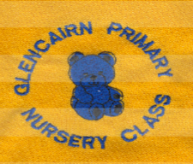
Welcome!  We would like to welcome all our families, those returning to us and those who are new joining us here at Glencairn. We are looking forward to our year ahead.  This month we will be settling into the nursery routine, building relationships, and making connections. The story we will be learning about over the next few weeks is Owl Babies by Martin Waddell. The rhymes/songs we will be focusing on are ‘I love you, you love me’ and The Glencairn Nursery song. To stimulate the children’s creativity skills, we will be introducing the artist of the month, this month is L.S. Lowry.  The Nurture Principle we will be focusing on is Transitions, ensuring all children have a smooth return or start to their nursery life, the SHANARRI indicator is Safe. The children’s right article of the month is Article 1 – everyone has rights and it’s ok to have feelings and we can name them.  Making connections  If possible could you send a photo of your family to help us make connections with your child? We plan to create a nurture wall within the home corner displaying photographs of our families.  Illnesses/allergies  Please inform staff of any allergies or dietary requirements.  If your child has been given Piriton or Calpol before entering nursery you must inform staff.  If your child has been sick or has diarrhoea, please do not send them back to nursery until 48 hours after their last episode.  Safety and security  To ensure the safety and security of all children we ask you close the nursery gate behind you. The nursery door will be always locked, please buzz to gain access, a member of staff will be on door duty during busy times. The main gates will be locked from 9.00 am – 12.15 am and 1.45 pm – 4.00 pm. If you require access to the nursery out with these times, please call the nursery mobile. | Contact Details  Glencairn Primary School and Nursery Class  Glencairn Street, Motherwell, ML1 1TT  Tel: 01698 274982  Mobile 07583122840  Email-  enquiries-at-glencairn@northlan.org.uk  X (Twitter)  Follow us at: @GlencairnNursery  Or @GlencairnNC  Newsletter  The newsletter will be sent out monthly to keep you updated.

Children’s Groups
To foster a sense of belonging every child has been placed in a group with a keyworker. Due to staff changes some children may have swapped groups. All staff members in Glencairn Nursery nurture and care for every child.
The groups are -
Red Ladybird Group – Keyworker – Miss McCafferty
Green Caterpillar Group – Keyworker – Miss O’Rourke
Blue Butterfly Group –Keyworker – Miss Cleary
Orange Firefly Group – Joint Keyworker – Miss Cain and Mrs Cambridge.
Purple Dragonfly Group – Keyworker – Mrs Donaldson
Turquoise Turtle Group – Keyworker – Miss Farrell
All children will continue to be supported by Miss Bone, Mr Patrick and Mr Olu.

The nursery is managed by:
Head teacher - Mrs Reilly
Principal Teacher – Mrs Nicholson
Principal Leads – Mrs McGowan and Mrs Ward.
Lead Early Years practitioner – Mrs Cambridge

SWAY’s
We continue to use SWAY as an online learning profile, please make sure you have completed a permission slip to access your child’s unique code. You will be sent a new link to be able to view your SWAY. Any problems please speak to Mrs McGowan.

Nursery Funds
We rely on nursery funds to bring essential money into the nursery. We use this money to buy snack items, Christmas gifts, Easter eggs and to buy new resources and plan outings to enhance the children’s learning. We are requesting parents contribute £2 each week into the nursery funds. Thank you.

Nursery Initiatives
Throughout the year there will be an opportunity for all children and parents to work alongside staff members to take forward some initiatives. If you are interested in finding out more information, please speak to a member of staff at the door.

Solihull parenting group with Mrs Ward and Mrs McGowan
Parent Early Education programme with Mrs Ward
Book bug with Miss Farrell and Miss Cleary
Language Land with Mrs McGowan
Early Language and Listening Group with Miss Cain and Mrs Ward
Heuristic group with Mrs McGowan and Miss McCafferty
Sunnybank with Miss McCafferty

Some of these initiatives will take place in the corridor, we ask you when picking your child up from the morning session to arrive after 12.30 and when dropping off in the afternoon session to arrive before 1.30.

Improvement plan
We have three priorities this year. 1 – to continue developing our outdoor area. 2, - to promote emotional resilience and self-awareness for all children. 3 – To promote the importance of and raise attainment of a targeted group of children in developing listening and talking skills.
As part of our third priority, we ask you to complete a questionnaire on the development of communication and language skills within children 3-5 years. We do have a paper copy for you to complete but also have a QR code if you prefer.
We would really appreciate your participation in answering these questions to help aid any future developments.


Routine of the day
Nursery session times are 8.00 – 12.40 and 1.15 – 5.55

Morning Session
8.00 – 9.15 Soft start and breakfast
9.15 – 12.00 Free play – following children’s interests, introducing learning provocations and experiences
11.10 – 12.10 – Rolling lunch/free play
11.30 – Heuristic group
12.00 - Early Language and Listening Group
12.15 – Gathering time
12.30 – 12.40 Home time

P.M session.
1.15 – 1.30 Gathering time
1.15 – 2.30 Rolling lunch/free play
1.30 -5.45 Free play – following children’s interests, introducing learning provocations and experiences.
1.45 – Heuristic group
2.30 - Early Language and Listening Group
4.00 – 4.30 rolling light snack
4.30 – 5.55 freeplay and soft finish
5.55 – all children have left the nursery.

Pick up/drop off routine.
When dropping off in the morning we ask you to sign your child in on the laminated sheets at the nursery entrance. When picking up your child from 12.30 to 12.40 we ask you to go into the playroom and go to their group area to sign out. When dropping off in the afternoon session 1.15 – 1.30 we ask you to go into the playroom and drop off your child at their group area and sign in, when returning to pick them up please sign you child out on the laminated sheets at the nursery entrance.

Group areas –
Orange Fireflies – art area
Purple Dragonflies – block area
Turquoise Turtles – snack area
Red Ladybirds – story corner
Blue Butterflies – House corner
Green Caterpillars – loose parts area

Spare clothing
Can you ensure your child has spare clothes in their nursery bag in case of accidents? Please make sure your child’s name is on all of their belongings.
We also ask that your child does not bring toys from home to nursery as they can become distressed if their toys go missing or get broken.

Important Reminders

- Please also make sure your child’s outside shoes do not have laces if your child cannot tie laces by themselves, as the children are encouraged to change their shoes themselves.
- Please ensure that when you enter and exit the nursery grounds, you do not use the nursery car park. This is for staff only unless you have a blue badge.

Glencairn Primary and Nursery aims and values.

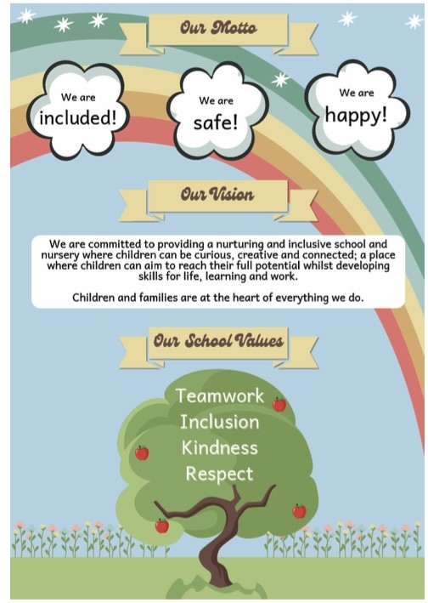

THE SCHOOL YEAR: 2024-2025
We are a 48-week establishment and are only closed on these dates. However, a few children may share funding with childminders and during term time. Please note that during holiday periods our session times may vary.

August 2024
In-service day: Monday 12th of August 2024
In-service day: Tuesday 13th of August 2024
Children return: Wednesday 14th of August 2024

September 2024
September weekend holidays: Friday 27th of September 2024 until Monday 30th of September 2024

October 2024
October week: Monday 14th of October until Friday 18th of October (term time)

November 2024
In- Service Day: Monday 18th of Nov 2024

December 2024 - January 2025
Christmas and New Year Holidays: Tuesday 24th of December until Friday 3rd of January.

February 2025
Mid-term break Monday 17th and Tuesday 18th of February
In Service Day: Wednesday 19th of February 2025

April 2025
Good Friday 18th and Easter Monday 21st of April 2025

May 2025
May day holiday: Monday 5th of May 2025
In-Service day: Tuesday 6th of May 2025
May weekend holiday: Friday 23rd and Monday 26th of May 2025

Schools close
Wednesday 25th of June 2025

Fair Monday
Nursery is closed 15th of July 2025

