Glencairn Primary School
September Newsletter





Just a reminder to return all parental consent forms to the school as soon as possible. The form gives your child permission for the whole school year. Each time your child goes on an outing or local walk we will let you know via a letter, email or text.  Open Afternoon  We look forward to meeting you from 3.10pm on 11th of September. It will be very busy so here is a reminder of where the classes are- P1a, P1b, P2/1, P2, P3a, and P3b are downstairs. P4a, P4b, P5a, P5b, P6a, P6b, P6c are upstairs and P7a and P7b are the the modular units.  Tea and coffee will be served in the school hall.  Breakfast Club  Remember we have a Breakfast Club service from 8.15am every day. All pupils welcome. All Free School Meals are free which includes all P1-P5 pupils. If you child pays, the cost is £1- 1 child, £1.50- 2 children, £1.80- 3 children and £2.10- 4 children.  Just a reminder that playground supervision starts at 8.45am. Please do not send children into the playground before this time. If children come to school before this time, they are welcome to attend our Breakfast Club, 8.15pm to 8.45am.  Child Protection  If you see something in and around the school that you are concerned about with regard to the protection of children, please speak to Mrs Reilly who is the Child Protection officer for the school and nursery.  ASDA Rewards App  You can support fundraising in our school art no cost to yourself by selecting our school on your ASDA rewards app. Click on Cashpot on the app and choose Glencairn. Our postcode is ML1 1TT. We already have £130! It runs for the next three months. | Parent Council Halloween Disco  The P1 and P2 party will take place during the school day on the 30^{h} of October and the P3 and P4 disco will be in the school hall 6pm to 7pm and the P5 to P7 disco will be in the school hall from 7.15pm-8.15pm. Further information to follow.  Safety  Please do not send lollipops into school as a snack for your child. Children running in the playground or climbing on the trim trail could potentially fall and choke on a lollipop. Thank you for your co-operation.  A reminder that we are a nut free school and no nuts should be sent in as snacks.  Holidays  September 2024  September weekend holidays: Friday 27th September 2024 to Monday 30th September 2024.  October 2024  October break: Monday 14th October 2024 to Friday 18th October 2024

Glencairn Primary School
September Newsletter

School Gates and Road Safety
Thank you for trying to keep a clear pathway into the school so children can arrive safely and for dropping off your children at the main access gates. The P1s have settled in well to the morning routine.

The roads around our school are very busy and will become busier as we move into winter. Please refrain from parking on the zig zag lines outside the school or near corners where it makes it difficult to cross the road safely. Please be mindful when parking outside our neighbours’ houses that they still have access to driveways.

Please refrain from parking in the staff car park or blocking any cars from entering John Thomson House or Ravenscourt on Camp Street. Thank you.

School Improvement Plan
Our School Improvement Priorities this session are Improving reading attainment at second level- P5 to P7, staff will do training on the Circle Framework to review and improve our inclusive learning environments and we will continue to develop our curriculum offer and include more community links and outdoor learning.

We will update you throughout the year on our progress towards our Improvement priorities.

Fundraiser
Children can come to school in own clothes on Thursday 26th September for a sponsored bounce. We are hiring two bouncy castles.This has been arranged by our Parent Council to help raise funds for school. A sponsor form and letter will be sent home next week for all P1 to P6 children and P7 will do a different sponsored activity, which is a walk on the Tuesday 24th September for their residential trip.

Out of Hours Learning
We will shortly be starting up our programme of After School Clubs run by Sports Leaders and members of our staff. These are are great way for children to develop skills and meet different people. We will be in touch soon with more information on which year groups will be involved.

Uniform
It is great to see the children looking so smart in their uniforms. Please ensure that they wear uniform every day unless it is a non-uniform day. If children are wearing outdoor PE kit, this should be plain, self-coloured and without sports logos. Please remember to label all clothing items that may be removed in school for ease of identification.

Parents Portal
If you have not do so already, we encourage you to sign up for a My Gov account and from there you can pay for school meals and sign into the Parents Portal which we are introducing. If you need your child’s unique number for school meals payments, please email us on
enquries-at-glencairn@northlan.org.uk

https://digital.northlanarkshire.gov.uk/myaccount
Accessing the Parent Portal
Please make sure that the web address typed is exact or type mygovscot into your search engine.

- Go to the Website
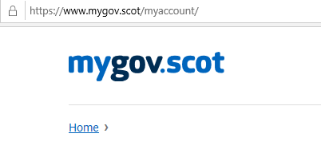

- Scroll down and click on the link
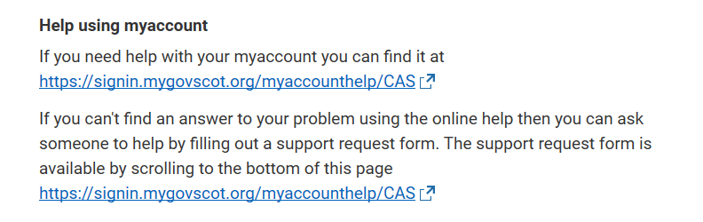

- Click on Register
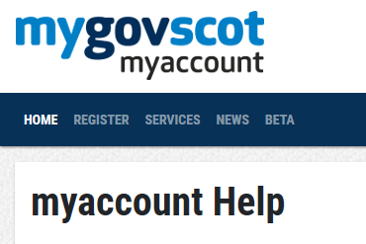

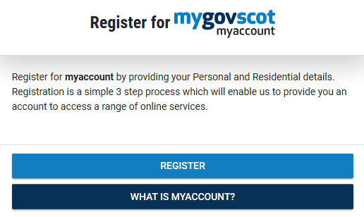
- Click on register and fill in the information

Once you have registered you will receive an e mail to VERIFY the account. You need to access your e mail and click verify. Your mygovscot account will then be active and you can go onto the PARENTS PORTAL

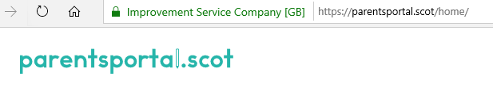
- Go to Website


- Click on sign in

- Sign in using your MYGOVSCOT account which you created at Stage 1.
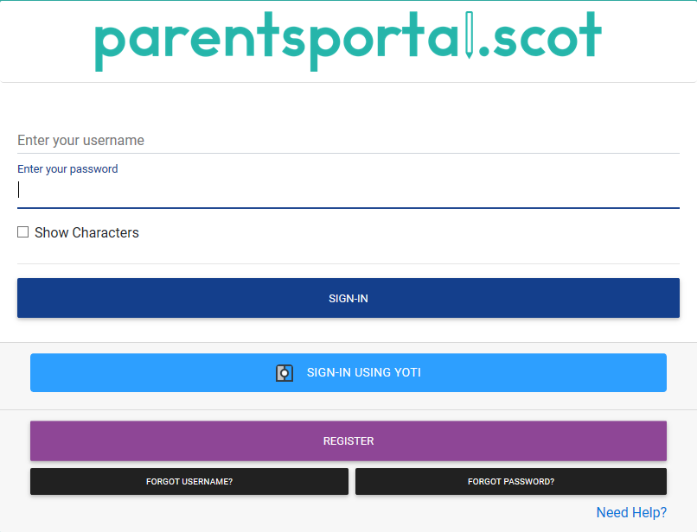

- Click on Link Child
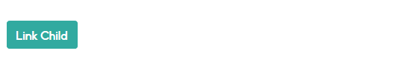

- Click Start the process


Using the Data Sheet issued by the school fill in the child’s information EXACTLY as it is on the Data Sheet.
Once linked a one time code will be sent to either your phone or e mail. ENTER THE CODE.

Your access to the PARENTS PORTAL will now be pending until the school APPROVES IT.
Once APPROVED you can access the PORTAL.

