
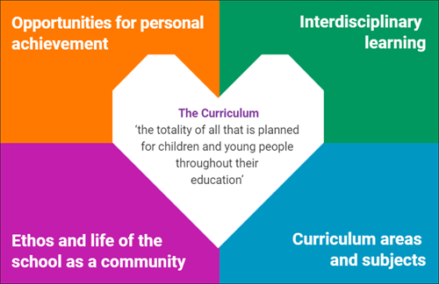
Curriculum and Planning Audit September 2024
Curricular Area | In place | To include
Languages | Literacy and English  French and Spanish progression
Numeracy and Maths | Numeracy and Maths  SEAL  Number talks
Health and Wellbeing | Healthy.Scot planner  Our healthy world in IDL  RSHP  Respect Me  Think U Know | A progressive PE planner
Expressive Arts | Art planner for Early, First and Second levels  Dance planners | Progressive Art, Drama and Music planners (Music Express)
Religious and Moral | Progressive planner for all stages | Composite classes
Sciences | IDL
Social Studies | IDL
Technologies | IDL

Next steps
Develop a Maker Space for Enterprise, Design and Technologies such as textiles, engineering and cooking and develop the outdoor classroom area for a range of learning experiences.

Cross- Cutting themes through Interdisciplinary Learning

Enterprise in Education​
​Global Citizenship​
​Personal, Social and Emotional Development​
​Digital Literacy​
DYW Links​
​Outdoor Learning

Skills developed through the Four Capacities and IDL
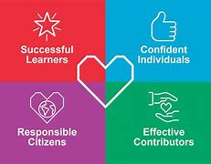
Successful Learner​
Focusing​
Sense Making​
Curiosity​

Effective Contributor​
Adapting​
Collaborating​
Communicating​

Responsible Citizen​
Feeling​
Initiative ​
Integrity​

Confident Individual​
Creativity​
Leading​
Critical Thinking​

Next steps
Use the Skills Framework for evaluate the learning,
and develop an individual skills tracker.
Whole school cross- curricular progression

Our ​  Scientific​  World​ | Our Technological World​ | Our Geographical World​ | Our ​  Healthy ​  World​ | Our​  Historical World​ | Our​  Sustainable World​

Entitlement to Learning for Sustainability
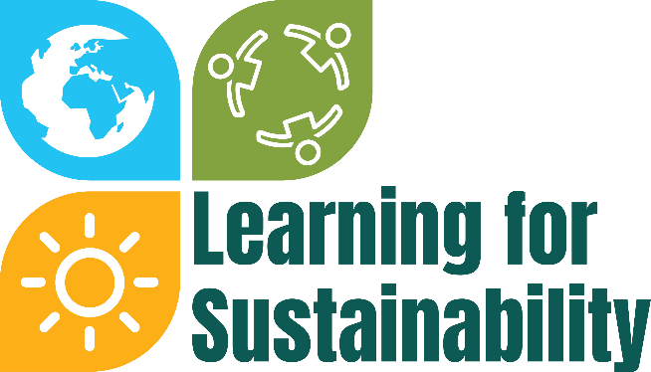

Scotland's learning for sustainability action plan 2023 to 2030 "Target 2030: A movement for people, planet and prosperity " aims to build an inspiring movement for change so every 3 to 18 place of education becomes a sustainable learning setting by 2030.
In Glencairn all children experience their entitlement to Learning for Sustainability through the Global Goals in Our Sustainable World (IDL) and at whole school assemblies and through the ECO schools award. We will also be collaborating with Climate 180.
Opportunities for Personal Achievement
Children experience a range of opportunities from Bikeability, Swimming, forest skills groups, after school clubs, participation in sporting events, P7 buddies and a P7 residential week. Out of school achievements are recognised at assemblies.
Children have achievements in our Eco, Digital and School Sports Awards, by being House Captains and members of Pupil Leadership Groups such as Right Respecting Schools, Pupil Council, Sustainability Ambassadors and Digital Leaders.
Ethos and the life of the school as a community
We value our community and take part annually in charity fundraising, donations to the foodbank, recycling school uniforms, links with local care home, ASDA, The Kings, Maranatha, and St Mary’s churches, the library, the Letitia McKell Maker Space, the Heritage Centre, lunchtime clubs and playground activities.

