**Glenboig Primary**

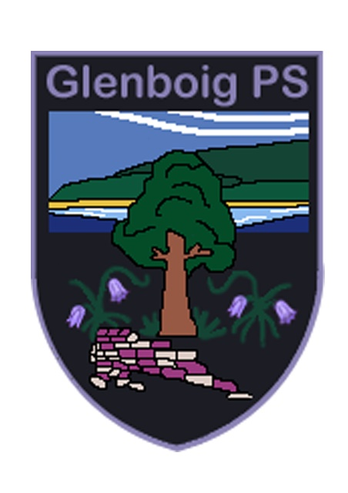

**Positive Relationships and**

**Behaviour Policy**

**Together We …**

**Dream Big, Work Hard, Shine Bright**

Reviewed: August 2019

Next review date: August 2021

Introduction

***‘Dream Big, Work Hard, Shine Bright’*** is the vision and aspiration of all at Glenboig Primary School and all stakeholders share in our values of: **High expectations, Working hard, Family & Community, Integrity, Equality, Equity, Nurture and Resilience.**

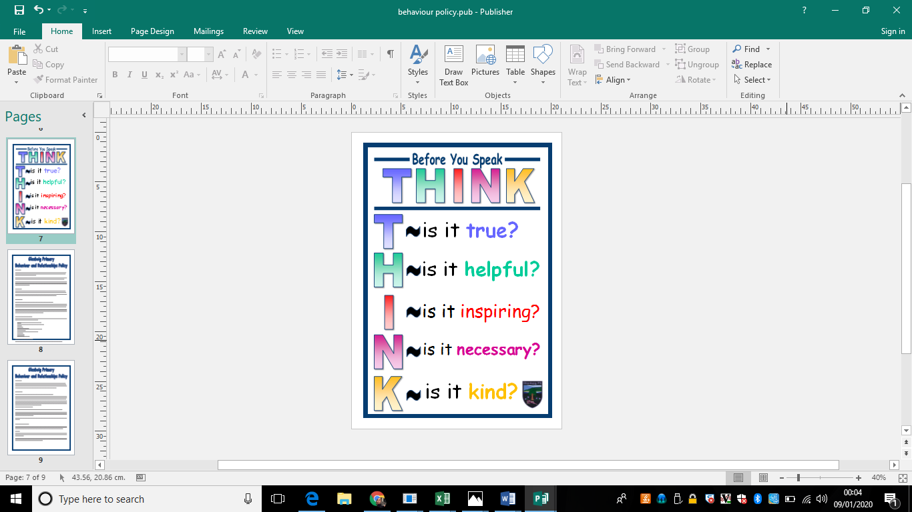We recognise that positive behaviour and relationships are central to effective learning. At Glenboig, we expect everyone to show respect for all others, to be honest and to take responsibility for their actions.

The children come to school as individuals, and as such will display a wide variety of behaviour patterns based on home values, life experience and attitudes. In line with our work on UNICEF Rights Respecting Schools we continue to work towards a common standard of behaviour based on the UN Convention on the Rights of the Child (UNCRC).

We use the phrase THINK when considering how we speak to others:

Class Charter

Each class begins a new session by creating a Class Charter, which is based on the UNCRC. The Class Charter is at the heart of creating responsible citizens and should be referred to frequently throughout the year. As part of the curriculum, we use various methods to help the children to develop important skills and qualities such as resilience, teamwork, negotiation, anger management and flexibility.

House System

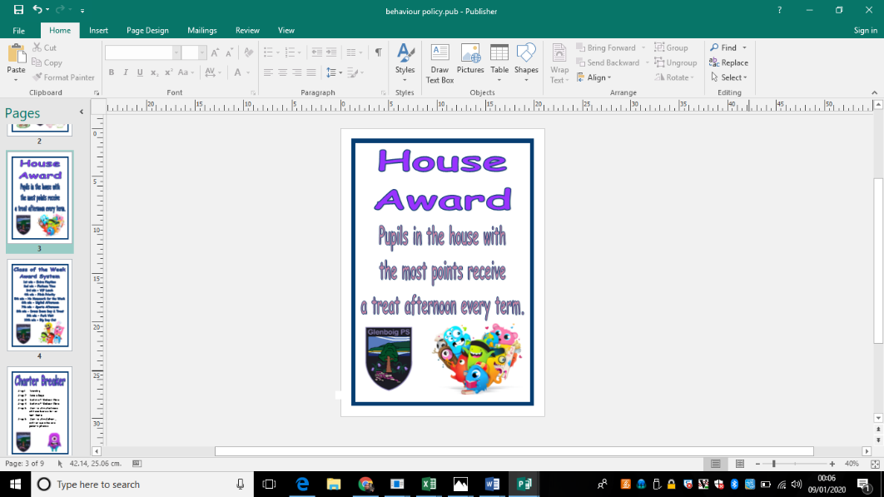

We have 4 houses in Glenboig Primary, each named after areas in our villiage.

Two Primary 7 pupils will be elected as Captains for each house, and will take responsibility for leading their houses. This will involve them encouraging and modelling good behaviour, positive attitudes and teamwork. The House Captains will also have a pastoral care duty for the younger children in their house.

Throughout the session there will be opportunities for team-building such as house competitions and earning house points. House points may be awarded for any positive behaviour or achievement, including neat lines, sitting well at assembly, good manners or showing kindness to others. At the end of each term, the house with the most points will enjoy an extra reward.

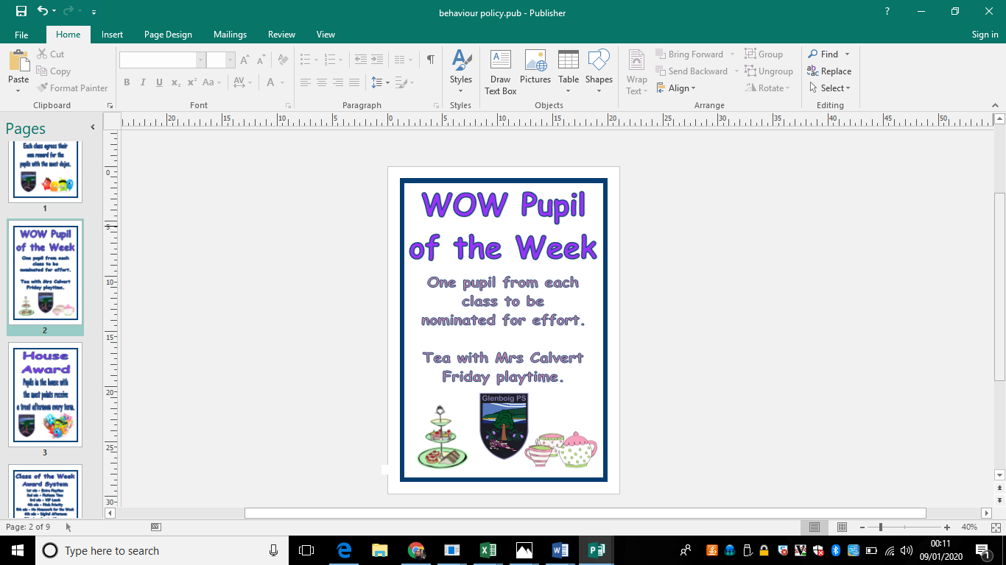Positive Consequences (Rewards)

We believe that children should be encouraged and rewarded for behaving well and working hard. We use the following positive rewards, amongst others:

Non-verbal rewards such as thumbs up or a smile;

Praise;

Showing work to another teacher or the Head Teacher;

Stickers;

Certificates;

Letters home to parents;

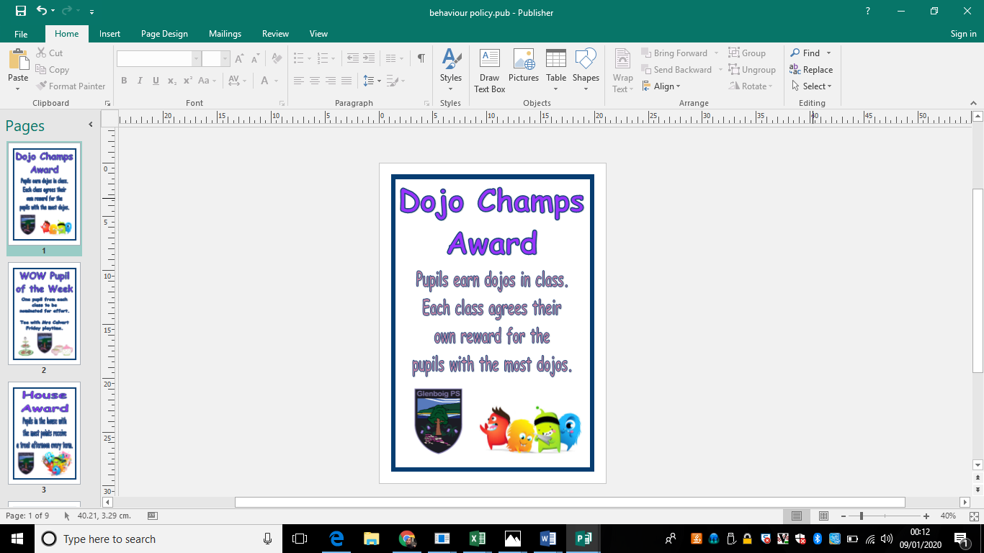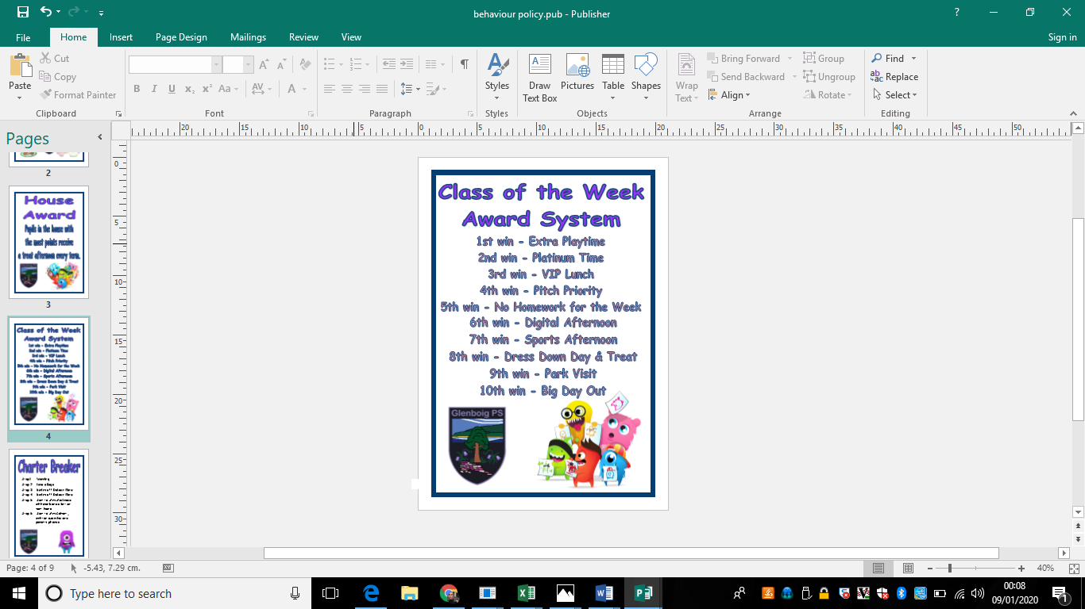Celebrating achievement on Twitter or the website;

Displaying work;

Awards throughout the year at assemblies;

Dojo points;

House points;

Wow Pupil Certificates and Tea with the HT

Class Tokens & reward system;

Golden Time (*appendix 2)*

Committees

Every child will hae a role on a committee which will have a lead member of staff and P7 leaders. This gives children the opportunity to have a direct impact on an area of improvement for the school, a voice and the opportunity to represent their peers in their area of interest.

Pupil Council

Each class will elect a representative to our pupil council. They will be consulted on a number of issues throughout the year, they will consult with, represent and report back to their peers.

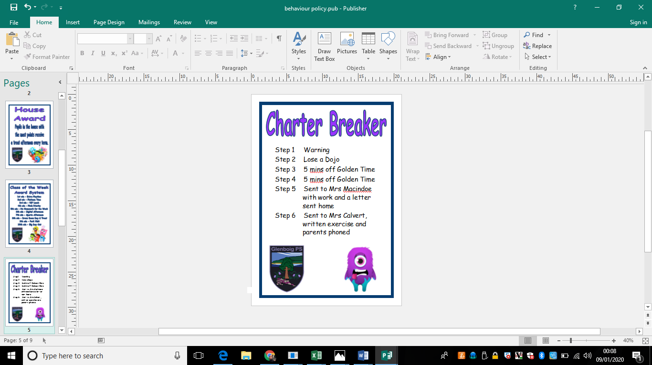Negative Consequences (Sanctions)

The UNCRC states that *“Discipline in schools should respect children’s human dignity”* (Article 28).

In order to protect the rights of our pupils, we believe it is important to build clear consequences for negative behaviours into this policy. Consequences should be linked to the inappropriate behaviour and should help the pupil to

reflect on why their behaviour was unacceptable. A staged system has been developed with our pupils council to support this.

If a child is displaying behaviour which is not respecting the rights of others, a series of procedures will be followed:

Step 1 Warning

Step 2 Lose a Dojo

Step 3 5 mins off Golden Time

Step 4 5 mins off Golden Time

Step 5 Sent to Mrs Macindoe with work and a letter sent home

Step 6 Sent to Mrs Calvert, written exercise and parents phoned

Racist or Bullying Behaviour

Any incident of racist or bullying behaviour is unacceptable and must be recorded through Click & Go, in line with North Lanarkshire Council policies and procedures. These incidents are reported annually to the authority. Please refer to the school policies on bullying and promoting race equality, for full details.

Exclusion

Exclusion is a legal process. Exclusion from Glenboig Primary School will only happen as a last resort, when all other measures and a range of strategies have been tried and failed, or in cases of serious indiscipline.

*Appendix 1*

The Six Principles of Nurture

1.       Children's learning is understood developmentally

2.       The classroom offers a safe base

3.       The importance of nurture for the development of wellbeing

4.       Language is a vital means of communication

5.       All behaviour is communication

6.       The importance of transition in children's lives

Lucas,S., Insley,K. and Buckland,G. (2006) *Nurture Group Principles and Curriculum Guidelines Helping Children to Achieve*, The Nurture Group Network.

*Appendix 2*

Golden Time

**Golden Time forms an important part of the Promoting Positive Behaviour and Relationships policy. Children will take part in Golden Time fortnightly and they will sign up to planned activities with different members of staff.**

Teachers will be given a register of pupils attending their activity in advance. If a pupil does not have all their Golden Time, they should still report to their activity but sit and reflect upon why they have not earned all their Golden Time minutes and how things could be different next week.

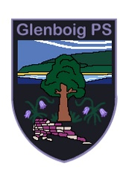Reflection Sheet

Name: ____________________ Date: ___________

1. Draw what happened. Write a sentence if you can, or ask an adult to write it for you.

________________________________________________________________________________________

1. How did you feel?

happy sad worried cross scared

1. How did the other person feel?

happy sad worried cross scared

1. Draw what you will do now to make it better.

Heather1

Reflection Sheet

Name: ______________________ Class: ____ Date: ___________

**What** happened?

________________________________________________________________________________________

**Why** were your actions or choices not acceptable? Think about how others might be feeling or how they have been affected.

____________________________________________________________________________________________________________________________________

**How** did you feel at the time? **How** do you feel now?

________________________________________________________________________________________

**What** could you have done differently?________________________________________________________________________________________

**What** positive choices do you need to make now?

________________________________________________________________________________________________________________________________________________________________________________