SELECTING WOOD
Types of Wood
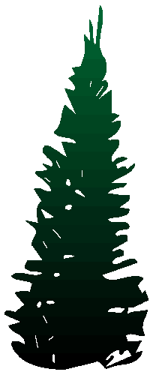
There are three types of wood, Softwood, Hardwood and Manufactured Boards.
Softwood
Coniferous trees (trees that keep their needle-like leaves throughout the year) provide softwood. They can grow quickly with straight trunks. They are often grown in plantations and are replaced when they are cut down. The wood is quite cheap and is used in the building industry for windows and doors etc. When the trunk is converted the waste is used for making paper and card.

Hardwood
Deciduous trees (trees that lose their large leaves every winter) provide hardwood. They grow slowly and sometimes have twisted trunks. They are often not replaced when cut down. The wood is costly and is used for fine furniture and wooden toys, etc.
Note: The difference between softwood and hardwood is a biological difference, not one of softness and hardness. The softest wood is Balsa - it is a hardwood!

Manufactured Boards
These are made from the waste wood left over from conversion. They use thin sheets (plywood), small blocks (blockboard), wood chips (chipboard) and wood fibres (fibreboard). They are generally cheaper than solid wood and can be made into large sheets that do not warp or twist easily.
AVAILABILITY
You can buy solid wood as rough sawn (very rough surface) or planed. The sizes shown at the wood yard are the rough sawn sizes (nominal size), if you buy the wood planed the true sizes will be up to 3mm less.
Planed planks can be planed top and bottom only, this is known as PBS (planed both sides). If the edges are planed as well it is known as PAR (planed all round).

Shapes and Forms
Wood yards sell wood in standard forms, the most common are shown below.
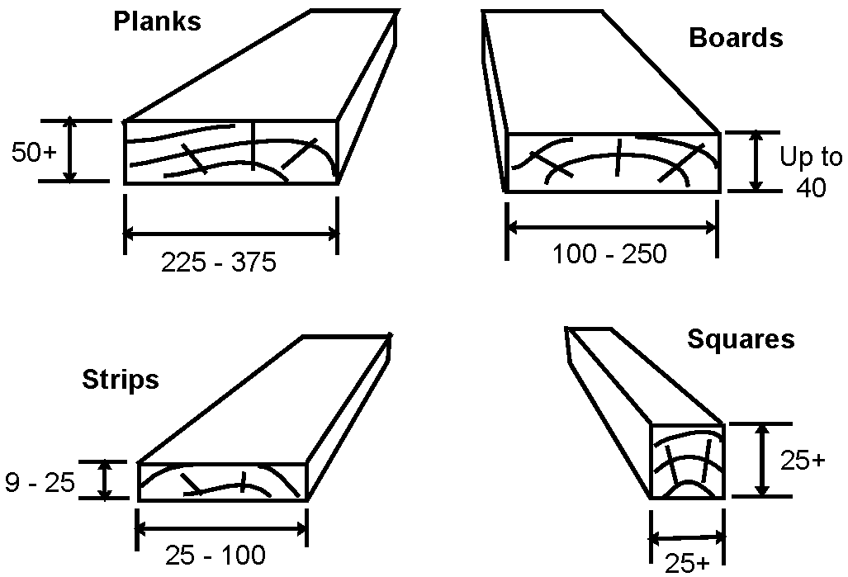
Note: The dimensions are in millimetres.

Choosing Softwood
NAME | PROPERTIES | USES | COST
Scots Pine  (Deal) | Straight grained, but knotty, quite strong and easy to work | Building construction. When used outside it needs protection. Takes paint well. | Low
Parana  Pine | Straight grained with few knots, quite strong and durable, warps easily | High quality interior  construction and  furniture | High
Spruce | Quite strong, with small knots, resistant to splitting but not durable  durable | Fitted furniture, e.g. kitchen cabinets. | Low
Cedar | Straight grained that is knot free. Very light in weight. Very durable,  inside and outside. Quite soft. | Used outside for shed construction and quality fencing. | High

Choosing Hardwood
NAME | PROPERTIES | USES | COST
Ash | Light in colour, flexible and tough, steam bends well, varnishes well. | Tool handles, cricket bat handles, ladders, veneers. | Med
Beech | Mid-brown colour, hard, strong and tough, tends to warp, steam bends well. | High quality furniture, toys, tool handles, veneers | Med
Oak | Light brown, hard, tough, heavy and durable outside. Gets harder with age. | High quality furniture, garden furniture, boat building, veneers | High
Mahogany | Red in colour, medium weight, quite strong, durable inside, warps  easily | High quality furniture, shop furniture, boat fittings, veneers. | High
Manufactured Boards
Plywood
Made from thin sheets of wood (veneers), glued together with the grain direction at 90° to the one next to it. They always have an odd number of layers 3,5,7 etc. to reduce warping

Medium Density Fibreboard (MDF)
Made from fine wood fibres, compressed and glued together. When in use it is normally covered by a plastic coating or hardwood veneer but also takes paint well to produce a good finish.

Blockboard
Strips of softwood are glued together and then sandwiched between two hardwood veneers. The edges look rough and are often covered with a thin hardwood strip

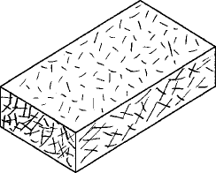
Chipboard
Made by compressing and gluing small chips of waste wood. When in use it is normally covered by a plastic coating or hardwood veneer.

Hardboard
Made by compressing and gluing pulped wood. It is smooth on one side and rough on the other.

NAME | PROPERTIES | USES | COST
Plywood | Strong in all directions, quite stable but can warp. A water-proof ply is available. | Tabletops, worktops door fronts, drawer bottoms, small boats(waterproof ply) | Med
MDF | Does not warp easily, cuts and planes well without splitting,  needs a finish. | Tabletops, worktops, veneered furniture, clock cases. | Med
Blockboard | Does not warp easily. Very strong, rigid and rather heavy. Edge finishing is difficult. | High quality furniture, stage flooring, fire doors. | High
Chipboard | Heavy, can warp easily, joining pieces together is not easy, needs a finish. | Cheap plastic coated furniture,  roofing boards, partitions | Low
Hardboard | Not very strong, warps easily, needs a finish. | Door panels, cheap drawer bottoms, cabinet backs. | Low

- What sort of trees do hardwoods and softwoods come from
- Name 3 softwoods and 3 hardwoods.
3. What are manufactured boards made from?
4. State 2 advantages that manufactured boards have over solid timber?
5. Which softwood might you choose to make a dog kennel from?
6. Why is beech often used to make childrens toys?
7. Which hardwood might you choose to make a child’s toy truck?
8. Explain how plywood is constructed.
9. Which manufactured board would IKEA select to use in the manufacture of a
chest of drawers?
10. Which manufactured board might you choose to make a long shelf for heavy books?
11. What is the environmental advantage of making and using chipboard?

COMMERCIAL PRODUCTION METHODS
When producing large quantities of a product, a production line is set up to produce large numbers of each part and allow them to be put together as efficiently as possible. Automatic machines and computer controlled machines are an essential part of a modern production line.
A Computer Controlled (CNC) Router
The bedhead shown below could be manufactured by the CNC router shown above. A rectangular board would be positioned on the machine. The router would then:
a) cut the curved edge.
b) mould the curved edge.
c) drill the holes
All three operations happen without the operator doing anything.

Sawing
Large scale sawing is done using circular saws or band saws.
Used for cutting straight through the complete length or width of the wood
Bandsaw
Used for cutting curves or for cuts finishing part way through the length or the width of the wood.

Planing
The wood is held down and passed over revolving blades that take a cut from the underside.
Sanding
The wood is passed under large moving belts made from abrasive cloth. The belts can be as much as 1.5 metres wide.
Finish
Varnish or paint is sprayed on, in a dust free atmosphere. This gives a very smooth and even finish.

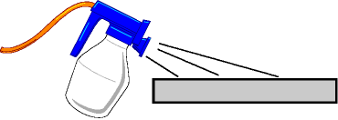

SHAPING WOOD – LAMINATING
Laminating is a method used to:
a) create a curved wooden shape.
b) create thin, rigid and tough flat material.
A laminate is made up of layers of veneers (thin sheets of natural wood) glued one on top of another. Unlike plywood, the grain of each sheet is normally lined up in the same direction.

Rigidity and Toughness
A laminated strip of wood is far more rigid and tougher than the same size strip of natural wood.
Rigidity
When a strip of natural wood is bent, the top surface stretches and the inner surface compresses
Natural Wood
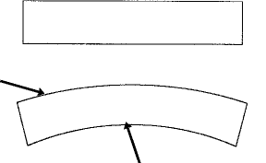
Both top and bottom surfaces are the same length

Top surface stretches

Inner surface compresses

For a strip of laminated wood to bend in the same way, each layer must be able to slide over the layers above and below. Strong glue prevents the sliding from happening, so the strip is rigid.

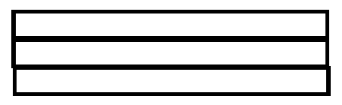
Each strip is the same length

When bent, each strip remains the same length, the set glue must have allowed slippage to occur.
This cannot happen without the glue line breaking up and the laminate falling apart!

The same happens in reverse, if the strips are glued together in a bend, it is not possible to straighten the bend after the glue has set.

Toughness
A laminated strip is tougher than solid wood because a crack that starts on one side of the strip is stopped by the glue line and does not go all the way through. (unless of course the force is too great, every material has a limit)
A crack in laminated wood will tend to stop at the glue line

A crack in solid wood will travel all the way through

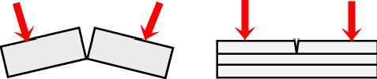

Laminating a flat strip
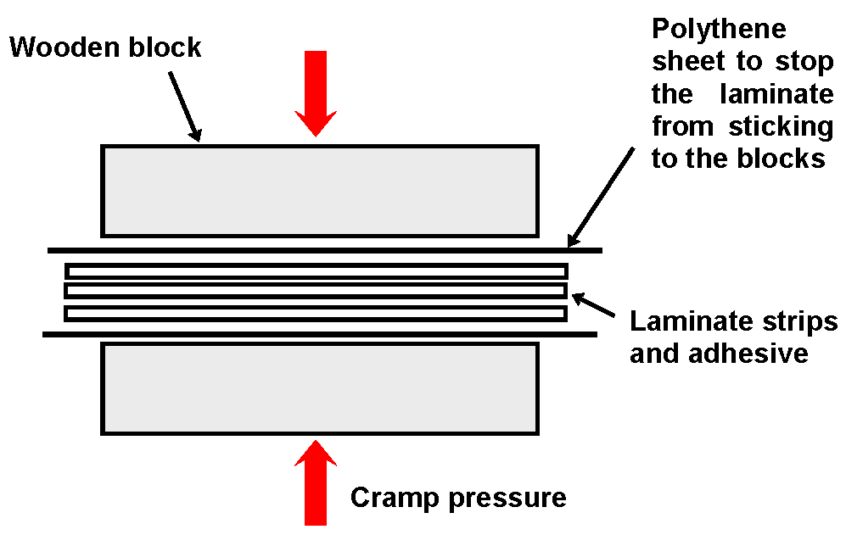
Laminating a curved strip
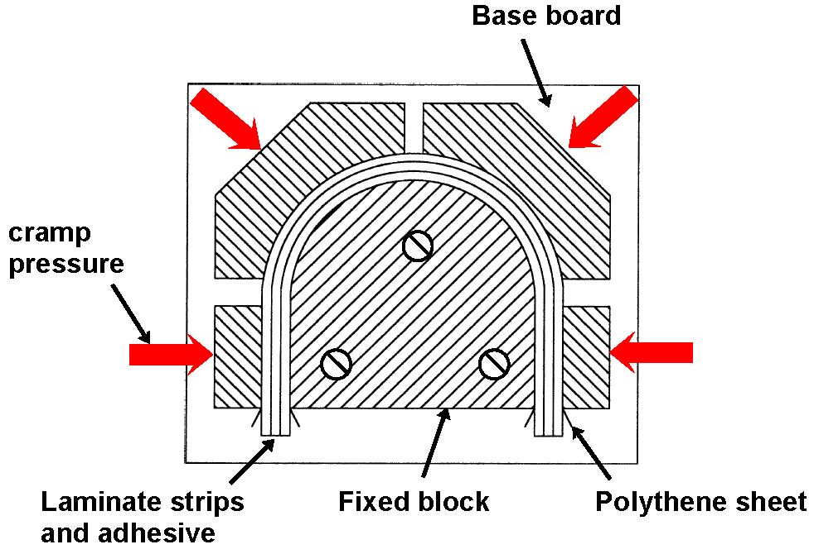

1. What are the advantages of CNC machines?
2. What are the parts of a wood laminate?
3. How is it that a laminate is more rigid than solid wood?
4. Show how laminated wood is tougher than solid wood.
5. Illustrate the set-up for laminating a flat strip.
6. Illustrate the set-up for laminating a curved strip.
7. What is the purpose of using polythene sheeting when laminating?

