Illustrating the Principles of Design
Principles of Design Lesson 2
The examples you'll find here demonstrate varying degrees of each of the six principles of design in a before and after format. View them individually and as a whole to see how different principles are applied. How might you do any of these differently?
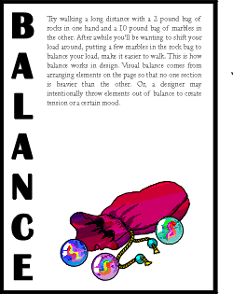
You can create balance with the three elements (text block, graphic, vertical text) here but in the first example they appear to be just random elements with no unity or balance. In the second "Balance" example the text block and graphic are resized to bring them closer together and better balance each other.

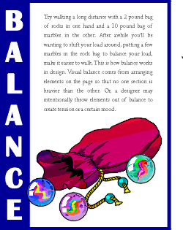
To tie the elements together, move them closer together (resizing helps accomplish this). Notice that the graphic (one of the marbles) slightly overlaps the box enclosing the vertical text, unifying the two elements. Reversing the word "balance" out of the blue box also adds more contrast to the composition. The increased leading in the text block redistributes the white space in a more balanced manner.

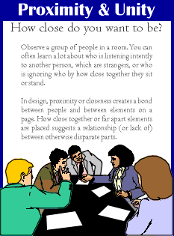
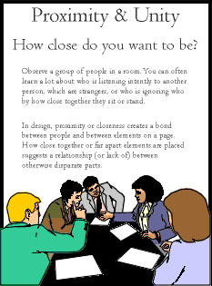
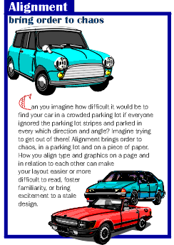
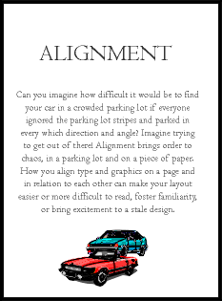
The graphic anchors the bottom of the page, but the four text elements all float on the page with no apparent connection to each other (proximity/unity). The change in the headline (font change, reversed out of blue box) along with the subheading pulled in closer provides balance with the graphic on the bottom. The spacing between the two paragraphs of text is reduced slightly as well.
There is nothing inherently wrong with centered headlines, text, and graphics. They lend a formal tone to a layout. But, for this series of layouts something a bit more informal is called for. Also, large blocks of centered text are usually harder to read.
In the second "Alignment" example, text alignment is left-aligned, ragged right, wrapped around the bottom graphic which is aligned more to the right, opposite an added graphic that is aligned to the right to help balance the overall design.

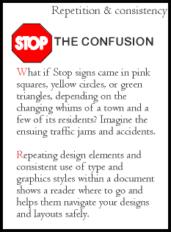
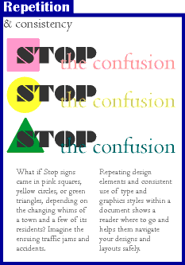
Within the second "Repetition" example, the headline is repeated three times using graphics that tie in with the copy in the text blocks. The repetition of the colors in the shapes and headline text that are in the copy help to reinforce the theme. Overlapping the graphic and text elements unifies the elements of the design.
Another aspect of consistency that can be seen when viewing all 6 of the "after" examples is the blue borders, blue reversed boxes, and the typeface (Britannic Bold) used for the names of all the principles of design. The drop cap used in three examples (Bermuda LP Squiggle) is another element of consistency.
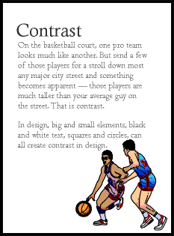
There's isn't enough contrast between the headline and text due in part to size but also because the two different serif faces used or too similiar (not obvious from the small graphic, trust me, they are different typefaces).

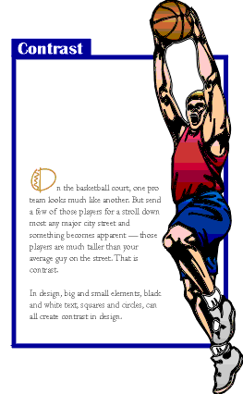

That oversized graphic provides real contrast and reinforces the copy (tall basketball players). Dropping the text down to the bottom portion of the page also reinforces the 'towering' aspect of the graphic. The reversed text in the blue box,the blue border, and the drop cap carries through the overall unifying elements found throughout the series. Additionally, the round shape of the drop cap and its color echo the shape and color of the basketball in the graphic. The drop cap and the reversed text on the left side plus the left-aligned text help to balance the large graphic element.
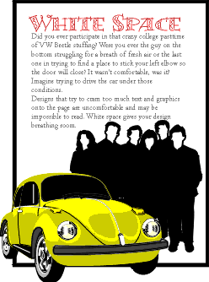
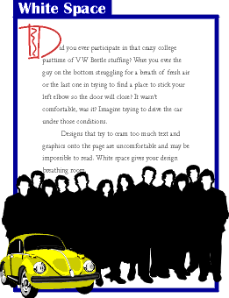
White space doesn't have to be white. The large block of black created by the graphic of people adds a large block of black white space. Multiplying the number of people and reducing the size of the car in the second "White Space" example provides additional contrast and reinforces the theme of the copy. Additional leading, larger margins, deeper paragraph indents all add white space or breathing room to the design.
The oversized drop cap is another element of contrast and also helps to balance the page with the large, dark elements at the bottom of the page. The drop cap style, reversed title, and blue box are consistent with the rest of the series.
In the next six lessons in this section we will look at each principle of design in more detail and explore ways to incorporate each into your designs. We'll also touch on the ways that your software can simplify some related tasks, such as using style sheets to aid repetition and consistency or using leading and other spacing features to improve proximity, unity, and distribution of white space

