
Greenfaulds High School


N4 N5 Physics
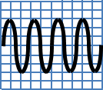
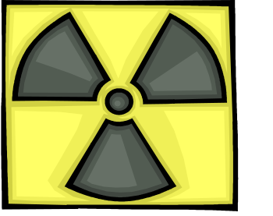
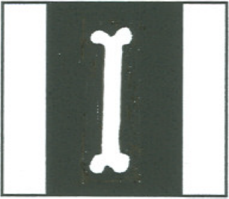
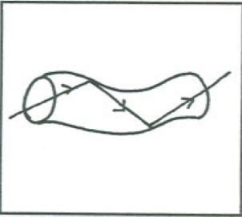
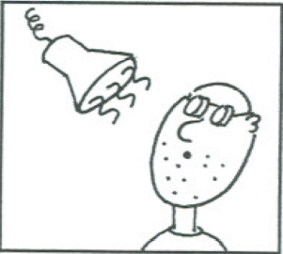
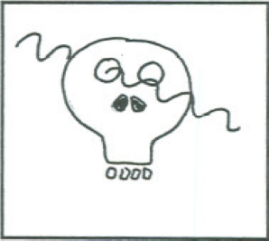
f
v
λ
f
N
t
v
d
t

Waves & Radiation
Problems
Data Sheet
Speed of light in materials |  |  |  |  |  |  |  |  |  |  | Speed of sound in materials
Material |  |  |  |  | Speed in m/s |  |  |  |  |  | Material |  |  | Speed in m/s
Air |  |  |  |  | 3 x 10⁸ |  |  |  |  |  | Aluminium |  |  | 5 200
Carbon dioxide |  |  |  |  | 3 x 10⁸ |  |  |  |  |  | Air |  |  | 340
Diamond |  |  |  |  | 1⋅2 x 10⁸ |  |  |  |  |  | Bone |  |  | 4 100
Glass |  |  |  |  | 2⋅0 x 10⁸ |  |  |  |  |  | Carbon dioxide |  |  | 270
Glycerol |  |  |  |  | 2.1 x 10⁸ |  |  |  |  |  | Glycerol |  |  | 1 900
Water |  |  |  |  | 2⋅3 x 10⁸ |  |  |  |  |  | Muscle |  |  | 1 600
 |  |  |  |  |  |  |  |  |  |  | Steel |  |  | 5 200
Gravitational field strengths |  |  |  |  |  |  |  |  |  |  | Tissue |  |  | 1 500
 | Gravitational field strength on the surface in N/kg |  |  |  |  |  |  |  |  |  | Water |  |  | 1 500
Earth | 10 |  |  |  |  |  |  |  |  |  | Specific heat capacity of materials
Jupiter | 26 |  |  |  |  |  |  |  |  |  | Material |  |  |  |  | Specific heat capacity in J/kgºC
Mars | 4
Mercury | 4 |  |  |  |  |  |  |  |  |  | Alcohol |  |  |  |  | 2 350
Moon | 1⋅6 |  |  |  |  |  |  |  |  |  | Aluminium |  |  |  |  | 902
Neptune | 12 |  |  |  |  |  |  |  |  |  | Copper |  |  |  |  | 386
Saturn | 11 |  |  |  |  |  |  |  |  |  | Glass |  |  |  |  | 500
Sun | 270 |  |  |  |  |  |  |  |  |  | Glycerol |  |  |  |  | 2 400
Venus | 9 |  |  |  |  |  |  |  |  |  | Ice |  |  |  |  | 2 100
Uranus | 11⋅7 |  |  |  |  |  |  |  |  |  | Lead |  |  |  |  | 128
Pluto | 4⋅2 |  |  |  |  |  |  |  |  |  | Silica |  |  |  |  | 1 033
 |  |  |  |  |  |  |  |  |  |  | Water |  |  |  |  | 4 180
 |  |  |  |  |  |  |  |  |  |  | Steel |  |  |  |  | 500
Specific latent heat of fusion of materials
Material |  |  |  | Specific latent heat of fusion in J/kg |  |  |  |  |  | Melting and boiling points of materials
 |  |  |  |  |  |  |  |  |  | Material |  |  | Melting point in ºC |  |  |  | Boiling point in ºC
Alcohol |  |  |  | 0⋅99 x 10⁵
Aluminium |  |  |  | 3⋅95 x 10⁵ |  |  |  |  |  | Alcohol |  |  | -98 |  |  |  | 65
Carbon dioxide |  |  |  | 1⋅80 x 10⁵ |  |  |  |  |  | Aluminium |  |  | 660 |  |  |  | 2470
Copper |  |  |  | 2⋅05 x 10⁵ |  |  |  |  |  | Copper |  |  | 1 077 |  |  |  | 2 567
Glycerol |  |  |  | 1⋅81 x 10⁵ |  |  |  |  |  | Glycerol |  |  | 18 |  |  |  | 290
Lead |  |  |  | 0⋅25 x 10⁵ |  |  |  |  |  | Lead |  |  | 328 |  |  |  | 1 737
Water |  |  |  | 3⋅34 x 10⁵ |  |  |  |  |  | Turpentine |  |  | -10 |  |  |  | 156
 |  |  |  |  |  |  | SI Prefixes and Multiplication Factors
Specific latent heat of vaporisation of materials |  |  |  |  |  |  | Prefix |  |  |  |  | Symbol |  |  | Factor
|Material |  |  | Sp.l.ht vap(J/kg) |  |  |  | giga |  |  |  |  | G |  |  | 1 000 000 000=10⁹
Alcohol |  |  | 11⋅2 x 10⁵ |  |  |  | mega |  |  |  |  | M |  |  | 1 000 000 =10⁶
Carbon dioxide |  |  | 3⋅77 x 10⁵ |  |  |  | kilo |  |  |  |  | k |  |  | 1 000 =10³
Glycerol |  |  | 8⋅30 x 10⁵ |  |  |  | milli |  |  |  |  | m |  |  | 0⋅001 =10⁻³
Turpentine |  |  | 2⋅90 x 10⁵ |  |  |  | micro |  |  |  |  | μ |  |  | 0⋅000 001 =10⁻⁶
Water |  |  | 22⋅6 x 10⁵ |  |  |  | nano |  |  |  |  | n |  |  | 0⋅000 000 001=10⁻⁹
1. Speed of Sound
National 4 – The Speed of Sound
- The following apparatus was set up to measure the speed of sound:
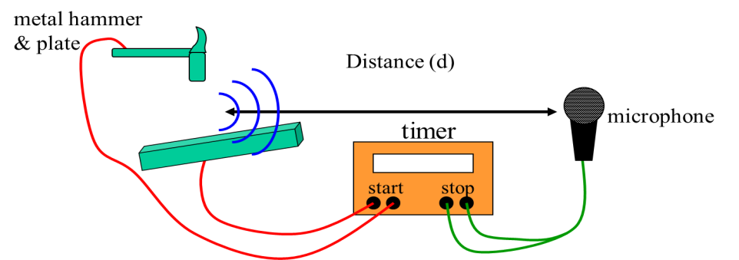

- Describe how you would use this apparatus to measure the speed of sound.
- If the distance between the hammer and microphone was increased, would this give you a more accurate or less accurate result? Explain your answer.

- Physics teacher, Paul, is waiting at the green of the 18th hole at Palacerigg golf course. He sees his friend, Danny, about to tee off. The tee is 436 metres away from Paul, who quickly decides that this would be a perfect opportunity to measure the speed of sound. Luckily his mobile phone is equipped with a stopwatch.
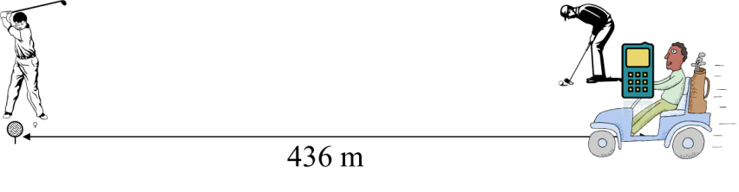
Paul

Danny

- Describe how Paul measures the speed of sound on the golf course.
- Explain whether or not you think he will get an accurate result.

- (a) During a thunder storm, what signal is made first – the sound, the light or are they both made at the same time?
(b) So why do we see the light before we hear the thunder?

- (a) State an approximate value for the speed of sound in air.
(b) What is the speed of light in air?

- The diagram below represents the particle arrangement for an ice cube (solid) changing to water (liquid) then steam (gas).
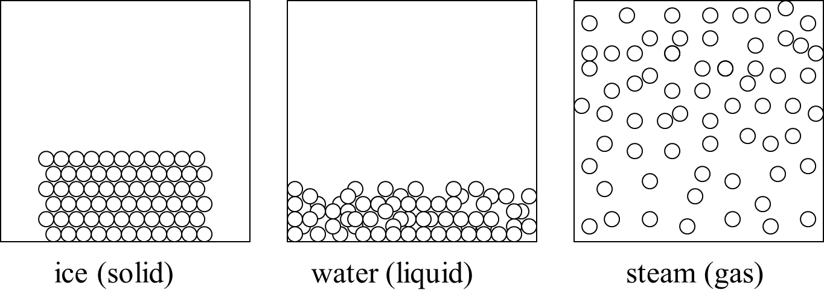
By thinking about the arrangement of the particles, do you think sound will travel fastest in a solid, or liquid or gas?
Explain your answer.
2. Speed, Distance and Time Calculations

National 4 – Speed, Distance, Time

In this section you can use the equation:
distance
time
average speed =

also written as

v =
d
t

where d = distance in metres (m)
v = average speed in metres per second (m/s)
t = time in seconds (s).
Helpful Hint
The speed of light is much faster than the speed of sound. In fact light from objects around us appears to reach us instantaneously.

In this section use:
speed of light in air = 300 000 000 m/s and speed of sound in air = 340 m/s.

1. Calculate the average speed for each of the following wave signals, in air, and state whether the signal is sound or light.

(a) 600 000 000 metres covered in 2 seconds.
(b) 1700 metres covered in 5 seconds.
(c) 500 metres covered in 1.47 seconds.
(d) 8600 metres covered in 25.3 seconds.
(e) 6500 metres covered in 0.000022 seconds.
(f) 255 metres covered in 0.75 seconds.

2. Calculate how far light travels in:

- 1 second (b) 3 seconds (c) 10 seconds.

3. Calculate how far sound travels in:

- 1 second (b) 3 seconds (c) 10 seconds.

4. Colin is worried about the dangers of being out on the golf course during a thunder and lightning storm. He sees a flash of lightning and counts 4 seconds before he hears the clap of thunder. How far away is the storm?

5. A group of Physics students sets out to measure the speed of sound. The pupils stand a distance of 200 metres from the teacher who has a flash gun and starter pistol. The pupils have to start their stopclock when they see the flash and stop it when they hear the bang. The experiment is carried out three times and the results are shown in the table below.

Distance from gun to pupils (m) | Time recorded (s) | Speed of Sound (m/s)
200 m | 0·63
200 m | 0·62
200 m | 0·65

(a) Calculate the speed of sound from each pupil’s set of measurements.
(b) From the 3 results, work out the average value for the speed of sound.

6. Spectators are told to stay behind a barrier which is 100 m
from where fireworks are being set off at a display.
How long will it take spectators to hear a ‘banger’ after they see it
explode?

7. During the Edinburgh Tattoo, tourists on Princes Street see the canon smoke from the castle 3 seconds before they hear the bang. How far are they from the castle?
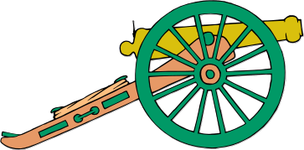

8. Michael sees a military jet and then 4⋅5 seconds later hears the roar from its engine. How far away is the jet?

9. In a 100m sprint race the timers start timing when they hear
the starter pistol and stop timing when they see the sprinters
cross the finishing line.

- Does this method overestimate or underestimate their sprint times? Explain your answer.

- How could the accuracy of the timing be improved?

10. During the demolition of some high rise flats in Glasgow, spectators saw the explosion first and heard it 7 seconds later.

- Why was there a delay?

- How far from the explosion were they standing?

National 5 – Sound Echoes

11. Peter is standing a distance of 100 m from a large building. He shouts loudly and hears an echo.


100 m

- How far did the sound travel between leaving Peter and returning to him as an echo?

- If the speed of sound in air is 340 m/s, how long did it take for the sound to return to Peter?

12. Claire is standing 50 m from a large cliff face. She shouts loudly and hears an echo.


50 m

- How far did the sound travel between leaving Claire and returning to her as an echo?

- If the speed of sound in air is 340 m/s, how long did it take for the sound to return to Claire?

13. A hiker stands in a canyon and shouts so that she hears an echo from the canyon wall. She records a time of 0.47 seconds between shouting and hearing the echo.



(a) How far did the sound travel in this time, assuming it travelled at 340 m/s?

(b) Calculate the distance between the hiker and the canyon wall.

14. SONAR (SOund Navigation And Ranging) equipment can be used to find fish under the water. The sound frequencies used in sonar systems vary from very low (infrasonic) to extremely high (ultrasonic).
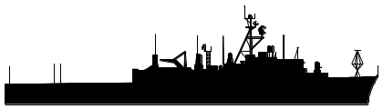


On one particular fishing trip, a sound pulse is transmitted and the echo from the sea bed is received 0.06 seconds later.
d

- How far did the sound pulse travel between transmission and detection?
(You will have to refer to the data page for the speed of sound in water.)

- How deep was the sea at this point?

- A large fish swam under the boat giving an echo time of 0.02 seconds.
Calculate how far below the boat the fish was swimming.

15. Ultrasound is sound that is so high pitched, humans cannot hear it.
During an ultrasound scan, a baby’s forehead is situated 7.5 cm from the transmitter / detector. The ultrasound pulse, travelling at 1 500 m/s, is reflected from the baby’s forehead.
jelly
transmitter / detector
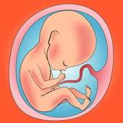

- What is the total distance travelled by the pulse?

- What time elapses between the transmission of the pulse and the detection of the pulse echo?

16. During an ultrasound scan of a thyroid gland, an ultrasound pulse, travelling at
1 500 m/s, is reflected from a piece of tissue situated 3 cm from the transmitter / detector.

- What is the total distance travelled by the pulse?

- What time elapses between the transmission of the pulse and the detection of the pulse echo?

Helpful Hint
1 millisecond = 1 ms = 0.001 s = 1 x 10⁻³ s

17. An ultrasound pulse is transmitted into an expectant mother’s womb and reflects from the baby’s bottom. The pulse echo is detected 0.08 milliseconds after being transmitted. The speed of sound through the body tissue is 1 500 m/s.
jelly

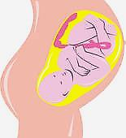

transmitter / detector

- How far does the pulse travel?

- How far from the transmitter is the baby’s bottom?

- Another pulse is reflected from the foot of the baby. If this pulse echo is detected 0.15 milliseconds after being transmitted, how far from the transmitter is the baby’s foot?

18. An ultrasound pulse is transmitted into the womb of an expectant mother and the pulse echo is detected after a time of 0.38 ms. The pulse was reflected by one of the baby’s knees situated 28.5 cm from the transmitter / detector. Show that the speed of sound in the womb is 1 500 m/s.

3. Transverse & Longitudinal Waves
National 4 – Types of Wave
- What do waves carry?

- What are the 2 types of waves that you have studied.

- Copy and complete the table below to show the wave type of each of the following waves:
water waves; sound waves; light waves; radio waves; microwaves; ultrasound.

L - - - - - - - - - - - | T - - - - - - - - -

- Look at the diagram below and answer the following questions.

direction of travel of wave

X

- What type of wave is this?
- The wave is moving from left to right. Describe how point X on the wave is moving.

- A “slinky” can be used to show different types of wave.
direction of travel of wave

X

- What type of wave is the “slinky” showing here?
- The wave is moving from left to right. Describe how point X on the wave is moving.

- Copy and complete the following sentences:

_________________ waves, for example water waves, carry __________ by vibrating at right angles to the direction of the wave’s motion.
_________________ waves, for example sound waves, carry _________ through a _____________ where the particles vibrate in the _____ direction as the wave’s motion.
4. Waves Words: Wavelength & Amplitude

National 4 – Wavelength and Amplitude

e.g.

The amplitude of a wave is the height from the centre line.
Helpful Hint
Wavelength ( symbol λ ) means the length of a wave. It is measured as the distance from one point on a wave to an identical point on the next wave.
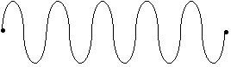
amplitude

λ

1. ‘A-B’ represents one wavelength in the diagram below.
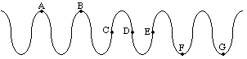

State two other pairs of letters which represent one wavelength.

2. How many waves are shown in each of the diagrams below?
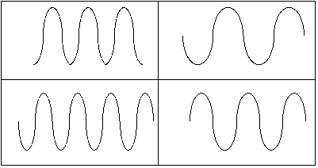
(a)
(d)
(c)
(b)

3. The wave train shown below is 20 metres long. How long is each wave?


4. The wavelength of the waves in the diagram below is 3 cm. What is the distance between X and Y?

X
Y

5. What is the wavelength of the waves in the diagram below?
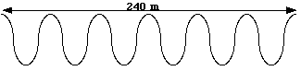

6. Draw a wave train consisting of 2 waves. Put the labels wavelength and amplitude on your diagram in appropriate places.

7.
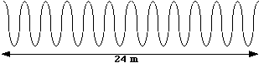
3 m
- How many waves are shown in the diagram above?
- What is the wavelength of each of these waves?
(c) What is the amplitude of these waves?

8. (a) Calculate the wavelength of the waves shown below.
4.2 m
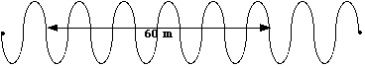
X
Y

(b) What is the distance from X to Y in this wave train?
(c) What is the amplitude of these waves?

9. A stone is thrown into a pond, and a wave pattern is produced as shown below. The wavelength of the waves is 6 cm.
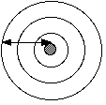
d
Calculate the distance, d, travelled by the outside wave.

10. Red light from a laser has a wavelength of 4 x 10⁻⁷ m in a certain glass. How many waves, from this laser, would cover a length of 2 cm in this glass?

5. Waves Words: Frequency

National 4 – Frequency of a Wave
In this section you can use the equation:

number of waves
frequency
time
=

where frequency is measured in Hertz (Hz)
time is measured in seconds (s).

1. Calculate the frequency of each of the following waves:
(a) 10 waves passing a point in 5 seconds.
(b) 240 waves produced in a time of 60 seconds.
(c) 30 waves produced in a time of 60 seconds.
(d) 9 600 waves passing a point in 800 seconds.
(e) In a 90 second period of time, 4 500 waves are produced.
(f) Every 15 seconds, 300 000 waves are generated.

2. If a wave machine produces 5 waves each second what is the frequency of the machine?

3. A man stands on a beach and counts 40 waves hitting the shore in 10 seconds. What is the frequency of these waves?

4. Some sound waves have a frequency of 10 000 Hz. How many of these waves will be produced in 100 seconds?

5. Water waves with a frequency of 1.6 Hz pass beneath a pier. How many waves pass the pier in 60 seconds?

6. Waves crash onto a beach at a frequency of 0.25 Hz. How many waves hit the beach in 1 minute?

7. In a swimming pool a wave machine creates waves with a frequency of 2 Hz. How many waves are produced in 5 minutes?

8. A smoke alarm sends out high-pitched sound waves with a frequency of 12 000 Hz. How long will it take this alarm to emit 240 000 waves?

9. A tuning fork makes a sound with a frequency of 440 Hz. How long does it take to produce 2 200 waves at this frequency?
10. A clarinet player plays a long note emitting 9 000 waves with a frequency of 1 500 Hz. For how long does she play this note?

11. A woman’s ear detects 4 000 sound waves from an alert on her mobile phone. If the frequency of the sound is 8000 Hz, how long does the alert last?

12. How many 12 000 Hz sound waves will a keyboard produce if it holds this note for 5 seconds?

13. How long will it take a boy to send out 1 800 sound waves if he whistles a note with a frequency of 600 Hz?

14. A rock is thrown into a pond and an overhead photograph is taken 2 seconds later. The photograph, as shown in the diagram below, reveals that 5 waves were produced in the 2 second period.

What was the frequency of these water waves?

15. A pebble was thrown into a still pond and wave ripples were produced at a rate of
3 waves per second.
The diagram below represents the wave pattern in the pond a short time after the pebble was dropped.

(a) What was the frequency of the waves, in Hertz?

(b) How many waves are represented in the diagram above?

- How long did it take for this wave pattern to form?

6. Wave Traces
National 4 – Wave Traces

1. Although sound waves are longitudinal, they can be converted to electrical signals and represented on an oscilloscope as transverse waves.
Use the words “high frequency” or “low frequency” and “loud” or “quiet” to describe the sound represented by each of the following oscilloscope traces:

- (b)

(c) (d)

2. Look at the oscilloscope trace below, which represents a sound from a keyboard.

- Draw the trace that would be obtained if a note of higher pitch but same volume was played.

- Draw the trace that would be obtained if the same note was played at a louder volume.

7. Diffraction
National 5 – Diffraction of Waves

- What is meant by “diffraction” of a wave?

- Copy and complete the following diagrams to show diffraction of water waves.
Take account of the different wavelengths in the first 2 diagrams.

- Copy and complete the following sentence with the words low, short, high, long:

“___________ waves diffract better than ____________ waves so _________ frequency waves diffract better than ___________ frequency waves.”

4. T.V. waves have higher frequencies than radio waves and microwaves have even higher frequencies than T.V. waves.

- How does the wavelength of a T.V. wave compare with that of a radio wave?
- Which will be easier to receive in hilly areas, T.V or radio signals?
Explain your answer.
- Why are microwaves not very useful for communication between transmitters and receivers on Earth, yet they can be used to communicate around the world via satellites?

5. (a) The list below shows the wavelengths of 3 radio signals. Which of the radio signals will diffract most easily around a hill? Explain your answer.

A - wavelength = 0.2 km
B - wavelength = 100 m
C - wavelength = 8 000 cm

(b) The list below shows the frequencies of 3 waves. Which of the waves will diffract most easily around tall buildings? Explain your answer.
Refer to the data page for information about the prefixes, M and k, if necessary.

A - frequency = 50 MHz
B - frequency = 500 000 Hz
C - frequency = 800 kHz

8. Sound Level
National 4 – Sound Level

1. Use the following table of information to answer the questions below.
Sound Levels for Various Environmental Sounds
Weakest sound heard | 0dB
Whisper Quiet Library at 2 m | 30dB
Normal conversation at 1 m | 60-65dB
Telephone dial tone | 80dB
City Traffic (inside car) | 85dB
Train whistle at 500', Truck Traffic | 90dB
Level at which sustained exposure may result in hearing loss | 90 - 95dB
Hand Drill | 98dB
Snowmobile, Motorcycle | 100dB
Sandblasting, Loud Rock Concert | 115dB
Pain begins | 125dB
Pneumatic riveter at 1 m | 125dB
Even short term exposure can cause permanent damage - Loudest recommended exposure WITH hearing protection | 140dB
Jet engine at 30 m | 140dB
Death of hearing tissue | 180dB
Loudest sound possible | 194dB

(a) What is the approximate sound level of a whisper at a 2 m distance?
(b) What produces a sound level of 100 dB?
(c) Why is the sound level of 90 – 95 decibels so important?
(d) Explain why ear protection should be worn if operating a hand drill for a prolonged period of time.
(e) Draw a bar graph to show the sound levels of a whisper, normal conversation, truck traffic, a motorcycle and a jet engine.
2. What do we call loud sounds that are harmful to our environment?
3. Noise cancellation technology is used in headphones worn by helicopter pilots. Why is this useful?
4. Sounds can be reflected and absorbed. In a sound proofed recording studio, the walls are covered in material to prevent sound escaping from the studio. Should this material be a good absorber or a good reflector of sound? Explain your answer.
5. Give 2 examples of noise pollution.

9. Sonar and Ultrasound
National 4 – Applications of Sonar and Ultrasound
1. State the frequency range of human hearing.

2. Explain what is meant by the word “ultrasound”.

3. State 3 applications of ultrasound.

4. Explain how ultrasound can be used to examine a baby in the womb. Draw a diagram to support your answer and label it with the words, transmitter and receiver.

5. Which of the following wave properties is important when ultrasound is used to examine the inside of a body: refraction, diffraction or reflection?

6. Why is jelly used on a patient during an ultrasound scan?

7. For what does the acronym, SONAR, stand?

8. Read the news article below then answer the questions that follow.

Wed, 04 Apr 2012 3:22p.m.
Environmentalists in Peru are warning that an unprecedented number of dead dolphins are washing up on the country's shores because of the use of deep water sonar systems by the shipping industry.
It follows the discovery of 615 of the mammals in the last few weeks along a 135 kilometre stretch of coastline. As many as 3,000 dead dolphins have been found since the beginning of Peru's summer.

Researchers at the Organisation for the Conservation of Aquatic Animals (ORCA), a Peruvian marine animal conservation organisation, said that ships using deep water sonar are to blame for the mass deaths.

After studying the corpses of many of the dolphins, it was noticed that they did not bear marks of external damage caused by fishing practices or signs of poisoning. Instead, researchers found damage in the dolphins' middle ear bones, which is said to be a sign of decompression syndrome. "We have been noting that the animals were suffering from acute decompression syndrome - that is to say, a violent death produced by an acoustic boom that disorients the animal and produces haemorrhages which cause the animal to end up dying on the beach," said ORCA director Dr Carlos Yaipen.

The damage is said to come from sonic bursts that are produced by deep water sonar signals sometimes used in the search for petroleum. US federal regulators are curbing an oil and natural gas exploration company from using seismic equipment that sends out underwater pulses along Louisiana's coast until the bottlenose dolphin calving season ends.

ORCA calculates that the phenomenon represents the highest number of beached dolphins recorded anywhere in the world in the last decade

(a) For what does “ORCA” stand?
(b) How many dead dolphins have been found since the beginning of Peru’s summer?
(c) What evidence did the researchers at ORCA have to suggest that deep water sonar was to blame for the death of the dolphins?
(d) What action has been taken elsewhere in order to protect dolphins from the impact of sonar?
10. The Wave Equation

National 4 – Speed, Frequency and Wavelength

In this section you can use the equation:

speed = frequency x wavelength

also written as

v = f λ

where v = speed of the wave in metres per second (m/s)
f = frequency in Hertz (Hz)
λ= wavelength in metres (m).

1. Calculate the speed of the each of the following waves, given the frequency in Hertz and the wavelength in metres:

 | Frequency (Hz) | Wavelength (m)
(a) | 5 | 3
(b) | 30 | 20
(c) | 10 | 2
(d) | 0.5 | 50
(e) | 2 | 0.25
(f) | 50 | 0·02

2. Sound of frequency 440 Hz has a wavelength of 3·41 m in water. Calculate the speed of this sound in water.

3. What is the speed of waves which have a frequency of 50 Hz and a wavelength of
3 m?

4. Water waves in a swimming pool are travelling with a speed of 2 m/s and have a wavelength of 0·8 m. What is their frequency?

5. A wave generator in a ripple tank creates waves which have a wavelength of 0·02 m. If the speed of these waves is 1·2 m/s what is their frequency?

6. Waves produced by a wave generator in a ripple tank have a wavelength of 0.016 m. At which frequency is the wave generator operating, if the wave speed is 0·64 m/s?

7. The musical note ‘E’ has a frequency of 320 Hz. If sound travels with a speed of
340 m/s in air calculate the wavelength of this sound in air.
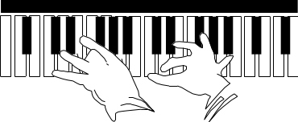

8. A wave machine in a swimming pool produces waves with a frequency of 1 Hz. If they travel across the pool at 1·5 m/s, what is their wavelength?

9. The speed of sound in steel is 5 200 m/s. What is the wavelength of a sound wave which has a frequency of 6 500 Hz in steel?

10. How fast will waves with a frequency of 15 000 Hz and a wavelength of 0.022 m travel?

11. What is the wavelength of waves which have a frequency of 6 000 000 Hz and a speed of 1 800 m/s?

12. Calculate the frequency of the waves shown in the diagram below given that they have a speed of 0·05 m/s.

0.001 m

13. John counts 40 complete waves along the length of a swimming pool. The pool is
50 m long and the waves are travelling with a speed of 3·75 m/s. Calculate:

- the wavelength of the waves

- the frequency of the waves

- the number of waves produced in 1 minute.

14. Waves, like the ones shown in the diagram below, are produced at a rate of 8 000 Hz. Calculate the speed of these waves.
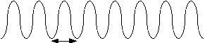
0·3 m
15. A wave pattern formed 3 seconds after a pebble is dropped into a pond is shown below.

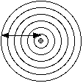
0.12 m

- How many waves were formed in 3 seconds?

- What was the frequency of the waves?

- What was the wavelength of the waves?

- Calculate the speed of the waves.

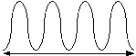
16. 30 water waves per second are created in a pool. Some of these are represented in the diagram.
0.28 m

- State the wavelength of the waves.

- Calculate the wave speed.

17. The waves shown in the diagram below were produced at a rate of 30 waves per minute.

9 m  - What is their frequency?  (b) What is their wavelength?  (c) Calculate the speed of these waves. | 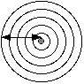

18. The diagram below represents some water waves coming onto shore.
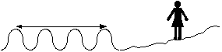
2·7 m

Jackie stands on the shore and counts 36 wave crests crashing onto it in
1 minute. Calculate the frequency, wavelength and speed of these waves.

National 5 – Speed, Frequency, Wavelength, Distance and Time

Helpful Hint
When dealing with waves, there are 2 equations you can use to calculate the speed of the wave. Sometimes you will firstly have to use one equation to calculate the speed, then use the other equation to find your answer.
v = d
t
v = f λ

19. It takes 25 seconds for a wave in a swimming pool to travel from one end of the pool to the other end. The wave has a frequency of 2·5 Hz and its wavelength is 0·4 m.

- What is the speed of the wave?

- What is the length of the pool?

20. An alarm is set off creating sound waves of frequency 10 000 Hz.
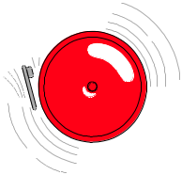
It takes 0∙6 seconds for the sound to reach a man who is standing at
a distance of 204 m from the alarm.

- Calculate the speed of the sound waves.

- Calculate the wavelength of the sound waves.

21. A wave generator in a ripple tank creates waves, which have a wavelength of 2·5 cm, at a rate of 6 waves per second. The ripple tank is 60 cm long.

- What is the frequency of the waves?

- Calculate the speed of the waves.

- How long will it take for a wave to travel the length of the ripple tank?

22. Waves of frequency 8·1 x 10⁵ Hz can travel a distance of 27 000 m in a time of
9 x 10⁻⁵ seconds. What is the wavelength of these waves?

23. An athlete is working on her hurdling technique with her trainer.  The trainer stands some distance up the track and blows his whistle, sending out 8 500 Hz sound waves which have a wavelength of 4 cm. It takes 0·22 seconds for the sound waves to reach the athlete.  Calculate the starting distance between the athlete and her trainer. | 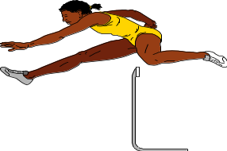

24. Consider the waves in the following diagram:
24 cm
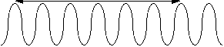

- What is the wavelength of these waves?

- Calculate the speed of the waves given that it takes 0·001 s for one complete wave to pass a point.

- Calculate the frequency of the waves.

- How many of these waves would pass a point in 1 minute?

25. The pond waves represented in the diagram below have a frequency of 24 Hz and a wavelength of 10 cm. The pattern was formed by dropping a stone into the water.



- Calculate the speed of the waves.

- How long did it take for this pattern to form from the moment the stone made
contact with the water?

Helpful Hint
1 millisecond = 1 ms = 0.001 s = 1 x 10⁻³ s
1 kilohertz = 1 kHz = 1 000 Hz = 1 x 10³ Hz
1 Megahertz = 1 MHz = 1 000 000 Hz = 1 x 10⁶ Hz

26. An ultrasound pulse of frequency 7 MHz is transmitted through 8 cm of muscle. The wavelength of the ultrasound in muscle is 2.29 x 10⁻⁴ m.
Calculate the time taken for the ultrasound to pass through the muscle.

27. Sound waves of frequency 4 kHz travel along a 2.6 m length of aluminium in a time of 0.5 ms.
Calculate the wavelength of the sound waves in the aluminium.

28. An ultrasound pulse, of wavelength 3.75 x 10⁻⁴ m, is transmitted into the womb of an expectant mother. It is reflected by the head of the baby and the reflected pulse is detected 0.2 ms after transmission. The baby’s head is positioned 15 cm from the transmitter / detector.
Calculate the frequency of the ultrasound used.

29. It takes 0.02 ms for a 15 kHz sound vibration to travel 6 cm through a bone.
What is the wavelength of this sound in the bone?

30. Assuming no energy losses, how far would sound travel, in 1 second, through a material in which a 2 kHz sound vibration has a wavelength of 95 cm?

11. Electromagnetic Spectrum
National 4 – Uses and Hazards of Electromagnetic Radiations

1. For each of the following electromagnetic radiations, state 2 uses:
a) microwaves
b) laser light
c) gamma rays
d) radio and TV waves
e) infra red radiation
f) x-rays
g) ultra violet radiation

2. An x-ray photograph is taken of a patient’s knee.
x-ray
machine

X
Y
Z

photographic film

a) At which position should the patient’s knee be placed; X, Y or Z ?
b) Why does the nurse stand behind a lead screen while the x-ray machine is operating?
c) Explain how the photographic film shows up the bones in the patient’s knee.

3. Infra red radiation is the name given to heat radiation.
a) What can be used to detect infra red radiation?
b) What is a “thermogram”?
c) Explain how cancerous tumours can be detected with a thermogram?

4. a) What is the danger of over exposure to ultra violet radiation?
b) Give ways in which this risk be reduced?

5. Laser pointers use low power laser beams however these can still be dangerous.
What part of the body would be most easily damaged by this laser light?

6. Over exposure to gamma radiation is dangerous. Explain why.

7. High energy x-rays can be used to reduce cancerous tumours. The x-rays are passed through the body at various angles to reach the tumour.

x-rays
healthy tissue

tumour

Why are the x-rays passed through the body at different angles?
National 5 – Electromagnetic Spectrum (Frequencies, Wavelengths, Energies)
8. What do all waves in the electromagnetic spectrum have in common?
9. Look at the following diagram of the electromagnetic spectrum:
TV
waves
visible light
A
B
C
D
E
F

a) Identify the parts of the spectrum labelled A, B, C, D, E and F.
b) In which part of the spectrum do the waves have the longest wavelengths?
c) In which part of the spectrum do the waves have the lowest frequencies?
d) In which part of the spectrum do the waves have the highest energy?
e) What colour of visible light has the longer wavelength, red or violet?

10. The list below shows frequency bands, wavelength ranges and energies associated with sections of the electromagnetic spectrum.

spectrum section | wavelength range  (m) | frequency band  (Hz) | energy range of waves (J)
1 | 4 x 10⁻⁷ to 7 x 10⁻⁷ | 4 x 10¹⁴ to 7.5 x 10¹⁴ | 3 x 10⁻¹⁹ to 5 x 10⁻¹⁹
2 | 1 x 10⁻³ to 1 x 10⁻¹ | 3 x 10⁹ to 3 x 10¹¹ | 2 x 10⁻²⁴to 2 x 10⁻²²
3 | Over 0.1 | Less than 3 x 10⁹ | Less than 2 x 10⁻²⁴
4 | 1 x 10⁻¹¹ to 1 x 10⁻⁸ | 3 x 10¹⁶ to 3 x 10¹⁹ | 2 x 10⁻¹⁷ to 2 x 10⁻¹⁴
5 | 1 x 10⁻⁸ to 4 x 10⁻⁷ | 7.5 x 10¹⁴ to 3 x 10¹⁶ | 5 x 10⁻¹⁹ to 2 x 10⁻¹⁷
6 | Less than 1 x 10⁻¹¹ | Over 3 x 10¹⁹ | Over 2 x 10⁻¹⁴
7 | 7 x 10⁻⁷ to 1 x 10⁻³ | 3 x 10¹¹ to 4 x 10¹⁴ | 2 x 10⁻²² to 3 x 10⁻¹⁹

Spectrum section 3 has the longest wavelength, lowest frequency and lowest energy. It covers Radio and TV waves.

a) Starting with spectrum section 3, order the sections from lowest to highest frequency and identify what part of the e.m. spectrum each section number relates to.
b) What is the wavelength range of gamma radiation?
c) What is the frequency band for ultra violet?
d) What range of energies would x-rays have?
e) What section of the electromagnetic spectrum has a wavelength range of
4 x 10⁻⁷ m to 7 x 10⁻⁷ m (or 400 nm to 700 nm)?
f) Give suitable wavelength values for red, blue and green light, in nm.

12. Electromagnetic Spectrum Calculations
National 5 – Speed, Frequency, Wavelength, Distance and Time
In this section you can use the two equations which you have used earlier in this unit:
v = f λ

v
d
=
t
and

Where v = average speed in metres per second (m/s)
f = frequency in hertz (Hz)
λ = wavelength in metres (m)
d = distance in metres (m)
t = time in seconds (s)

Helpful Hint
All waves in the electromagnetic spectrum travel at the speed of light (3 x 10 ⁸ m/s or
300 000 000 m/s) in air.

Useful prefixes when dealing with waves across the electromagnetic spectrum are:

nano (n) = x 10⁻⁹ (e.g. 3 nm = 3 x 10⁻⁹ m)
micro (μ) = x 10⁻⁶ (e.g. 2 μs = 2 x 10⁻⁶ s)
milli (m) = x 10⁻³ (e.g. 1 mm = 1 x 10⁻³ m)
kilo (k) = x 10³ (e.g. 3 kHz = 3 x 10³ Hz)
mega (M) = x 10⁶ (e.g. 5 MHz = 5 x 10⁶ Hz)
giga (G) = x 10⁹ (e.g. 4 GHz = 4 x 10⁹ Hz)

1, An Olympic athlete can run 100 m in 10 seconds. How far would a radio wave travel in 10 seconds?

2. On 12 December 1901, Gugliemo Marconi sent the first radio message across the Atlantic ocean. The message travelled a total distance of 3 440 km between Cornwall in England and Newfoundland in Canada.

How long did it take the radio message to travel between England and Canada?

3. A police patrol car is called to the scene of a road traffic accident. The police constables received the message sent from their police station on the car radio. The message took 6·5 x10⁻⁵ seconds to reach the car.

Calculate how far the patrol car is from the station when it receives the message.

4. A television signal is sent in the same way as a radio signal. To broadcast a television programme two radio carrier waves are needed. One wave carries the picture information and one wave carries the sound information.BBC 1 uses a 621·25 MHz radio wave to carry the sound signal and a 615·25 MHz radio wave to carry the picture signal.

Calculate the wavelength of each of these carrier waves.
5. A Channel 4 programme is transmitted from an aerial outside Inverness. A radio wave of frequency 645·25 MHz carries the sound signal. The picture signal is carried by a radio wave of frequency 639·25 MHz.

- Calculate the wavelength of the radio wave carrying the picture signal.

- How long would it take for the sound signal to reach Aberdeen which is 152 km from the transmitter?

- How far would the picture signal travel in 8·5 x 10 ⁻⁴ seconds?

6. A “geostationary” satellite is a satellite that remains above the same point on the Earth’s surface. In 1964, SYNCOM, the world’s first experimental geostationary satellite was launched into a 36 000 km orbit. Microwaves, of wavelength 2 cm, could be used to communicate with this satellite.
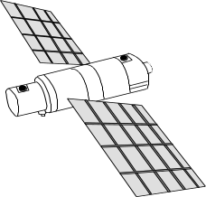

- Calculate the frequency of the microwaves used to communicate with SYNCOM.

- How long would it take a 2 cm microwave signal to travel 36 000 km?

7. A dish aerial at a ground station collects a 12 GHz signal transmitted by a satellite. The signal took 0·15 s to reach the aerial.

- What is the wavelength of this signal?

- How far away is the satellite from the ground station?

8. Microwaves are part of the electromagnetic spectrum and have many uses from telecommunications to cooking. Microwaves of wavelength 12 cm are used in ovens to cook food. The human body gives out microwaves too. These microwaves, of wavelength 9 cm, can be detected by a small aerial placed in contact with the skin. This then allows doctors to measure the temperature of organs inside the body.

Calculate the frequency of microwaves used in ovens .

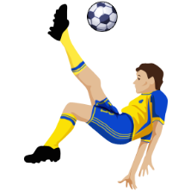
9. Tony sprained his ankle playing football. The physiotherapist used
infrared radiation to heat the tissue in his ankle and help it heal.

If the wavelength of the infrared radiation is 1.2 x 10⁻⁴ m in air,
calculate its frequency.

10. David is suffering from pains in his knees. The doctor in the hospital takes a “heat picture”, called a thermogram, of the knees which shows up inflammation of the joints caused by arthritis. The infrared radiation being given out by the knees has a frequency of 5 x 10¹² Hz.

Calculate the wavelength of this infrared radiation in air.

11. Our eyes can detect visible light which has wavelengths ranging from 400 nm to 700 nm in air. Light with wavelength of about 400 nm is violet in colour. Red light has a wavelength of around 700 nm.

Calculate the frequencies of violet light and red light.

12. The ancient Egyptians used ultraviolet radiation from the Sun’s rays to treat the skin complaint, acne. Ultraviolet radiation is still used in hospitals to treat this skin condition.

Calculate the wavelength of UV radiation that has a frequency of 8.8 x 10¹⁶ Hz.


13. X-rays were discovered in 1895 by Wilhelm Rontgen. They are now widely used in medicine and dentistry.

Phil is having an X-ray photograph taken of one of his molars which is giving him pain. The dentist positions the X-ray machine 10 cm from Phil’s tooth, and goes to stand behind a lead screen. The X-rays used have a frequency of 2 x 10¹⁷ Hz.

- Calculate the wavelength of these X-rays.

- How long will it take the X-rays to travel from the machine to Phil’s tooth?

14. Gamma rays typically have frequencies above 10 “exahertz”, or 1 x 10¹⁹ Hz.
Calculate the wavelength of gamma waves of frequency 1.2 x 10¹⁹ Hz.

15. Radio waves of different frequencies have different properties and are used for different purposes. Radio waves of frequency 30 Hz - 3 kHz are called extra low frequency (ELF) and are used for communicating with submarines which are moving in deep water.

- What is the wavelength of a 30 Hz ELF wave in air?

- A navy ship sends a radio message of frequency 3 kHz to a submarine directly below it. The signal travels at 2 x 10⁸ m/s in water. If the signal takes 3·4 x 10⁻⁷ seconds to reach the submarine calculate the depth, d, at which the submarine is cruising.
13. Refraction

National 4 – Lens Action on Light

1. Look at the 2 lenses drawn below:
A
B

a) Identify the type of each lens, A and B.
b) Copy and complete the diagrams to show how each lens affects the rays of light.

2. The following apparatus is set up to measure the focal length of a convex lens.
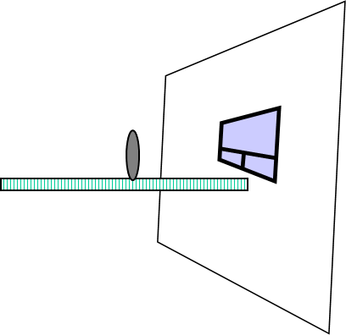
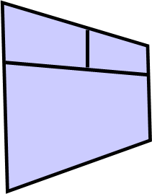

image
window
lens

metre stick

a) Describe how the apparatus is used to measure the focal length of the lens.
b) Should the window be near or far away from the lens, for the most accurate answer?

3. In an experiment, 2 lenses bring light to a point, as shown below.

a) What word is used to identify the point where the rays of light meet?
b) What conclusion can you make about the thickness of a convex lens?

4. a) What is meant by long sighted?
b) What type of lens is used to correct long sighted vision?

5. A woman struggles to read a car registration plate at a distance, but can easily read her book.
a) What sight defect does she have?
b) What type of lens is used to correct this sight defect?
National 5 – Refraction Measurements and Definitions

6. What is meant by the word “refraction”?

7. The diagram below shows light passing through a rectangular block of perspex.

A
B
F
E
C
D

a) What name is given to the dotted line?
b) Which angle is the “angle of incidence”?
c) Which angle is the “angle of refraction”?
d) What happens to the speed of the light as the light enters the perspex block?
e) What happens to the speed of the light as the light leaves the perspex block?

8. The “refractive index” (n) of a material, tells us about the “bending ability” of the material on light. The bigger the refractive index, the more the light will slow down in the material.
Copy and complete the following diagram to sketch how the light will pass through the blocks. You do not need to mark angles on your diagram.

air : n = 1

Glass A : n = 1.4
Glass B : n = 1.5
air : n = 1

In which block is the light travelling slowest?

9. Use a protractor to measure the angle of incidence and angle of refraction in each of the following diagrams, as the light enters the material.

a) b)

c) d)

10. Trace the following diagrams, or collect a copy of this page from your teacher.

Draw a normal at the point where the light enters each block, then label and measure the angle of incidence and angle of refraction at this point of entry into the material.

You will need a protractor.

a) b)

c) d)

e) f)

14. The Atom and Nuclear Energy
National 4 – Atomic Structure and Uses of Nuclear Energy

1. An atom consists of 3 types of particle.

a) Name the 2 types of particle that make up the nucleus, or centre, of the atom.
b) What are the particles that orbit the nucleus called?
c) What is the charge on each of the three types of particle in an atom?
d) Why are atoms “electrically neutral”?

2. Sources of nuclear radiation occur naturally but they can also be man-made.

a) Give an example of a natural source of nuclear radiation.
b) Give an example of a man-made source of nuclear radiation.

3. Nuclear radiation can be used in a variety of ways.

a) How can nuclear radiation be used for medical purposes?
b) How can nuclear radiation be used in industry?

4. Electricity can be generated using nuclear fuel.

a) What are the advantages of using nuclear fuel to generate electricity?
b) What are the disadvantages of using nuclear fuel to generate electricity?

5. Many people think that the health risk of living beside a nuclear power station is very high. Consider the following activities and decide whether you think they have a higher or lower risk associated with them, than the risk of living beside a nuclear power station.

a) Driving a car along the M8 from Glasgow to Edinburgh.
b) Swimming in the sea off the coast of Spain.
c) Flying from Glasgow to Florida.
d) Having a chest x-ray.
e) Eating a peanut butter sandwich on a regular basis.

Use the internet to find information that might help you answer these questions.

15. Nuclear Radiation and Reactions

National 5 – Nuclear Radiation and Types of Nuclear Reaction
1. Explain what is meant by “alpha”, “beta” and “gamma” radiation.

2. What is meant by the term, “ionisation”?

3. A radioactive source has an activity of 68 becquerels.

a) What does the word “activity” mean in this context?
b) How many nuclear decays would occur in this source in 1 minute?

4. It is thought that most of the Helium gas in our atmosphere comes from alpha particles taking electrons from other atoms in the air.

a) What word can be used, here, to describe the action of the alpha particles on atoms in the air.
b) Alpha can be “absorbed” by 10cm of air. What do you think happens to the alpha particles once they are absorbed by air.

5. a) What absorbs beta radiation?
b) What absorbs gamma radiation?

6. What 3 precautions could a radiation worker take in order to reduce the risk of over exposure while working with nuclear radiation?

7. State 4 sources of background radiation on Earth?

8. There are 2 types of nuclear reaction; fission and fusion.

a) Explain what is meant by each type of reaction.
b) Which type of reaction takes place in a nuclear reactor?
c) Which type of reaction causes the formation of a variety of elements in the stars?
d) Which type of reaction requires very high temperatures?
e) Both reactions give out lots of energy, but which one does not generate radioactive waste?

9. Explain, with the aid of a diagram, how a “chain reaction” can occur?

10. Look at the following nuclear reactions and decide whether each one is a fission or a fusion reaction.
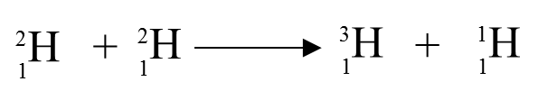
a)

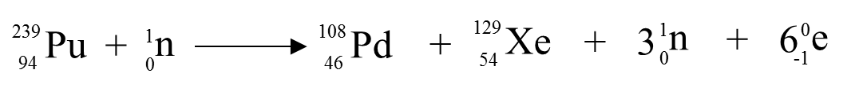
b)

16. Dosimetry
National 5 – Activity, Absorbed Dose and Equivalent Dose
In this section you can use the following equations:
A =
N
t
D =
E
m

H = D ω_{R}

Where A = activity of a radioactive source in becquerels (Bq)
N = number of nuclear decays
t = time in seconds (s)
D = equivalent dose in grays (Gy)
E = energy in joules (J)
m = mass in kilograms (kg)
H = equivalent dose in sieverts (Sv)
ω_{R} = radiation weighting factor.

The table below gives information about radiation weighting factors for various types of radiation.
Type of Radiation | Radiation Weighting Factor
alpha  beta  gamma  x-rays  slow neutrons  fast neutrons | 20  1  1  1  2.3  10

- In a sample of radioactive material, 8 x 10⁷ decays occur in a time of 40 s. Calculate the activity of the source.

- A radioactive source has an activity of 40 000 Bq. How many nuclear decays will happen in 20 seconds?

- A gamma source has an activity of 300 MBq. How many nuclear decays occur in
1 minute?

- How long will it take for 1.2 x 10⁶ nuclear decays to occur in a source if the activity of the source is 10 kBq?

- What is the average activity of a radioactive rock if it gives a count of 36 000 decays during a period of 2 hours?

- Copy and complete the following table:

 | Mass of Absorber  (kg) | Energy Absorbed  (J) | Absorbed Dose  (Gy) | Type of Radiation | Radiation Weighting Factor | Equivalent Dose  (Sv)
A | 2 | 10 |  | Alpha
B | 5 | 50 |  | Gamma
C | 0.5 | 25 |  | Slow neutrons
D | 10 | 400 |  | Fast neutrons
E | 60 | 2400 |  | X-rays

- Which 2 masses received the same absorbed dose?

- Explain why the biological effect on these 2 masses is not the same.

- Which mass is affected most by the radiation received?

- A patient’s thyroid gland receives an absorbed dose of 500 Gy from a source so that 15 J of energy is absorbed by the gland. Calculate the mass of the thyroid gland.

- A hospital worker, who has a mass of 70kg, receives an absorbed dose of 100 μGy. How much energy did the worker absorb?

- An industrial worker receives an equivalent dose of 200 μSv from alpha particles. Calculate his absorbed dose.

- What is the radiation weighting factor of a radiation that gives an absorbed dose of 500 μGy and an equivalent dose of 1 mSv?

- A patient receives a chest X-ray with an equivalent dose of 2 mSv. What is the patient’s absorbed dose?

- A dental X-ray produces an absorbed dose of 0.3 mGy. What equivalent dose will this X-ray give?

- A nuclear worker is exposed to a radioactive material producing an absorbed dose of 10 mGy. The radiation emitted has a weighting factor of 3. Calculate the equivalent dose for this exposure.

- A tiny amount of alpha emitting material was swallowed by a fish. The fish received an equivalent dose of 5 μSv. What absorbed dose did the fish receive?

- In one week a nurse received an absorbed dose of 80 μGy while working in the X-ray department of a hospital. The radiation that accounted for this was gamma.

- If the mass of the nurse was 60 kg, how much energy did she receive from the X-rays?

- Calculate the equivalent dose received by the nurse in this one week period.

- What equivalent dose would the nurse have received has she been exposed to alpha instead of gamma?

- Readings on monitors near Chernobyl indicated absorbed doses of 1 mGy due to gamma radiation, 200 μGy due to slow neutrons and 40 μGy due to fast neutrons. The readings were all taken over a period of 1 hour.

- Calculate the equivalent dose that would be received in this area, over the 1 hour period, from each type of radiation.

- Calculate the total equivalent dose that would be received in this area over the 1 hour period.

- The exposure limit for workers in this area is 50 mSv in any one year.
How many hours of exposure, to the nearest hour, would take a worker to this limit?

- On 11 March, 2012, an earthquake in Japan caused a crisis at a nuclear power station in Fukushima. An equivalent dose of 400 millisieverts was recorded over a period of 1 hour. Fortunately, this dropped significantly over the following days.
An expert said “exposure to a dose of 400 millisieverts is unlikely to cause radiation sickness - that would require a dose of about 1 sievert or 1 gray. However, it could start to depress the production of blood cells in the bone marrow, and is likely to result in a lifetime risk of fatal cancer of 2 - 4%. Typically, a Japanese person has a lifetime risk of fatal cancer of 20 - 25%.”
Officials say emissions of radioactive materials at Fukushima currently stand at about 10% of those from the 1986 Chernobyl disaster.

- The expert said “a dose of 400 millisieverts”. How would you correct this statement to make it more scientifically accurate?

- What level does the expert suggest would cause radiation sickness? Comment on the implication that this makes about the types of radiation involved.

- If a worker, with a mass of 80 kg, was exposed to 400 mSv of gamma radiation, how much energy would he absorb?

- A team of medical researchers were investigating the effect of different types of radiation on body tissue. The table below shows the absorbed doses measured over a 1 hour period from each type of radiation.

Type of Radiation | Absorbed Dose  (μGy)
gamma rays  fast neutrons  alpha particles | 100  400  50

- Use the data in the table to show which radiation is likely to be most harmful to this particular tissue.

- The maximum permitted dose equivalent for this tissue is 5 mSv.
For how long could the tissue be exposed to fast neutrons before it exceeds this limt?

- A sample of this tissue has a mass of 25 g.
How much energy will it absorb from fast neutrons in 2 hours?

17. Half Life Calculations
National 5 – Half Life
Helpful Hint
Half life is defined as the time taken for the activity of a radioactive source to halve.

e.g. “half life = 2 days” means that every 2 days the activity of the source will halve.

1. The initial activity of a radioactive source is 400 Bq. The sample has a half life of 2 minutes and is allowed to decay for 8 minutes. Calculate the activity of the source after 8 minutes.

2. A radioactive tracer has an activity of 160 Bq. The tracer has a half life of 5 hours and decays for 15 hours. What is its final activity?

3. A radioactive source with a half life of 2.5 minutes decays for 10 minutes. The source has an initial activity of 64 kBq. Calculate the final activity of the source.

4. Radioactive paint is left decaying in a room for 3 hours. The initial activity of the paint was 320 Bq and it has a half life of 1 hour. Calculate the final activity of the paint.

5. Radioactive rocks emit radiation which can be harmful if exposure to them is not controlled. Some rocks have an activity of 160 Bq and emit radiation over a 3 day period. What is the final activity of these rocks given that their half life is 12 hours.

6. An isotope of Bismuth is left decaying for 4 hours. The half life of the source is 60 minutes and the initial activity is 200 counts per minute. Calculate the final activity of the isotope in counts per minute.

7. A sample of radioactive Uranium has an initial activity of 600 kBq. After 14 days its activity drops to 150 kBq. Calculate the half life of the source.

8. A sample of radioactive Polonium-218 has an initial activity of 1 400 kBq. After 9 minutes its activity has dropped to 175 kBq. What is the half life of the Polonium?

9. Calculate the half life of a radioactive sample which has an initial activity of 2 000 Bq that drops to 125 Bq in a period of 16 hours.

10. Calculate the half life of a radioactive source given that it takes 45 minutes for its activity to drop from 2 400 counts per minute to 75 counts per minute.

11. A beta source has an activity of 3 kBq and this drops to 750 Bq in a period of 24 days. What value does this give for the half life of the source?

12. An isotope of Indium has a half life of 100 minutes. After a period of 5 hours it is found to have an activity of 5.75 counts per minute. Use this information to calculate the activity of the source at the start of the 5 hour period.
13. Calculate the initial activity of a radioactive source whose activity falls to 20 kBq in 16 minutes, given that it has a half life of 2 minutes.

14. A radiactive rock decayed for 48 hours giving a final activity of 480 kBq. What was the initial activity of the rock if its half life was 12 hours.

15. A radioactive source has a half life of 2 days. What fraction of its activity remains after:

- 2 days (b) 6 days (c) 20 days?

16. Radioactive Caesium has a half life of 32 minutes. What fraction of its activity remains after:

- 32 minutes (b) 64 minutes (c) 160 minutes?

17. A radioactive sample has a half life of 20 seconds. How long has the sample been decaying if the fraction of its initial activity that remains is:

- 1/4 (b) 1/16 (c) 1/64?

18. How many half lives have passed if:

- 1/8 of the activity remains?
- 1/32 of the activity remains?

19. A radioactive sample has a half life of 30 seconds. How long has the sample been decaying if 1/16th of the sample’s original activity remains?

20. A medical physicist set up an experiment to check the half lives of some radioactive samples to be used as tracers in kidneys. He plotted the results from 2 experiments as shown below:
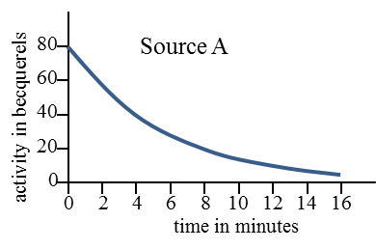
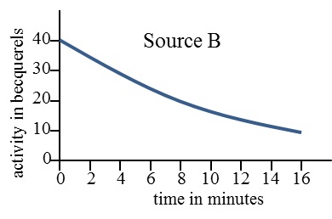

Use the graphs to estimate the half life of each source.

21. A student sets up the following apparatus to measure the half life of a sample of “Carbon 11”. Since the experimant is carried out in a sealed container we can assume that background radiation is negligible.
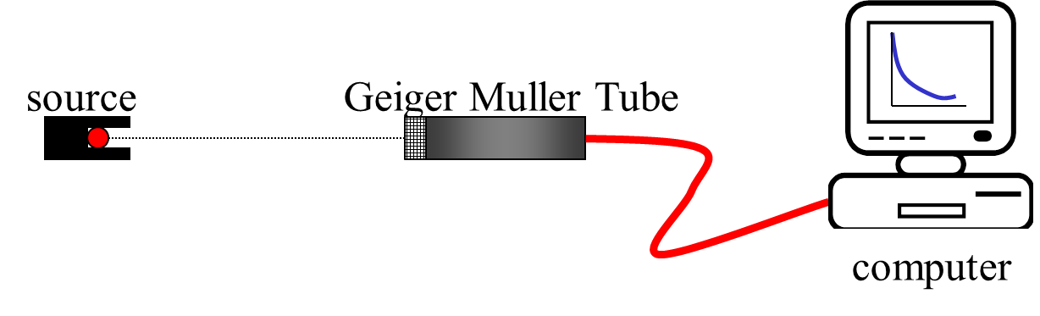
Geiger counter

The following results are obtained:
Time  (minutes) | 0 | 10 | 20 | 30 | 40 | 50 | 60 | 70
Activity  (counts per minute) | 800 | 600 | 410 | 310 | 200 | 150 | 100 | 75

Plot a graph of these results and use it to calculate the half life of Carbon 11.

22. Use the graph below to answer the following questions.
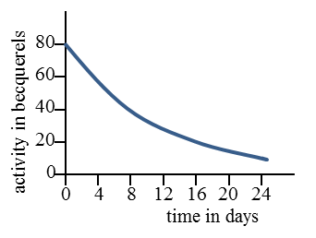

- What is the half life of the source?

- What should be the activity of the source after 32 days?

Helpful Hint
Background radiation often has to be accounted for in experiments with radioactive sources. It does not come from the source in the experiment, but from other sources such as cosmic rays etc. Background count should be measured then subtracted from any recorded count (or activity) during an experiment in order to obtain accurate readings from the source being investigated.

23. During an experiment with a radioactive source, Eddie and Ann measured a background count of 14 counts per minute. With the source in place, they recorded readings of 94 counts per minute and, 3 hours later, 24 counts per minute.
Use their results to calculate the half life of the source.
24. An experiment to measure the half life of a radioactive source was set up and the background activity was measured as 15 Bq. A measurement of activity beside the source dropped from 375 Bq to 60 Bq over a 9 day period.
Calculate the half life of the source.

25. On a day when the background count was measured as 30 counts per minute, the folowing readings were obtained from a radioactive source. The readings have not been corrected for background.

Time  (hours) | 0 | 1 | 2 | 3 | 4 | 5 | 6 | 7
Activity  (counts per minute) | 230 | 190 | 160 | 130 | 110 | 95 | 80 | 70

- Plot a corrected graph of activity against time for the source only.

- Calculate the half life of the source.

