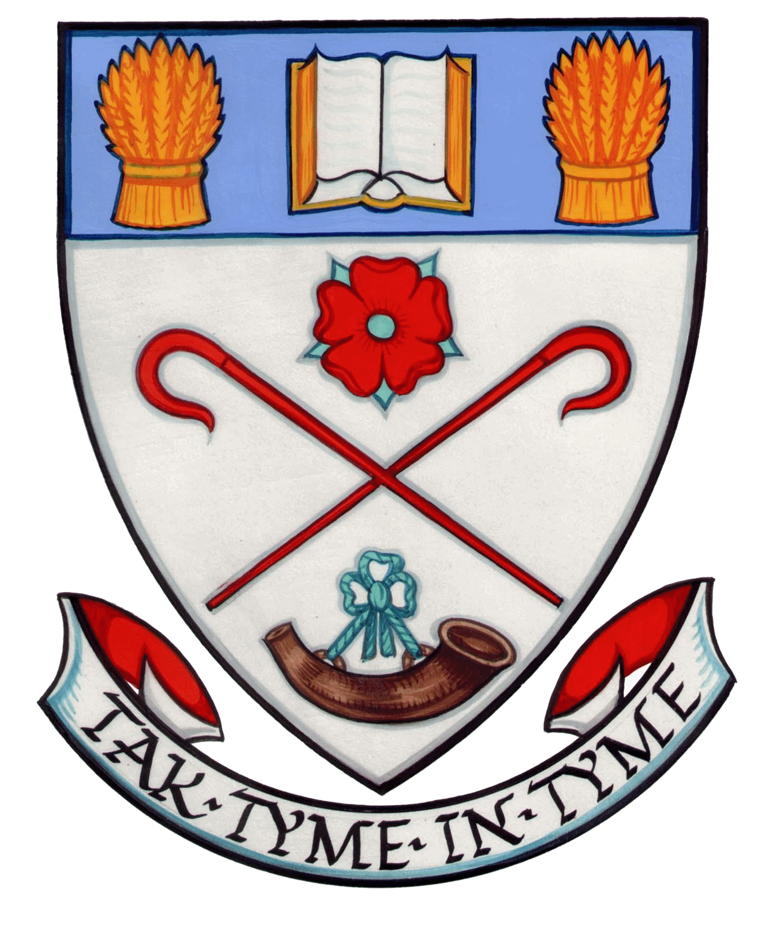

Greenfaulds High School Parent Council
Constitution

- This is the constitution for Greenfaulds High School Parent Council.
2. The objectives of the Parent Council are:
- To work in partnership with the school to create a welcoming school which is inclusive for all parents
- To promote partnership between the school, its pupils and all its parents
- To develop and engage in activities which support the education and welfare of the pupils
- To identify and represent the views of parents on the education provided by the school and other matters affecting the education and welfare of the pupils.

3. The membership will be a minimum of 3 parents/carers of children attending the school. The upper limit is 20.

4. The Chair, Vice-chair, Secretary and Treasurer of the Council will be agreed by the Parent Council members immediately following its formation.

5. The Parent Council will be selected for a period of up to three years after which they may put themselves forward for re-selection. Any parents of a child at the school can volunteer to be a member of the Parent Council. In the event that the number of volunteers exceeds the number of places on the Council, members will be selected. Anyone not selected to be a member of the Council may be offered the opportunity to be part of any sub-groups set up by the Council.

6. The Council may co-opt up to 5 others to assist it with carrying out its functions. These can be teachers, senior pupils, school chaplain or any other members of the local community. Local authority councillors are welcome to attend meetings and will be permitted to participate at the discretion of the Chair.

7. The Parent Council is accountable to the Parent Forum for Greenfaulds High School and will make a report to it at least once each year on its activities on behalf of all the parents.

8. If eighty members of (10%) of the Parent Forum request a special general meeting to discuss issues falling within the Council’s remit, the Council shall arrange this. The Council shall give all members of the Forum at least 2 weeks’ notice of the meeting and, at the same time, circulate notice of the matter, or matters, to be discussed at the meeting.
9. The Annual Meeting will be held by beginning of October each year. A notice of the meeting including date, time and place will be sent to all members of the Parent Forum at least two weeks in advance. The meeting will include:
- A report on the work of the Parent Council and its committee
- Selection of new members to the Parent Council
- Discussion of issues that members of the Forum may wish to raise
- Approval of the accounts and appointment of the auditor

10. The Parent Council will meet at least 6 times every school year.

11. Should a vote be necessary to make a decision, each parent member at the meeting will have one vote, with the Chair having a casting vote in the event of a tie.

12. Any 4 members of the Parent Council can request that an additional meeting be held, and all members of the Parent Council will be given at least one week’s notice of date, time and place of the meeting.

13. Copies of the minutes of all meetings will be available to all parents and careers of children at Greenfaulds High School and to all teachers at the school. Copies will be available from the Secretary of the Parent Council/Clerk to the Parent Council and from the school office.

14. Meetings from the Parent Council shall be open to all members of the Parent Forum, unless the Parent Council is discussing an issue which it considers to be confidential. In such discussions, only members of the Parent Council and the Head Teachers, or his/her representative, can attend.

15. The Treasurer will open a bank or building society account in the name of the Parent Council for all Parent Council funds. Withdrawals will require the signature of the Treasurer and one other Parent Council member.

16. The Treasurer will keep an accurate record of all income and expenditure, and will prove a summary of this for each Parent Council meeting and a full account for the Annual Meeting. The Parent Council accounts will be audited by the auditor appointed at the previous Annual Meeting.

17. The Parent Council shall be responsible for ensuring that all monies are used in accordance with the objectives of the Parent Council.

18. Should the Parent Council cease to exist, any remaining funds will be passed to the education authority to be used for the benefit of the school (or schools), where this continues.
6 October 2015

O:\Parent Council\Constitution after AGM Oct 2015.docx

