Greenfaulds High School English Department
Accessing Pupil SharePoint on Glow

If using a laptop or computer:
- Login to glow using https://glow.rmunify.com/account/signin/glow
- In the Home section on the left panel, you will find the SharePoint tile. If not, search for it in the search bar at the top right of the page.
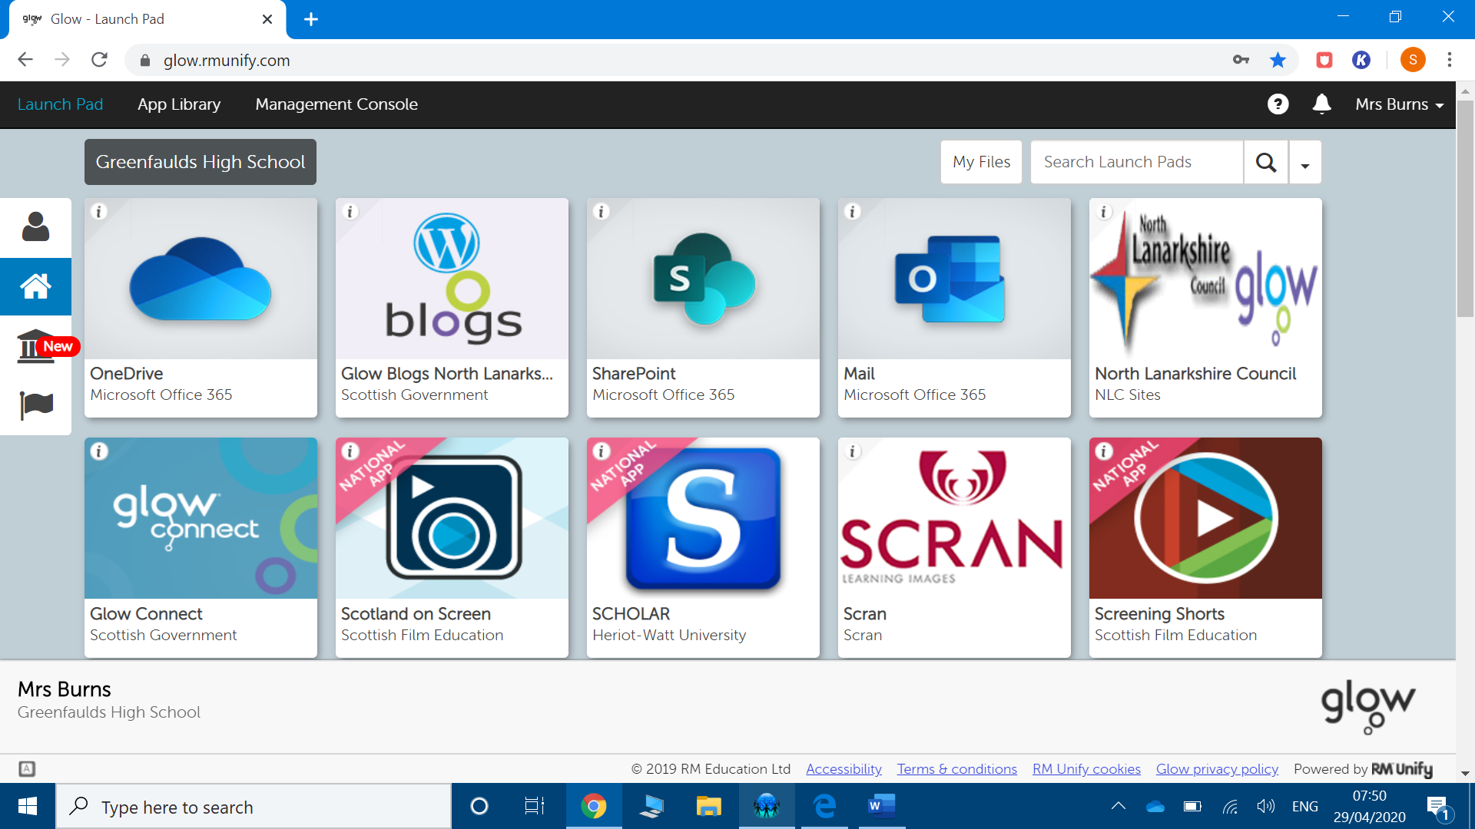

- Click on this to enter.
- Select Pupil Area
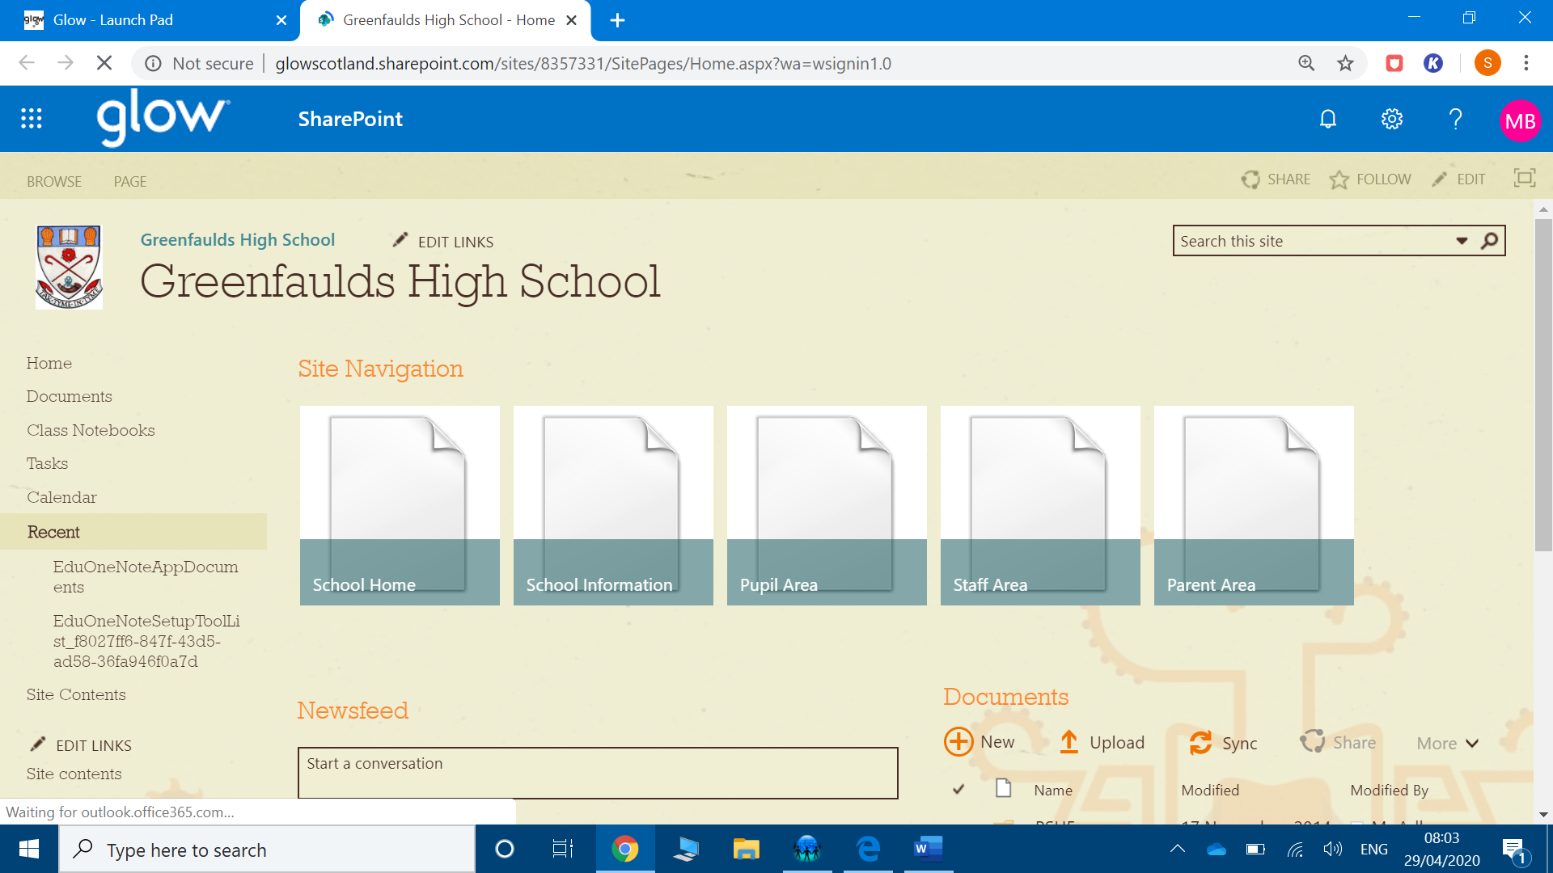

- Select Language to find English work that has been uploaded for pupils.
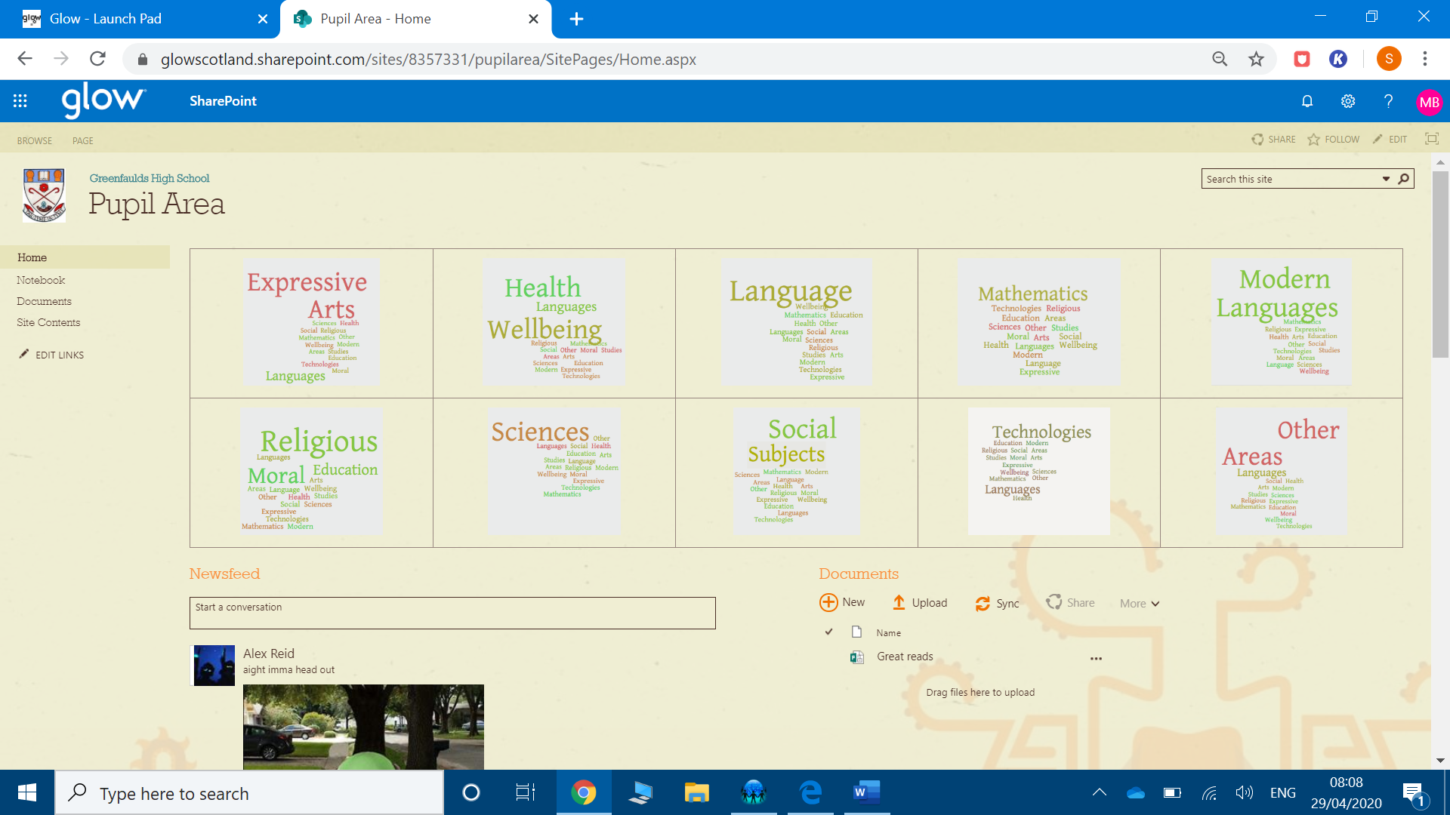
- The work is split into year groups.
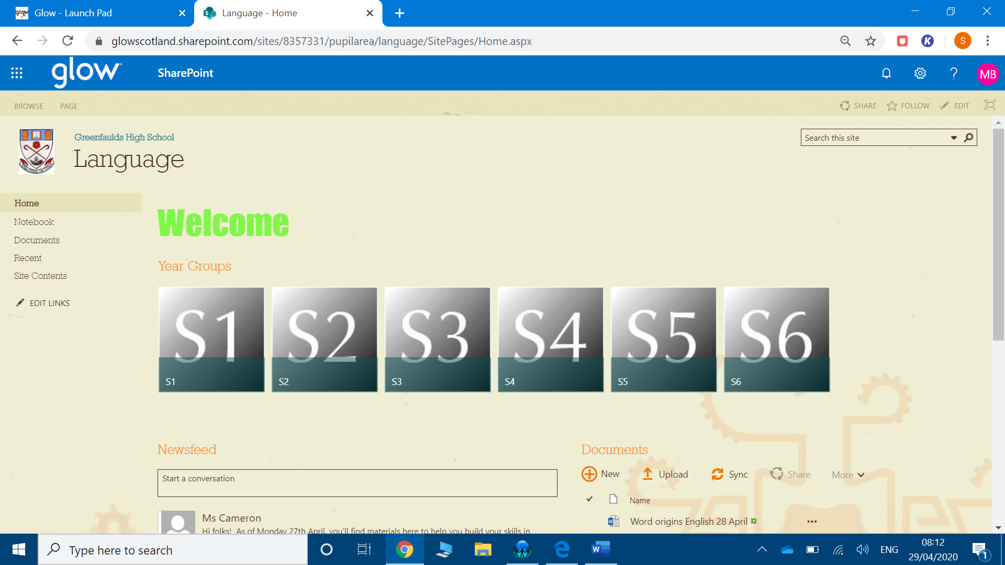

If using a tablet:
- Follow steps 1-3 above.
- You will be brought to a page which looks like the one below. Click on ‘subsites’ button at the top right.
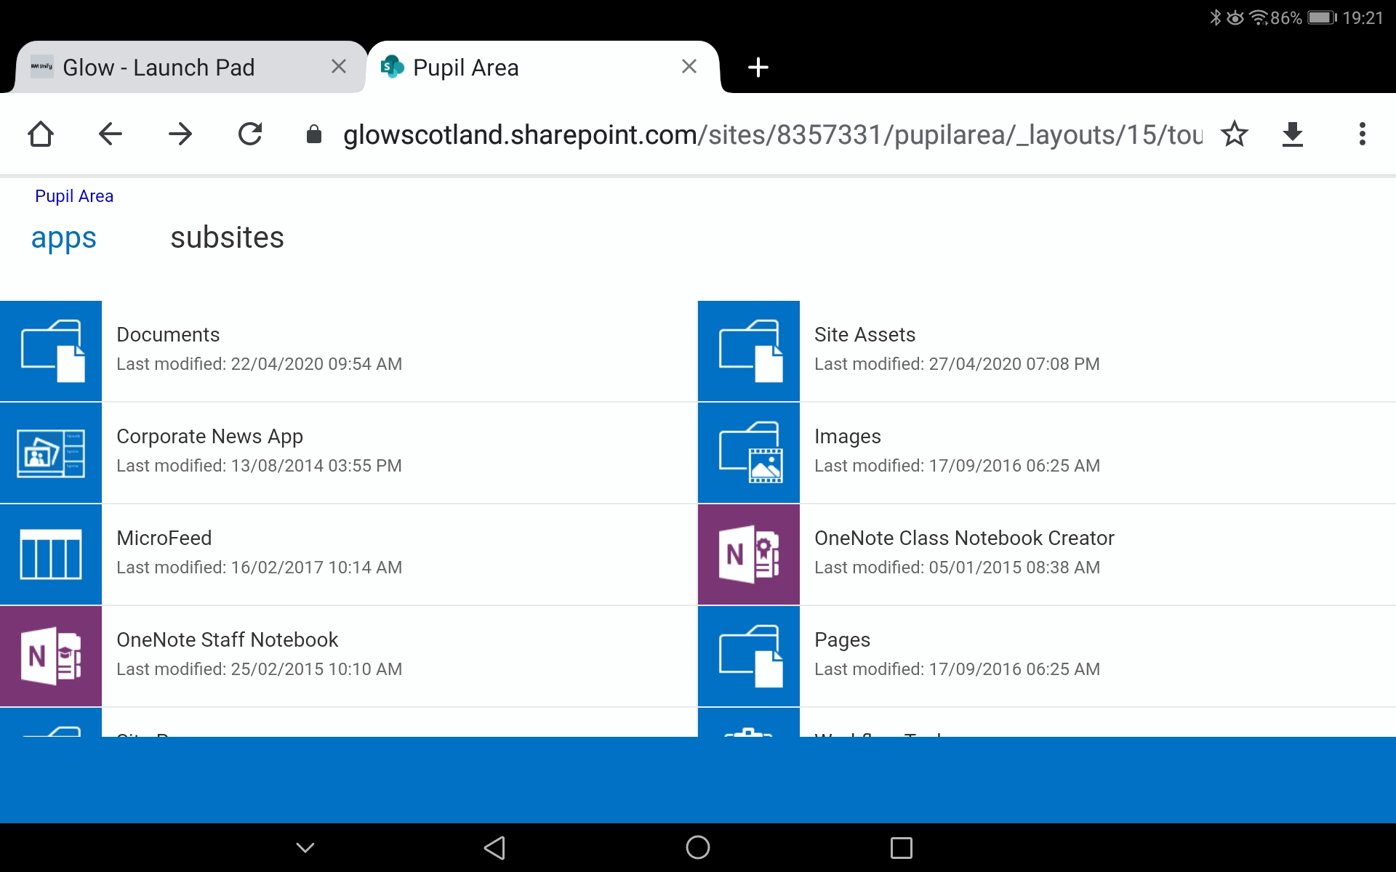
5. Then select ‘Language’ and then the correct year group, for example: ‘S1 documents’.

