NLC Literacy & English Learning at Home
2nd – 4th Level: Reading Fiction – Enjoyment and Choice

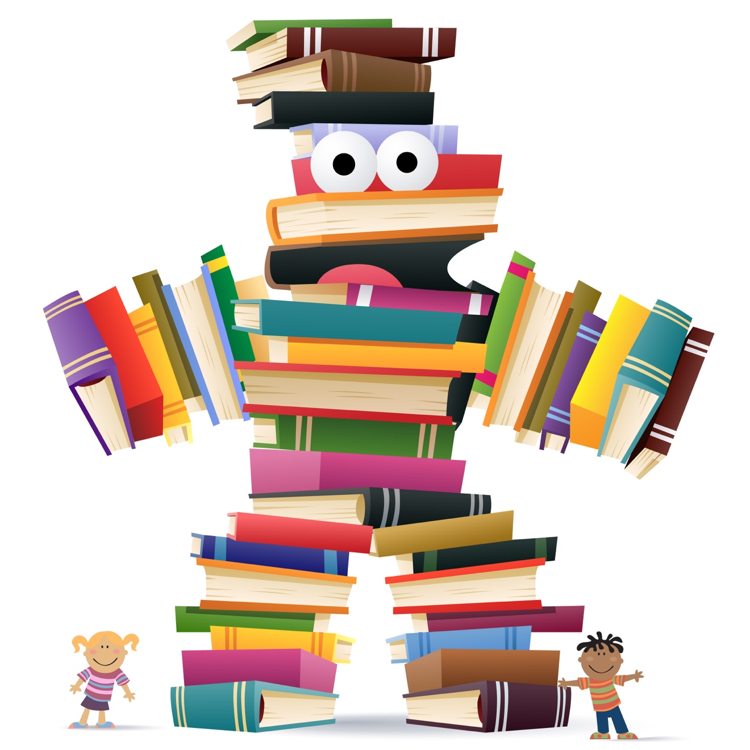

Independent Reading

Name: Novel:

Before Reading - Prior Knowledge & Predictions
Choose any novel you have at home to read over the next 6 weeks. Look at how many pages there are in total and divide this up so that you give yourself a reading target each week to get it finished within the 6 weeks.
This isn’t a rule though, just some advice. So if you need more time, then take more time; especially if the book is more than 300 pages!
Before you begin to read your novel consider the title, author, blurb and front cover. Record a few ideas, expectations or predictions based on your ‘Prior Knowledge’ on a visualiser like the one below.

Before you start the novel, look through this document to see what you will be doing as you read.
Metalinguistics
As you read your novel, make a list of some (not all) words you come across where the meaning isn’t immediately obvious but you are able to use the strategies you’ve been taught to figure out their meaning.
- Break down the word to see if you understand part of it. Does this make it clearer?
- Look at the other words around it (the context). Do any of these give you a clue as to the meaning?
- If you’re still unsure, check a dictionary or google. Then go back and read the word in context.
Each week, record some in a table like the one below.
Select at least 12 examples from throughout the novel – 1 or 2 examples from each week’s reading.
Word | First Guess | Steps taken to understand the word | Best meaning in context

Fluency & Expression
Once a week take a page of your book and film yourself reading it aloud. Use this guide as your criteria for assessing your performance as you watch/listen back:

Assessing Reading
Accuracy
Are all the words read correctly?
Are any words added or missed out?
Fluency
Does the reading flow?
Does the reader pay attention to punctuation?
Expression
Does the reader capture the mood of the text?
Does he/she make it sound interesting?
Clarity
Is the reader’s voice clear & audible?
Pace
Is it too fast/too slow?
Are there any other issues with the reading?

Visualisation
As you read the novel, try to show what you learn about one particular character or the narrator using a visualiser of any format. Include a range of information: observations about their personality and behaviour, direct quotes (perhaps as evidence of your points), paraphrased ideas and drawings.
Yours could look like the visualiser below. Record what you learn about the main character throughout or at the end of each week’s reading.

Inference
Sometimes authors require readers to ‘read between the lines’ to figure out what they are really trying to say. As you read the novel, try to find 6 instances (just one per week) where the author’s ideas or opinions are not stated explicitly. You may find it helpful to look at examples of imagery (simile, metaphor, personification…), word choice or sentence structure. Often these are used to imply meaning, rather than state it outright.
Record your examples on a table like this:
What the author says | What I think the author means by this | I know this because …
e.g. “Each day’s better than the next.” | e.g. Life is depressing. | e.g. If each day is better than the one which comes next, then the speaker is saying that their life gets worse every day.

Main Events (Paraphrasing & Summarising)
At various stages of your reading you will come to the end of different sections of the story: the opening, the complication (where the problem arises), the resolution (problem gets tackled/solved) and the conclusion/end. As you finish each stage, write down a few notes in your own words under the relevant heading to explain what happened in that section.

After Reading – Main Ideas or Themes
When you have finished your novel, you should have some idea as to the main ideas, purpose or theme that the author was trying to address. The theme or focus of the novel may change as you read or it may remain constant throughout.
Record what you think the main ideas/ theme/ purpose for each section of the novel listed again on the diagram below.

