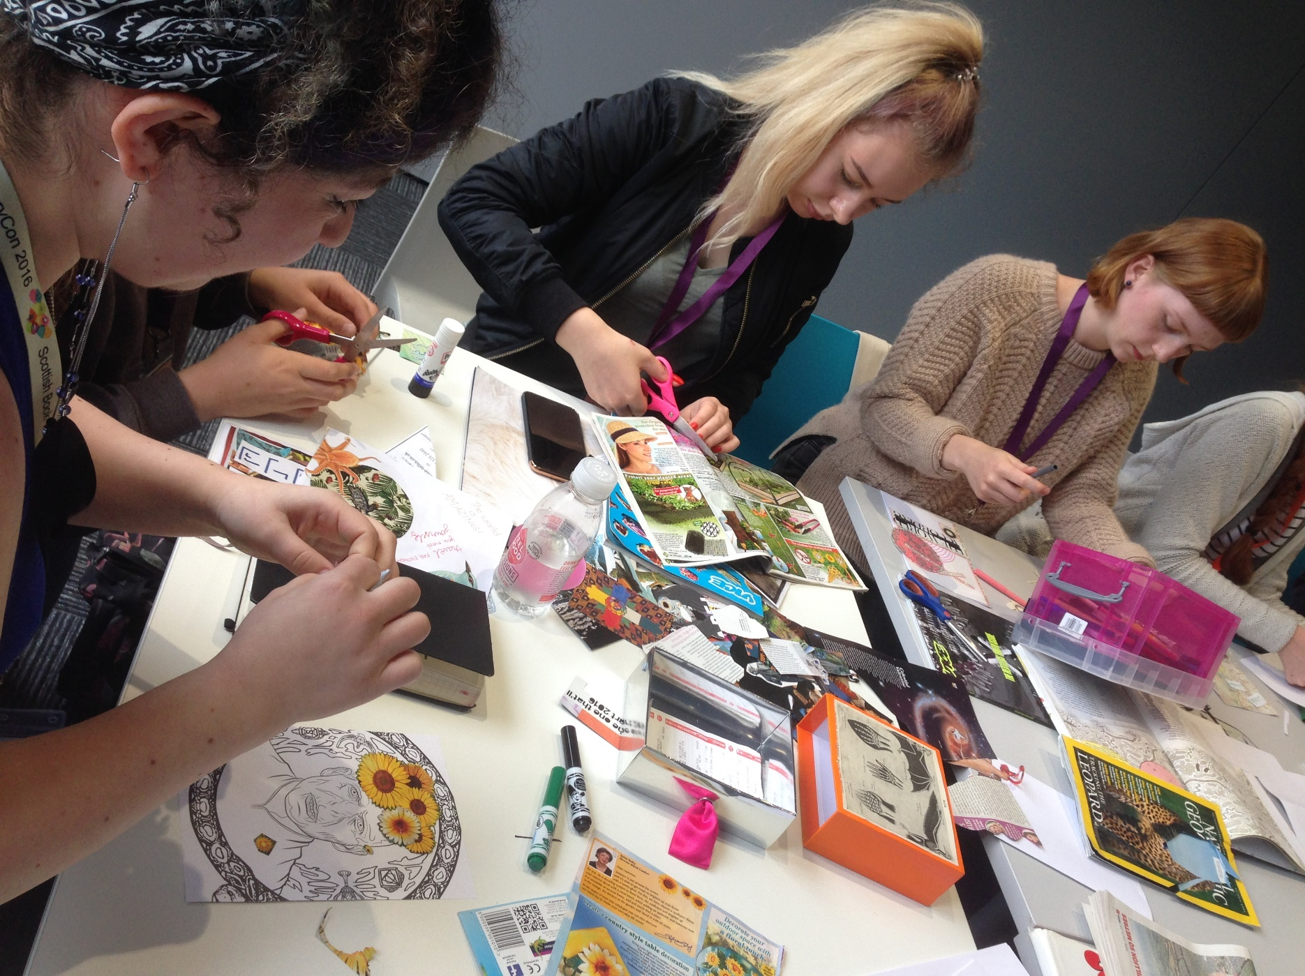

How to write a comic book scene
Age 12-16

CFE Levels Third to Fourth

Resource created by Metaphrog

Adapting novel scenes into comic format
scottishbooktrust.com

/scottishbktrust

@scottishbktrust

Contents
Comic adaptations: how faithful should you be? 2
Introduction to a typical comic page 3
The techniques of comic writing 4
Bringing characters to life in a comic 7
Bringing setting to life in a comic 8
Writing a script 9
Worksheets 12

About this resource
Comics offer an exciting way to tell a story, bringing words and pictures together in a lively art form. When adapting a book into a comic, it’s not a case of simply putting pictures along with words. The pictures give the reader lots of information about the setting and what the characters think and feel.
This resource will help your pupils to learn about the different techniques used to create comics. The activities use Private Peaceful by Michael Morpurgo as an example text, but the activities can be adapted for any book. Ask pupils to select a scene from Private Peaceful or their chosen text to work with.
Pupils will learn:
- what to consider when adapting a novel scene into a comic strip
- the techniques of comic writing, such as narrative boxes or speech bubbles
- creating the setting of a comic
- writing a script and choosing the layout for a page
This resource was created by Metaphrog, a comic book illustrator and writer duo based in Scotland.

Comic adaptations: how faithful should you be?
When you’re adapting a novel scene into a comic strip, you need decide how faithful to the original you want to be. Your options are:
- Recreate the setting, characters and plot of the story as faithfully as possible
- Take the original story and characters but move it to a new setting
- Choose to create a new story inspired by the original. You might choose to use the original characters, but give them new characteristics or change the plot.
For example, there are three different comic adaptions of The Strange Case of Dr. Jekyll and Mr. Hyde by Robert Louis Stevenson (see figures below):
- Alan Grant and Cam Kennedy’s full colour version keeps the language, form and chapter structure of the original.
- Andrzej Klimowski and Danusia Schejbal’s version keeps the structure and themes of the original, but is drawn in black and white.
- Lorenzo Mattotti and Jerry Kramsky’s changes the novels time and place, and uses the original to explore ideas afresh and reinterprets core themes.
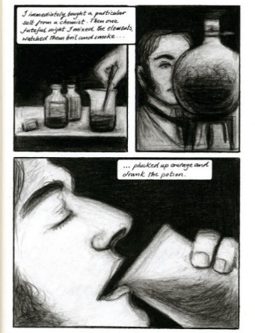
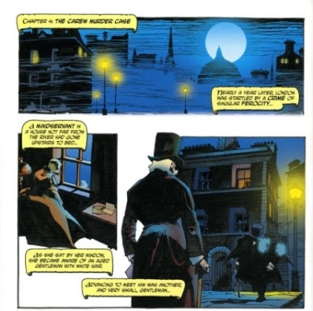
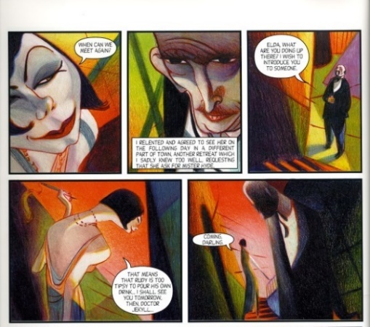
When adapting your own novel scene you will need to think about how faithful you are to the original text, and what you choose to keep and what you choose to lose.
Figure 1: page from The Strange Case of Dr. Jekyll and Mr. Hyde by Alan Grant and Cam Kennedy

Figure 2: page from The Strange Case of Dr.Jekyll and Mr. Hyde by Andrzej Klimowski and Danusia Schejbal

Figure 3: page from The Strange Case of Dr. Jekyll and Mr. Hyde by Lorenzo Mattotti and Jerry Kramsky

Activity: adaptions ENG 4-19a, LIT 4-02a
Consider the following questions:
- What is your opinion on adaptations?
- Should they keep to the original story and characters?
For instance, The Hunger Games and Divergent have recently been adapted for film and the Roald Dahl classic Charlie and the Chocolate Factory was remade with a very different character of Willy Wonka. Discuss some adaptations you have seen or read, and whether you think they worked well.
Introduction to a typical comic page
Each page of a comic should help tell the story while keeping things visually interesting for the reader.
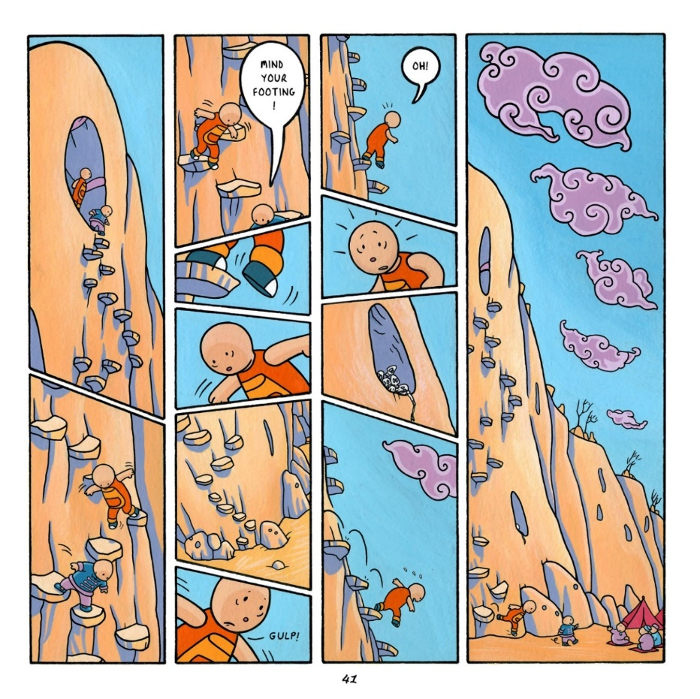
A glance at the page should suggest the atmosphere and ideas of the story and be eye-catching. You also need to make actions on a page flow, but they should be clear and readable.

Figure 4: page from Louis: Night Salad by Metaphrog

Activity: Louis: Night Salad EXA 4-07a, ENG 4-31a
Look at figure 4, Louis: Night Salad. The main character Louis and is trying to make his way down a cliff. Write a few paragraphs of prose based on this scene; describe what is happening and what the two characters in the scene are thinking and feeling.
Now think about the following questions:
- What do you feel when you look at this page?
- How have the comic creators conveyed the characters thoughts and feelings?
- Is there anything on the page you find particularly interesting or eye-catching?
- What kind of atmosphere do you think is created on this page?
- What sort of story do you think Louis: Night Salad is?
Everyone reacts to comics differently. Discuss and compare your answers in pairs.
In figure 4, the illustrators aim was for the reader to feel what Louis is feeling; frightened, excited, and unsure where to put his feet. By bookending the page with two tall panels, and using fast cutting and unusual panel shape in between, the reader gets a sense of imbalance and of the danger Louis faced. Did these elements come up in your discussion?
The techniques of comic writing
Comics can look simple but are complicated at the same time. Lots of different things can appear on the page, but in general the building blocks of comics include panels, narrative boxes, speech bubbles, lettering, and visual metaphors.
Panels
Panels are used in comics to frame the action. The way you lay out the panels on the page is important, as it affects the rhythm and pace of the story. You can:
- Create page-sized panels for scene setting, or for effect and emphasis
- Remove panel borders to create a pause or suspend time, as seen in figure 5
- Use large panels to make it feel like time is slowing down
- Use small panels to speed up the action and make time pass more quickly
- Insert smaller panels into larger panels to add detail, space action out, or add or hide information
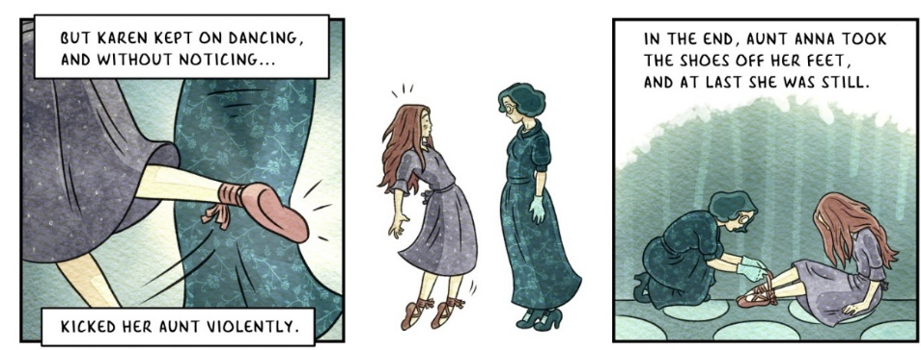
- Cut- off at angles to make the action more dynamic (see figure 4)

Figure 5: panels from The Red Shoes and Other Tales by Metaphrog
000

Gutters are the spaces between the panels. The reader imagines or accepts that time passes in these spaces.
Closure is when a comic artist only draws a small part of something, and the reader’s brain pictures the rest. For example, if you just draw a claw and the reader pictures the rest of the monster.

Activity: panels
Based on what you have just learnt, discuss the pages in figure 6.
- Do you notice a difference between the way you read each page?
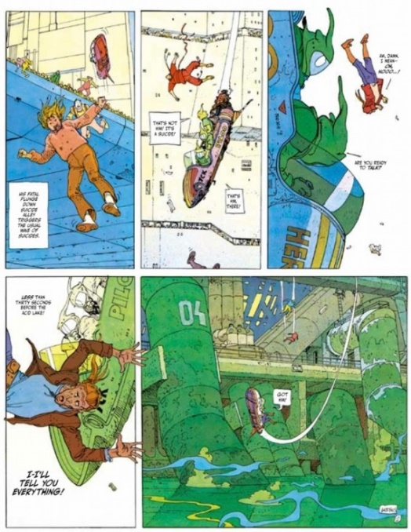
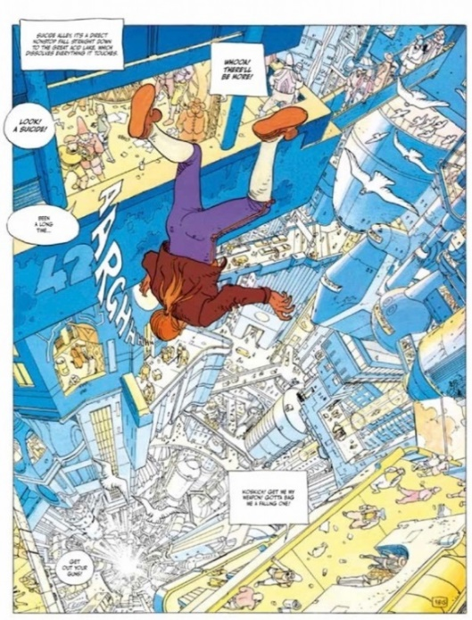
- Do you notice anything about the layout?
Figure 6: pages from The Incal by Moebius and Jodorowsky

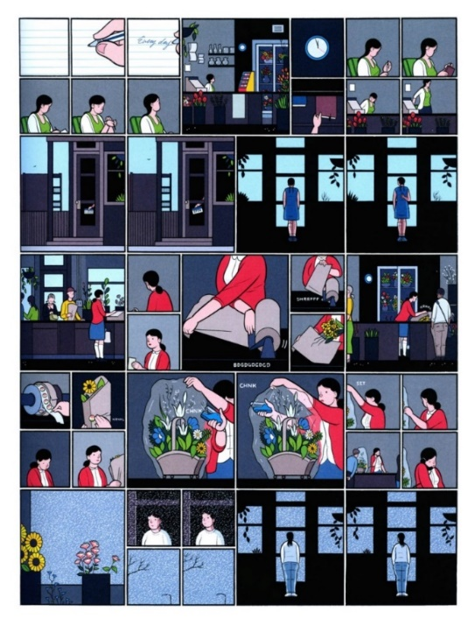
Activity: small panels LIT 4-02a, ENG 4-19a
Look at figure 7. What does it make you feel? How do you think the artist intended you to read the page? How does time seem to pass on this page? This is an example of a comic artist challenging convention, Chris Ware is using small panels to try and slow time down.
Activity: plan your panels ENG 4-31a, EXA 4-03a
Read through your chosen scene from Private Peaceful. Are there any parts where you think you would use a particular size of panel? Note these down for your reference later on.
Activity: closure EXA 4-03a
Think about how you might apply the closure technique of just showing part of something to the list below. What would the reader need to see?
Figure 7: page from The Acme Novelty Library by Chris Ware

- An approaching tank or army
- A dangerous animal
- An earthquake
- Or find something in Private Peaceful or your chosen text to illustrate
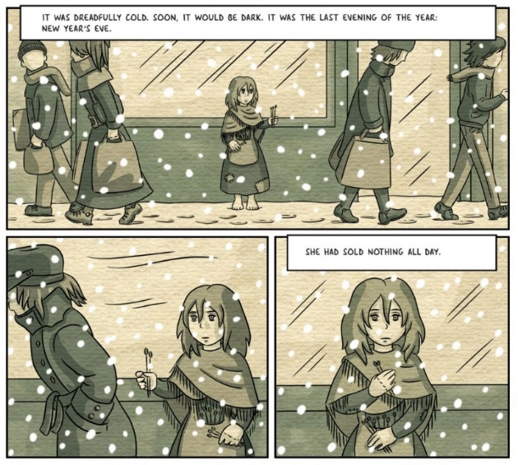
Exposition and narrative boxes
Exposition is the detail that the reader needs to know to make sense of the story. For example, in figure 8 from The Little Match Girl, we don’t know from looking at the illustrations that it’s New Year’s Eve, so the narrative box tells us.
When exposition is required, or when the narrator is speaking, you can use a narrative box.
Speech bubbles
The characters in a comic can voice their dialogue through speech bubbles. You can use a different font for each characters’ speech. If you want to show an inner voice, it might be more practical to use a narrative box for the characters thoughts.
Figure 8: page from The Little Match Girl by Metaphrog

Dreams, imagination and thoughts can be shown in a separately shaped, wobbly-lined thought bubble.
Lettering
Your pupils can choose the type and size of font best for each character. Larger bolder lettering can be used to show when characters are speaking with loud voices.
Onomatopoeia
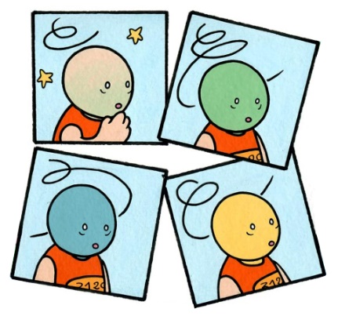
Onomatopoeia are words that sound like what they refer to and are closely associated (BIFF BANG POW!) with comics. The words can be used as pictures in the comic panels.
Emanata
These are the symbols or lines that can emanate from a character or a thing to show their state of mind (see figure 9 or 10). Typically emanata can show when someone or something is, for example, hot, frightened, smelly or angry…
In Louis: Night Salad Metaphrog used emanata to show how Louis was feeling.
Figure 9: panels from Louis: Night Salad by Metaphrog

Visual metaphors
An example of visual metaphor can be seen in figure 9. The reader can see that Louis is ‘feeling green’, a simple metaphor which obviously means he is feeling unwell.
In Private Peaceful we learn that Tommo does not feel he lives in his big brother’s shadow. On the contrary he says, “I live in his glow.” This is a strong metaphor, but how do you think you would show this “glow” in an illustration?

Activity: lettering ENG 4-19a, ENG 4-31a
In Private Peaceful identify when different fonts have been used and explain why the author has chosen to do this.
Next, look at the scene you have chosen to adapt from Private Peaceful. Do you think it would be appropriate to use larger or bolder lettering for a character at any point in this scene? Do you think that certain characters in the scene might require a certain type of font? Why? Note these down for your reference later on.
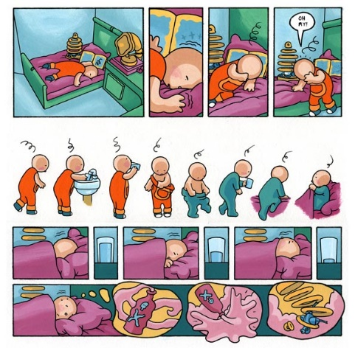
Activity: emanate ENG 4-19a, ENG 4-31a
Look through your chosen scene from Private Peaceful. Are there any parts where you could try to use emanata, or any other technique you’ve learned about, to show what the characters are feeling? Write some brief notes for later reference.
Activity: exposition ENG 4-19a
Have a look through your chosen scene from Private Peaceful. Do you think there is any exposition in your scene that you could put in narrative boxes? Note this down for later reference
Figure 10: page from Louis: Night Salad by Metaphrog

Bringing characters to life in a comic
You can bring your characters alive in different ways, particularly by using facial expressions and body language.
When telling a story visually it is important to make the key characters stand out. Each character should be easily distinguishable to facilitate ease of reading. Various techniques can be used to achieve this, including:
- A strong shape, colour or outline
- A prop or gimmick, like an umbrella
- A distinct physical feature, such as a moustache
See figure 6 for an example of this in action. The main character Karen stand out through her red shoes and red hair. Comics lend themselves well to exaggeration, so be sure to exaggeration your characters traits or features visually.
In a comic, you need to be able to show what the main characters are like, but you also need to show how they get on with each other.
Activity: characters ENG 4-19a, ENG 4-31a, EXA 4-03a
Identify the main characters in Private Peaceful, and write a brief description for each. Note down some things you might use to make them stand out, based on the guidance above.
Now, choose one character and produce a finished drawing suitable for a comic adaptation of a particular scene. Write an explanation of why you have chosen to draw the character this way.
Activity: character interaction
ENG 4-19a, ENG 4-31a, EXA 4-03a
Think about the relationships between the main characters. For example, how does Tommo feel about each of his brothers? How does he feel about Molly? How can you tell from what he says and does?
After this, select two characters, e.g. Charlie and Molly. Think about how you might show in a drawing how they feel about each other. Draw them together and write a short description of why you have chosen to depict them this way.
Bringing setting to life in a comic
The setting is where a story or scene takes place. You can draw your reader into the story by making careful choices about your illustrations.
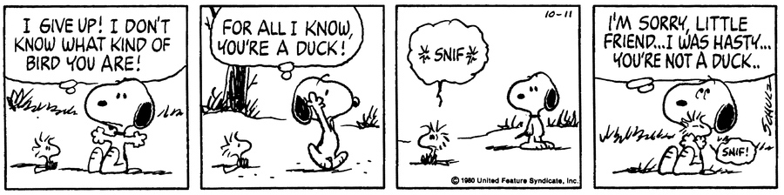
But not all comic creators draw the setting in lots of detail. Some illustrators only draw very small details and rely on the imagination of a reader to fill in the rest (see figure 11). Here, the world is only formed from a few suggested trees or bushes.
Figure 11: Peanuts by Charles Schulz

Activity: compare settings EXA 4-07a, ENG 4-19a
Consider the five comics on worksheet 1. For each page consider the following questions:
- Write down a few words to describe the setting.
- What techniques do you think the artist has used to make the setting look and feel this way?
- Where and when do you think the story is set? What makes you think this?
Researching your setting
To make your comic adaptation of Private Peaceful you will need to do research and investigate World War I.
For instance, if your chosen scene takes place in the battlefields, you will need to be able to represent a trench or the soldier’s uniform.
In figure 12, you can see how Jacques Tardi has reproduced soldiers’ uniforms, and how he uses washed out blue grey colours to evoke the coldness of war.
Activity: research LIT 4-14a
Carry out some research into the setting for your chosen scene. Write notes for later reference to help with your illustration. You could also print relevant photographs.
Figure 12: page from Goddamn This War! by Jacques Tardi

Activity: creating atmosphere ENG 4-31a, EXA 4-03a
Look at worksheet 2 and think about the settings in Private Peaceful. In the right hand columns of the table, write down what things you’d like to convey about each of the settings: what do you want the reader to know about the setting, and how do you want them to feel? Then write down some things you might do in your comic to create the atmosphere.
Writing a Script
It is useful to write a script for your comic. Writing a script helps with planning and laying out the story visually.
You will need to decide what text to leave out, and what language style and tone to use. Scenes or text can be condensed to what is strictly necessary, and visuals can replace parts of the text, such as descriptions.
In your script you should include dialogue and what the characters are doing (see example below). If you’re working on the script and someone else is doing the drawing, it’s up to you to decide how much detail or direction to give for characters and setting.
Example script adapted from page 62 of Private Peaceful
[Charlie’s mother answers the door. The Colonel is standing there, scowling.]
COLONEL: That boy of yours is a despicable thief, Mrs. Peaceful!
[A panel shows Charlie in the hallway, nervous but defensive.]
CHARLIE: He was going to shoot her, mother. I had to do it.

Activity: script writing ENG 4-31a
First, go through a photocopied extract of your book scene. Highlight all of the narration and dialogue that you want to include in your comic adaptation.
Based on this, start writing your script. You can use the example above as a guideline. As with any writing process, feedback is essential. Swap your script with another person and ask for their feedback based on the following questions:
- Is there anything in the script which could be shown in an illustration instead?
- Does everything in the script help the reader to understand things about the characters and plot?
- Are any of the sentences too long, perhaps too long to fit inside a comic panel?
Planning the layout and writing your comic
Once you’ve got the script, you can do a first draft of the actual comic. The more carefully a story has been planned, the better the rend result will be.
You have a choice of different shots: general views, middle shots and close-ups.
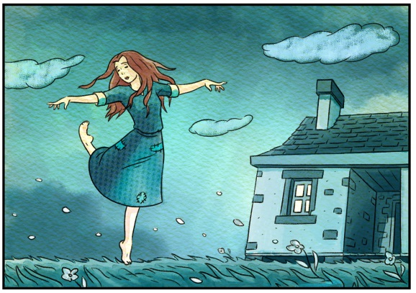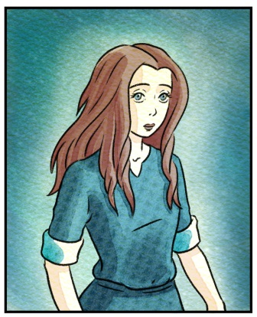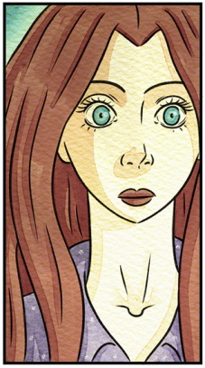
General view Middle shot Close-up
Figure 13: panels from The Red Shoes by Metaphrog

Activity: laying out shots EXA 4-07a
Have a look at each type of shot in figure 13 (you can also look at figures 6 and 8) and discuss what effect the artist is trying to achieve. When do you get closest to the character’s feelings?
Structure
Comic book scenes work much the same to any story structure: there’s always a beginning, middle and end of each scene. The beginning usually introduces the setting and characters, the middle presents the main problem, and the end presents the resolution or characters reaction.
For the beginning, when you’re trying to introduce your reader to your setting, one technique you can use is ‘visual shorthand’. Film makers, like Alfred Hitchcock, often speak of using visual shorthand: for example, starting a story with a landmark such as the Eiffel Tower lets the reader know that the story takes place in France.
Comics often start with a general, wide view and then move in on the characters while also introducing the plot (see figure 1).

Alternatively, the comic can start from a close-up and zoom out to set the scene (see figure 2 and 6). Equally, some comics may even start directly with action panels (see figure 5).
Activity: drawing your comic ENG 4-31a, EXA 4-03a
It’s time to write and draw your comic. Read your script through to get a feeling for the rhythm and pacing of the scene, then draw some rough panels and sketches to see if they work. The drawings do not need to be refined or finished in the first draft but the shapes of the main elements in the panels and on the pages should be clear enough to be readable and recognisable. Work through several drafts till you’re happy with your finished product! Remember, here are the topics you’ve covered: use your knowledge of all of them to produce the best possible comic:
- How faithfully should you stick to the source material?
- The techniques of comic writing – panels, closure, narrative boxes, lettering, visual metaphors, onomatopoeia and emanata;
- Bringing characters to life;
- Bringing the setting to life;
- Panel sizes and layout.
Finished comics can be created using pencils, pens and ink, brushes with ink, crayons, collage, glitter and gum. Combining words and pictures: the only limit is your own imagination.

Worksheet 1
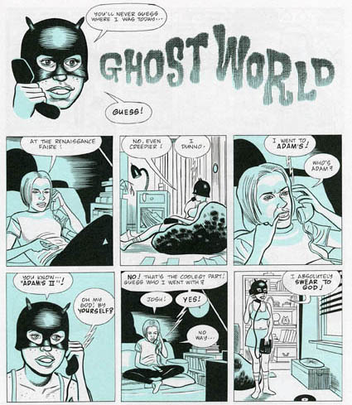
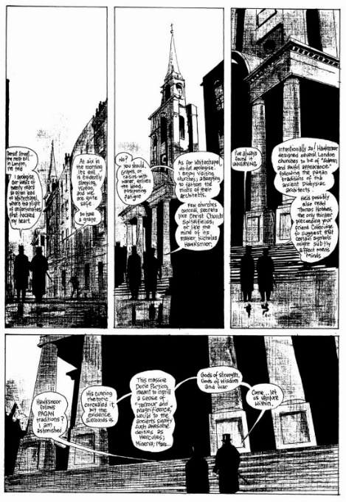

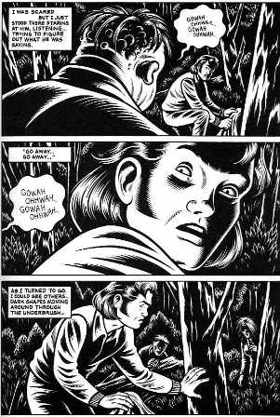
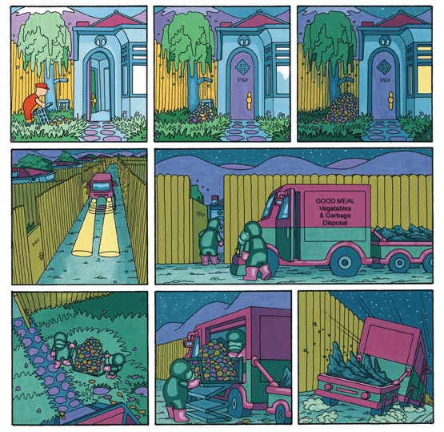

Top left: Hell by Alan Moore and Eddie Campbell, top right: Ghost World by Daniel Clowes, middle left: Louise: Red Letter Day by Metaphrog, middle right: Black Hole by Charles Burn, bottom both: The Arrival by Shaun Tann.
Worksheet 2
Setting | What I want to convey | How could I convey these things?
A rural childhood | The countryside  The small village  The happiness of Tommo and Charlie’s childhood | The countryside could be represented in some panels by the robin’s nest, the crows and a field  The small village could be suggested in some panels by depicting its inn and church tower  Bright colours could be used to show the happiness of childhood in the countryside
First day at school
No Man’s Land

The trenches

