FOOD SUPPLY
The human population is over 7 billion and growing: it is estimated that it will be 9 million by 2050.
Feeding over 7 billion people requires a sufficient and sustainable supply of food. This makes food security a hugely important subject for the future of the human race.
Food security is defined as access to food of adequate quantity and quality:
- sufficient food must be available at all times;
- food must be sufficiently nutritious and varied to provide a balanced diet;
- people must have economic means to obtain the available food.

Food security: the challenge
- Rapid increase in global population leads to increase in demand for food and energy.
- Population increase higher than rate of food production.
- 2 billion people already lack food security i.e. are malnourished or starving.
- Malnourishment leads to poor health.
- Growth of biofuels removes arable land from crop production.
- Effects of global warming e.g. alteration of environment; increase in insect pests.

Food security: Biology’s contribution
Meeting these challenges is a very complex issue. Biological science can contribute in many ways, including:
- selective breeding for high-yielding crops and animals
- genetic modification for disease/drought resistance
- development of biodegradable pesticides
- efficient irrigation systems
- education on birth control
- new agricultural areas in countries now too cold for farming (as a result of climate change)

There are around 75,000 edible plant species, yet 95% of our food supply comes from only a few main crop species:

- Cereals e.g. maize, rice
- Root crops e.g. potatoes, cassava
- Legumes e.g. soya

Factors affecting plant growth
Environmental factors
- temperature
- rainfall
- atmospheric carbon dioxide levels
- light availability

Crop factors
- crop cultivar
- pests
- disease
- competition

Soil factors:
- area under crop
- fertiliser levels
- soil type
- drainage

If the area of land suitable for growing crops is limited, agricultural practice can:

- add minerals (fertiliser) or water (irrigation systems);
- use a higher-yielding cultivar;
- use necessary amounts of pesticides, fungicides and herbicides;
- develop pest-resistant crop plants;
- develop crops with higher nutritional value;
- develop crops easy to grow and harvest;
- graze livestock in areas unsuitable for arable use.

Energy transfer
The source of energy for most living things is light from the Sun, trapped by plants (producers) in the process of photosynthesis. Some of the energy is passed along food chains to various levels of animal consumers.
Much (90%) of the energy is lost at each level:

- undigested food and waste;
- maintaining body temperature;
- movement

Only 10% is incorporated into body tissues.
As a result of this loss of energy, livestock production generates far less food per area of land than plant production.
90% energy lost 90% energy lost

Cereal plant Farm animal Human
10% energy passed on 10% energy passed on
The shorter the food chain, the more energy efficient it is. Therefore arable land planted with crops produces far more food than the same land planted with grass to feed livestock.
However, not all land can be planted with crops, in which case it is more efficient to use them for livestock

Cereal plant Farm animal Human
10,000 kJ 1000 kJ 100 kJ

Cereal plant Human
10,000 kJ 1000 kJ
PLANT GROWTH AND PRODUCTIVITY
All food production, plant or animal, depends on the process of photosynthesis.
Photosynthesis
Photosynthesis is the process by which green plants convert light energy into chemical energy in molecules of glucose. Carbon dioxide (from air) and water (from soil) are the raw materials and oxygen is a by-product.
The light is absorbed by photosynthetic pigments (e.g. chlorophyll) in the chloroplasts of green plants.

Light
Light is a form of electromagnetic radiation that travels in waves. It consists of minute packages of energy called photons.
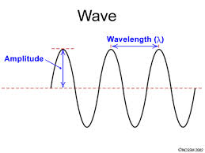

Visible light is made up of a spectrum of different colours. Each colour of light has a different wavelength.
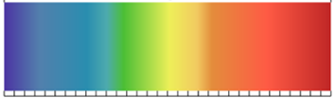
400 nm 500 nm 600 nm 700 nm

The distance between two crests is called the wavelength (λ) and is measured in nanometres (nm)
(1 nm = 10⁻⁹ m).

Light on leaves
Light may be absorbed, transmitted or reflected by substances e.g. a green leaf.

reflected (12%)

absorbed (83%)
transmitted (5%)

Light absorption
A pigment is a substance that absorbs (and reflects) visible light. The colour of the pigment is the light that is not absorbed e.g. a green pigment absorbs red and blue light but not green. There are many types of plant pigment, including:
- Chlorophyll a
main pigments
- Chlorophyll b
- Carotene
carotenoids
- Xanthophyll These pigments absorb different wavelengths of light.

Separation of pigments
The pigments can be separated using paper or thin-layer chromatography. Thin-layer chromatography is performed on a sheet of glass, plastic or aluminium foil, which is coated with a thin layer of silica gel.
Leaf pigments are extracted by grinding leaves with fine sand and propanone, then filtering out the extract. This pigment mixture is then spotted onto the gel several times.
As the solvent slowly travels up the plate, the different pigments travel at different rates and the mixture is separated into different coloured spots.
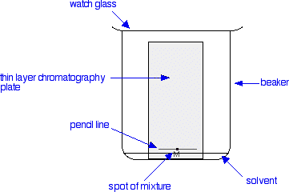
Light absorption
A leaf pigment extract is prepared.
White light is passed through the extract, then passed through a spectroscope e.g. glass prism: black areas show which colours have been absorbed by the leaf pigments.
Spectrum viewed through chlorophyll

Chlorophyll absorbs mainly blue and red light.

Role of pigments
Chlorophyll a makes up around 50% of plant pigments. Chlorophyll a and b absorb mainly blue and red light.
Other pigments, known as accessory pigments, (such as the carotenoids) absorb energy from other regions of the spectrum and pass it on to chlorophyll. This allows a plant to use a wide range of wavelengths of light for photosynthesis.
Action spectrum
An action spectrum shows the extent to which different wavelengths of light are used for photosynthesis.

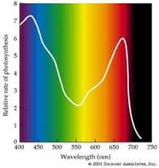
Absorption spectrum
The absorption of each wavelength of visible light by each pigment is measured using a spectrometer.
The data can be used to plot a graph:
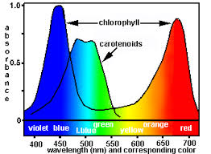

:

Absorption and Action spectra - comparison
Comparison of absorption and action spectra reveals a close match – good evidence for the crucial role played by leaf pigments in photosynthesis.
Site of photosynthesis
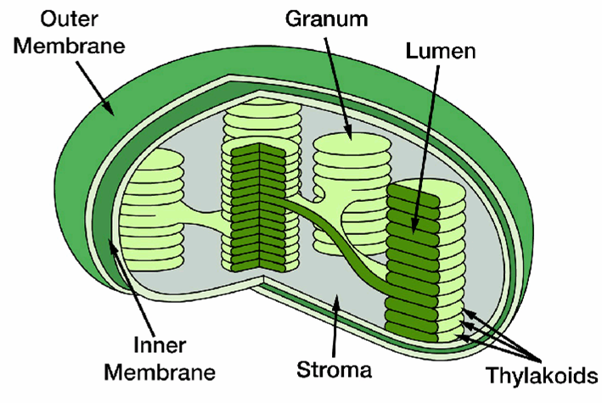
Photosynthesis consists of two stages:
- light-dependent stage – several LIGHT REACTIONS
- temperature dependent stage - CARBON FIXATION
Both of these stages take place in the chloroplasts.
The photosynthetic pigments are contained in the grana, therefore this is where absorption of light energy takes place. Each granum is composed of a stack of thylakoids.
Carbon fixation occurs within the stroma of the chloroplast.

The Hill reaction
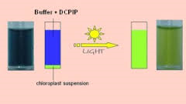

In 1939 a biochemist, Robert Hill, demonstrated that oxygen is produced during the light-requiring steps of photosynthesis. He went on to demonstrate the role of hydrogen and the electron transport chain.
Extracted chloroplasts are mixed with a DCPIP, a blue hydrogen acceptor that loses its colour when it combines with hydrogen in the presence of light. [Results in diagram]
Conclusion: the colour change is due to photolysis – water has been broken down into hydrogen (now joined to DCPIP) and oxygen.
DCPIPH2

[colour of chloroplasts only – DCPIPH2 is colourless]
[chloroplasts + DCPIP – dark blue]

Energy capture and photolysis
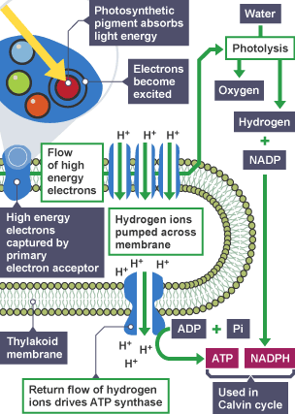
Light energy is absorbed by chlorophyll a, exciting its electrons i.e. raising them to a higher energy state.
These electrons are captured by a primary electron acceptor and then transferred along an electron transport chain on the thylakoid membrane.

This releases energy that is used:
- by the enzyme ATP synthase to generate ATP;
- for photolysis of water into oxygen and hydrogen.
The ATP is used to provide energy for the second stage of photosynthesis, the Calvin cycle.
The hydrogen binds to the coenzyme NADP to make NADPH , also used in the Calvin cycle.
The oxygen is released into the atmosphere.

Carbon fixation: the Calvin cycle
The detail of what happens in second stage of photosynthesis was first described in the 1940s by Melvin Calvin, who studied the reactions that convert carbon dioxide into sugar. The second stage of photosynthesis is named after him.
The hydrogen (as part of NADPH) and the ATP from the light dependent stage, along with carbon dioxide, are essential for the Calvin cycle, which takes place in the stroma of the chloroplast.
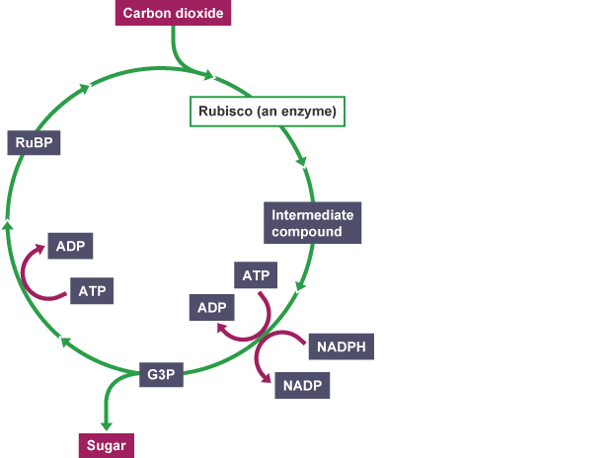
- Carbon dioxide enters the cycle and becomes attached to RuBP (ribulose bisphosphate). This reaction is controlled by the enzyme RuBisCO (ribulose bisphosphate carboxylase/oxygenase).
- The carbon dioxide and RuBP combine to make 3-phosphoglycerate.
- The 3-phosphoglycerate then joins with the hydrogen from NADPH and is phosphorylated by the addition of inorganic phosphate (P_{i}) from ATP which supplies the energy for the process.
- This process produces glyceraldehyde-3-
phosphate (G3P).
- Some G3P is then used to regenerate RuBP (to continue the process).
The remainder is used to synthesise sugars.

3PG

Uses of sugar
- Respiration
- Starch (storage carbohydrate)
- Cellulose (structural carbohydrate)
- Biosynthetic pathways e.g. lipids, proteins, nucleic acids

Plant productivity
Some of the carbohydrate formed during photosynthesis is assimilated i.e. used to ‘build’ the plant and results in an increase in biomass.
Biomass: mass of organic material, usually measured as dry mass as water content of plants fluctuates.
Net assimilation (overall increase in biomass) = increase in mass due to photosynthesis minus loss in mass due to respiration.
Conditions | Rate of respiration v. photosynthesis | Net assimilation
Darkness | Respiration rate greater | < 0
Dim light | Rates equal | 0
Bright light | Respiration rate less | > 0

Measuring net assimilation rate
Assimilation rate is measured as the increase in dry mass per unit area of leaf per unit of time.
Plants are grown under different conditions and the dry mass of discs from growing leaves is measured.

Productivity
Productivity is the rate at which plants in an ecosystem generate new biomass. It is measured as units of biomass per unit area per unit time e.g. grams per square metre per year (g mˉ² yˉˡ).

Factors affecting productivity
Rate of photosynthesis, and hence productivity, is affected by environmental factors, mainly temperature, light intensity and carbon dioxide concentration.

Limiting factors
The rate at which photosynthesis proceeds to limited by whichever one of these factors is in short supply e.g. light intensity is the limiting factor on a dull summer day.
Light as a limiting factor
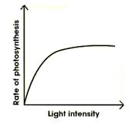
Carbon dioxide concentration is increased:
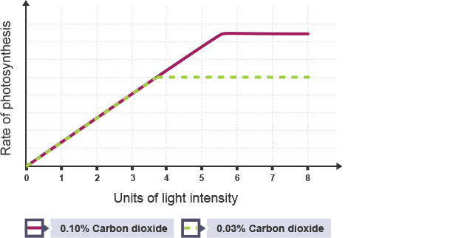

0.1% carbon dioxide
Some other factor is limiting
Light is the limiting factor

0.03% carbon dioxide

A

Limiting factor
A light intensity
B carbon dioxide concentration
C another factor

Productivity and leaves
B

Photosynthesis happens mainly in a plant’s leaves therefore productivity depends on arrangement, shape and number of leaves. A mosaic pattern and an optimum number of leaves presents maximum leaf area to light, with minimum shading.
Crop planting density
Increasing crop density leads to an increase in productivity as maximum use is made of available light and land available.
Planting beyond an optimum level is of no benefit due to shading of leaves; competition for water and minerals; easier spread of pests.
Leaf area index
Leaf area index (LAI) is a ratio of total leaf area: area of ground covered by leaves and indicates efficiency of light interception by leaves. As LAI increases, productivity increases to a maximum and levels off as lower leaves become shaded by those above.

Assessing productivity
In order to grow crops efficiently to ensure the maximum yield, farmers/scientists/policy makers need to be able to assess the growing potential of the area.
The biological yield of an area is the total biomass of plant produced: this indicates the total producing power of the land.
The economic yield is the mass of the desired product (e.g. mass of just the barley grains from a barley field).
Biological and economic yields are used to calculate the harvest index.

Harvest index
The harvest index is used to measure crop yield. It is calculated using the formula:
dry mass of economic yield
dry mass of biological yield
This is often expressed as a percentage:
dry mass of economic yield x 100%
dry mass of biological yield

PLANT AND ANIMAL BREEDING
Manipulating heredity
Breeders of crops and livestock have been manipulating heredity for thousands of years. Selective breeding is the process by which selected individuals are bred together to produce offspring with desirable features e.g. improved cultivars of plants or breeds of animals.
Desirable feature | Example
Higher yield | Wheat
Higher protein content | Soya bean
Disease resistance | Potato (to blight)
Pest resistance | Tomato (to eelworm)
Frost resistance | Strawberry
High milk yield | Dairy cattle
High meat yield | Beef cattle
Useful physical characteristic | Uniform height
Ability to thrive in certain environment | Maize in cold, damp climate

These improvements support sustainable food production. Farmers and breeders select plants and animals with the required characteristics to be parents of the next generation. This brings together desired alleles so that the offspring are more useful than the parents.

Test cross
A test cross is a cross between an organism whose
genotype for a certain trait is unknown and an organism
that is homozygous recessive for that trait.

Polygenic inheritance
Polygenic inheritance involves the alleles of more than one gene and controls characteristics showing continuous variation e.g. height. The effect of the genes involved is additive. The greater the number of genes involved, the greater the number of intermediate phenotypes produced. Many traits showing polygenic inheritance are influenced by the environment.

Outbreeding
Outbreeding involves the fusion of two gametes from unrelated members of the same species and promotes heterozygosity.
Wild animals and cross-pollinating plants are naturally outbreeding. Recessive alleles are often present but masked by dominant alleles.

Inbreeding involves the fusion of two gametes from close relatives and promotes homozygosity. It is naturally occurring in some species of self-pollinating plants e.g. peas, wheat and rice. Inbreeding ensures that each generation receives the alleles for the desired characteristics. [Recessive alleles are eliminated by natural selection.]

Effects of inbreeding
Desired effect: selected plants or animals are bred for several generations until the population breeds true to the desired type.
Negative effects:
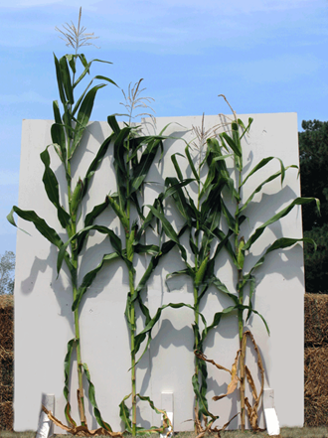
- loss of heterozygosity (not a problem for naturally inbreeding plants)
- Inbreeding depression
Inbreeding depression results from forcible inbreeding of a natural outbreeder, Problems arise due to homozygous recessive alleles that may be harmful (usually masked). Inbreeding depression often leads to a decline in vigour, size and fertility e.g. in maize – the plant on the left is the original that was forcibly inbred.
Avoidance of depression
Parent plants selected are homozygous for desired characteristics but heterozygous for others.

Crossbreeding
Inbreeding is not usually carried out indefinitely because of the problems associated with it.
New alleles can be introduced into a plant or animal species by crossbreeding with a strain that has a different but desired genotype.

Back crossing
A back cross involves the crossing of an F1 hybrid with one of its parents or with a genetically identical individual.
Back crossing may be used to incorporate a required gene from a parent while maintaining other desired features
e.g. cultivated tomatoes are crossed with eelworm-resistant wild tomatoes; the F1 are back crossed with the cultivated parent for several generations until most wild genetic material (apart from resistance to eelworm) has been eliminated.

F1 hybrids
An F₁ hybrid is an individual resulting from a cross between two genetically dissimilar parents.
Breeders cross members of one variety of a species having a desired characteristic with members of another variety that have another desired characteristic in an attempt to produce a hybrid that has both desirable characteristics.
Such a cross between two different homozygous parents creates a uniform F1 generation.

F1 hybrids have to always be produced from true-breeding parents therefore the parent breeds have to be maintained.
An F1 self-cross will produce a genetically diverse F2, usually unsuitable as a crop but useful for production of new varieties.
Selection and backcrossing may be used to maintain a required breed.
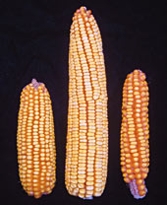

Hybrid vigour
F1 hybrids have increased vigour, yield and fertility because recessive alleles are masked
by superior dominant alleles. Example: the maize cob in the centre is the F1 from the parents
on either side.

Plant field trials
A plant field trial is a type of investigation, set up to:
- compare the performance of two different plant cultivars
(e.g. conventional versus GM) under the same set of experimental conditions;
- find out the effect of different environmental conditions on a new cultivar of crop plant.

Designing a plant field trial
Once the factor to be investigated has been decided, the following factors must be considered:
- selection of treatments to be used;
- number of replicates to be included;
- randomisation of treatments.

Example: conducting a field trial to investigate the effect of the concentration of nitrogenous fertiliser on a new cultivar of cereal plant.
Selection of treatments
For each equal sized crop only one variable should be altered e.g. concentration of fertiliser. All other variables should remain constant to ensure that a fair comparison can be made.
Number of replicates
To minimise experimental error then a minimum of three replicates must be set up. The more replicates are set up the more reliable the results. [Experimental error: differences in each plot and in how the experiment was carried out.]

Randomisation of treatments
a | d | b | c
b | a | c | d
d | b | a | c
Randomised field trial

In the field on the left, 4 treatments (a, b, c and d) are being investigated, each repeated 3 times.
If the plots in a field are treated in an orderly way then bias may exist e.g. one side of the field may be wetter. Randomisation (field on right) helps eliminate bias.

a | b | c | d
a | b | c | d
a | b | c | d
Non-randomised field trial
Block A

B

C

Genetic transformation can be used to enhance a crop species which can then be used in a breeding programme e.g.
Gene(s) added | Host organism | Benefit
Gene for Bt toxin (kills insects), taken from soil bacterium | Crop plants e.g. maize | Crop resistant to insect pests; yield increased.
Genes for vitamin A | Rice | ‘Golden’ rice that provides vitamin A; better nutrition.
Gene for herbicide resistance (from naturally resistant plants) | Soya, maize, sorghum | Herbicide kills weeds without damaging crop; yield increased.

Genetic technology
Plants and animals can be also be enhanced by use of genetic technologies such as genome sequencing and genetic transformation.

Genome sequencing can be used to identify organisms that possess alleles for a desired characteristic. These organisms can then be used in breeding programmes.

CROP PROTECTION
Natural ecosystems
In a natural ecosystem a balance exists between producers and consumers. There is also a diverse variety of plant species that co-exist with their fellow plants, insects and micro-organisms. The diversity and genetic variety amongst species make them more resilient to weeds, pests and fungal infections.

Monocultures
In a monoculture only one species of crop plant is grown, usually over a large area. The members of the crop are often genetically identical. This makes them very susceptible to weeds, pests and disease. Weeds, pests and fungal infections have to be strictly controlled to ensure the greatest yield of the crop.
Weeds
Plants compete for light, space, water and soil nutrients. Weeds (i.e. plants growing where not wanted) will compete with crop plants. Competition in monocultures can be reduced by spacing out seeds when sowing e.g. growing the plants in rows.
However, the gaps fill in with weeds, which may reduce crop yield.

Economic impact of weeds
In agriculture, weeds have a significant economic impact. They may:
- cause a significant reduction in crop productivity due to competition;
- release chemical inhibitors into the soil, further reducing crop growth;
- contaminate grain crops with their seeds and reduce the crop’s value;
- act as hosts for crop pests and diseases.
Properties of perennial weeds
Perennial plants live for several years, becoming dormant in winter and growing again in spring.
Perennial weeds are already established in the habitat, are able to reproduce vegetatively (asexually) and have storage organs to provide food when conditions are poor.

Properties of annual weeds
Annual plants complete their entire life cycle (from seed to death) in one year.
Annual weeds grow very quickly, have a short life cycle, produce vast numbers of seeds and their seeds are viable for long periods of time.

Invertebrate pests
Three main groups:
- insects e.g. aphids (feed on sugary sap); caterpillars (eat leaves)
- molluscs e.g. snails and slugs (eat leaves)
- nematode worms (root parasites).
Damage to leaves reduces photosynthesis, hence less sugar produced. Loss of sugary sap reduces energy supply to tissues.
This causes a reduction in vigour and yield. Some pests can also be a vector (carrier) for diseases which can damage the crop.
Plant diseases
Plant diseases are caused by pathogens such as fungi, bacteria and viruses. These can be spread through the air, the soil or by invertebrate vectors.
Economic effects: poorer yield; reduced marketability (blemished); reduced storage life (degrade too quickly).

Control of weeds, pests and diseases
Weeds, pests and diseases can be controlled in two ways: cultural and chemical.
Cultural crop protection

These are techniques for controlling weeds, pests and diseases which are non-chemical. They have developed over a long period of time from traditional farming methods, some by trial and error.
- Ploughing
By turning over the top 20cm of soil every time a field is ploughed, many weeds are buried deeply enough for them to die and decompose.
- Weeding
Removal of weeds done early in the life of the crop to reduce competition. Weeds removed from edges of fields as they provide a breeding ground for pathogens.
- Crop rotation
A series of different crops are grown one after the other on the same piece of ground, over 4 growing seasons. Pathogens in the soil from the first crop cannot then grow on the second crop. Growing leguminous (nitrogen fixing) plants can add nutrients to the soil.
- Clearance of crop residue e.g. stubble or straw (may harbour fungal spores if left).
- Cover crop - planting of crop e.g. clover, that prevents growth of weeds on fallow ground.
Chemical crop protection

Herbicides, pesticides and fungicides can be used to control pests when cultural means of control fail.
Herbicides can be selective, systemic or contact.
- Selective herbicides mimic the action of plant growth hormones. This speeds up the metabolism of broad leafed plants to the extent that they use up their food reserves and die. Narrow-leaved plants e.g. cereal crops, are not affected.
- Systemic herbicides are absorbed by the plant and quickly transported to all areas of the plant. This has a lethal effect on the leaves and the roots of the plant.
- Contact herbicides kill all green plant tissue they come in contact with. They are biodegradable so their effect is short-lived. However, the roots survive and plants can regrow.

Pesticides The three main pest groups are killed by different pesticides e.g. insecticide, molluscicide, nematocide.
These are used extensively in agriculture and help to prevent crop loss of around 30% (Scotland). Pesticides can be either contact or systemic. Contact pesticides work in two ways:
- killing the invertebrates when they come into contact with the spray;
- leaving a protective residue on the plant which kills future invertebrates.
Systemic pesticides are absorbed by the plant and only kill invertebrates when they ingest plant material.
Fungicides can be used to protect crops when environmental conditions and disease forecasts suggest that infection is likely.
Example
The airborne spores of the fungus causing potato blight are more likely to infect plants when certain temperature and humidity levels occur over two days. Farmers can apply fungicide in advance when these conditions are forecast. Prevention is more effective than treatment.
Fungicides
Fungicides can also be contact or systemic.
Contact fungicides are sprayed onto crops and absorbed by fungal spores when they start to germinate. This causes the fungi to die. They are easily washed away by the rain and need to reapplied to crops regularly.
Systemic fungicides are absorbed by the plant and are therefore not washed away by the rain. They give better protection and only kill fungi that are affecting the crop plant.

Problems with chemicals
Ideally a plant protection chemical should be:
- specific to the pest concerned;
- short-lived (i.e. should not persist in the environment but be broken down into harmless by-products);
- safe for animals and human consumption.
Problems include:
- toxicity to animal species;
- persistence in the environment;
- accumulation in food chains;
- resistance in pest populations.

Resistance to pesticides
A few individuals in a crop may have resistance to a pesticide.
They survive the pesticide and pass their resistance to the next generation (natural selection), eventually producing a population of resistant pests after continued use of the pesticide.
Pesticide persistence and accumulation
Many plant protection chemicals have been found to persist in the environment.
Whilst they are found at low concentrations in the environment they accumulate along food chains i.e. become more concentrated at each level as the chemical persists in cells.
The once widespread use of DDT resulted in the death of top predators e.g. sparrowhawks. DDT is banned in many countries but still widely used in developing countries.

Biological control works well in enclosed systems e.g. glasshouses where temperature can be controlled and control agents kept confined.
Biological control: risks
If a control agent escapes into an environment free from its predators, parasites or disease then its numbers can increase rapidly and threaten indigenous species
Integrated pest management
IPM uses a combination of chemical, biological and cultural methods and plant resistance to improve yield.
IPM aims to: reduce chemical use; only use infrequently needed and biodegradable chemicals; reduce pest numbers to a level not causing economic damage and at which biological control can take over.
Biological control
Biological control describes the control of a pest population through the introduction of one of its natural enemies that will act as a control agent e.g. predator (ladybirds used to control aphids); parasite (Ecnarsia (parasitic wasp) lays eggs inside whitefly and destroys it); pathogen (Bacillus thuringiensis infects caterpillars with Bt toxin).
Timing of the introduction of the biological control agent is very important e.g. the predator must find its prey.
The control agent is introduced when crop infestation has begun and environmental conditions are favourable for its introduction.

ANIMAL WELFARE
It is important that domesticated animals are well looked after. They should be able to:
- behave in natural ways;
- live free from disease;
- grow vigorously.

The Animal Welfare Act 2006 made legal the “Five freedoms for animal welfare” identified by the Farm Animal Welfare Council.
These are, freedom from:
- hunger and thirst
- discomfort
- pain, injury and disease
- fear and distress
and freedom to express normal behaviour

Costs and benefits
Improvement of conditions is expensive for the farmer and the cost is passed to consumers. However, healthy, unstressed animals grow and reproduce better and produce better quality products e.g. milk, meat, eggs.

Ethics
Ethical questions involve values and rules that govern human conduct. Many traditions stress the need to care for domesticated animals e.g. from the Jewish tradition, “A righteous man cares for the needs of his animal” (The Book of Proverbs). The need for food security should not compromise the ethical treatment of animals.
Behavioural indicators of poor welfare
Animals in poor conditions display the following types of behaviour:
- stereotypy
- misdirected behaviour
- failure in reproductive behaviour
- altered activity levels
These are all indicators of poor animal welfare.

Stereotypy
Stereotypy usually refers to repetitive behaviours in captive animals. It is often displayed in confined spaces and involves actions such as:
- chewing movements in pigs;
- pacing in zoo cages by big cats;
- chewing and kicking in stabled horses.
Some view stereotypy as a natural response to confinement in an unnatural environment.

Misdirected behaviour
Inappropriate use of normal behaviour towards an animal itself, another animal or its surroundings.
- Self-mutilation e.g. excessive licking, plucking and chewing of hair and feathers.
- Damage to others e.g. caged hens pecking feathers and skin.
- Surroundings e.g. sucking of inanimate objects; chewing of cage bars.

Failure in reproductive behaviour
Poor conditions and isolation can be responsible for failure of animals to breed successfully. They can also lead to rejection of offspring. These failures can be overcome by ensuring that young mammals and birds have contactwith their own kind in a good environment.

Altered activity levels
Unusually high or low levels of activity are both indicators of stress.
- High level e.g. hyper-aggressive stamping and head-lowering in bulls
- Low level e.g. excessive sleeping

Ethology
Ethology is the scientific study of animal behaviour, usually under natural or semi-natural conditions.
Ethogram example: Capuchin monkeys
Behaviour category | Definition
Aggression | Chasing, biting, hitting or screaming at another monkey. May include threat displays, such as shaking branches or lunging at another.
Play | One monkey chases or wrestles with another, in a non-aggressive manner.
Resting alone | Lying or sitting away from the group.
Resting together | Lying or sitting in contact with another monkey
Feeding | Searching for/manipulating/ingesting food
Moving alone | Locomoting across the ground or in the trees without another monkey.
Moving together | Locomoting across the ground or in the trees with another monkey.

An ethogram is a list or diagram of observed behaviour, often used when studying the welfare of domesticated animals.

An ethogram gives evidence of an animal’s normal responses. Data from an ethogram can be tested by appropriate investigation and can be used to make conclusions about abnormal behaviour and welfare needs.

Anthropomorphism
Anthropomorphism is the attribution of human behaviour to an animal: care must be taken that a human interpretation
is not given to animal behaviour.
Scientific data e.g. from an ethogram study should be the basis for the suitable treatment of domestic animals.

Preference tests
Preference tests provide animals with controlled choices and indicate which conditions they prefer.
Examples of preference tests for hens:
- flooring types (straw, sawdust, sand)
- space (large or small)
- grain type (several types).

Motivation
Motivation directs the behaviour of an animal to satisfy a basic need such as food, water, sleep or freedom from discomfort.
The strength of motivation depends on the level of need. A hungry animal will make an effort to reach food as it is motivated by hunger e.g. a hungry dog pulls on leash to reach food.

A preference test can be used to compare motivation for two behaviours by offering a choice e.g. access to food or area for dust-bathing; comfortable bedding or company.

SYMBIOSIS
Symbiosis is an ecological relationship between organisms of two different species that live in direct contact with one another.
These are intimate relationships that have evolved over millions of years (co-evolution).
There are two types of symbiosis: parasitism and mutualism.

Parasitism
In parasitism one organism, the parasite, derives its nutrition from another organism, the host, which it exploits. The host is harmed or at least loses some energy and/or materials to the parasite. Parasites often have a limited metabolism and cannot survive outside the host’s body e.g. tapeworms do not have a digestive system since the host has already digested the food.
Some parasites live inside and others outside the host.
Examples of parasites: fleas, ticks, tapeworm, Plasmodium falciparum (causes malaria), Cuscuta epithymum (parasitic plant)
Ophiocordyceps unilateralis (parasitic fungus)
Transmission of parasites
- Direct contact: passed from person to person by physical contact e.g. head lice.
- Release of resistant stages: survive adverse environmental conditions until they come into contact with a new host e.g. cat fleas have resistant larvae and pupae.
- Use of a vector: e.g. Plasmodium, the unicellular organism that causes malaria, is passed from human to human by a mosquito.
Life cycle of tapeworm
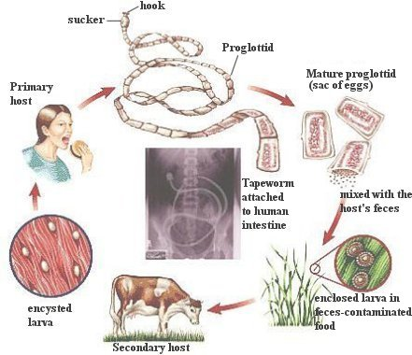

Parasitic life cycles
There are two types of parasitic life cycle:
- Direct life cycle: eggs are shed and pass on to a new member of the host species.
- Indirect life cycle: in addition to using a primary host species as the site for its sexual reproduction, the parasite also employs a secondary host species in its life cycle e.g. tapeworm.

Mutualism
In a mutualistic symbiotic relationship both organisms involved benefit from the relationship.
These can be:
- relationships where both organisms provide a service e.g. Clown fish and anemones
- relationships where one organism provides a service and the other receives a resource e.g. flowering plants and bees.
- relationships where both organisms receive a resource e.g. human gut microflora.
Human gut microflora
The human gut is full of many species of bacteria, fungi etc. which perform many useful functions:
- fermenting unused energy substrates;
- training the immune system;
- preventing growth of pathogenic bacteria;
- regulating the development of the gut;
- producing vitamins such as biotin and vitamin K.

The micro-organisms in return receive a steady supply of food
Clown fish and anemones
- The anemone’s stings provide the fish with protection from predators
- The fish defend the anemones from the butterflyfish that eat them.

Flowering plants and bees
- The bees pollinate the plants.
- The plants provide nectar which is a food source for the bees.

Cellulose digestion by herbivores
Herbivores need to digest cellulose but many do not have cellulose-digesting enzymes.
Instead, cellulose-digesting micro-organisms inhabit gut chambers such as the first two chambers of a cow’s stomach.
- The herbivore receives sugar and other metabolites.
- The micro-organisms receive protection, warmth and a constant food supply.

Symbiotic origin of chloroplasts and mitochondria
It is thought that chloroplasts and mitochondria may have evolved from two different types of prokaryotic cells that had initially become residents in larger anaerobic cells: this is called endosymbiosis.
Mitochondria: anaerobic eukaryotes engulfed aerobic prokaryotes that evolved into mitochondria.
Chloroplasts: some of the newly evolved eukaryotic cells then absorbed photosynthetic cells that became chloroplasts.

Benefits
In this mutualistic relationship:
- the smaller cells that became mitochondria and chloroplasts benefited by gaining security;
- the larger cell benefited from improved energy output and food from photosynthesis.
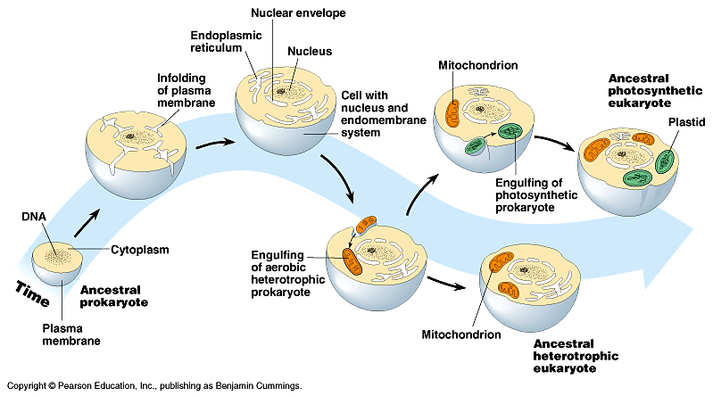

Evidence
Mitochondria and chloroplasts resemble bacteria in having:
- circular DNA;
- prokaryote-type ribosomes;
- similar structure and size;
- inner membranes with similar enzymes and transport systems;
- replication similar to bacterial cell division;
- rRNA that seems to have originated in bacteria.

Symbiosis and anthropogenic climate change
Some important symbiotic relationships may be seriously affected by anthropogenic (man-made) climate change.
These include coral and tree root mycorrhiza.

Coral
Coral polyps are sessile animals with a hard exoskeleton. They have a mutualistic relationship with zooanthellae, unicellular algae that live in and between its cells:
- the polyps use carbohydrate made by the algae;
- the algae have security and use nitrogenous waste from the polyps.

Warm temperatures cause the zooanthellae to die, ‘bleaching’ the coral. Thermal stress also weakens the coral’s immune system. The forecasted rise in sea water temperature is likely to have serious effects on coral reefs.

Mycorrhiza
Many plants are in a mutualistic relationship with mycorrhizal fungi:
- fungal hyphae increase surface area for absorption of water and minerals by plant;
- plant provides fungus with carbohydrates.

Many trees are very dependent on this symbiosis. A drier climate in future may result in death of the fungus and hence of the trees.

SOCIAL BEHAVIOUR
Social groups
Many animals live in social groups ranging in number from two to several thousand.
Advantages of living in social groups include:

- protection;
- easier to catch food;
- easier to find a mate;
- have help with raising young.

Group members react to social signals and have certain behavioural adaptations.

Social hierarchy
A social hierarchy is a system where members of social group are organised into a rank order resulting from aggressive behaviour between the different members of group.
A high-ranking individual dominates subordinates e.g. pecking order in birds, hierarchies in wolves

Hierarchies in mammals
Wolves maintain hierarchies through displays of ritualised threat and submissive gestures.
Dominant behaviour: teeth bared; ears and hackles raised; head raised and eyes staring.
Submissive behaviour: teeth covered; ears, hackles and tail lowered; head lowered and eyes averted

Advantages of a social hierarchy
Social hierarchies improve a species’ survival chances because:
- aggression between members is ritualised so real fighting is kept to a minimum and serious injury avoided;
- energy is conserved;
- experienced leadership is guaranteed;
- most powerful (and therefore evolutionally “fittest”) will pass on their genes to the next generation.
Co-operative hunting
Predatory mammals often hunt together as groups to increase their hunting success e.g. lions, wild dogs, wolves, killer whales
Different animals employ different cooperative hunting techniques e.g. ambush and running down. The ambush strategy is used by lions and involves driving the prey towards other lions which remain hidden. Dogs and wolves take turns at running down prey to the point of exhaustion and then attacking it.
Benefits:
- all members of the group get a share, so all members of the group benefit (although the dominant animal gets more);
- they can tackle larger prey, and so gain more food than hunting alone;
- minimises injury.
Social mechanisms of defence
“Safety in numbers”: by staying together as a large group/herd many animals are protected from predators.
Being in a shoal, herd or flock means that there are many eyes to look out for predators and alert the group. It also makes it harder for predators to pick out one animal from the rest.
Some animals form a defensive formation for further protection: e.g. musk ox form a defensive ring with the cows and calves at the centre. musk ox
Bobwhite quails roost in circles and “explode” in a predator’s face before escaping.
Baboons have a strict social hierarchy and always march in a certain order: dominant males stay in the centre with females and infants; young males and juveniles keep to the edge and raise the alarm if the group is threatened.
Altruism
Altruistic behaviour is unselfish behaviour which is detrimental to the donor and beneficial to the recipient e.g. one meerkat standing guard while others eat. Altruistic behaviour seems to contradict ‘survival of the fittest’ but this is not the case.
There are two possible explanations for altruistic behaviour: reciprocal altruism and kin selection
Reciprocal altruism
This involves one animal giving help to another animal in the prospect of the favour being returned.
Examples: grooming to remove parasites in apes; feeding of hungry vampire bats by those that have fed well on blood
(a hungry bat may die if unfed for two nights, so the benefit gained is greater than the cost to the donor).
Option 1: testify against accomplice: if accomplice stays silent you go free, he gets 8 years.
Option 2: testify against accomplice: if he testifies against you, you both get 4 years.
Option 3: both remain silent: both get 1 year.

Option 3 is the best possible mutual outcome though not the best personal outcome.
Reciprocal altruism model: The prisoner’s dilemma
● Two suspects are charged with a crime which they have committed.
● There is not enough evidence to convict them for this crime
(penalty 8 years).
● There is evidence to convict them for a minor offence (penalty 1 year)
● They are interviewed separately by police and given three options.

Kin selection
Individuals may reduce their own net lifetime production of offspring in order to help their relatives reproduce.

If a parent sacrifices itself so that its offspring can survive it has already passed on its genes so this altruism may involve personal sacrifice but is not a sacrifice in evolutionary terms.
Sacrifice for less close relatives is still beneficial to the population as a whole if shared useful genes are be passed on i.e. it is a sacrifice where the benefits outweigh the costs.

A Coefficients of relatedness table shows the proportion of genes that are identical in related individuals.
Relationship | Coefficient (r)
Parent–offspring | 0.5
Siblings | 0.5
Half-siblings | 0.25
Uncle/aunt–niece/nephew | 0.25
Grandparent–grandchild | 0.25
First cousins | 0.125

Kin selection can lead to the extreme altruism of the workers of some social insects.
Even though the workers are sterile, they help their siblings to survive and reproduce, passing on by proxy the genes responsible for their altruistic behaviour.
Social insects
Complex social behaviour has evolved in some insect societies such as bees, wasps, ants and termites.
A division of labour exists:
- food gathering and defence are carried out by numerous sterile members of the colony;
- reproduction is the responsibility of only a few fertile individuals.
This extreme altruism of the workers of social insect colonies is based on kin selection: the workers help to raise offspring of close relatives rather than have their own.
Honey bees
A honey bee colony has three castes of bee: queen, workers and drones.
- Queen: female that produces eggs that are fertilised by drones to become workers; she also lays unfertilised eggs that become drones.
- Drones: haploid males whose role is purely reproductive – to find and mate with a queen.
- Workers: non-reproducing females (all sisters) that maintain and defend the hive rather than reproduce.

This strategy has proved to be a very efficient way of passing on genes: the workers share many genes with the queen so they ensure that the queen is able to reproduce as efficiently as possible rather than trying to raise their own broods.
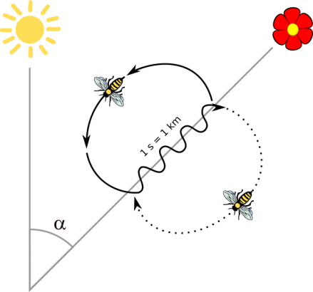
Signalling in honey bees
Worker bees forage for nectar and pollen and return to the hive to indicate where it is to others. They perform a waggle dance to communicate to the colony the distance and direction of food and the richness of the supply.
Minimises energy expenditure by other members of the hive in location of food.

Ants search for food in a meandering pattern. Once food is located, an ant returns home, leaving scent markers. Other ants follow trail, reinforcing scent marks, until supply is finished.

Development of social insect societies
Social insect societies are thought to have arisen as follows:
- Nest built and shared by community of insects; each female has own young.
- Communal nest; young reared co-operatively.
- Some insects reproduce; others carry out tasks for whole community.
- Improved communication; clear division of labour; few reproductive individuals; rest specialised to look after young.
Ecosystem services
Ecosystem services are the benefits to humans provided by natural ecosystems. Some insects are of economic importance to humans as they provide ecosystem services e.g. ● role of bees in pollination;
● use of parasitic wasps to control whitefly;
● role of termites in enriching poor soil.
Keystone species
A keystone species plays a critical role in the structure and working of an ecosystem. Many social insects are keystone species as their absence could lead to instability and collapse of the ecosystem.
● Termites: major contribution to soil fertility in semi-desert and savannah areas due to their role in the decomposition of plant debris and dead wood.
● Bees: vital role in pollination.

Primates
Primates are placental mammals with:
- dextrous hands and feet with opposable first digit;
- stereoscopic vision (and 3-colour in some);
- highly-developed brain (in some).
They vary greatly in size, from the Pygmy mouse lemur (45g) to the Mountain Gorilla (260kg).
Parental care
Primates produce a small number of offspring but take great care of them. Offspring are helpless but with a strong handgrip to hold onto their mother.
Young primates therefore have time to learn complex social behaviours essential for survival e.g. communication, co-operation, sharing, foraging, hunting, recognising danger.
They learn to communicate using language (a mixture of sounds and gestures) and practise adult behaviour during play.

Parental care includes:
- feeding
- cleaning
- protection from temperature extremes
- transport
- defence
Reducing conflict: ritualistic display
Threat display: examples
Primate | Threat display
Chimpanzee | Swaggering, hunched shoulders, arms out, mouth open, lips over teeth, hair bristling
Gorilla | Chest-beating, roaring, strutting, staring, hair bristling
Marmoset monkey | Back arched, tail raised, staring, fur erect

Threat
Two social primates competing for a resource (e.g. mate) usually exhibit a threat display that makes them look larger and fiercer.
One will make itself more intimidating; the other will then concede defeat and adopt appeasement behaviour.

Appeasement
Reverse of threat ritual: body made to look smaller, flatter, motionless and unthreatening.
Females and subordinate males use appeasement behaviours to show acceptance of dominant male.

Ritualistic displays and appeasement behaviours reduce conflict: weak and strong individuals live is a close group without needless hostility.

Grooming is employed as a way of reducing tension: it maintains hygiene and cements friendships.

Facial expressions are very complex and significant:
Expression | Meaning
Eyes closed | Submission
Lip smacking | Friendly, submissive greeting
Open-mouthed grin | Appeasement of feared individual
Pouting | Begging for food
Full, open grin | Excitement

Body posture
Body posture is often used to emphasise position in a dominance hierarchy and to avoid conflict.
Examples
Subordinate male chimpanzees use servile postures when greeting a dominant male: they make soft, grunting noises and bow low, looking up respectfully.

Females use sexual presentation to appease a dominant male by presenting their rumps, thus avoiding aggression.

Social status
An individual’s status within a social hierarchy is not always static and may change.
Example: Vervet monkey
- Females form a social hierarchy (males leave at puberty).
- Rank is passed from mother to daughter.
- All ranks are very close to their offspring.
- Relationships are maintained by grooming.
- May extend to include non-relatives – alliances formed.
- Females of high status attract more non-kin grooming partners.

This pattern can be changed by the arrival of the first babies in the group. All females are attracted to a newborn baby, whatever its mother’s rank, and will groom the mother. A low-ranking mother who gives birth early can thus increase her status.
Complexity of social structure
Primate societies are complex. Their social structure is related to: ecological niche, resource distribution and taxonomic group.
Group size
Group size and social organisation vary between and within species. A large group has a more complex social structure.
Group size and organisation are affected by:
- predator pressures;
- availability and distribution of resources, mainly food (group size increases when food is plentiful).

Ecological niche
Primate ecological niches are very variable e.g. gorilla and bushbaby:
Gorilla | Bushbaby
Forest-dwelling but semi-terrestrial | Forest – upper branches
Diet mainly foliage | Diet mainly insects
Disperse seeds | Disperse seeds
Nest on ground nightly | Pollinate nocturnal flowers

Collective defence
Primates have good group defence systems. Some primate societies are fission-fusion (‘split –join’): members split up to forage but sleep as a group e.g. spider monkeys and baboons.
Advantages of fission-fusion:
- maximises chance of finding food;
- minimises chance of nocturnal predator attack.

Resource use
Most primates are omnivorous, eating a range of foods including fruit and meat. Young male chimpanzees hunt
co-operatively to catch prey such as monkeys and pigs. Chimpanzees also use sticks as tools to probe insect nests e.g. termite mounds.

Tool use by chimpanzees
Chimpanzees can make and use tools for use as:

- weapons (branches used as clubs or missiles)
- cleaning ‘cloth’ (leaves)
- sponge (mass of leaves to collect water)
- fly whisk (leafy twig)
- anvil and hammer (two stones for cracking nut)
- probe (twig for insects)

Resource distribution
Primate groups have a home range where they move around searching for food and places to sleep and rest.
Range size depends on animal’s preferred food:.
- Small range: e.g. leaf-eaters (food always available).
- Large range: e.g. fruit-eaters (food not always available and is widespread).

Primate taxonomic groups
Primates in the same taxonomic group have similar ecological niches and social structures e.g.
- Bushbabies - small insectivorous tree-dwellers in large social groups.
- Gorillas - large semi-terrestrial leaf-eaters in small social groups.
Generally, the more distantly related the primates, the more different their niches.

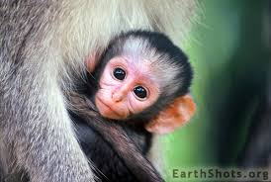

MASS EXTINCTION AND BIODIVERSITY
Extinction
Extinction is the dying out of groups of organisms. If, over an extended period of time, the birth rate of a species is less than the death rate, then extinction will eventually occur.
Extinction is a natural phenomenon. A species goes extinct if it is not able to adapt to changes in its environment, or compete effectively with other organisms.
Throughout Earth’s history, it is thought that over 99% of all the species that have ever lived have become extinct.
Mass extinctions
Mass extinctions are periodic rises in the extinction rate above the background level. They are events caused, not by changes in habitat or competition, but by catastrophes.
Perhaps over 95% of all extinctions have occurred as background events, with the rest consisting of catastrophic events which:
- were geologically rapid;
- occurred across the globe;
- caused a large number of species to become extinct at the same time;
- spread across all the world’s ecosystems.
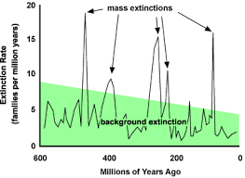
Fossil evidence indicates that there have been several mass extinction events. Five main extinction events have been identified, with two of especial significance:
● Permian, ca. 250 mya, the biggest extinction of all time when about 95% of marine species and 50% of land species were lost (thought to be due to rise in global temperature of ca. 10°C).
● Cretaceous - Tertiary (K/T), 65 mya, famed for the death of the dinosaurs, with other species also lost (possibly due to volcanic activity/asteroid impact causing global cooling).

Mass extinctions are related to changes in global climate e.g. an ice age, when land is frozen and sea levels drop.
Species that are not adapted to the new environment will not survive. However, other species may now be well-suited to the new conditions and will prosper e.g. mammals began to dominate when a major event (perhaps global cooling) caused the demise of the dinosaurs.
Regaining of biodiversity
Following a mass extinction, biodiversity has been regained by adaptive radiation of the survivors.
Example
Original mammals became adapted to the different ecological niches available e.g. jungle, desert, grassland, icy regions, ocean. This success was promoted by their being endotherms, producing milk for and giving parental care to young.
Extinction rate
Extinction rate = number or % of species becoming extinct/given area/unit time.
It is usually calculated from presence/absence of birds and mammals.
This calculation is only an estimate: estimating extinction rate is difficult and approximate.
Holocene extinction
The Holocene is the name given to the last 11,700 years of the Earth's history — the time since the end of the last major glacial epoch, or "ice age."
Holocene extinction is the name given to extinction of species in this era, usually due to human activity. It includes the disappearance of many large mammals or megafauna such as the woolly mammoth and the glyptodon (giant armadillo-like animal.
Human influence
Humanity has greatly influenced the Holocene environment: while all organisms influence their environments to some degree, few have ever changed the globe as much, or as fast, as our species is doing.
The vast majority of scientists agree that human activity is responsible for "global warming", an observed increase in mean global temperatures that is still going on.

The current extinction rate (est. over 1000 species p.a.) is one of the highest in earth’s history and is due to changes caused by human activities. This is estimated to be about 1,000 times higher than the natural background rate.
This is caused by habitat destruction and over-hunting which has gone on since the 17th century and has escalated over time. Ecosystem degradation, pollution and other factors are causing an ongoing mass extinction of plant and animal species. According to some projections, 20% of all plant and animal species now on Earth will be extinct within the next 25 years.

The annual IUCN (International Union for Conservation of Nature) Red List of Threatened Species indicates the level of threat to thousands of species.
Measuring biodiversity
Biodiversity is the total variation among all living things. Biodiversity measurements are useful in helping to monitor change and to assess which areas and species should be supported.
Biodiversity has three main measurable components:
- genetic diversity
- species diversity
- ecosystem diversity

Genetic diversity
Genetic diversity can be measured by counting:
- the total number of different alleles that exist in a population and
- how frequently they occur.
If a population loses some of its genetic diversity (e.g. due to human activities) then it may not be able to adapt to future environmental conditions.

Species diversity
Species diversity is the number of species (richness) and their relative abundance in an ecosystem. Investigation into the species diversity of a local area may involve the use of a species diversity index e.g. Simpson’s diversity index.
Biodiversity indices can be used to compare habitats e.g. polluted/unpolluted; invasive species etc. A community with a dominant species has a lower biodiversity index than one without.

Ecosystem diversity is the number of distinct ecosystems in a defined area.
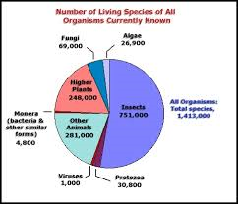
Species databases
The estimated number of known living species is 2 million but some think that the real number is between 5 and 20 million.

There are many species databases, in different countries and for different groups of living things. A database with information on all known species would be extremely useful but difficult to compile.
Some attempts are being made to do this e.g. the Catalogue of Life organises information from over 100 databases and claims to be “the most comprehensive and authoritative global index of species currently available”.

Island biogeography is the study of factors affecting distribution and diversity of species of isolated natural communities.
The ‘island’ may be a:
- true island (land surrounded by water)
- habitat island (area surrounded by an unlike ecosystem e.g. oasis, mountain peak, fragmented forest).

The species diversity of a habitat island depends on its area and degree of isolation from similar habitats: the smaller and the more isolated a habitat island, the lower its species diversity.
Fragmentation of habitat, e.g. cutting roads through rainforest, has a very negative impact on species diversity.

Why maintain biodiversity?
Maintaining biodiversity is important for many reasons including:
- use of plants and animals for food, medicines and other products;
- maintenance of important ecological processes e.g. oxygen production, pollination;
- aesthetic enrichment of human life;
- recreation e.g. camping, hiking, fishing, bird-watching;
- conservation of species for future generations;
- duty of care for other species – ‘stewardship’.

THREATS TO BIODIVERSITY
There are many threats to biodiversity, both globally and locally.
These include:
- over-exploitation
- habitat loss and fragmentation
- introduced, naturalised and invasive species
- climate change
Over-exploitation
Humans exploit (make use of) many natural resources, including plant and animal species.
Over-exploitation is the consumption of resources at a rate faster than they can be replaced e.g. removal of more of a species than can be replaced by reproduction.
Example: over-fishing of cod in the North Sea where such large catches were being landed that the numbers of cod went into dramatic decline. This happened across the world to many fish and other marine species.

If over-exploitation is halted rapidly then populations can recover. Strict rules on catch sizes have led to some signs of recovery in cod numbers in the North Sea. A moratorium on whaling has not succeeded in stopping the decrease in whale populations as some countries have ignored the ban.

The bottleneck effect
A bottleneck event is one in which a significant percentage of a population or species is killed or otherwise prevented from reproducing e.g. natural disaster or over-exploitation. This reduces the numbers in a population and consequently the genetic diversity of that population. The population may not now be able to adapt to environmental changes or pressures, such as climate change or a loss of available resources.

If the members of the surviving population are genetically similar, reproduction will be equivalent to inbreeding, with further loss of variability and reproductive success. The population may become extinct or may slowly recover.

Bottleneck effect: examples
Northern elephant seals have reduced genetic variation, probably due to a population bottleneck caused by over-hunting that reduced their population size to as few as 20 individuals at the end of the 19th century.
Their population has since risen to over 30,000, but their genes still carry the marks of this bottleneck: they have much less genetic diversity than southern elephant seals that were not so intensely hunted.

Cheetahs
The few thousand cheetahs still living are genetically very closely related, possibly the survivors of climate change 10,000 years ago. They have several adaptations that have allowed them to survive e.g. several fathers for each litter.
Habitat fragmentation
Habitat fragmentation can be caused by:
- geological processes that slowly alter the layout of the physical environment e.g. river formation;
- human activity that is more rapid e.g. forest clearance.

The resulting habitat fragments
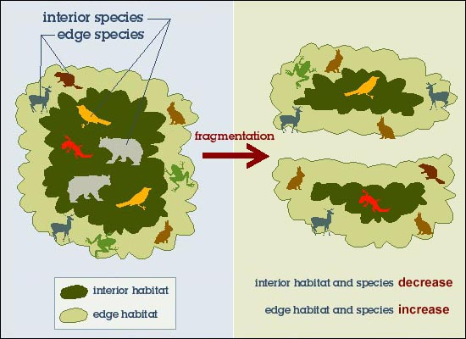
- have a smaller total surface area than the original habitat;
- have lower species richness than a large area of the same
habitat.

Edge to interior ratio
Fragmentation leads to an increase in the ratio of edge to interior, favouring species that are adapted to living on the edge.
Habitat fragments suffer from degradation at their edges and this may further reduce their size.
Edge species may then invade the habitat interior at the expense of species already there.

Habitat corridors

Habitat corridors
Habitat corridors are pathways of natural habitat linking otherwise disconnected fragments e.g. hedgerows linking forest fragments; motorway underpasses for wildlife.

Habitat corridors between fragments allow:

- re-colonisation if there is a local extinction
- mating
- feeding
- territorial behaviour

They solve the problem of isolation but not of loss of interior.
Benefit: act as safe passages for species between neighbouring habitats.
Possible negative effect: allow spread of disease between fragments.

Habitat corridors have been set up for tigers in Russia and India with varying degrees of success e.g. Siberian tigers have increased in number but are genetically very similar.
Introduced, naturalised and invasive species
Introduced (non-native) species: species that people have moved either intentionally or accidentally to new geographic locations.
Naturalised species: introduced species that become established within wild communities.
Invasive species: groups of naturalized species that have spread rapidly and eliminated native species.

Non-native species are often successful because they may:
- lack predators;
- lack parasites and pathogens;
- lack competitors that would normally limit their population in their native habitat;
- prey on native species;
- outcompete native species for resources;
- hybridise with related native species.
Hedgehogs released into garden in South Uist in 1974 to control snails and slugs.

No predators, pesticides or busy roads so hedgehogs multiplied and discovered ideal food source - eggs of ground-nesting birds.

20 years later, hedgehog population was over 5000 and numbers of internationally important wading birds had fallen dramatically.

Project set up in Uist to trap and remove hedgehogs but hedgehogs are now established throughout the islands.

Foreign species introduced into a new geographical location.

These become introduced species and establish themselves in the new location.

They then become naturalised species in the location.

Some naturalised species spread rapidly and outcompete native species.

These naturalised species then become invasive species.

Example: hedgehogs in South Uist

Climate change
Climate change is a natural part of the history of the planet.
The Earth is warm enough for life because of the “greenhouse effect”:
- heat energy from the Sun strikes the Earth and is then reflected from its surface;
- carbon dioxide and methane (“greenhouse gases”) in the atmosphere trap some of this reflected heat energy, keeping the planet warm.
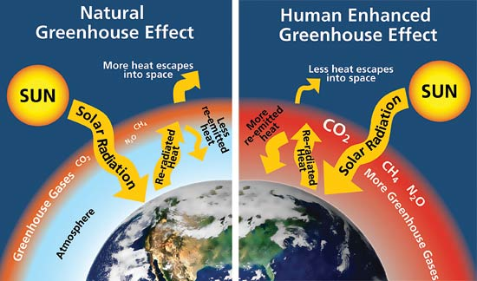
Anthropogenic climate change
The increasing human population has led to increased demand for food and other resources.
This has, in turn, led to activities such as:
- deforestation – cutting down trees that would remove carbon dioxide from the atmosphere;
- burning of fossil fuels, adding large volumes of carbon dioxide to the atmosphere;
- some forms of large scale agriculture that produce carbon dioxide and methane.
These have all caused an increase of greenhouse gases in the atmosphere.
An increase in concentration of greenhouse gases leads to increased trapping of heat in the atmosphere.

Effect on biodiversity
Changes in climate and weather patterns have a great effect on biodiversity. A temperature rise of just 2°C can cause a global shift in climate.
Some regions will become warmer; some will become drier while others become wetter:
e.g. reduced rainfall in the tropics will have a major effect on rainforests, while Alpine flora may not survive increasing temperatures at high altitude.
Effects include:
- change in the distribution and abundance of species;
- change in timing of seasonal events e.g. migration;
- changes in composition of plant and animal communities;
- habitat loss;
- increase in sea temperatures.
The overall trend will be a loss of biodiversity.

Climate change modelling
Scientists use computer models to simulate factor interactions and predict the impact of climate change on biodiversity.
They can be used to predict temperatures, rainfall and extreme weather events.
Modelling is not always accurate and can only make predictions about future events and their impact.
The real challenge is in finding ways to reduce the levels of greenhouse gases.

