GRAPHIC DESIGN

You are working on a project to design a poster about Dumfries using built environment imagery. Here are 2 posters which use a built environment theme.

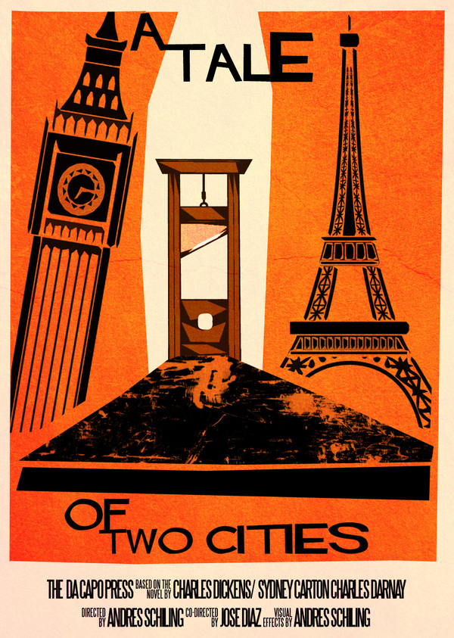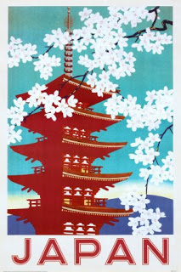
Saul Bass – Film poster Poster for Japanese tourist board

Put your name on your answer paper, and the title that is at the top of this page.

Look at these posters. You are going to write a paragraph about each of them. In each paragraph you must
- Describe the image – what is the picture of? Realistic or stylised? Colourful or limited colour scheme?
- Describe the lettering – capitals or lower case? Hand-drawn or added on computer? Does the chosen font tie in with the image?
- Say how the designer has given the poster visual impact – how have they made it eye-catching and attractive to look at?
- Say how the designer has communicated their message, and say what that message is. Sometimes a poster is selling a product, advertising a product, or showing an idea. Sometimes it is trying to make us think a certain way.
- If you can, say how the image was created, and what technology or materials might have been used.

(Don’t forget to repeat these questions for the 2nd poster)

Say which of these posters you like best. Give at least 2 reasons why you prefer it.

If you finish all of this, carefully draw a copy of one of the posters on plain paper.

