CRITICAL EXERCISE STILL LIFE PAINTING

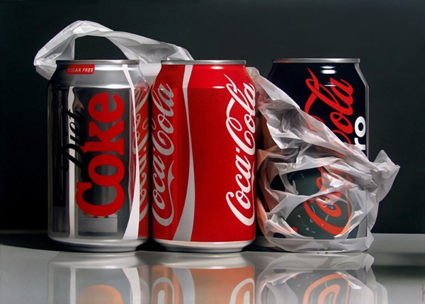
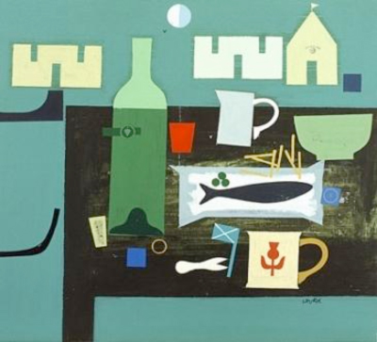
1. Coke Cans – Pedro Campos 2. Still Life – Simon Laurie

WRITE ANSWERS IN SENTENCES

- What is the subject matter of painting 1? 1 mark

- How would you describe the style? 2 marks

- What is the subject matter of painting 2? 1 mark

- How would you describe the style? 2 marks

- Comment on the colour scheme in painting 1 2 marks

- Comment on the colour scheme in painting 2 2 marks

- Comment on the media handling in painting 1 (describe brushstrokes/ use of tone/ thickness of paint) 1 mark

- Comment on the media handling in painting 1 (describe brushstrokes/ use of tone/ thickness of paint) 1 mark

What is your opinion of these paintings? What do you like/dislike about them?
Do you think the artists show imagination and creativity? Do they have skill and talent?

- Painting 1. 3 marks

- Painting 2. 3 marks

- Which painting do you prefer? Give at least 2 reasons for your answer. 2 marks

realistic detailed abstract precise flat 2 dimensional 3 dimensional primary/secondary colours related colours harmonious hot/cold colour families texture pattern meticulous simplified
photo-realistic interpretation stylised symbolise

