ART AND DESIGN RELATED STUDIES
PORTRAITURE

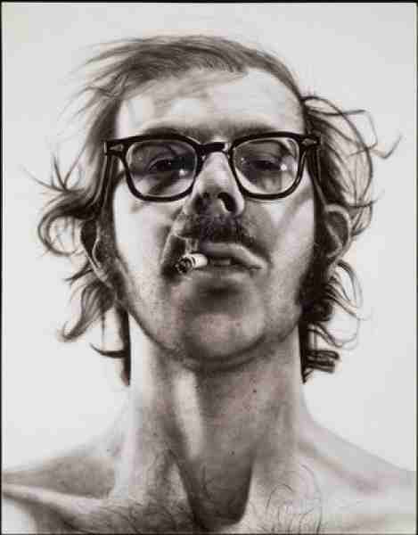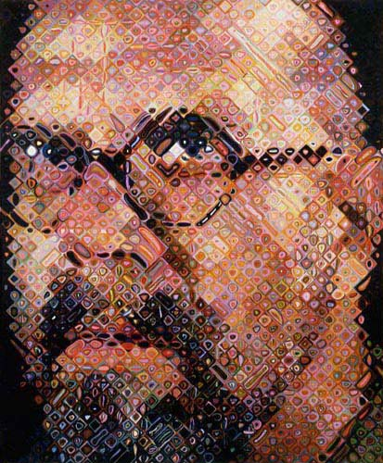
Big Self Portrait, acrylic on canvas 1967-68 Self Portrait, oil on canvas, 1997

CHUCK CLOSE

Chuck Close is an American artist. He works in a variety of media: painting, drawing, photography, collage, and printmaking, and he has made a series of self-portraits from the 1960s to the present day, showing himself getting older.
He often works on a very large scale. Close typically begins with a photograph of a face, creating a painting through a grid-based reconstruction of the image. His draughtsmanship is superb, with the huge scale of his black and white self-portraits making them particularly impressive. In 1988 he became disabled, and had to change his style of working.
His more recent paintings see him working on a mosaic of small diamonds or squares which combine to create a large-scale, realistic image, but which separately are abstract and colourful.

Complete the following, writing your answers in sentences:

- Look at the painting on the left. Describe this painting in detail – what can you see? What can you work out about this person? 5 marks
- Tone is the most important visual element in this painting. Comment on how he has used tone to great effect. 2 marks
- Look at the painting on the right. Describe this painting in detail – what can you see? How has he created this image? 5 marks
- Colour and pattern are the most important visual elements in this painting. Comment on how he has used these to great effect. 2 marks
- Compare the paintings to each other. What is similar? What is different? 4 marks
- What is your opinion of the two paintings we have looked at by Chuck Close? Give reasons for your answer. 2 marks

Total: 20 marks

