Posters …………………………………………………………………………….. Critical Activity
Answer all questions in sentences
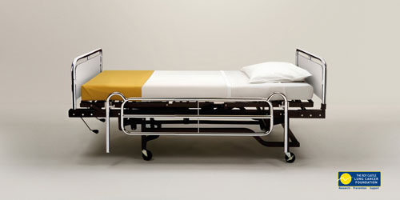
Lung Cancer poster
What gives this poster visual impact? (what makes it eye catching?)
[2]
Explain the message the designer is communicating [3]

Think, Don’t Drink Poster
Who is the target market for this poster? Why do you think that? [3]
Do you think this poster is effective? Give 2 reasons [2]

Eat Healthier poster
What is the message this poster is communicating? [3]
What company is the poster criticising, and why? [2]

Just Say No poster
Who do you think the target audience is for this poster, and why? [2]
How would you improve this design? [1]

Which of these posters do you like best? Give 2 reasons [2]

Scores of 15 or more will receive merits. Don’t forget to put your name on your work.

