[](https://www.google.co.uk/imgres?imgurl=http%3A%2F%2Fimg.clipartstockphotos.com%2Flunch-time-clip-art-crnmf9y.jpg&imgrefurl=http%3A%2F%2Flapendos.xyz%2Fpreschool-lunch-time-clip-art%2Ffoldable-lunch-containers-clipart-for-preschoolers.html&docid=Vh8eK4Pj4)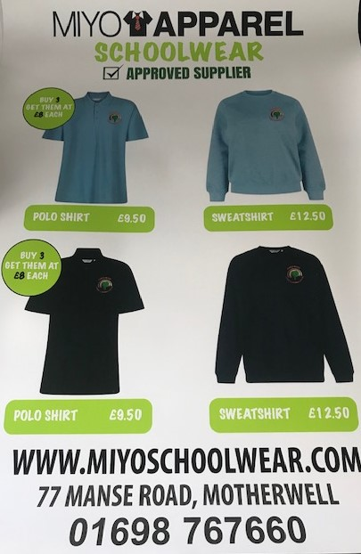

**‘Our Promise to You’**

**I promise you every day your child will learn something. Some days they will bring it home in their hands. Some days they will bring it home in their heads, And some days they will bring it home in their hearts.**

**-Valerie Welk**

**Allotment Learning**

**The staff have been developing our allotment space over the holidays in preparation for the new term. We are hoping the allotment will be accessed as a curricular area from August where children will choose on arrival if they wish to spend time there. Staff will meet the children there at 8:40am and 1pm. Toileting area and snack will be readily available. It would be beneficial to chat with your child about this option so that they can be dressed for the ever changing weather elements. The endless learning, adventures and fun this area will provide will really enhance your child’s opportunities for learning and development.**

**Nursery Uniforms**

**Last term one of our parent’s suggested using a local supplier for our nursery uniforms to make ordering more accessible. Below is the price list and contact details for MIYO school wear. Please make contact directly with Miyo Apparel to place your orders.**

**‘Loving Lunches’**

**As from August 2019 our morning children will be piloting the 1140 hr lunch provision within the centre. A rolling lunch will be offered to children from 11am during the session and children will choose for themselves if they wish to participate. The lunch will be prepared and served by Braidhurst kitchen staff with the nursery staff supporting the children. If there are any changes with regards to your child’s food allergies or intolerances since you completed your enrolment form could you please speak with Jackie or Louise as soon as possible.**