

**June 2019 Newsletter**

As the end of term approaches we have some

important dates for your diary:

Thank you to everyone for your fundraising efforts over the past few months. Money raised from our Sponsor Nature Walk/Crazy Hair Day/Raffles and Hairband sales so far has been. **£1018.00**



Nursery Trip to Ayr



Parents/carers & children to arrive outside nursery gates at 9.15am to board the coaches

Bus leaving Fife Drive 9.30am

Bus leaving Ayr at 2pm



**Nursery Trip**

6th June 2019

**Parent Meetings**

Week beginning 10th June 2019

**Calvinball Family Event**

20th June 2019

**Graduation**

**27th June 9.30am**

**Last day of term**

Friday June 28th

**1st Day back in new term**

Wednesday 14th August 2019

**SWAY** Just a reminder to access your child’s SWAY profile that records your child’s exciting learning journey at Forgewood. Your feedback is so important to us so please take time to comment on your child’s progress by completing the parent’s comment section. Thank You!

 Reporting to Parents

Soon your child’s progress report will be uploaded to SWAY. Meetings with your child’s keyworker will take place week beginning 10th June. Specific dates will be identified over the next few days by your child’s key worker.

Calvinball Family Event

Taking place on Thursday 20th June.

Look out for the flyer with your group’s designated show times.

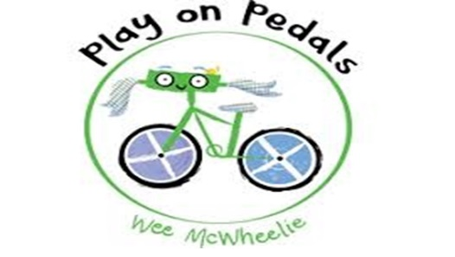

Due to the ongoing success of the Play on Pedals programme over the past year we are now in a position to offer out hire of the balance and pedal bikes to our children. So if you would like to borrow a bike just speak to Annmarie who will take you through the steps.

Happy Cycling!!!



**Transition Visits to school**

The transition to school visits have been going really well, we have received some great feedback from our children.



A few of our parents have organised a Graduation Celebration being held in Forgewood Community Centre from 11.30am to 1.30pm on Thursday 27th June 2019.

Everyone Welcome

Bouncy Castle, Games, Party food.



**We would like to thank you for your support and kindness over the past year. We wish you a happy, safe & warm summer ahead.**

**We look forward to seeing you all in the new term. To our children and families off to Primary 1 we wish you well on the next stage of your learning journey.**