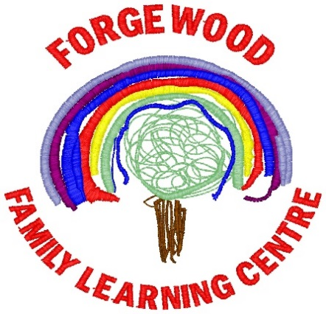

**January/February 2019 Newsletter**



Our next parent/ carer Committee meeting will be held on Tuesday 19th February 2019 at 10.45am & 1.15pm

Everyone Welcome

Please come along and share your thoughts and ideas on how we can make Forgewood FLC even better



The weather has been really cold recently. Can you please ensure your child has appropriate outdoor clothing such as a warm hat, gloves, scarf and wellingtons to explore the outdoor learning environment





Mid Term Break: Monday 11th & Tuesday 12th February 2019 nursery closed

In-service Day: Wednesday 13th February 2019 nursery closed to all children

Spring Break: Monday 1st April to Friday 12th April 2019 (inclusive) nursery closed

Good Friday 19th April 2019 and Easter Monday 22nd April 2019 (inclusive) nursery closed

May Day: Monday 6th May 2019 nursery closed

In-service Day: 7th May 2019 nursery closed to all children

Mid-term holiday: Friday 24th May 2019 and Monday 27th May 2019 nursery closed to all children

End of Term: Friday 28th June 2019 last day of term

In-service day: Monday 12th August 2019 nursery closed to all children

Tuesday 13th August 2019 nursery closed to all children

Children return: Wednesday 14th August 2019





We hope to have our Graduation Ceremony in Braidhurst High School in June 2019. As soon as future dates are confirmed we will share these with you.

Why not sign up to our nursery twitter page where you can keep up to date with nursery news and learning.

Find us here:

@CentreForgewood





Nursery to School transition visits are now underway. We have had a few visits from our feeder primary’s visiting the children which have went really well. We will keep you informed of when the next visits will take place



Your child’s safety is very important to us, therefore just a little reminder that the doors of the nursery will open for the start of each session at 8.35am and 12.55pm. At the end of the session the doors will open at 11.40am and 3.45pm

Thank you for your cooperation

Our Vision

At Forgewood Family Learning Centre we will ensure all children become the very best they can be.

We believe we will do this by providing a happy, inclusive quality learning environment where every child is valued, respected and where their aspirations, dreams and thirst for learning is nurtured and celebrated.



**Nursery BLOG**

Please remember to check our BLOG for an update on the learning and teaching as well as updates on what’s happening the week ahead. Type in the link below <https://blogsdownlead.org.uk/nl/forgewood>

600hrs Early Learning & Childcare for 2-year olds.

You or a family member’s child could be entitled to almost 600 hours per year free early learning and childcare under the new criteria. Your 2-year-old may be eligible if one of the following apply. You are in receipt of one of these benefits:

* Income Support
* Income based job seekers allowance
* Any income related element of the Employment and Support Allowance
* Child Tax Credit but not Working Tax Credit and your income is less than £16,010 per year
* Maximum Child Tax Credit and maximum Working Tax Credit and your income is less than £6,240
* Support under Part VI of the Immigration and Asylum Act 1999
* Or they are:
* Looked after
* Under a kinship care order
* Live with a Parent Appointed Guardian

For more information on how to apply speak to Jackie, Louise or you can speak with NLC support staff on 01236 812281. For more information visit:

northlan.gov.uk/familyinformationservice or earlylearningandchildcare.scot