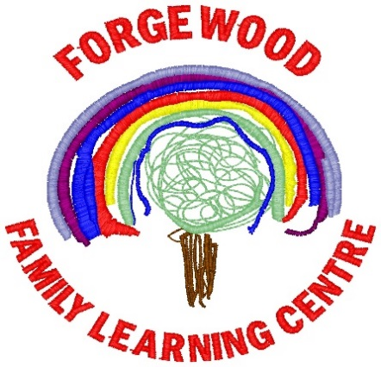

October/November 2018 Newsletter
2-5 Playrooms
As you know we have begun operating a 2-5 years learning environment for our children. It’s very early stages yet and we would just like to thank you for your enthusiasm and excitement shown at this time. Children are telling us how much they love it. We can already see new friendships forming and children exploring their new learning environments, trying new things and learning from their peers. We will keep you updated regularly. If you have any questions or ideas just let us know we would be happy to listen.

Session Times
The session times are as follows:
Morning Session:
2-3: 9.15am – 11.45am
3-5: 8.40am – 11.50am (Doors will open at 11.40am)
Afternoon Session:
2-3: 1.15pm – 3.45pm
3-5: 1.00pm – 4.10pm (Doors will open at 3.50pm)
Can we ask if you wish to pick your child up outwith these times that you inform your childs keyworker or call ahead.

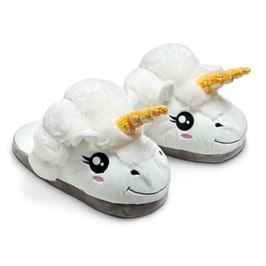
Can we please remind parents/carers to ensure their child has soft indoor shoes to wear while in the playrooms?
Halloween Celebrations
Will take place on Wednesday 31st October, there will be Halloween themed experiences on offer. Fancy dress is optional. (No scary costumes please)

We would appreciate any party snack donations (see party snack lists at your child’s welcome time group)
31st October 2018 Halloween Celebrations
19th November 2018 In-service Day Nursery Closed to all children
21st December 2018 Christmas Party for our 2-5’s
24th December 2018 - Re-open Monday 7th January 2019 Festive Celebrations

Our next parent Committee meeting will be on
Thursday 1st November 2018 10.45am
Friday 2nd November 2018
1.15pm
Please come along and share your thoughts and ideas in how we can make Forgewood Family Learning Centre even better.
The weekly donation (£2) will now be collected in banks at your child’s group or signing in area. Look out for our little pigs.

We would like to welcome our new Lead Graduate Practitioner Alethea Britton who will be joining our team on November 19th 2018

Christmas Party Celebrations
Will take place on 21st December 2018. I am sure there will be a very special visitor dropping by. !!

Just a little reminder to bring a change of clothes for your child to nursery

Our Vision
At Forgewood Family Learning Centre we will ensure all children become the very best they can be.
We believe we will do this by providing a happy, inclusive quality learning environment where every child is valued, respected and where their aspirations, dreams and thirst for learning is nurtured and celebrated.

Nursery BLOG
Please remember to check our BLOG for an update on the learning and teaching as well as updates on what’s happening the week ahead. Type in the link below https://blogsdownlead.org.uk/nl/forgewood

600hrs Early Learning & Childcare for 2-year olds.
You or a family member’s child could be entitled to almost 600 hours per year free early learning and childcare under the new criteria. Your 2-year-old may be eligible if one of the following apply. You are in receipt of one of these benefits:
- Income Support
- Income based job seekers allowance
- Any income related element of the Employment and Support Allowance
- Child Tax Credit but not Working Tax Credit and your income is less than £16,010 per year
- Maximum Child Tax Credit and maximum Working Tax Credit and your income is less than £6,240
- Support under Part VI of the Immigration and Asylum Act 1999
- Or they are:
- Looked after
- Under a kinship care order
- Live with a Parent Appointed Guardian
For more information on how to apply speak to Jackie, Louise or you can speak with NLC support staff on 01236 812281. For more information visit:
northlan.gov.uk/familyinformationservice or earlylearningandchildcare.scot

