

May/June 2017

Newsletter



Children have been taking part in transition visits over the past few weeks and these have been going well. Some visits are just about to start and I am sure they will be a great success. Forgewood Family Learning Centre work closely with your child’s Primary to ensure that information about your child's learning and achievements is passed on. Practitioners also share other information that will help the teacher support your child's learning, for example friendship groups, preferred ways of working.



This years end of term celebration/Graduation will take place on 23rd June 2017 and will be held in Braidhurst High School Hall. We look forward to seeing you all there.

Morning children to arrive at nursery at 9.15am

Afternoon children to arrive at nursery on that day at 1.30pm

**Sponsored Sing a Thon Pyjama Day Monday 5th June**

Help us raise funds for our End of Term celebrations and new outdoor learning fence slats. Children to come along in their PJ’s ready to sing and dance their way through their favourite songs. Sponsor sheet attached to this newsletter.

****For parents of children who will be starting school in August 2017 we will be holding parental consultations over the next couple of weeks where we will share and discuss your child’s progress. Please speak with your child’s key worker who will identify a suitable time.



To celebrate the end of term Amazonia will be visiting the nursery on June 19th. There will be animal handling sessions with exotic animals for the children to admire or even hold Animals may include snakes, tarantulas, tortoises, insects, snails and frogs.

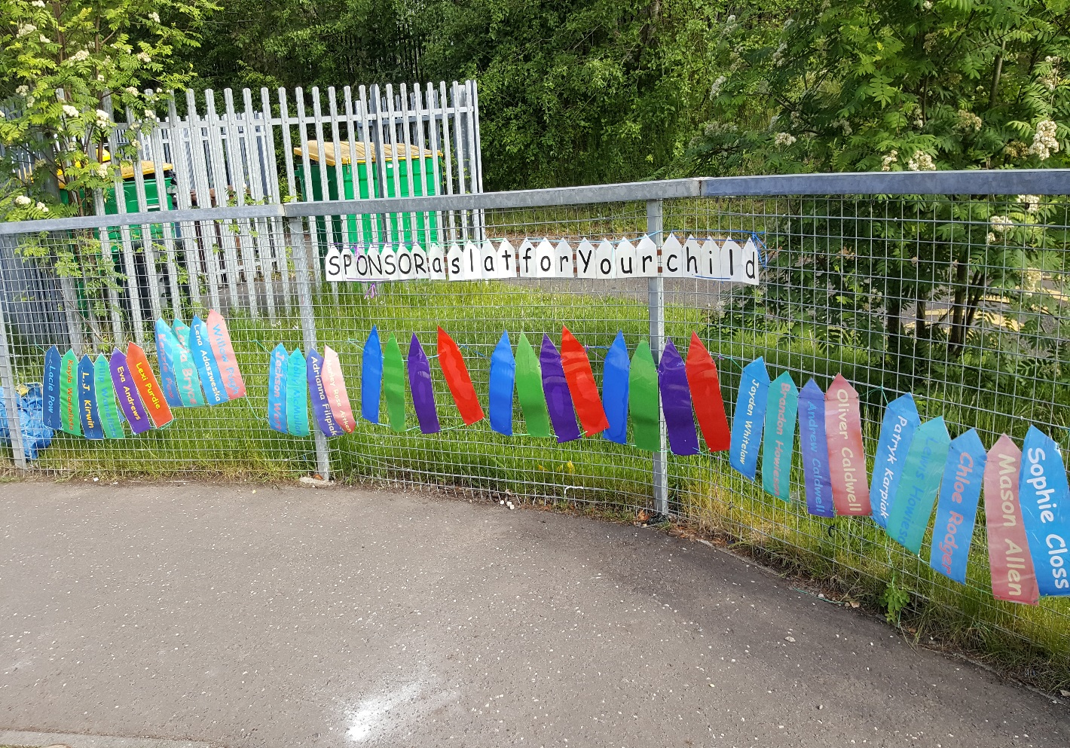

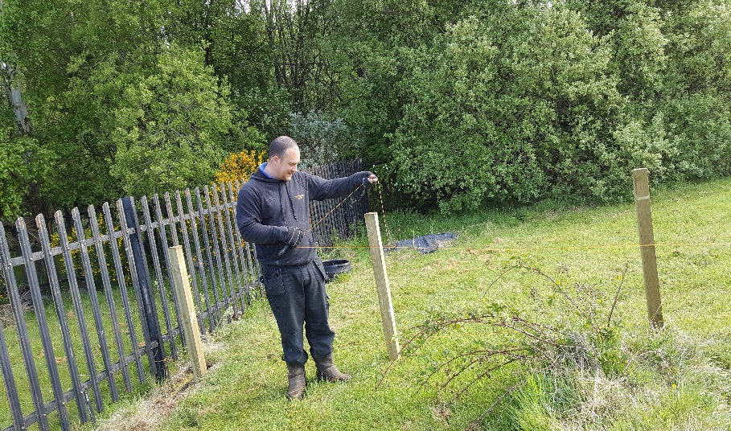



From all staff, children and parents to **David Caldwell Joiners, David** has given his labour for free to erect the fence.

As you know we have been asking parents to **Sponsor a Fence Slat** which would allow us to buy the wood needed to build a secure fence around greenspace kindly given to us by Braidhurst High School. This space will further enhance children’s outdoor learning opportunities and support us in providing access to green space during their nursery session. ***GREAT NEWS!*** *A*s you can see from the pictures the work has begun which means we really need you help in paying for the remainder of the fence slats.

If you haven’t already please sponsor a slat, see Jackie or Julie who will be happy to help. Just £2.00 per slat

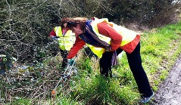 We will be looking for volunteers to help staff tidy our new outdoor learning garden to get ready for our Official opening during our Garden Party on 20th June. We will keep you posted on dates for this.

**Nursery BLOG**

Please remember to check our BLOG for an update on the learning and teaching as well as updates on what’s happening the week ahead. Type in the link below <https://blogsdownlead.org.uk/nl/forgewood>

For your child’s safety please ensure

that you close the 3-5 garden gate when entering and leaving the nursery.



**It’s everybody’s responsibility to make**

**sure I’m alright**

Protecting children from harm and abuse is everybody’s responsibility. Within the Centre we have very clear Child Protection roles and responsibilities, with the Child Protection co-ordinator being Jackie Fulton. However, if you see or hear anything which you are concerned about regarding a young person’s wellbeing in or around the nursery, please speak to Jackie or Julie in her absence in the first instance or indeed contact the local Children and Families Team, Scott House, 73/77 Merry Street, Motherwell, 01698 332100

600hrs Early Learning & Childcare for 2 year olds

From August 2015 the criteria for free places changed to benefit more families.

You or a family member’s child could be entitled to almost 600 hours per year free early learning and childcare under the new criteria. Your 2 year old may be eligible if one of the following apply. You are in receipt of one of these benefits:

* Income Support
* Income based job seekers allowance
* Any income related element of the Employment and Support Allowance
* Child Tax Credit but not Working Tax Credit and your income is less than £16,010 per year
* Maximum Child Tax Credit and maximum Working Tax Credit and your income is less than £6,240
* Support under Part VI of the Immigration and Asylum Act 1999
* Or they are:
* Looked after
* Under a kinship care order
* Live with a Parent Appointed Guardian

For more information on how to apply speak to Jackie, Julie or you can speak with NLC support staff on 01236 812281 For more information visit:

northlan.gov.uk/familyinformationservice or earlylearningandchildcare.scot





To comply with NLC audit procedures we will now be collecting toy/snack donations on a Monday and Wednesday morning and afternoon. Anne our Clerical staff and Julie will be in our 3-5 playroom collecting donations.



Children from our 3-5 playroom will be visiting Park Springs Care Home on 31st May to take park in their annual Garden Party. The children and staff have taken part in several visits over the past year and it’s a lovely way to end the nursery term.

Children in the 3-5 playroom take part in the Three Read Programme which promotes their early literacy skills. 40pm. Please ensure your child arrives on time at the start of the nursery session (8.40am & 1pm) as late arrivals disturb your child’s **Three Read Groups.**

**Diary Dates**

**25th & 28th May** – Holiday Friday and Monday

**19th June** visit from Amazonia

**20th June** – Garden Party to celebrate the official opening of our outdoor learning garden.

**23rd June** - End of Term celebrations/Graduation

**28th June** – Last day of Term for our 3-5 children in the Annexe

**15th & 16th August** – In-service Day

**17th August 2017** - Children return to nursery in our Annexe



If you wish to contact the nursery details below:

**Fife Drive**: 01698 274909

**Annexe**: 01698 522706



[](http://www.google.co.uk/url?sa=i&rct=j&q=&esrc=s&source=images&cd=&cad=rja&uact=8&ved=0ahUKEwjhrs2U17zQAhUBnRoKHSD9AvwQjRwIBw&url=http://peninsulatruckrepair.com/feedback.html&bvm=bv.139782543,bs.2,d.ZGg&psig=AFQjCNFwtCfQNrtwVnHaqnjtQhxPjwy0Vw&ust=1479914976527691)

Please tell us how you think we are doing?

**&**

How could we make it better?

We have created a:



wall for you to share your thoughts and ideas. Thank you to everyone who has contributed so far. The information you share with us will help us make Forgewood Family Learning Centre an even better place for your child to learn and develop.

[Type a quote from the document or the summary of an interesting point. You can position the text box anywhere in the document. Use the Drawing Tools tab to change the formatting of the pull quote text box.]