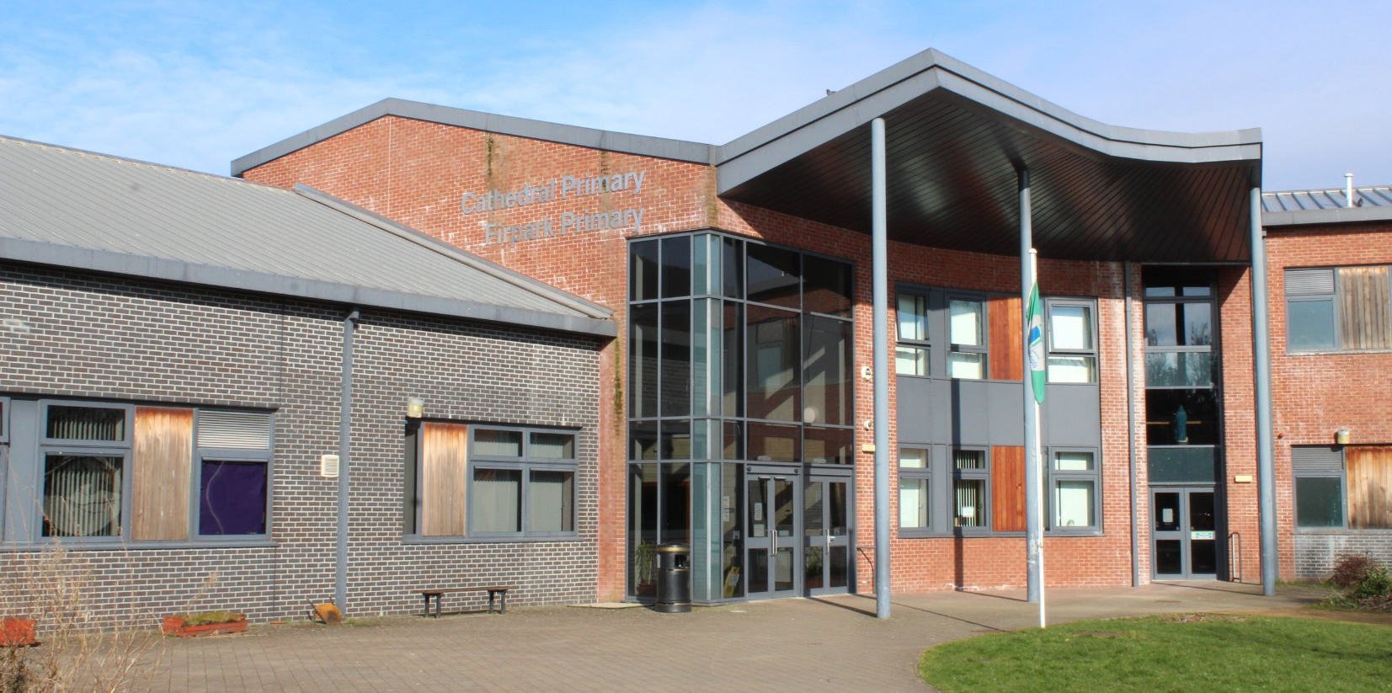

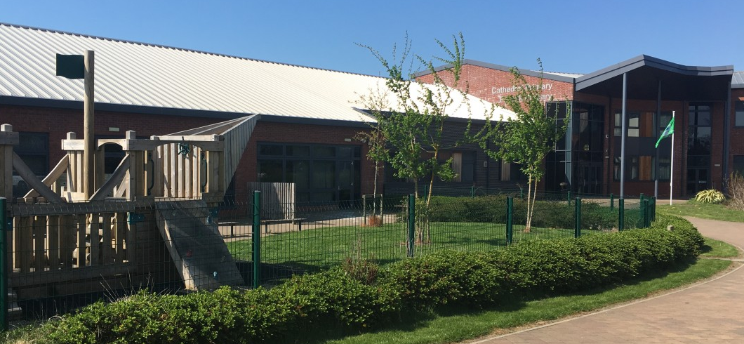
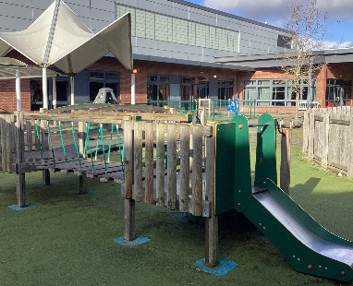

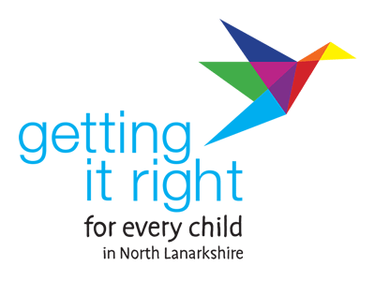

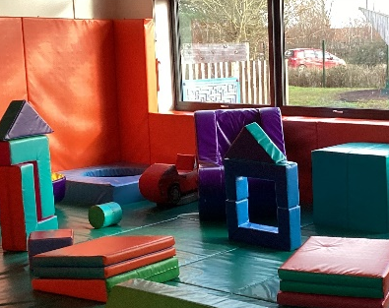
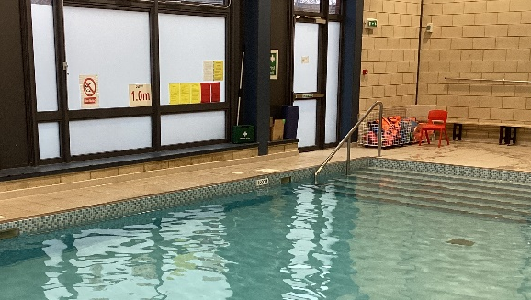
Firpark Primary School Handbook 2026-2027
Table of Contents

School information | 3
Letting Procedures | 3
School Profile | 4
School Staff | 5-6
School Hours & The School Year 2026-2027 (Holidays) | 7-8
Transition | 8
The Curriculum | 8-10
Classes and Key Learning Resources | 11
Homework | 12
Assessment and Reporting | 12
Additional Support Needs | 13
Planning | 13-14
Dispute Resolution | 14
School Improvement Planning | 15
Out of Hours Opportunities | 15-16
Equal Opportunities & Social Justice | 16
Spiritual, Social, Moral and Cultural Values | 16-17
Freedom of Information & GDPR | 17-21
Child & Adult Protection | 22
School Discipline and Anti-bullying | 22-23
Supervision in non-class times | 23
Home and School Links | 23
Attendance | 24
Family Holidays during Term Time | 24-25
Extended Leave with Parental Consent | 25
Exceptional Domestic Circumstances | 25
Clothing and Uniform | 25
Firpark Primary School Dress Code | 26-27
School Meals | 27
The availability of special diets | 27
Lunch Arrangements | 28
Placing Requests | 28-29
Transport | 29
Medical Health Care & Information in Emergencies | 29-30
The Parent Forum | 30
The Parent Council | 30-31
Pupil Forums | 31
Additional Information and Useful Contacts | 31-34

School Information

Name of School: Firpark Primary School

Address: 177 Milton Street
MOTHERWELL
ML1 1DH

Telephone: 01698 274933

E-Mail: nlwebsterm@northlan.org.uk

Website: https://blogs.glowscotland.org.uk/nl/firparkprimary/

Head Teacher: Mr Stephen Cotter (Acting)

Denomination: Inter Denominational

Capacity of School: Number of Pupils: current roll - 153

Age Range: 5 - 12 yrs. (Pr. 1-7)

Letting Procedures:

Any person/s wishing to hire a community facility within the school should apply to the Department of Community Facilities Services at:

Community Facilities Section
Civic Centre
Windmillhill Street
Motherwell
ML1 1AB

Tel: 01236 812407
Fax: 01698 302138
E-mail: school&facilitybookings@northlan.gov.uk

School Profile

Welcome to Firpark Primary School. Our school is part of a shared campus in Milton Street Motherwell. We are co-located with Clydeview Primary School and Our Lady of Good Aid Cathedral Primary School.
The school is within walking distance of the main shopping precinct and local amenities and has good public transport links.
The school was purpose built to accommodate pupils with additional support needs. It has excellent access facilities for children with mobility needs and all the rooms are situated at ground level. Within the school building there are sixteen classrooms, a sensory room, soft playroom, swimming pool and two structured play spaces. Our shared facilities include the dining hall and gym halls. We also have access to outdoor playing fields and almost all classes open out to an external courtyard.
Firpark is a school for primary aged children with a wide range of additional support needs. The school serves Bellshill, Motherwell and Wishaw districts of North Lanarkshire.
The current roll of the school is 153. Staffing is in line with authority guidelines, currently 28.4 full time equivalent teachers including the Shared Head Teacher, Shared Depute Head Teacher, Depute Head Teacher, 2 Principal Teachers, 1 Shared Enhanced Support Assistant and 36 full time equivalent Learning Assistants. The Health Board provides visiting services including school nursing team, doctor and dentist, hygienists, physiotherapists and occupational therapists. The Health Board together with Education & Families Services jointly fund Speech and Language therapy sessions.
The school has undertaken a range of very successful joint initiatives with Clydeview Primary who moved into the repurposed Daisy Park Community Centre (In September 2022) and Cathedral Primary and we continue to work on strengthening these working partnerships.
The school encourages positive links with parents and has a strong Parent Council. The school is an integral part of the community, both educationally and socially.

School Staff 2025-2026
Shared Head Teacher (Firpark and Clydeview) | Mr Stephen Cotter (Acting)
Shared Deputy Head Teacher (Firpark & Clydeview) | Vacant
Deputy Head Teacher | Mrs Colette Ellis
Principal Teacher Infants | Mrs Catherine McGuire
Principal Teacher Juniors | Mrs Caitlin Anderson

Class Teacher  Class Teacher  Class Teacher | Mrs Amy Gaughan(0.8)  Miss Emma Smith  Miss Antonia McAree
Class Teacher | Miss Linsey Crockert
Class Teacher | Mrs Jennifer Carty (0.5)
Class Teacher  Class Teacher | Mrs Clare O’Hanlon  Mrs Catherine McGuire
Class Teacher | Mrs Arlene Coleman (0.8)
Class Teacher | Mrs Sara-Elise Carlin
Class Teacher  Class Teacher  Class Teacher  Class Teacher  Class Teacher | Mrs Laura Murdoch  Miss Lyndsey McGill  Miss Hannah Ferguson  Mrs Mel Frame  Mrs Jennifer Howard
Class Teacher | Mrs Sharon McAree
Class Teacher | Mrs Charlene Lindsay (0.5)
Class Teacher | Miss Suzanne Mooty (0.6)
Class Teacher | Mrs Penny McGrellis (0.8)
Class Teacher | Mrs Joanne Pearson (0.8)
Class Teacher | Mr Jonathan Divers
Class Teacher  Class Teacher | Mrs Jen McBrolly  Mrs Sally Stewart
Class Teacher | Mrs Charlene Bell

Specialist Teachers

P.E. Class Teacher (incl. Swimming) | Mrs Caitlin Anderson
P.E. Class Teacher | Miss Jemma Maule
Music | Mrs Eileen Robertson
School Support Staff
Learning Assistants: | Clerical Assistants
Mrs Karen Anderson | Mrs Myra Thomas
Mrs Eileen Boyle
Mrs Patricia Brady
Mrs Laura Cochrane | Janitors
Mrs Angela Cullen | Mr Michael Soares
Mrs Yvonne Lennox | Mrs Josephine Duffy
Mrs Alison Francis
Mr Aiden Pratt | Bus Escorts
Mrs Ann McKenna | Mrs Nancy Marshall
Mrs Joyce Paterson | Mrs Jean Bradley
Mrs Angela Selkirk | Mrs Karen Anderson
Mrs Margaret Taggart | Mrs Laura Cochrane
Ms Angela Wallace | Mrs Angela Selkirk
Mrs Siobhan Duignan | Mrs Theresa Hughes
Mrs Ada Olender | Miss Claire McNeely
Miss Nicola Fairley | Mrs Alison Francis
Mrs Theresa Hughes | Mrs Margaret Taggart
Miss Emma Wilson
Mrs Barbara Szczepanska | Enhanced Learning Assistant
Mrs Jill Anderson  Miss Zoe Douglas  Miss Gabrielle Speirs  Mrs Stacey Wilson  Mrs Karen Fleming  Miss Nicole McGhee  Miss Alesandra Sciusco  Mr Gerald Gilmartin  Miss Chloe McCall  Miss Rebekah Grant  Mrs Emma Gibson  Mrs Gillian Thorburn  Miss Amanda Easton  Miss Imogen Williamson  Mrs Jennie Carlin  Mr William McNair  Mrs Clair Cumming  Miss Tia Divers (LSA) | Mr Rhys Townsend
School Hours
Opening time for pupils: 8.55a.m.
Interval: 10.40 – 10.55 a.m.
Lunch: 12.00 noon – 1.00 p.m.
Closing time for pupils: 3.00 p.m.

All P1 pupils will attend school full-time from the first day of the school year.

The School Year 2026-2027
In-Service | Monday 10 August 2026  Tuesday 11 August 2026
Pupils Return | Wednesday 12 August 2026
September Weekend | Friday 25 September 2026 to  Monday 28 September 2026 (inclusive)
October Week | Monday 12 October 2026  Friday 16 October 2026 (inclusive)
November In-Service | Monday 16 Nov 2026
Christmas Holidays | School Closes: Friday 18 December 2026 at 2.30pm  Monday 21 December 2026 to Monday 4 January 2027 (inclusive)  Pupils return on Tuesday 5 January 2027
February Break | Monday 15 February 2027 and  Tuesday 16 February 2027
February In-Service | Wednesday 17 February 2027 (in-service day)
Spring Break & Easter Weekend | Friday 26 March (Good Friday)  Monday 29 March (Easter Monday)
May Day | Monday 3 May 2027 (May Public Holiday)
May In-Service | Thursday 6 May 2027 (in-service)
May Weekend | Friday 28 May 2027 and  Monday 31 May 2027 (inclusive)
School Closes | Friday 25 June 2026 at 1.00pm

Transition

Nursery- Primary

Following the offer of a place to attend Firpark Primary, parents are invited to an informal meeting in the school. This provides them with the opportunity to view the school and meet the staff. Representatives from the Senior Leadership Team are then invited to attend reviews for nursery pupils. Transition arrangements are organised with individual’s schools and a formal induction day is organised in late May.

Primary-Secondary
Opportunities are provide for both pupils and parents at the Primary 7-S1 transition stage. “Taster Days” are arranged for pupils to experience Secondary classes. Parent Information evenings are also held for parents. Transition meetings are held for all pupils 12 months prior to the pupil’s school leaving date.

Transfer from Primary to Secondary School
Pupils normally transfer between the ages of 11½ and 12½ so that they will have the opportunity to complete at least 4 years of secondary education. Parents will be informed of the arrangements preceding the date of transfer at the start of the new sessions.
Firpark Primary have an enhanced transition programme to provide maximum support for pupils and families. Details of this programme will be shared with parents prior to transition beginning.

What is Curriculum for Excellence?
Curriculum for Excellence (CfE) is Scotland’s national curriculum. It provides a coherent and inclusive curriculum from 3-18 years wherever learning is taking place, including early learning childhood centres, schools, colleges and community learning. It places children and young people at the heart of Scottish Education.
The purpose of Curriculum for Excellence is encapsulated in the four capacities – to enable each child or young person to be
• a successful learner,
• a confident individual,
• a responsible citizen and
• an effective contributor.
These four capacities govern the entire curriculum from age 3 to 18 and aim to raise the standards of achievement for all learners.
Curriculum for Excellence is underpinned by the values inscribed on the mace of the Scottish Parliament – wisdom, justice, compassion and integrity.
Throughout Curriculum for Excellence there is a strong focus on Literacy, Numeracy and Health and Wellbeing across all aspects of learning and every teacher will support learners with the development of these, including digital literacy skills.
Curriculum for Excellence is defined as:
The totality of all that is planned for children and young people throughout their education’.
The opportunities for learning and teaching are governed by the Four Contexts for Learning, which ensure that the education your child receives is informative, interesting, relevant and fun.
These contexts are:
• Ethos and life of the school as a community
• Curriculum areas and subjects
• Interdisciplinary learning
• Opportunities for personal achievement.

What are the curriculum areas in Curriculum for Excellence?
There are eight curriculum areas: -
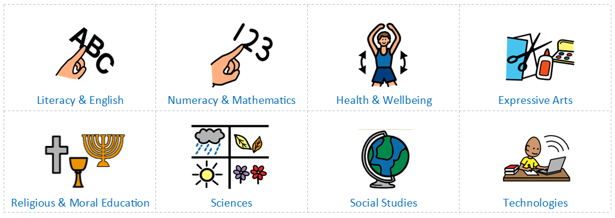

Literacy, Numeracy and Health & Wellbeing are given added importance because these skills are so vital in everyday life. All teachers have responsibility to teach these 3 core areas. Within the school’s Vision and Values Statement, Communication, Independence and Social Skill development are extremely important and as such the school provides a wide range of experiences for pupils in their immediate, local and wider communities. This is enhanced through a Total Communication environment and Core Curriculum. Where appropriate, published Literacy and Numeracy schemes are used such as Oxford Reading Tree and North Lanarkshire Active Literacy Programme and SEAL. These are supplemented by resources which teachers have developed to cater for the specific pupil needs.
Pupils learn in different ways, through listening, watching and doing. Teachers plan and prepare lessons so that children can experience a variety of learning styles across the curriculum. Teaching and Learning is focussed and the school has an active learning approach. In the early years children will have a range of learning experiences that include planned and purposeful play and stimulating learning which engages and challenges children’s thinking using real life and imaginary situations. As children progress through school they continue to be involved in active learning experiences which are engaging and give them ownership of their own learning. These become increasingly linked to providing pupils with opportunities to make choices and develop the skills necessary for interdependent and independent learning.

Milestones
In addition to the Curriculum for Excellence, some of our learners work within the ‘Milestones’ which focus on the stages of development which are not tracked within the official Curriculum for Excellence document. These stages of development are Communication, Making Connections, Self and Emotions and Functional Movement. More information can be found about Milestones on the Education Scotland Website.
Classes and Key Learning Resources
Class composition is arranged according to age and stage. However, where appropriate, classes in the same year group may be formed into groups arranged according to ability.
In addition to individual GIRFMe Plans, pupil learning is assessed, planned and evaluated termly through detailed forward plans devolved directly from the CfE and referencing Milestones document where relevant.

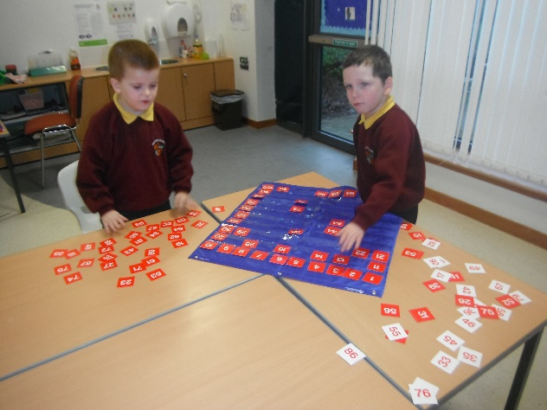

Literacy and numeracy are given added importance as these skills are vital in everyday life. All teachers have the responsibility to teach literacy and numeracy.
Where appropriate, published literacy and numeracy schemes are used. These are supplemented by a bank of materials which teachers have developed to cater for the specific needs of our pupils.
Read, Write Inc, PM Readers, Link Up, and Oxford Reading Tree are used for the teaching of reading. TJ Maths, Numicon, S.P.M.G. and Heinemann together form the core Mathematic scheme throughout the whole school.
Through this, pupils experience a traditionally broad Scottish curriculum that develops skills for learning with a focus on literacy and numeracy. It also aims to encourage an active, healthy lifestyle and builds an appreciation of Scotland and its place in the world.
It also provides learning and teaching experiences that strike a better balance between equipping them with the skills for passing exams, skills for learning, skills for life and skills for work.
The curriculum promotes active learning and a cross curricular approach.

Homework
Where appropriate, homework activities are set weekly and will be relevant to learning taking place in school. The support and encouragement given by parents/ carers in this area is invaluable and helps to foster a positive home –school relationship. The school homework policy is available on the school website.

Assessment & Reporting
How will my child’s learning be assessed?
Assessment is an important part of the Curriculum for Excellence and, at all levels, pupils’ progress is closely monitored by teachers and staff.
In turn, teachers and staff work with pupils to reflect on their results, looking at their strengths and learning needs, agreeing next steps and action based on these. As they progress, pupils become more involved in this process, as they develop the skills to make effective judgments on their own learning, developing personal expertise that will be important to them throughout life. Assessment also helps teachers plan learning experiences which are motivating and challenging. Children who may have additional support needs will be assessed using methods best suited to their individual requirements.
Each year your nursery/ school will let you know what is being done to continue to implement Curriculum for Excellence so that you can be confident that your child is receiving a high-quality education.
Staff assess pupils both formally and informally throughout the year. On-going monitoring of pupils work and progress is carried out and recorded on ‘Connecting Steps’ which is our school-wide assessment tracking system and linked to both Curriculum for Excellence and Milestones.
Parents are invited into the school throughout the year for two parent evenings. These events allow parents to gain information on their childs’ learning and assessment. In addition to this throughout the year contact is made with parents through the Community Learning Development Officer to ensure parents are kept up to date with opportunities for family learning and development.

Additional Support Needs
Firpark Primary School complies with the Additional Support for Learning (Scotland) Act 2004 as amended by the Additional Support for Learning (Scotland) Act 2009 and the Additional Support for Learning: Statutory Guidance 2017.
North Lanarkshire Council’s policy is contained within “Support for Learning Policy into Practice 2”, a copy of which is available in the school. The school has a Support for Learning Policy, available from the school on request, which is consistent with North Lanarkshire Council guidelines.
Looked After Children i.e. children who are cared for directly or whose care is supervised by the local authority are deemed to have Additional Support Needs unless assessment determines otherwise.
Firpark Primary School caters for pupils with English as an additional language along with their additional support needs.

Education & Families Services implement a process of Staged Intervention as detailed below:-
Level 1 - Education staff identify that a child or young person needs support or planning which can be met within the school using classroom and whole school resources
Level 2 – Requesting support from within Education & Families (services/resources outwith school) e.g Educational Psychologist, Community Learning and Development
Level 3 – Requesting support from another agency (Joint working with partner agency/agencies including 3rd Sector). When further planning is required to further develop the wellbeing of children and young people the Named Person may request assistance from colleagues in partner agencies.
Level 4 – Integrated and Compulsory working with other agency/agencies. Targeted intervention(s) required to promote the wellbeing of the child would be identified by relevant agencies (child’s Network of Support) and included in the Child’s Plan. A Lead Professional would be identified. At level 4 there would an expectation that a statutory Child’s Plan with integrated assessment, integrated chronology and Lead Professional is in place.

Planning
Getting it Right for Me Plans (GIRFMe)
GIRFMe enable staff to plan effectively for children and young people when interventions are requires to support their learning a improve outcomes. Parents/carers and pupils are an essential part of the assessment; planning and review processes and their views will be actively sought.
Some children and young people may require significant support from education and at least one other agency, such as health, social work and/or voluntary agency to help them meet their learning targets. Where this support requires a high level or co-ordination the opening of a Co-ordinated Support Plan (CSP) may be considered. A CSP may be initiated by the school or another agency.
Parents/carers and young people can, if they wish, request that a CSP be considered and would be involved in the process.
Parents/carers will receive letters from the Education Authority throughout the CSP process.
Parents/carers and young people will be invited to take part in multiagency meetings and their views will be recorded in the plan.
Where more intensive support for a child or young person needs to be planned for, usually when a number of agencies are involved in supporting their wellbeing then a Child’s Plan may be developed. The plan will tell you what actions need to be taken and who will help with each action. It will usually be someone called a ‘Lead Professional’ who will have the job of making sure that the actions outlined in the plan take place and things get better for the child or young person.
All pupils in Firpark Primary School hold a GIRFMe Plan which is monitored and updated termly alongside detailed class Forward Plans.

Dispute Resolution
North Lanarkshire Council is committed to resolving any differences of views through discussion, dialogue and building on common ground.
If the matter cannot be resolved with the Education Authority you have the right to request mediation. An independent mediation service is available to parents/carers and young people through Resolve (see contact details at the back of this handbook). Mediation is free through Resolve and independent of the Education Authority.
In the event that a disagreement cannot be resolved through mediation, then an application for Independent Adjudication (see contact details at the back of this handbook) can be made by parents/carers free of charge. The Independent Adjudicator will make recommendations to the Education Authority about how the dispute should be resolved.
The Additional Support Needs Tribunal has been set up to hear appeals made by parents/carers or young people on the decisions made by the Education Authority relating to Co- ordinated Support Plans, placing requests and post school transition. If you disagree with any decision relating to your child’s Co-ordinated Support Plan, either the creation of a CSP, or the content of it, you may be entitled to refer to the Tribunal

School Improvement Planning
Our current School Improvement Plan highlights priorities in the development of:
- To improve consistency and quality of learning and teaching for all learners by ensuring almost all lessons are appropriately differentiated and tasks, activities and resources are appropriately matched to all learners’ needs. To further develop the understanding of GIRFEC Pathway and impact while enhancing wellbeing opportunities across the school.
- To embed NLC’s Parental Engagement Strategy; encouraging participation and promoting engagement and representation in decision-making.
All staff are involved in these developments through implementation of working parties within the school. Following completion and under HGIOS 4 staff will work in consultation to identify priorities for the next session 2026-2027.
Further information on School Improvement Planning can be found on the school website.
Out of School Hours Opportunities
Many of our pupils have the opportunity to participate in a range of school lunch clubs. These include:-
- Football
- Messy/ sensory Play
- Table top games
- Arts and Crafts
- Choir

Pupils are involved in a wide range of sports activities including:
- Swimming
- Football
- Cross country
- Athletics
- Karate

Our pupils also participate in a range of joint initiatives with Clydeview Primary School and Cathedral Primary School. These include being part of a committee with representatives from both schools organising joint ventures (Campus Connections). Some ventures have included:
- Lenten Charity Appeals/Fun Days
- Joint Art Groups
- Beats of Brazil Music
- Gardening and Bikeability

Each year we offer Primary 7 pupils the opportunity of experiencing an Outward Bound Course at Strathclyde Park, working alongside the Rangers on a number of activities.
The aims in all of the above experiences are to:
- Develop independent living skills
- Develop self-esteem and social interaction skills
- Provide a range of experiences in a variety of settings which will stimulate interest and knowledge of the world in which they live.

Equal Opportunities & Social Justice

We seek to remove barriers in order to promote equality of opportunity and secure social justice for all pupils regardless of race, belief, gender or ability. In line with the Equality Act 2010, the Services’ Promoting Equality and Diversity Circular Gen 155-10 and the Council’s Equality and Diversity Policy and Equality Strategy 2019-2025.

In this matter we will strive to achieve our aims through our commitment-

- To ensure the equal status of all pupils.
- To recognise and promote ability.
- To value the contribution made by everyone.
- To ensure that pupils are aware of their own value.
- To afford pupils the opportunity to participate in all activities.
- To allow pupils to participate in the process of decision-making in matters which concern them.

The school is committed to ensuring it’s policies and practices do not impact adversely on any particular group(s) of people and opportunities to promote equality are actively pursued.
Implementation of the Education and Families Equality Policy including The Equality and Human Rights Commission’s Technical Guidance for Schools in Scotland is the essential guide for the school community to promote equality. This can be accessed at https://www.equalityhumanrights.com/en/publication-download/technical-guidance-schools-scotland

Spiritual, Social, Moral and Cultural Values
Firpark Primary School is non-denominational. The school work in accordance with the Council’s policies on religious education and religious observance.
Parents/ Carers from ethnic minority religious communities may request that their children be permitted to be absent from school in order to celebrate recognised religious events. Only written requests will be considered. Appropriate requests will be granted on not more than three occasions in any one school session and the pupils noted as an authorised absentee in the register.

Freedom of Information
Freedom of Information (Scotland) Act 2002 came into force in 2005. The Act allows anyone to ask for information held by the Council and imposes a time-scale of 20 working days for the Council to respond. To deal with Freedom of Information requests, the Council has appointed a Corporate Freedom of Information Officer with the support of an officer in each Service. The Freedom of Information Co-ordinator can be contacted by telephone on 01698 302484

General Data Protection Regulations (GDPR) Statement for Education
What is this statement?
This statement explains when and why we collect personal information about you, your child or young person and how this information is used, the conditions under which it may be disclosed to others and how it is kept secure.
Who are we?
North Lanarkshire Council is a Local Authority established under the Local Government etc. (Scotland) Act 1994. Education & Families is located in Civic Centre, Motherwell, ML1 1AB.
Why do we need your personal information and that of your child or young person?
The Council has a legal obligation to deliver an effective education service to all children and young people in North Lanarkshire. In order to do this we need to collect personal information about children, young people and their families so that we can help them to learn and keep them safe.
Legal basis for using your information
We provide this service as part of our statutory function as your Local Authority. Processing your personal information is necessary for the performance of a task carried out in the public interest by the Council. If the information we have asked for is not provided, then we will not be able to provide this service to your child or young person.

Your personal information
Education and Families uses the national IT system, SEEMiS, to store personal information electronically. We ask parents/carers during registration and enrolment to provide us with their child’s name, date of birth, gender, address, family contact details (phone/email). We will also ask you to update this information annually.
We may also ask you for information about medical conditions, additional support needs, religion, and ethnicity. We may also record information you might wish to provide about your family circumstances.
We require this information to ensure children and young people are educated appropriately, supported, and that we take account of their health and wellbeing.
During a child’s journey through education a pupil’s record is kept, this core record is mainly paper based and is stored securely in the child or young person’s establishment. If the establishment has requested assistance from educational staff outwith the nursery or school, key staff from these services may also store information securely about your child or young person.

How will we use this information?
Your personal information will be used:
- to enrol your child or young person in nursery or school
- to provide your child or young person with an appropriate education
- for teaching, enrolment and assessment purposes and to monitor educational progress of children and young people
- to support pupil learning, improve outcomes and identify where additional support is needed to help children and young people
- to provide appropriate pastoral care to support health and wellbeing of children and young people
- to keep children and young people safe
- to maintain records of attendance, absence and behaviour of children and young people (including exclusions)
- to support children and young people during transitions when moving on each year from nursery to primary, primary to secondary and when they move or leave school
- to enable schools and establishments to process personal data in support of SQA and Further Education
- to monitor and report on pupil attainment and achievement in relation to the national improvement framework issued by the Scottish Government
- to assure the quality of our education services in line with national expectations from Education Scotland.

Who do we share information with?
To support your child or young person’s access to appropriate education and meet our legal obligation, personal information may be shared internally between Services of the Council. From time to time, education staff may also need to share information about you, your child or young person with another person from another agency or service, e.g. Social Work, Health.
We also share information with Scottish Government and bodies such as Education Scotland, Scottish Qualifications Authority, Skills Development Scotland and other organisations that support children and young people’s learning.
When a child or young person moves or transfers to another school the Council has an obligation to pass on information with regards to pupil records to the new school.
Only identified staff and those who require to have the information to enable them to carry out their job, will have access to you, your child or young person’s information. We care about the information we hold in respect to the education of children and young people. We will keep this information safe and secure.
How long do we keep your information for?
We only keep personal information for the minimum period of time necessary. Sometimes this is set out in law, but in most cases it is based on what we need to fulfil our function. We maintain a ‘records retention and disposal schedule’ which sets out how long we hold different types of information for. You can view this on the Council’s website.

Your rights under GDPR
You can:
- Request access to your information – you have the right to request a copy of the personal information that we hold about you, your child or young person. You can ask us to confirm what personal information is being used and with whom it has been shared with.
- Request a correction to your information – we want to make sure that all personal information is accurate, complete and up to date. Therefore you may ask us to correct any personal information that you believe does not meet these standards.
- Request the restriction of processing – this enables you to ask us to suspend the processing of personal information about you, your child or young person, for example if you want us to establish its accuracy or clarify the reason for processing it.
- Request the transfer – you can request the transfer of your information to another party.
- Deletion of your information – you have the right to ask us to delete personal information about you, your child or young person where:
  - you think that we no longer need to hold the information for the purposes for which it was originally obtained
  - you have a genuine objection to our use of personal information
  - or, use of personal information is contrary to law or our legal obligations.
If you wish to update any personal information, retrieve it, or have it removed from records please contact your child or young person’s head teacher or head of establishment in the first instance.

The Council’s Data Protection Officer
If you have any questions or are unhappy about the way that we use the personal information of your child, young person or yourself you can contact the Data Protection Officer.
Data Protection Officer (DPO)
Civic Centre,
Windmillhill Street,
Motherwell ML1 1AB
or by email to AITeam@northlan.gov.uk

The Information Commissioner
You also have the right to complain to the Information Commissioner about the way the Council has handled your rights, to enquire about any exercise of these rights or to complain about the way the Council has dealt with your rights (or any other aspect of data protection law).
Information Commissioner's Office,
45 Melville Street,
Edinburgh, EH3 7HL
or by e-mail to
casework@ico.org.uk

Transferring Educational Data about Pupils
Education authorities and the Scottish Government
Education Portfolio (SGEP) exchange data about pupils either on paper or electronically through the ScotXed programme.
The data collected and transferred covers areas such as date of birth, postcode, registration for free-school meals, whether a pupil is looked after by his/her local authority, additional support needs including disability, attendance, absence and exclusions from school. Pupil names and addresses are collected by the school and the council but they are not passed to SGEP. The postcode is the only part of the address that is transferred. Data is held securely and no information on individual pupils can be published by SGEP
Providing national identity and ethnic background data is entirely voluntary. You can choose the ‘not disclosed’ option if you do not want to provide this data. However, we hope that the explanations contained in this message and on our website will help you understand the importance of providing the data.
Why do we need your data?
In order to make the best decisions about how to improve our education service, SGEP and education authorities need accurate, up-to-date data about our pupils. We are keen to help all our pupils do well in all aspects of school life and achieve better educational outcomes. Accurate and up-to-date data allows SGEP, education authorities and schools to:
plan and deliver better policies for the benefit of all pupils,
plan and deliver better policies for the benefit of specific groups of pupils,
better understand some of the factors that influence pupil attainment and achievement,
target resources better.

Your GDPR rights
The collection, transfer, processing and sharing of ScotXed data is done in accordance with the GDPR. We also comply with the National Statistics Code of Practice requirements and other legislation related to safeguarding the confidentiality of data. GDPR gives you the right to know how we will use your data. This message can give only a brief description of how we use data. Fuller details of the uses of pupil data can be found on the ScotXed website (www.scotxed.net).
SGEP works with a range of partners including Education Scotland and the Scottish Qualifications Authority. On occasion, we will make individual data available to partners and also academic institutions to carry out research and statistical analysis. In addition, we will provide our partners with information they need in order to fulfil their official responsibilities. Any sharing of data will be done under the strict control and prior agreement of the Data Access Panel in SGEP, which will ensure that no subject specific data will be made public as a result of the data sharing and that such data will not be used to take any actions in respect of an individual.
Further details are available on:
https://www2.gov.scot/Topics/Statistics/ScotXed/PrivacyInformation
Any Concerns
If you have any concerns about the ScotXed data collections you can email school.stats@scotland.gsi.gov.uk or write to:
The ScotXed Support Office, SEGP, Area 1B, Victoria Quay, Leith, EH6 6QQ.
Alternative versions of this page are available, on request from the ScotXed Support Office, in other languages, audio tape, braille and large print.
Want more information?
Further details about ScotXed data exchanges are available on the ScotXed website, http://www.scotxed.net.
Child Protection
Every adult in Scotland has a role in ensuring all our children and young people are safe and protected from harm at all times and in all situations.
The Head Teacher is responsible for the schools actions in response to Child Protection concerns
If there are any Child Protection concerns the Head Teacher or the Child Protection Co-ordinator will follow North Lanarkshire Child Protection Procedures and Guidelines
Child Protection Co-ordinator & GIRFEC Named Person is:
Mr Stephen Cotter

Telephone Number: 01698 274933

Adult Protection
The Council has responsibility under the Adult Support and Protection (Scotland) Act 2007 for the protection and support of adults at risk of harm within North Lanarkshire. Its employees therefore have the responsibility to ensure the welfare of all adults at risk of harm with whom they come into contact, as well as providing the highest possible standard of care for some of the most vulnerable members of our society. If
there are any Adult Protection concerns the Head Teacher or the Adult Protection Co-ordinator will follow North Lanarkshire Adult Protection Procedures and Guidelines
Adult Protection Co-ordinator is Mr Stephen Cotter (as above)

School Discipline
Within Firpark Primary we have developed a school ethos which strives to be caring and supportive of its pupils while emphasising the need for good discipline and the value of school rules. To ensure this, parental co-operation is vitally important.
The Promoting Positive Behaviour Policy operates in conjunction with the anti-bullying statement. The programme in our assemblies and class Circle Time covers the school rules and helps pupils to understand rewards, sanctions, privileges etc.

Anti-bullying
Firpark Primary already has a well-established caring attitude towards its pupils and staff. The school uses both local and national guidelines which define both rights and responsibilities to ensure that everyone is treated with respect and understanding, including NLC Promoting Positive Relationships: Respect for All: Anti-Bullying Policy, May 2019.
An adult presence is provided in playgrounds at break times in terms of the Schools (Safety and Supervision of Pupils Scotland) Regulations 1990.

Supervision in non-class contact times
Non-class contact time is provided for class teachers through PE, Swimming, Music and HWB lessons.
Learning Assistants cover is provided during non-class contact times along with subject teachers.
Adult supervision, including a promoted member of staff, is provided in playgrounds at break times in terms of the School (Safety and Supervision of Pupils) (Scotland) Regulations 1990.

Home and School Links
Firpark Primary School encourages strong links with parents and has a very active and supportive Parent Council. Daily links are made with parents through home school diaries and parent workshops are held throughout the school on a variety of curricular areas/issues.
The school uses the Class Dojo system with parents. This is very successful and the parental feedback has been very positive in terms of sharing information and being able to receive photographs and clips of their child’s day.
The school website has been developed and offers parents accessible information on events and photographs of the work within the school.
Parents are invited to attend all parents’ evenings throughout the year to discuss their child’s progress. GIRFMe Plans are available for parents to review and discuss including any relevant targets required for individual pupils. If for any reason a parent is unable to attend they are invited to telephone the D.H.T. to arrange another meeting at a mutually agreed time.
Under the Additional Support for Learning Act any child who requires intervention from other agencies may have a Coordinated Support Plan (CSP).
Review of CSP meetings take place every 12 months. Parents, class teacher, HT/DHT/PT and any other relevant agencies involved in working with the pupil meet together to discuss the pupil’s strengths and areas for development and progress made in set targets.
The parents are given the opportunity to discuss any issues and signs of progress which they may see at home. Parents are sent a copy of the reports and a brief summary of the meeting. Another copy is retained in school. CSPs are sent to the authority for approval and copies will then be forwarded to parents and school.

Attendance

Section 30 of the 1980 Education Act lays a duty on every parent of a child of “school age” to ensure that their child attends school regularly. Attendance must be recorded twice a day, morning and afternoon.

Regulation 7 of the Education (School and Placing Information) (Scotland) Amendment Etc. Regulations 1993 requires each child’s absence from school to be recorded in the school register as authorised or unauthorised: As defined by the Scottish Government.
At the start of each school session, parents will be asked to provide contact details including at least one emergency contact number. Parents are required to inform the school if these contact details change during the course of the school year.
Parents and carers are asked to inform the school if a pupil is unable to attend from the start of the school day on the first day of absence. Failure to do so will result in school staff accessing all contact numbers provided for the school. In terms of child safety, police will be contacted if all attempts to locate the child have been exhausted.
Parents/guardians are asked to inform the school by letter or telephone if their child is likely to be absent for some time, and to give the child a note on his or her return to school, confirming the reason for absence.

Pupil absence rates are monitored by Senior Management Team and families will be contacted should any concerns or patterns be identified.

Family Holidays during Term Time
Every effort should be made to avoid family holidays during term time as this both disrupts the child’s education and reduces learning time. Parents/guardians should inform the school by letter of the dates before going on holiday.
Absence will be classified as authorised only in exceptional circumstances.
Such circumstances may include a family holiday judged to be important to the well-being and cohesion of the family, following serious or terminal illness, bereavement or other traumatic events.
A family holiday classified under the “authorised absence” category will not include such reasons as: -
- The availability of cheap holidays
- The availability of desired accommodation
- Poor weather experience during school holidays
- Holidays which overlap the beginning or end of term
- Parental difficulty obtaining leave (except in cases where evidence is provided by the employer that it cannot accommodate leave during school holidays without serious consequences).

Family holidays with the above similar characteristics will be classified as unauthorised absence. Where the Head Teacher’s prior agreement has not been sought the absence will automatically be classed as unauthorised.

Extended Leave with Parental Consent
Where most family holidays will be classed as unauthorised absence (see above) extended leave with parental consent will not be considered the same as a family holiday.
Leave in such circumstances will be authorised under such circumstances as:
- Extended overseas educational trips not organised by the school
- Short –term parental placement abroad
- Family returning to its country of origin (to care for a relative, or for cultural reasons)
- Leave in relation to the children of travelling families

Exceptional Domestic Circumstances
Parents may request permission for such leave in writing and the school may authorise such requests under the following circumstances:

- The period immediately after an accident or serious illness
- A period of serious illness or critical illness of a close relative
- A domestic crisis which causes serious disruption to the family home, causing temporary relocation

It should be emphasised that the school attendance officer investigates unexplained absence, and that the authority has the power to write to, interview or prosecute parents, or to refer pupils to the reporter of the children’s hearings, if necessary. (See section 28 about school board involvement).

Clothing and Uniform
All North Lanarkshire schools must have a dress code which encourages pupils to dress in a way which is appropriate to attendance at school. This dress code must not lead to direct or indirect discrimination on grounds of race, religion, gender or disability. Prior to drawing up the dress code the parents, pupils and staff were fully consulted. It is the expectation of the education authority that parents will be keen to support the dress code and written agreement may be sought.

Wearing of school uniform is encouraged and promoted in Firpark Primary School as a means of identifying with the school and as a proved foundation of good discipline. School uniforms can be purchased from Miyo in Craigneuk or ordered through Parent Council.

Firpark Primary School Dress Code
All pupils are encouraged to wear school uniform. This consists of maroon sweatshirts, with school logo and gold polo shirts.
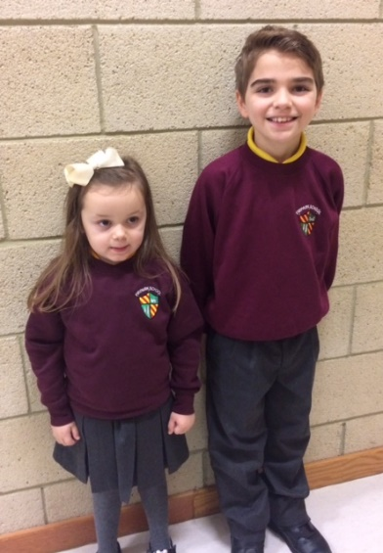

Clothing which is unacceptable in school under any circumstances includes items which:
- could potentially encourage factions (e.g. football colours)
- could cause offence (e.g. anti-religious symbolism or political slogans)
- could cause health and safety difficulties such as loose-fitting clothing, dangling earrings, and other potentially dangerous jewellery.
- are of flammable materials which may be a danger in certain classes (e.g. shell suits)
- could cause damage to flooring
- carry advertising in particular for alcohol or tobacco and
could be used to inflict damage on other pupils or to be used by others to do so.

Parents/carers in receipt of a clothing grant from the Council will be encouraged to purchase items which are in accordance with the school dress code. Approval of any requests for such grants in other circumstances are at the discretion of the Executive Director of Education and Families. Information and application forms may be obtained from first stop shops and can be downloaded from the Council website www.northlan.gov.uk
Parents are entitled to receive a clothing grant if they are in receipt of any of the following benefits: Income Support, Job Seekers Allowance (income based). Employment & Support Allowance (income related), Universal Credit, housing benefit, council tax rebate.
Whilst in general terms it would not normally be the policy of the authority to exclude a pupil from school solely on the basis of his/her dress, persistent refusal to respond to a reasonable dress code may be deemed to be a serious challenge to the head teacher’s authority and to be detrimental to the wellbeing of the whole school community.
In such circumstances a head teacher may justify the use of school discipline procedure.
The Council wishes to minimise claims arising from the loss of pupils’ clothing and/ or personal belongings.
Parents/ Guardians are asked to assist in this area by ensuring that valuable items and unnecessarily expensive items of clothing, jewellery etc. are not brought to school. Parents should note that any claims submitted to cover the loss of such things are likely to be met only where the authority can be shown to have been negligent.

School Meals
School meals are prepared on the premises. Parents wishing to provide their child with a packed lunch may do so.

The availability of special diets:
Diets required as a result of a medical condition (a medically prescribed diet e.g. coeliac disease, diabetes, PKU, food allergy or intolerance) can be provided in school by our catering staff. A medically prescribed diet form must be completed and signed by the child’s Registered Dietician or General Practitioner. Procedures and forms can be accessed online through North Lanarkshire Council’s website, by the school, the catering service or also in some cases by the child’s dietitian or doctor. For some conditions (PKU, coeliac) parents/carers may be asked to supply prescription foods or attend a meeting to discuss the child’s dietary requirements.
For information a vegetarian meal option is offered on a daily basis.
Some children with additional support needs may require food to be adapted to an appropriate texture and consistency. In this instance the child’s Registered Dietician or Speech and Language Therapist will liaise with the Head Teacher and school catering service including the nutritionist to ensure appropriate food provision. In this case a form will still need to be signed by a medical professional including a Speech and Language Therapist.
It is important that the Head Teacher is aware of any medically prescribed diets within the school and on occasion may be asked to attend a meeting.
Forms that have not been signed by a medical professional will be rejected. The form will be returned to the parent along with a letter stating the reason for the refusal and also they will be issued with a new form.

Any change in the child’s dietary requirements must be advised through a Registered Dietitian or Medical Practitioner to the Facilities Support Services (FSS) Nutritionist. When children move to a High School or change schools FSS will need to be informed as soon as possible. Special Diets such as Vegan and ethnic diets can also be accommodated. In this case a Form B should be completed and can be signed by the parent.

All completed forms should be returned to the email: specialdiet@northlan.gov.uk

Lunch Arrangements
Lunches are served to all school pupils at 12 noon on a daily basis.
All pupils with Additional Support Needs between P1- 7 pupils are entitled to a free school meal.
Classes P1-3 are offered a choice of meal and served. P4-7 are taught and expected to queue up and choose from the menu provided. Some classes may eat in the dining hall where appropriate. They then sit in class groups for supervision purposes. Pupils are supervised by SLT and Learning Assistants during lunch times. Information and application forms for free school meals may be obtained from schools, First Stop Shops and Municipal Buildings, Coatbridge.

Parents/carers are entitled to receive a clothing grant if they are in receipt of any of the following benefits: Income Support, Job Seekers Allowance (income based). Employment & Support Allowance (income related), universal credit, housing benefit, council tax rebate.
Information and application forms for free school meals may be obtained from first stop shops and can also be downloaded from the council website www.northlan.gov.uk
Only Primary School children in P1 - P3 or those who are entitled to a free school meal in P4 – P7 are entitled to free milk.

From September 2020, all eligible two-year-olds and all children aged from 3 to those not yet attending primary school, that attend a North Lanarkshire Council Nursery or a Funded Provider (childminder or voluntary/ private nursery), will be entitled to 1140 hours Early Learning and Childcare provision. Those children attending for four hours per day, or more, will receive a free meal as part of the Early Learning and Childcare entitlement.

Placing Requests
You have the right to make a placing request for your child to be educated in a school other than the local school.
In December each year, the authority will advertise its arrangements for placing requests.
There are sound educational reasons for trying to ensure that the transfer or admission of children to a school takes place at the start of a school session. Other than those
who are moving home to a new area, parents/carers are advised to time any placing requests so that they take effect from the beginning of the new school session.
Every effort will be made to try to meet the parental wishes, but you should note that it is not always possible to grant every placing request to a particular school.
Placing requests to Primary School does not necessarily ensure that your child will have a direct entry to the associated secondary. Advice on this must be sought from the Primary School Head Teacher.
Further information on placing requests and procedures is available from the school or the council’s website.
Parents/carers and Young People have a right under the Additional Support for Learning Act 2009 to make a placing request for their child or young person to attend a nursery (including partnership nursery), special school or special class managed by the home authority. In the event of a successful placing request the authority are not required to provide transport. The Act also enables parents/carers and young people to make a placing request to attend a school/establishment belonging to another authority.

Transport

All children attending Firpark Primary School will be offered transport provision by the local authority. Parents wishing to transport their own child are entitled to do so and should notify the school in this instance. North Lanarkshire Council will cover the cost of 4 journeys per day in these circumstances.

The council does not provide transport for those pupils in receipt of a placing request other than in exceptional circumstances.

Medical Health Care

Firpark Primary School has an identified ASN nursing team who liaise closely with the parents and school regarding the pupil’s health and welfare. There are also two trained first aiders and two appointed persons among the teaching and support staff. The school medical officer visits the school to carry out routine medicals on the pupils. The oral health visitor visits the school regularly to monitor our teeth brushing programme and address any dental issues with individual children. Where relevant and appropriate she also liaises with the dentist to address any dental issues.

There is speech and language therapy provision within the school and other visiting services include physiotherapy and occupational therapy.

Should a child take ill in school they are taken to a member of the Senior Leadership Team who will assess whether or not they require to be taken home. They will then telephone the parent or emergency contact to make arrangements for uplifting the child.

Parents should inform the school of any particular medical requirements.

Information in Emergencies

We make every effort to maintain a full educational service, but in Emergencies on some occasions circumstances arise which lead to disruption. For example, schools may be affected by severe weather, temporary interruption of transport, power failures or difficulties of fuel supply. In such cases we shall do all we can to let you know about the details of closure or re-opening. We shall keep you informed by using letters, notices in local shops and community centres, announcements in local churches and announcements in the press, on local radio and the North Lanarkshire Council’s website and Twitter.

The Parent Forum
As a parent of a child at this school you are automatically a member of the Parent Forum. The Parent Forum is composed of all the parents and carers of children at the school.

As a member of the Parent Forum you can expect to:

- get information about what your child is learning
- get information about events and activities at the school
- get advice/help on how you can support your child's learning
- be told about opportunities to be involved in the school
- have a say in selecting a Parent Council to work on behalf of all parents at the school
- be invited to identify issues for the Parent Council to work on with the school.
The Parent Council

Firpark and Clydeview Primary Schools have a joint parent Council which has been running since August 2023. It consists of 14 parent representatives, 1 staff member and 1 co-opted member. The Head Teacher attends all meetings as professional adviser to the Parent Council.
The Parent Council’s rights and duties include:

- supporting the work of the school;
- representing the views of parents/carers;
- consulting with parents/carers and reporting back to the Parent Forum on matters of interest;
- promoting contact between the school, parents/carers, pupils, and the wider community;
- fundraising;
- taking part in the selection of senior promoted staff;
- receiving reports from the head teacher and education authority; and
- receiving an annual budget for administration, training and other expenses.
- Improving home school partnership and facilitating parental involvement
Members of Parent Councils, on a voluntary basis, may also have an advisory role in decisions on placing requests by parents in respect of those situations where the number of placing requests for a particular school, or for a particular stage in a particular school, exceeds the number of places available.

Name | Position on Council | School
Michelle Allan | Chair | Clydeview
Vicky Park | Vice Chair | FIrpark
Ashleigh Douglas | Secretary | Clydeview
Nicola Ross | Treasurer | Clydeview
Catherine MacMillan | Vice Treasurer | Firpark
Amy Martin | Parent Member | Clydeview
Julie Skilling | Parent Member | Clydeview
Caitlin McGrane | Parent Member | Clydeview
Gerry Rankin | Parent member | Firpark
Eraj Sajjad | Parent Member | Clydeview
Lynsey Stewart | Parent Member | Clydeview
Louise Campbell | Parent Member | Firpark
Clare Burnett | Co-opted Member | Firpark/ Clydeview

The Parent Council is selected for a period of two years, after which they may put themselves forward for re-selection if they wish. Any Parent of a child at the school can volunteer to be a member of the Parent Council. In the event that the number of volunteers exceeds the number of places set out by the constitution, members will be selected by process of election. Minutes of Parent Council meetings are available to all parents on request from the school office.
Pupil Forums
Pupils are represented within the school environment through our Firpark Pupil Council and our joint Campus Connections with Clydeview and Our Lady of Good Aid Cathedral Primary School. Pupils are elected on an annual basis and the Pupil Council is made up of one pupil member from each classroom.

Additional Information

Education & Families
Civic Centre
Windmillhill Street
Motherwell
ML1 1AB
01236 812310

Senior Education Manager Education Manager
Mr Alan Henry Mrs Jill Woodward
Education & Families Education & Families
Civic Centre Civic Centre
Windmillhill Street Windmillhill Street
Motherwell Motherwell
ML1 1AB ML1 1AB
01236 812291 01236 812488

Cluster Improvement Intergrated Lead Chief Executive Area Office
Mrs Carol McShane Civic Centre
Civic Square Motherwell
Motherwell ML1 1AB
01698 302222

Although this information is accurate at time of printing, there could be changes affecting any of the matters dealt within the document
-before the commencement or during the course of the school year in question.
-in relation to subsequent school years.
Education Authorities are required by law to issue a copy of the school handbook to certain parents in December each year. It details the current policies and practices of both the council and the school.

Contacts in relation to Support for Learning

Help and advice on any matters relating to Support for Learning can be obtained from:

Carol McShane CIIL Inclusion Cluster mcshanec@northlan.gov.uk

You can also get more help and advice from:

Enquire – The Scottish advice service for additional support for learning operated by Children in Scotland, Enquire offers independent confidential advice and information on additional support for learning.
Enquire also provide a range of factsheets,
Enquire,
Children in Scotland,
Rosebery House,
9 Haymarket Terrace,
Edinburgh,
EH12 5EZ
Tel No. 0345 123 2303
info@enquire.org.uk
www.enquire.org.uk for parents and practitioners/ for children and young people

Children in Scotland- Resolve Mediation 0131 313 8844
Email: resolve@childreninscotland.org.uk

Independent Adjudication
Scottish Government
Directorate for Learning
Support and Wellbeing Unit
Area 2C North
Victoria Quay
Edinburgh
EH6 6QQ

Reference to Additional Support Needs Tribunal (Scotland)
ASNTS
Health and Educational Chambers
First Tier Tribunal for Scotland
Glasgow Tribunals Centre
20 York Street
Glasgow
G2 8GT
0141 302 5860
www.asntscotland.gov.uk

NHS Lanarkshire

Bellshill Health Centre | 01698 575700
Motherwell Health Centre | 01698 242610
Wishaw Health Centre | 01698 355511

Social Work

Bellshill  303 Main Street  Bellshill  ML4 1AW | 01698 346666
Motherwell  Scott House  73/77 Merry Street  Motherwell  ML11 1JE | 01698 332100
Wishaw/Shotts  Kings House  King Street  Wishaw  ML2 8BS | 01698 348200

Community & Learning Development

Motherwell CLD Locality Office  Our Lady's High School  Dalziel Drive  Motherwell ML1 2DG | Tel: 01698 403830  E: CLD-Motherwell@northlan.gov.uk  Contact: Clare Burnett

