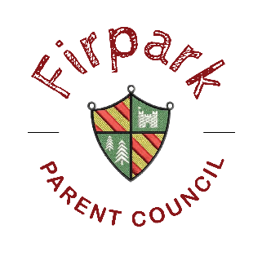
Dear Parents/ Carers
I hope you are all well and keeping safe through these difficult times. I understand anxieties are high right now with the continued changes throughout our school community.
First of all, I would like to extend a thank you to Mrs webster and all the staff for all the hard work in giving our children some face-to face teaching, and for all the support that they have given to us as parents over the last few weeks.
I wanted to communicate to you all directly and assure you all that the Parent Council is working hard behind the scenes on your behalf.
Covid 19:
I have been attending meetings every 2-3 weeks with Derek Brown and fellow ASN Chairs for updates on Covid guidelines and how this impacts the return of our school. In these meetings I also voice the struggles that you, our parents are having with home-schooling.
I have also written to Derek Brown to suggest ASN schools coming together as a united front, to show the impact that this is having on our children and families and pleading the case for our staff to be vaccinated. More recently I have written to Derek on 17th February and I have attached this below for all to see. On the back of this letter, I alongside my fellow members will now seek to write to MSPs to seek fairness for ALL our Children and the negative impact that lockdown has had on all of us. I thank those who have been able to send small statements giving insight into how your family life is just now. If you haven’t but wish to do so please send them across.
A council member attended a Q&A with Public Health Scotland to better understand the guidelines around certain groups being permitted to school while others are not. Thank you for submitting your questions to us and we are happy to put this forward at the meeting, the video will be on YouTube and we will share this via Twitter and Facebook page.
Clydeview Relocation:
I know that this could not have come at a worse time with all that is going on. You should have all received emails from NLC with the proposal, if not we can certainly pass this on to you.
The members and I will be meeting with Clydeview Parents to work in partnership on how this will affect both schools and their respective children and families. The Consultation period is now 6 weeks instead of the 16 that was stated in our first letter and we again will look to further seek guidance on this matter. I urge parents if you wish to attend the public meeting please do so. If any parents have questions arising from the consultation paper please email them across and we will seek to get you answers your opinion is very important and we will continue to have your voices heard.
Last but my no means least, I want you to know, you are not alone in this journey, we are here if you need to chat or for someone to listen to you. We are a Family here at Firpark and we can get through this together.
Please don’t hesitate to contact us at: FPParentcouncil@outlook.com
Best Regards,
Fiona Graham (chairperson)

