FIRPARK PARENTS PRESENT

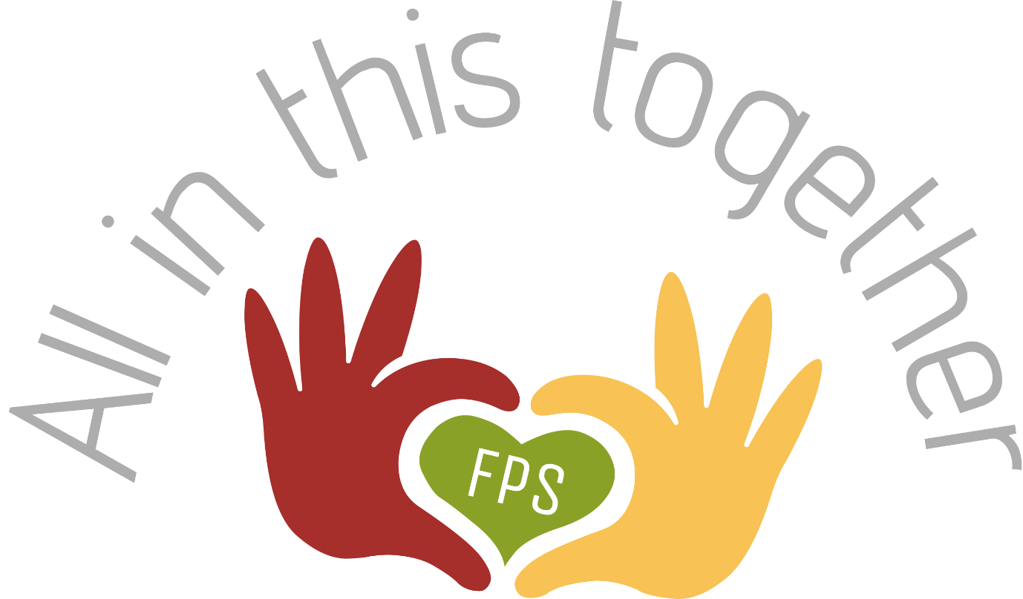

PARENT SUPPORT GROUP

COMING TO YOU THIS SUMMER

If you’re interested, please email fpparentcouncil@outlook.com for further details

