WEEK 1 | MONDAY | TUESDAY | WEDNESDAY | THURSDAY | FRIDAY
Hot Meal  RED BAND  TEST | Cheeseburger in a bun, served with potato wedges, vegetable sticks & salad (sauce portion offered) | Macaroni cheese served with peas, cauliflower and garlic bread (v) 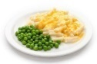 | Chicken curry  and rice served with a naan bread finger, sweetcorn and peas.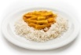 | Sausages* with waffles and carrots and broccoli | Fish and chips served with salad or peas 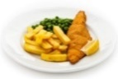
Hot Meal  Vegetarian (v) / Vegan (ve)  Alternative  GREEN BAND | Vegetable Burger in a bun served with potato wedges, vegetable sticks & salad (ve)  (sauce portion offered)  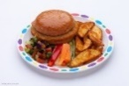 | NO OPTION | Vegetable curry and rice served with a naan bread finger, sweetcorn and peas. (v)  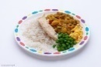 | Veggie sausages with waffles, carrots and broccoli (ve) | Quorn Nuggets and chips served with salad or peas (v)  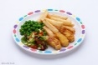
Baked Potato with a choice of filling  or  Pasta dish  YELLOW BAND | Baked potato served with  Tuna mayonnaise or cheese (v),  vegetable sticks and salad  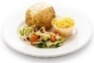 | Baked potato served with  baked beans (ve)  or tuna mayonnaise,  vegetable sticks and salad  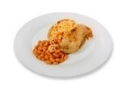 | Baked potato served with  Tuna mayonnaise or cheese (v),  vegetable sticks and salad  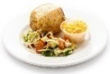 | Baked potato served with  baked beans (ve)  or tuna mayonnaise,  vegetable sticks and salad  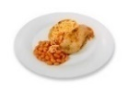 | Baked potato served with cheese (v) or tuna mayonnaise, vegetable sticks and salad  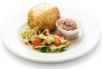
Soup and a deli choice  served with vegetable sticks  BLUE BAND | Sandwich  Choice of ham or cheese  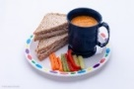 | Sandwich  Choice of chicken or cheese  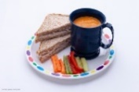 | Soft Bap (133712)  Choice of cheese or tuna mayonnaise | Sandwich  Choice of ham or cheese | Sandwich  Choice of chicken or cheese  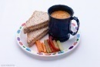
Choice of soup, home baking,  fruit or yoghurt | Lentil Soup (ve),  Fruit, or Yoghurt | Roasted Sweet Potato Soup (ve),  Home baking or fruit | Lentil Soup (ve),  Fruit or  Home baking | Hearty Vegetable  Soup (ve)  Ice cream or Fruit | Lentil Soup (ve)  Fruit, Yoghurt
Week Commencing – 16th May – 6th June – 27th June – 15th Aug - 5th Sept – 26th Sep, 24th Oct -14th Nov – 5th Dec – 9th Jan – 30th Jan -20th Feb - 13th Mar – 17th Apr – 8th May
All meals are served with milk or tap water and two portions of vegetables. Pupils can also select either soup, fruit or home baking, as indicated on the menu to accompany their meal
*chicken

WEEK 2 | MONDAY | TUESDAY | WEDNESDAY | THURSDAY | FRIDAY
Hot Meal  RED BAND | Pizza served  with salad and vegetable sticks (v)  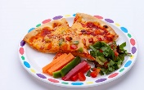 | Beef bolognaise pasta served with green beans or mixed salad  and garlic bread  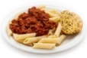 | Chicken Tandoori (Code: 33404) bites served with a wholemeal pitta bread finger, seasoned potato wedges salad, vegetable sticks and sweet chilli dipping sauce  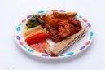 | Roast beef (Code: 29174) served inside Yorkshire pudding (code: 52992) served with gravy mashed potatoes, broccoli and carrots  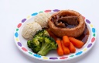 | Fish & Chips served with sweetcorn and peas  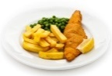
Hot Meal  Vegetarian (v) / Vegan (ve)  Alternative  GREEN BAND | NO OPTION | Tomato pasta  served with garlic bread, green beans or salad (v)  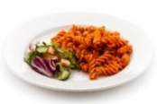 | Quorn sausage roll served with a wholemeal pitta bread finger, seasoned potato wedges salad, vegetable sticks | V Cheese Toastie, served with Baked Beans or tomato wedges (v)  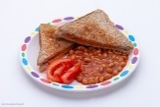 | Quorn Nuggets and chips served with sweetcorn and peas (v)  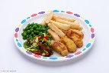
Baked Potato with a choice of filling  or  Pasta dish  YELLOW BAND | Baked potato served with  Tuna mayonnaise or cheese (v),  vegetable sticks and salad | Baked potato served with  baked beans (ve) or tuna mayonnaise, vegetable sticks and salad  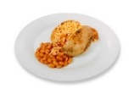 | Baked potato served with  Tuna mayonnaise or cheese (v),  vegetable sticks and salad  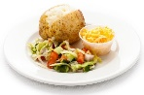 | Baked potato served with  baked beans (ve) or tuna mayonnaise, vegetable sticks and salad | Baked potato served with cheese or tuna mayonnaise, vegetable sticks and salad  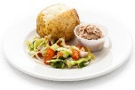
Soup and a deli choice  served with vegetable sticks  BLUE BAND | Sandwich  Choice of ham or cheese  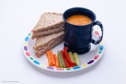 | Sandwich  Choice of chicken or cheese | Soft Bap (133712)  Choice of cheese or tuna mayonnaise | Sandwich  Choice of ham or cheese, | Sandwich  Choice of chicken or cheese  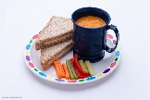
Choice of soup, home baking,  fruit or yoghurt | Lentil Soup  Fruit or Yoghurt | Vegetable Soup,  Sweet treat  or Fruit | Minestrone soup,  Fruit, Yoghurt or  Sweet treat | Vegetable Soup,  Ice cream  or Fruit | Lentil Soup,  Fruit or Yoghurt
Week Commencing – 23rd May- 13th June -22nd Aug – 12th Sept – 3rd Oct -31st Oct -21st Nov – 12th Dec 16th Jan –6th Feb – 27th Feb – 20th March – 24th April – 15th May

All meals are served with milk or tap water and two portions of vegetables. Pupils can also select either soup, fruit or home baking, as indicated on the menu to accompany their meal.

WEEK 3 | MONDAY | TUESDAY | WEDNESDAY | THURSDAY | FRIDAY
Hot Meal  RED BAND | Fish fingers* served with  mashed potatoes  and baked beans  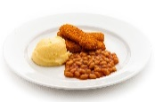 | Beef Lasagne (sheets: 28323) served with mixed salad, sweetcorn, and garlic bread 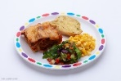 | Chicken curry  and rice served with a naan bread finger, sweetcorn and carrot  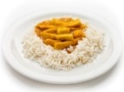 | Steak pie served with roast potatoes, broccoli and carrots  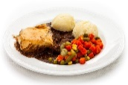 | Fish and chips with salad or peas
Hot Meal  Vegetarian (v) / Vegan (ve)  Alternative  GREEN BAND | Fishless fingers* served with  mashed potatoes  and baked beans | Cheese panini served with mixed salad, sweetcorn, and coleslaw (v) | Vegetable curry  and rice served with a naan bread finger, sweetcorn and carrot (v)  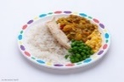 | Veggie sausage roll served with roast potatoes, sweetcorn and peas (ve)  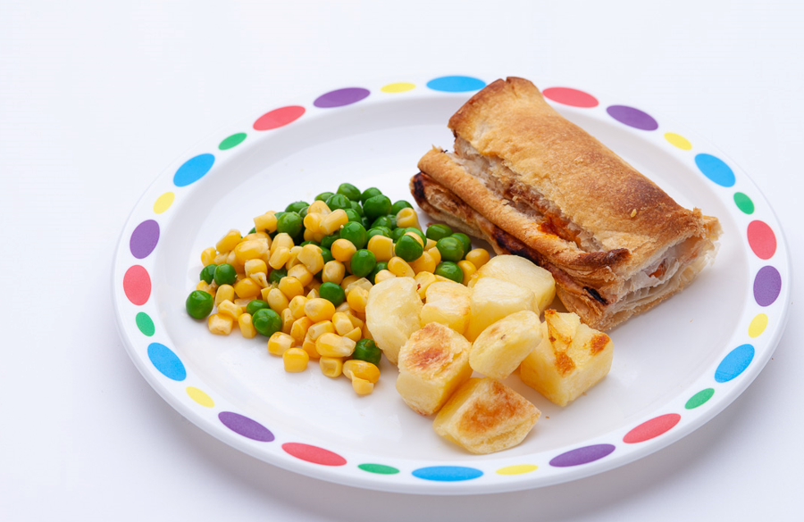 | Quorn Nuggets and chips served with salad or peas (v)  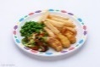
Baked Potato with a choice of filling  or  Pasta dish  YELLOW BAND | Baked potato served with  Tuna mayonnaise or cheese (v),  vegetable sticks and salad | Baked potato served with  baked beans (ve) or tuna mayonnaise, vegetable sticks and salad | Baked potato served with  Tuna mayonnaise or cheese (v),  vegetable sticks and salad | Baked potato served with  baked beans (ve) or tuna mayonnaise, vegetable sticks and salad | Baked potato served with cheese or tuna mayonnaise, vegetable sticks and salad
Soup and a deli choice  served with vegetable sticks  BLUE BAND | Sandwich  Choice of ham or cheese  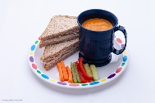 | Sandwich  Choice of chicken or cheese | Soft Bap (133712)  Choice of cheese or tuna mayonnaise | Sandwich  Choice of ham or cheese, | Sandwich  Choice of chicken or cheese
Choice of soup, home baking,  fruit or yoghurt | Lentil Soup  Fruit or Yoghurt | Tomato soup  Home Baking  Or Fruit | Chunky Vegetable Soup  Fruit or Yoghurt  Home Baking | Vegetable Soup  Ice cream Or Fruit | Lentil soup  Fruit or Yoghurt
Week Commencing – 30th May – 20th June – 29th Aug – 19th Sept – 10th Oct – 7th Nov – 28th Nov – 19th Dec – 23rd Jan – 13th Feb – 6th March – 27th March – 1st May – 22nd May
*Salmon
All meals are served with milk or tap water and two portions of vegetables. Pupils can also select either soup, fruit or home baking, as indicated on the menu to accompany their meal.

