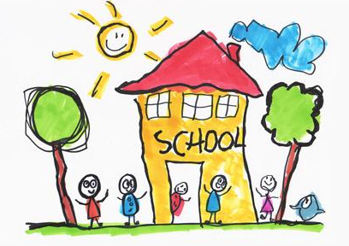

August 12th 2021
Dear Primary 1 Parents and Carers,
We are looking forward to your child starting school and hope the children are feeling really excited. We know that your child’s first day may be an emotional and worrying experience for you as a parent, especially in the current climate. Please be assured that we have been working hard to put special measures in place to ensure the start to the school day goes smoothly and is as special as possible whilst implementing Scottish Government guidance for the return to school.
One-way system
Primary 1 pupils have their own separate gate for entry at the start of the day and for collection at the end of the day. The gate is situated near our school pitch and sports pavilion, at the top of the hill in front of the playpark. Unfortunately parents are not permitted in our school playground. Therefore, we will have a one-way system in place.
Entry to school:
- One adult and child should enter by the Primary 1 gate.
- Primary One pupil is then dropped off just before playground gate where they will be met by a staff member and guided to class.
- Adults continue on long pathway (along pitch) and exit school via our staff carpark.
We are opting for a soft start for Primary 1 pupils. For Monday 16th and Tuesday 17th August; Primary 1 pupils can start between 9.30am and 10.00am. Please make use of this half hour soft start to avoid too many people arriving at the same time.
Collection:
- Primary 1 pupils can be collected at 2.45pm from the Primary 1 gate.
P1a (Mrs Wares) parents space out and stand along the long path.
P1b (Mrs Canning and Mrs Steven) parents space out around the triangular area to the side of the gate.
P1c (Miss Connelly) parents enter onto the pitch.
- Adults should spread out to maintain social distancing. We also kindly ask that parents wear a face mask to support us in keeping our school community safe.
- One way system remains in place for collection. Adults should enter P1 gate and move to allocated area as above.
- The class teacher will call the name of each individual pupil.
- As your child’s name is called, please step forward to collect your child and exit by the gate to the staff carpark. Please keep hold of your child’s hand when in this area.
We kindly remind you that parking in the staff carpark is not permitted.

From Wednesday 18th August school starting times for all pupils will be from 9.00am – 9.15am. This ‘soft start’ option prevents congestion around the school. Primary 1 pupils will continue to be collected at 2.45pm. We will follow the same procedures as outlined above.
I will attempt to make a short video to support drop-off and collection arrangements. Staff will be on site to offer support throughout.

Lunch and Collection Arrangements
Children can bring a packed lunch or have a lunch provided free by the school. If your child is ordering a school lunch please help the teacher by having a little chat with your child and discussing the menu (www.northlanarkshire.gov.uk/schools-and-learning/school-meals/meal-menus/primary-school-menu). Each morning your child’s class teacher will discuss the menu and place individual orders. It really helps if the children have had a chance to decide what they would like. Please inform the school of any dietary requirements or food allergies.
If your child is going to aftercare or going home on the school bus it is really important that parents inform the school. Your child’s safety is very important to us.
We will share photographs of the children settling in as we know how important it is for you to share in your child’s special first days of school. Keep a wee eye on our school website.
Thank you so much for your patience, cooperation and understanding. We look forward to working in partnership with you and can’t wait to see our new school pupils in their uniforms!!

Kindest regards.

Jennifer Hart
Depute Headteacher

