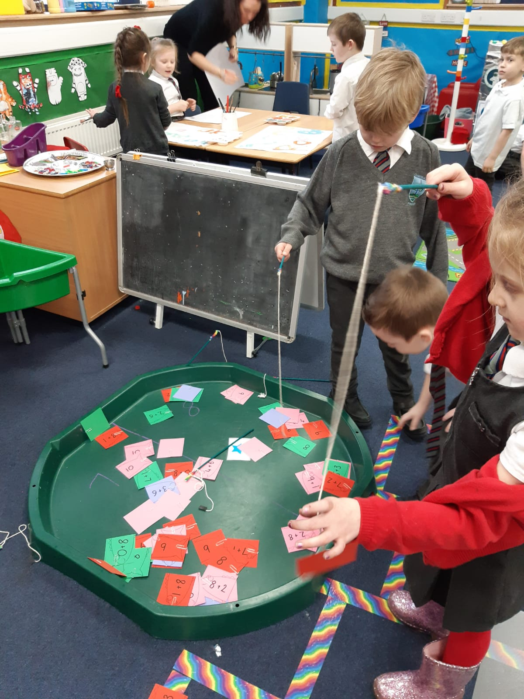
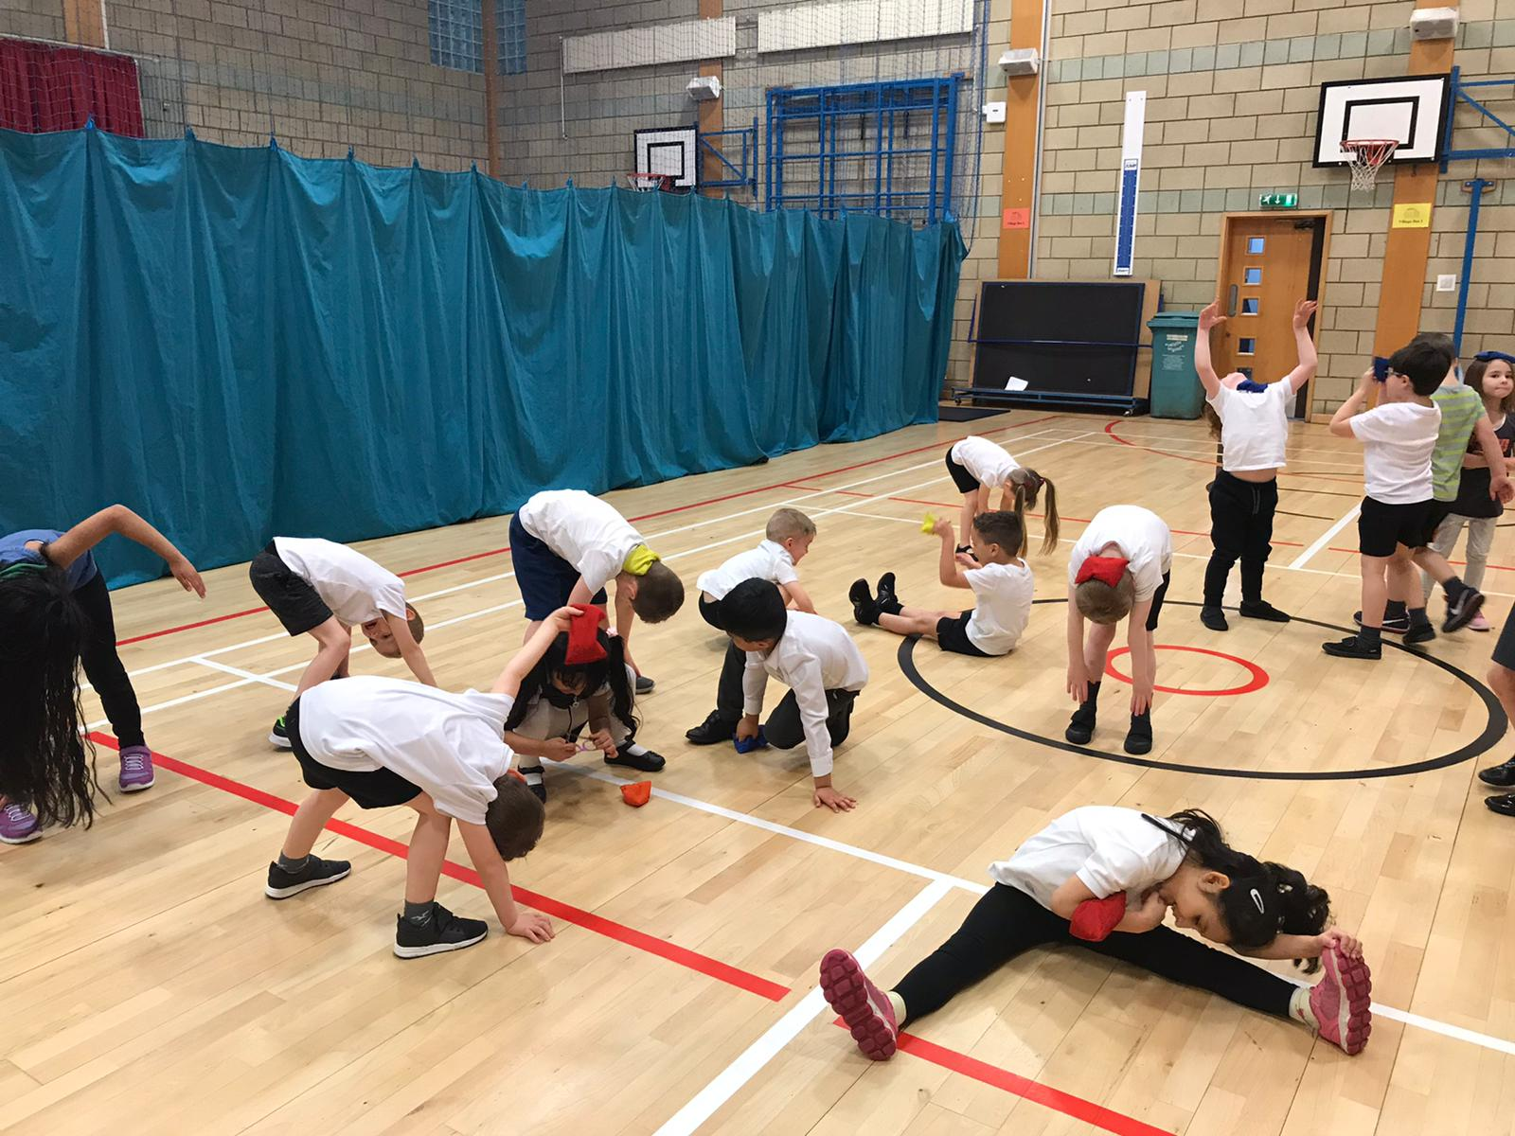
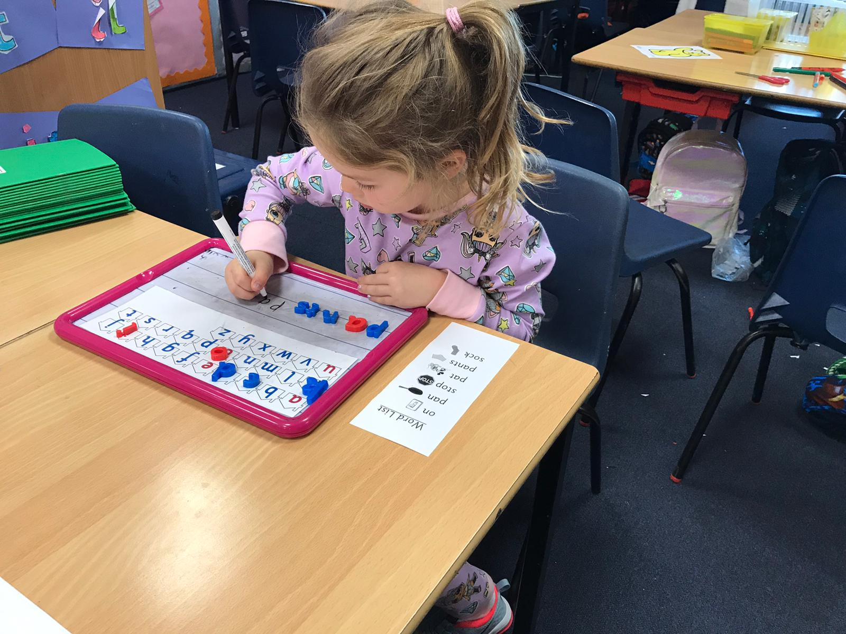

4th May 2021
Dear Parents and Carers,
I hope you are all well and the children are enjoying being back at nursery in the Spring Sunshine! We have lots of exciting things happening for transition in our summer term. We plan to send you videos from our Primary 1 staff and from our pupils so that you can get to know them better. We are making plans for a visit to the school and will be in touch with further information once we have received guidance from the authority. I have also been making phone calls to all of our nurseries this week. It has been so lovely to speak with key workers and nursery staff and have the opportunity to find out about the children’s likes, strengths and character. I will use this information to help me create the classes. Look out for a letter of introduction from your child’s teacher.
I have been blown away by the response to our Runaway Pizza Activity. Thank you so much for all of the wonderful photographs of the children’s pizzas. We now have a lovely Transition Display ready for your child starting school. It’s not too late to send in your photograph. You can send it to enquiries@cumbernauld-pri.n-lanark.sch.uk .
Today, I have sent you a PowerPoint Tour of the school. I hope that this will give you and your child a little taster of what our school looks like on the inside and also what the children get up to each week. I’m sure you will understand that Coronavirus has impacted on some of our weekly activities and routines but I wanted to give you a flavour of our whole school in the hope that things will be able to return to some form of normality in the future. The PowerPoint will also be added to our Transition Area on our website. Please use the link below to watch and discuss the slide show with your child.
Link for PowerPoint
https://www.youtube.com/watch?v=7BlXEQg4dGc
Thank you so much for supporting the school to ensure a smooth and happy transition for your child.
Kindest regards.
Jenny Hart
Depute Head Teacher

