Cumbernauld Primary School
Nursery to Primary 1 Transition 2021-2022
‘Questions You Might Have’
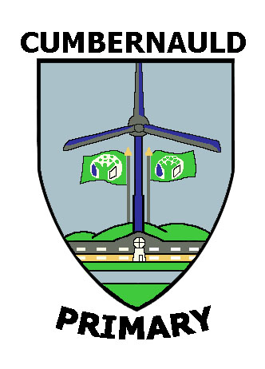

What is the school uniform?
At Cumbernauld Primary School pupils wear:
- A white shirt
- Cumbernauld Primary School Tie
- Grey trousers/shorts/skirt/pinafore
- Grey cardigan/jumper/slipover
We will add some photographs of our pupils in their school uniforms in ‘Our Tour of the School’ PowerPoint (coming soon).
P.E. kit
- White t-shirt
- Dark shorts
- Gym shoes or trainers
We also participate in outdoor P.E. so children require leisure bottoms and sweatshirt with outdoor trainers. Please make sure everything is labelled.

Where can I get school uniform?
Scotcrest Uniforms in Airdrie are the suppliers of our school tie and additional items of uniform. Please see the contact details below. https://scotcrestschools.co.uk
(Most recent information on website states that the shop is closed so only accepting online orders to be delivered).
Grey cardigans, jumpers, trousers etc. can be purchased from a wide variety of clothes shops and supermarkets.
Please know for any families in need there is support in providing school uniform through a wonderful charity known as Cumbernauld and Kilsyth Care. You can contact them on www.cumbernauldkilsythcare.org.uk . Let us know if we can support you in anyway.

Is there a Breakfast Club?
The school normally provides a Breakfast Club from 8.15am to 8.45am. Toast, cereal, fruit juice and milk are offered. We ask that children arrive between 8.15am and 8.30am to allow them time to eat their breakfast. Children go into the supervised playground from 8.45am.

What about lunch?
Children in Primaries 1-3 are entitled to a free school lunch. Menus are posted on our website and updated regularly. Each day the class teacher supports pupils when making their lunch selection
Children can bring a packed lunch to school if they prefer.

Transport
If your child is entitled to free school transport then you should have completed a transport form as instructed by our office staff via email.
In the morning school staff are positioned at the school gate to welcome children off the bus and into the playground.
At home time children are escorted on to the bus by school staff who ensure they are wearing their seatbelts.

I hope you have found the information useful. We will keep you updated as we learn new information. Thank you so much for your support and cooperation. We will be in touch shortly and look forward to getting to know you and your child over the coming months.

Jenny Hart
Depute Head Teacher

