How to log into GLOW

- Go to www.glowconnect.org.uk
- Click on ‘Log in to GLOW’ and enter login details.
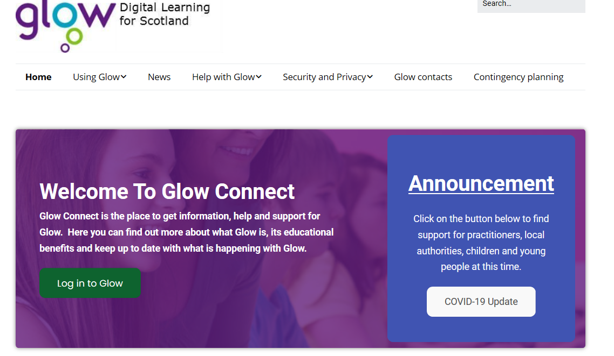

OR

OR
- Google/search ‘glow login’
- Click on link
