How to access Teams on GLOW

- Go to www.glowconnect.org.uk
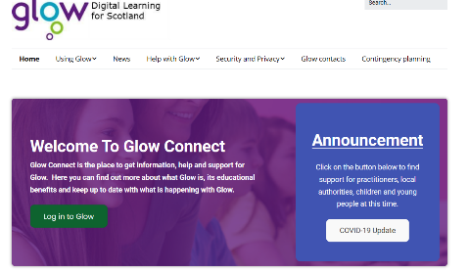
- Click on ‘Log in to GLOW’ and enter login details.

- Click on app library

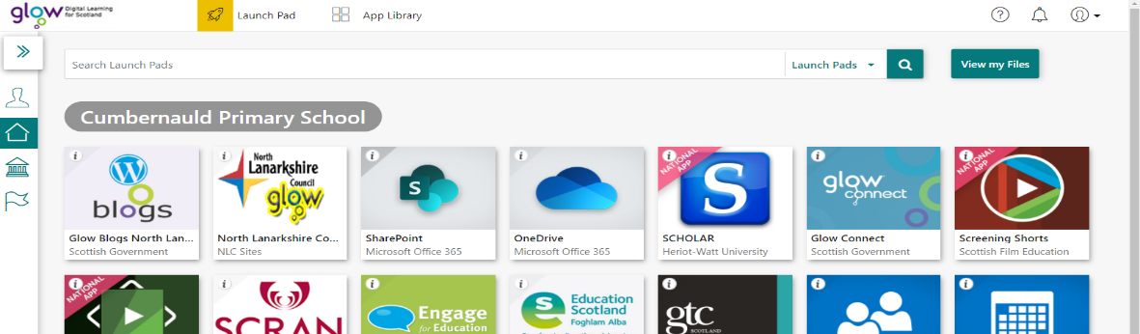

- Search ‘Teams’.
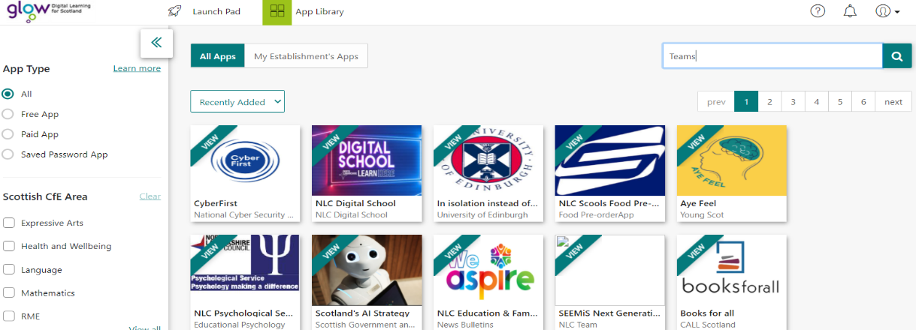

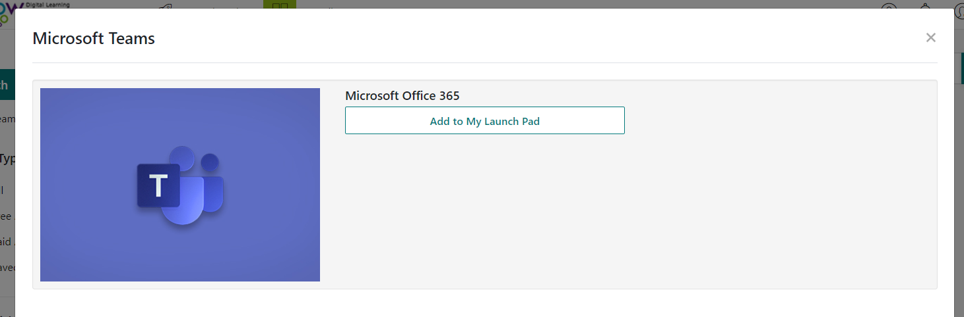
- Click on ‘Teams’ then add to launch pad for easy access.

- Open ‘Teams’ to access your class team.

