Why not create an Easter picture for your window? (Just like the rainbows that have been appearing in people’s windows) It might help brighten someone’s day!  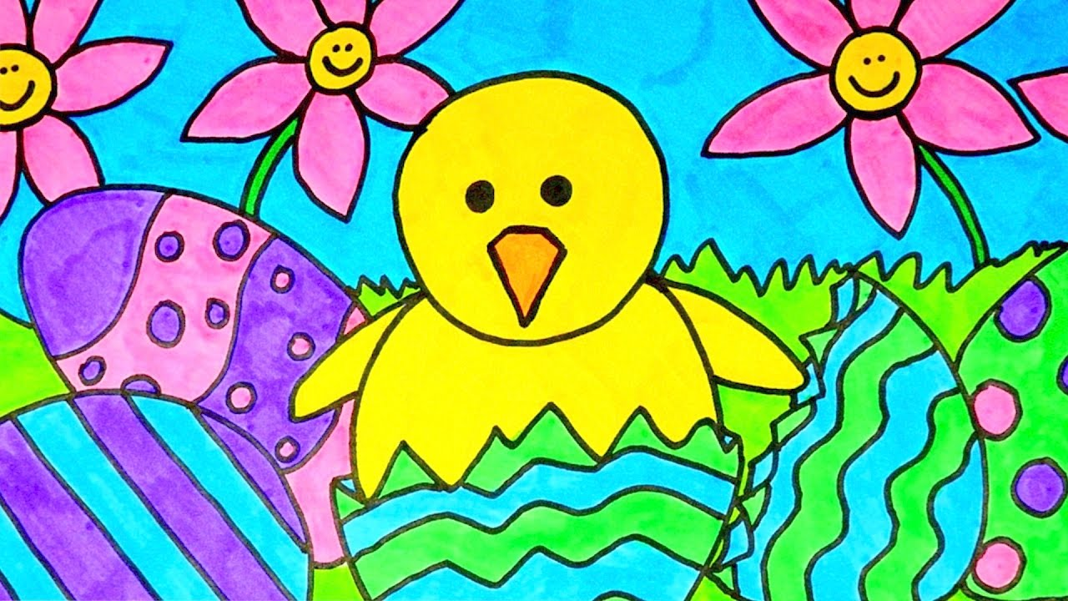 | Create an Easter Egg Hunt for your family in the house or garden. You could create clues and riddles to guide them round your hunt. What will the prize at the end be?   | Why not draw a map for your Easter Egg Hunt?  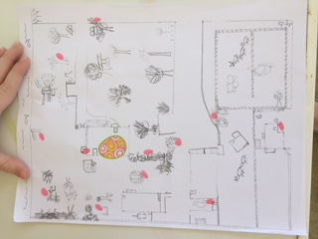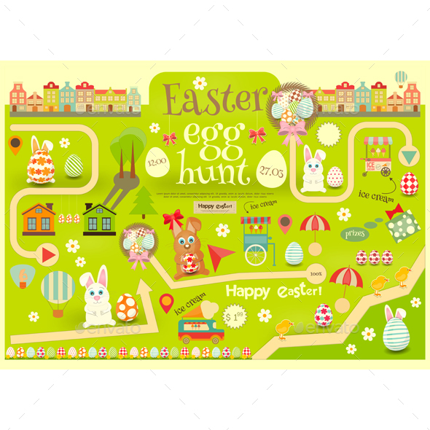 | Decorate an egg.  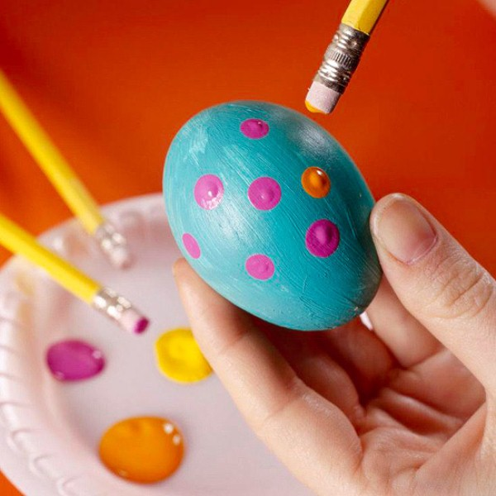
Why not try some Easter baking or cooking with ingredients you have in the house?   | Make an Easter card for someone you love or care about.  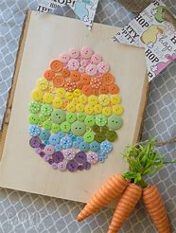 | Make an Easter/Spring Themed obstacle course in your garden. Who is the fastest? Who is the funniest?  There could be bunny hops and leap frogs.   | Create an Easter bonnet using materials you have round the house – paper plates/newspaper. Don’t use any toilet roll!!  