Step 1 – Sign in to Glow
Visit the Glow sign in screen: https://glow.rmunify.com/

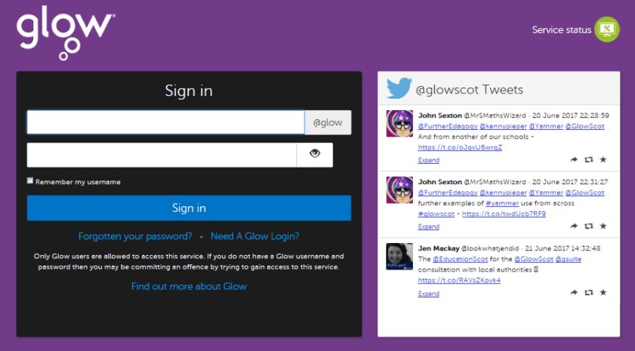
Enter your username and password in the boxes shown (clicking the eye icon allows you to see your password as you type it in) then click ‘Sign in’.
Step 2
That should take you to your launch pad. It looks like this:
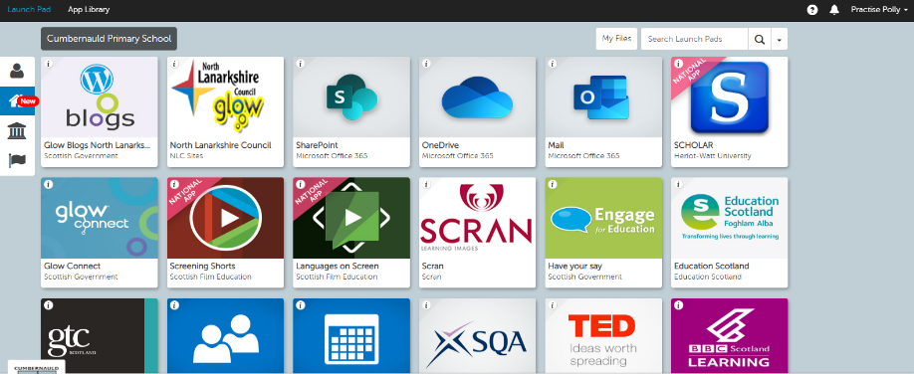

Step 3
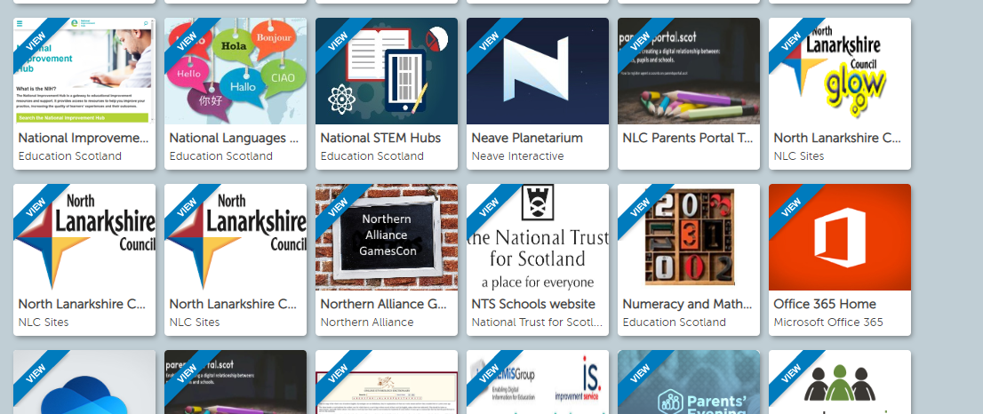
- Locate office 365 home on your launch pad.

Step 4 and 5
- Open Microsoft office 365 to access a range of apps.
- Click on Teams.
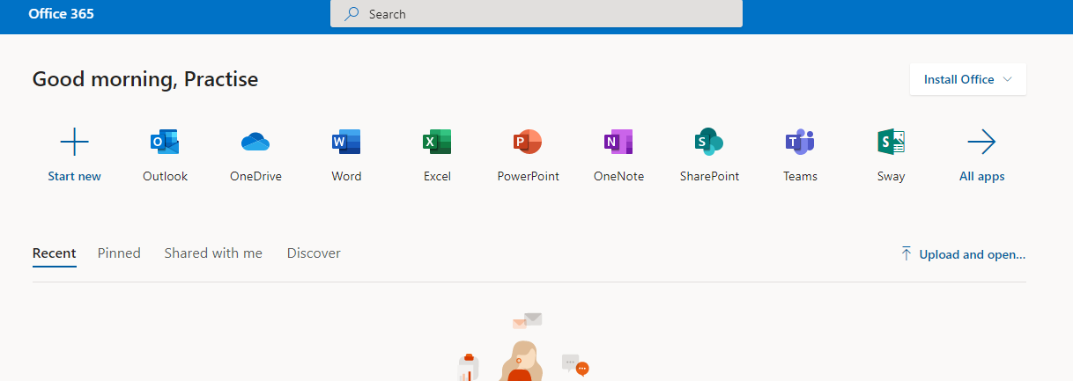
Step 2
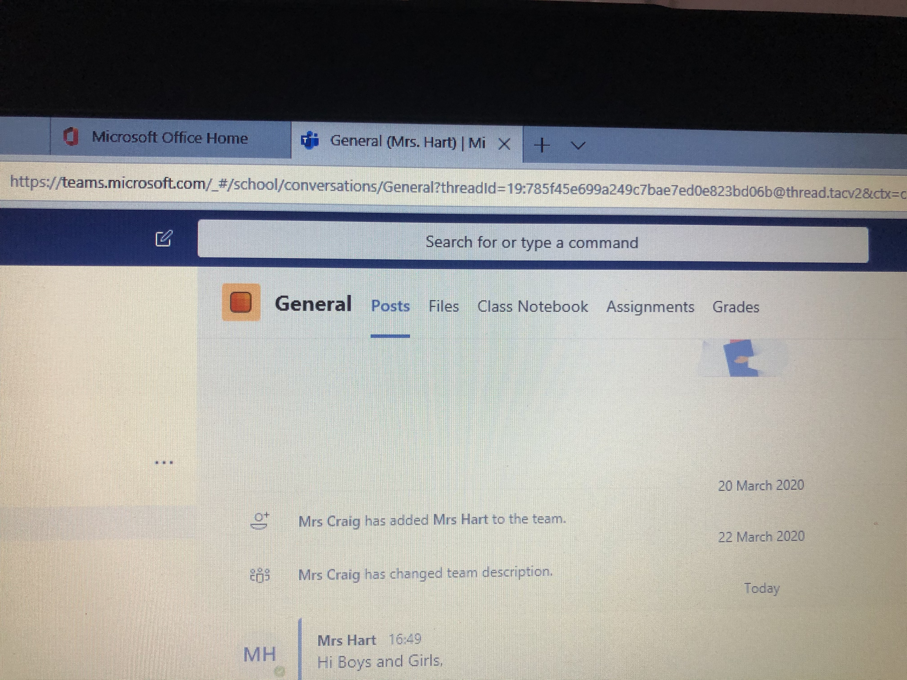
Step 7
- Have a look in files to see if your teacher has set a task for you. Good luck!
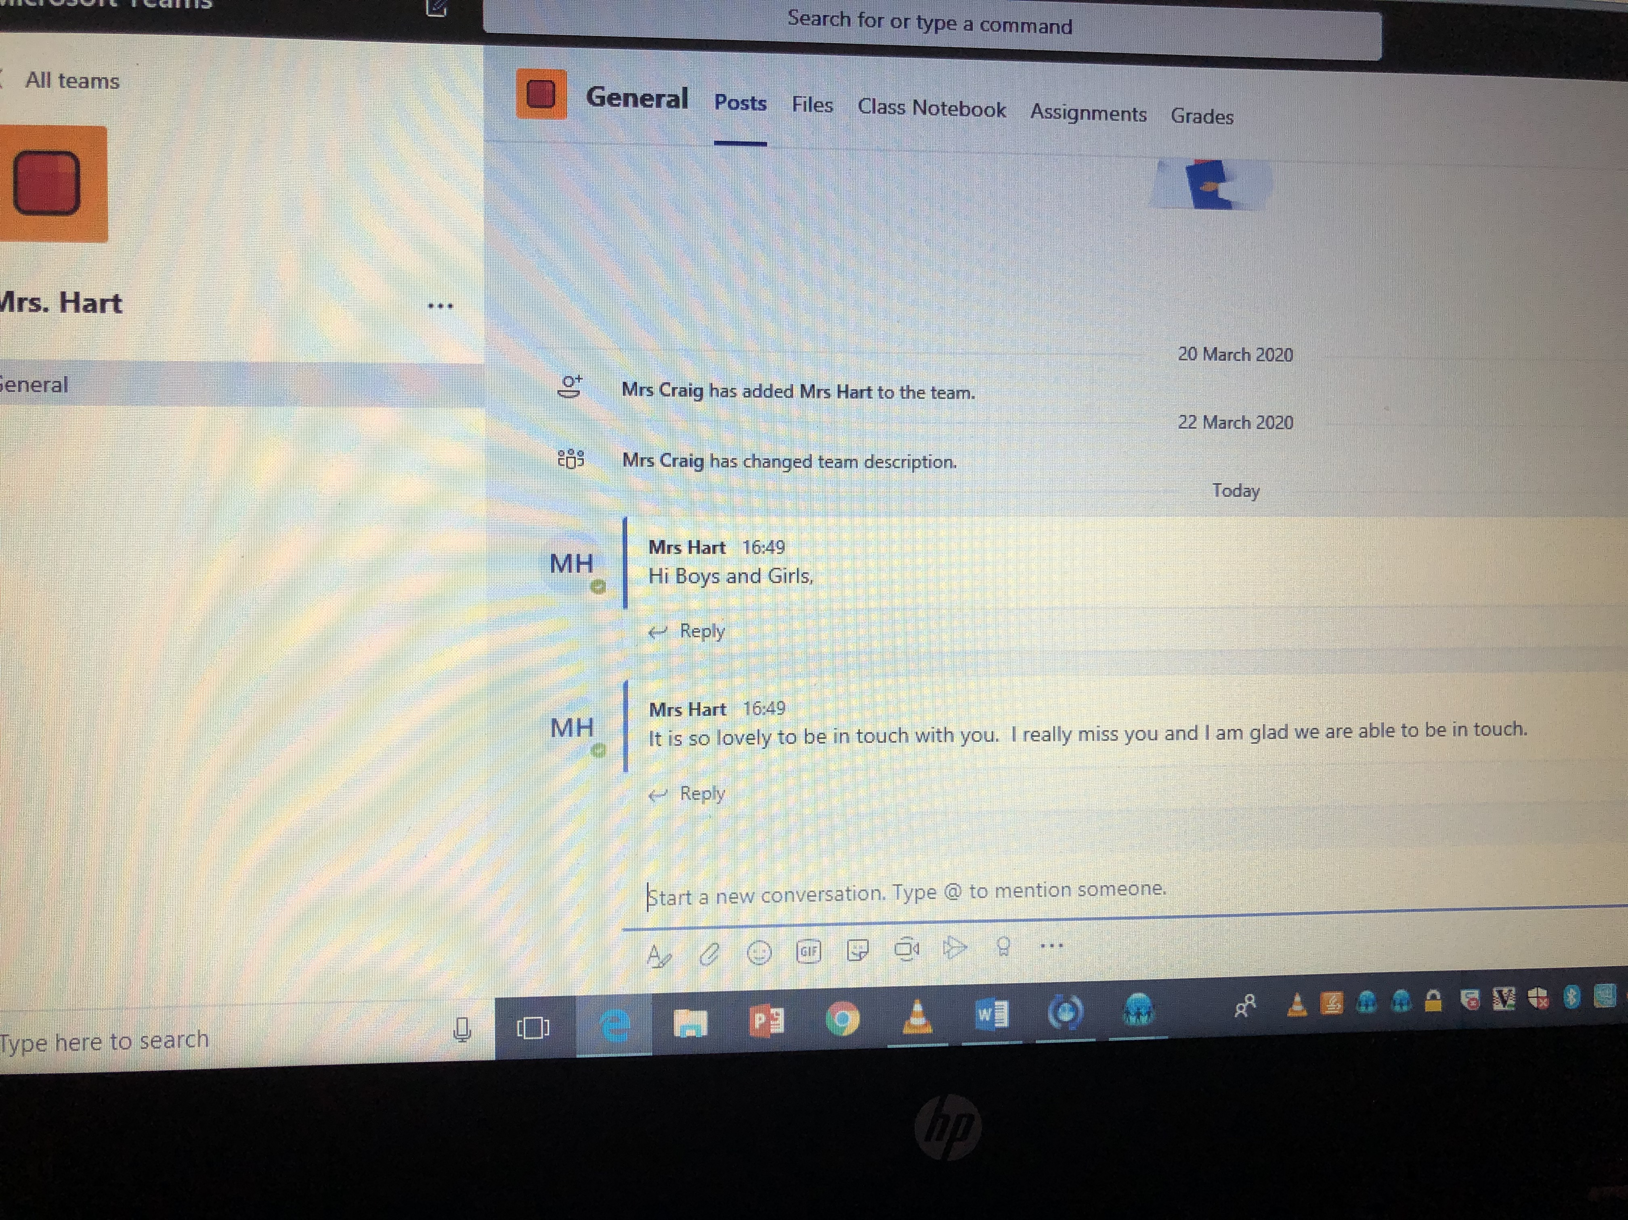
- You will see messages from your teacher and questions from your classmates.
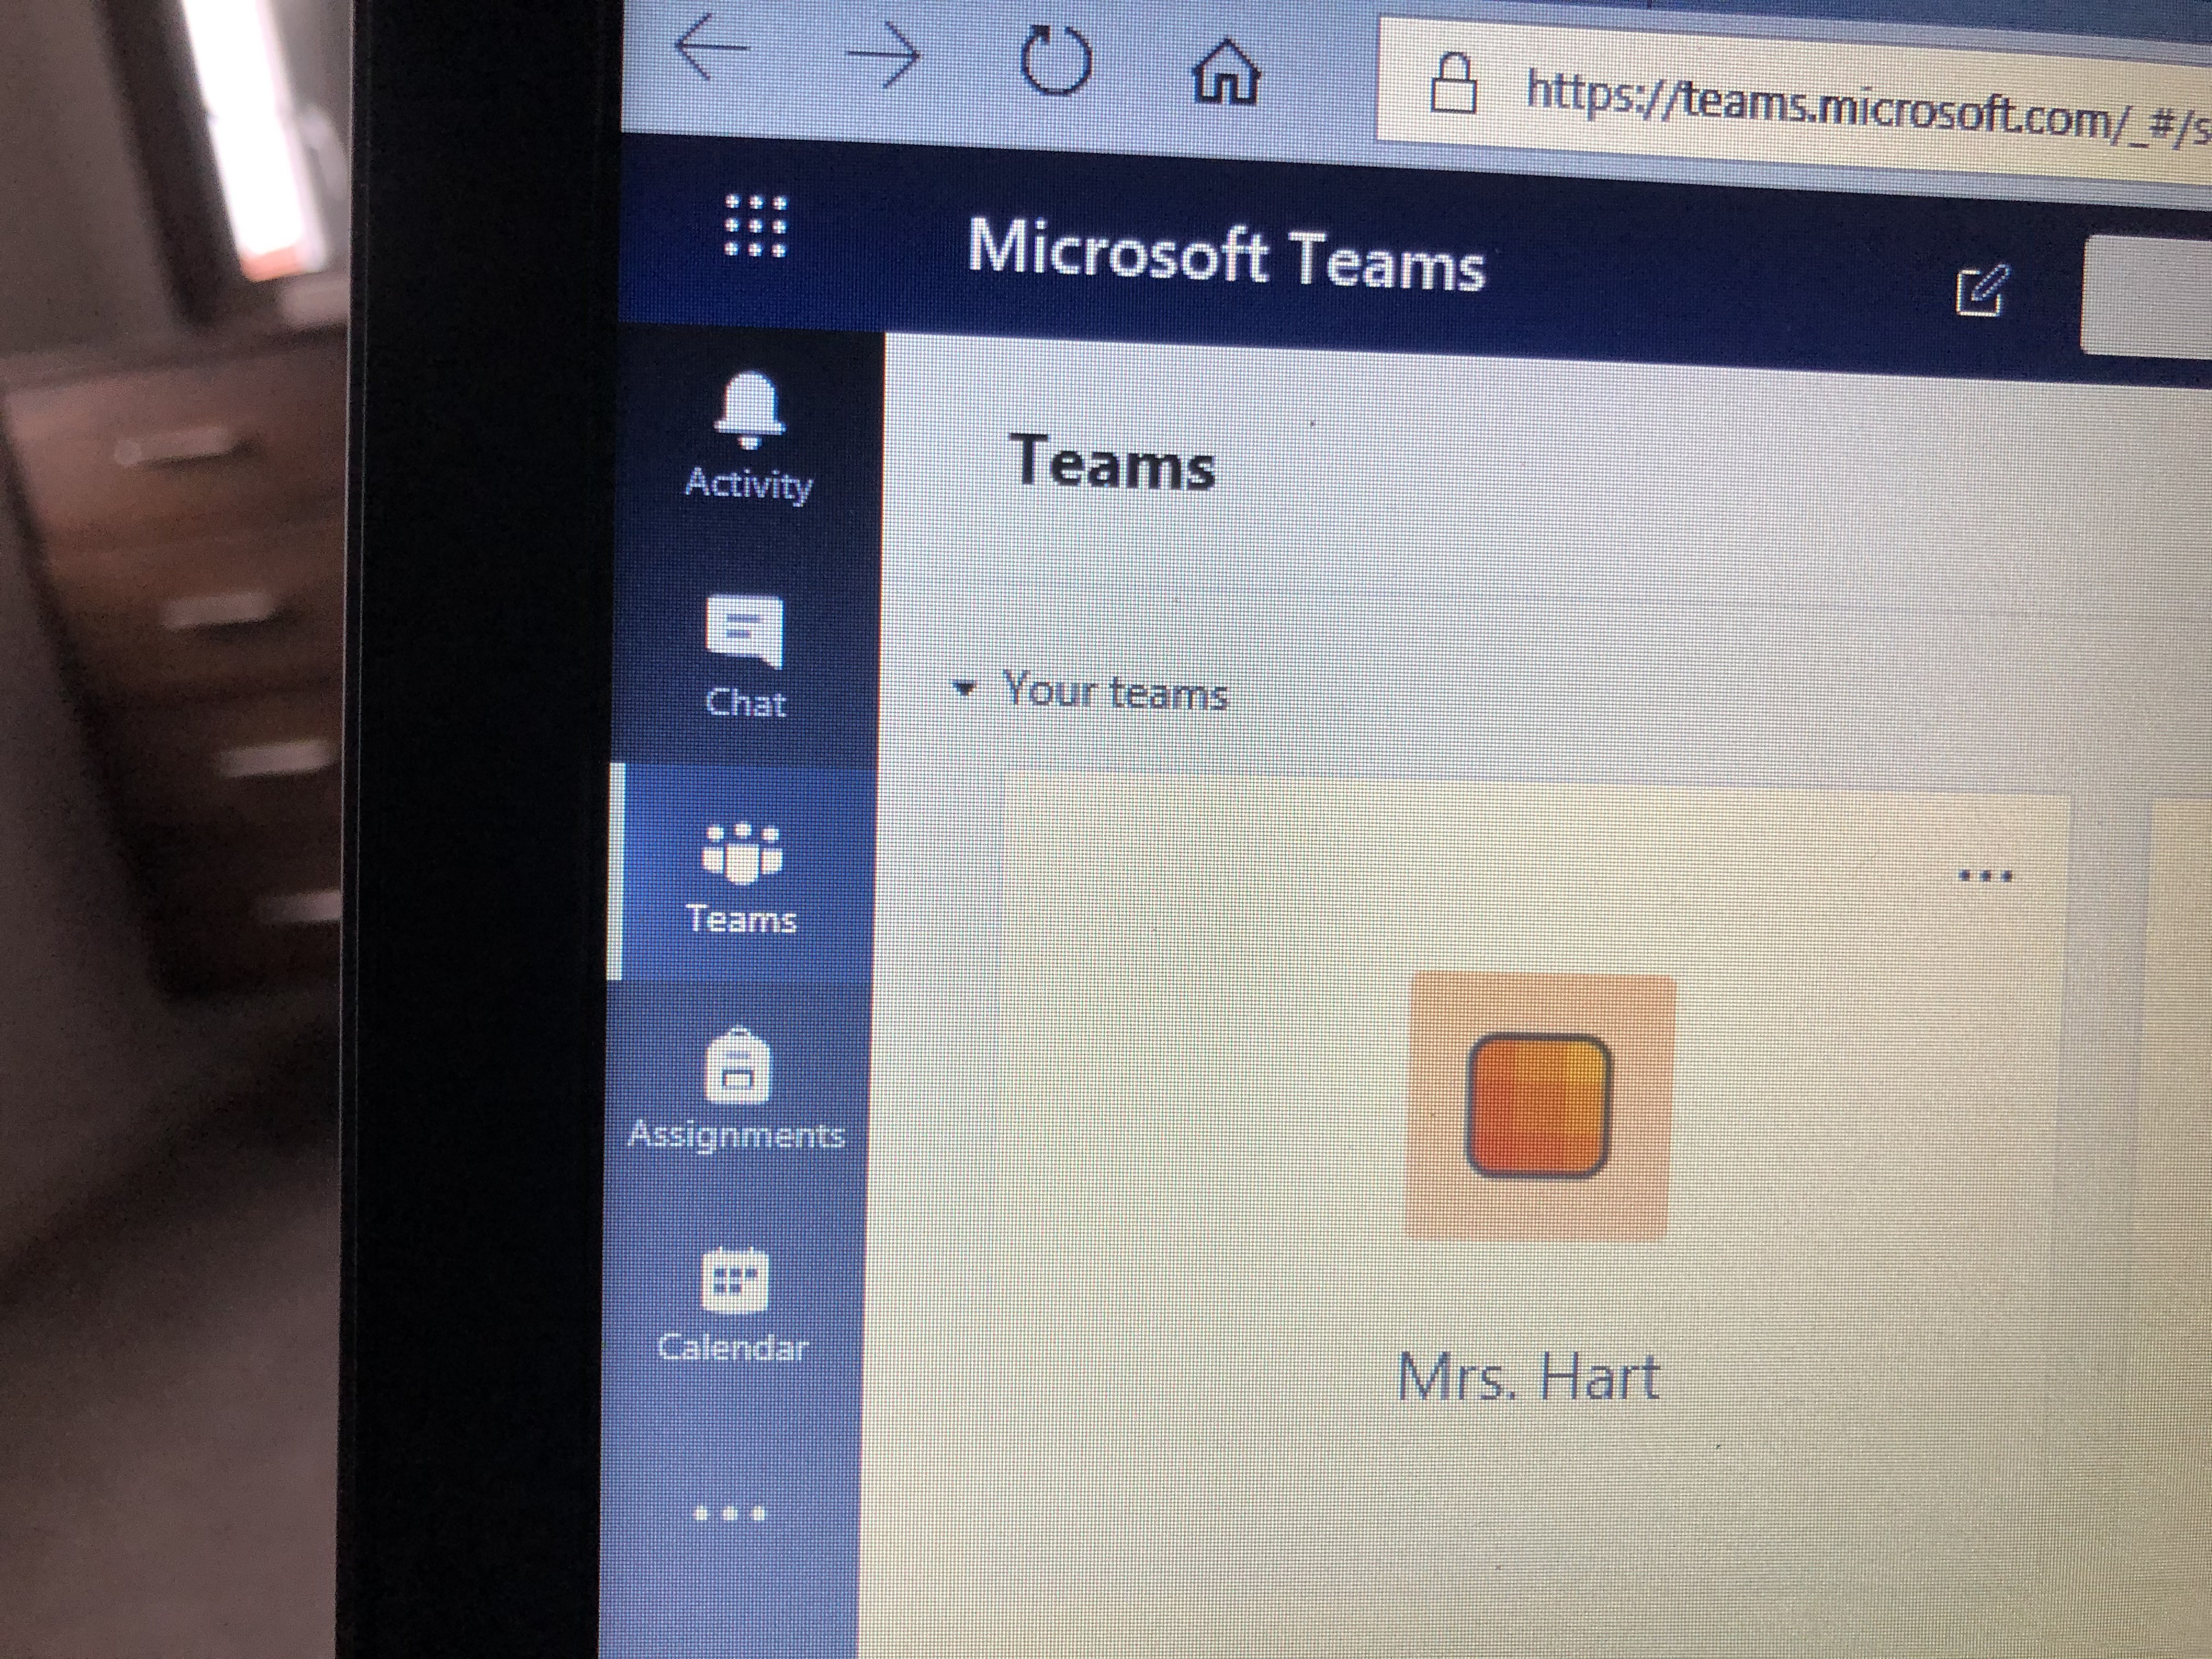
Step 6
- That should take you to your teams – ready to hook up with your teacher and your tasks. Just press your team icon button.

