Being off School

You might have heard about people talking about Coronavirus or Covid-19. This is a bug that can make people sick. They may begin to cough 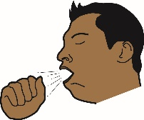 or get a high temperature 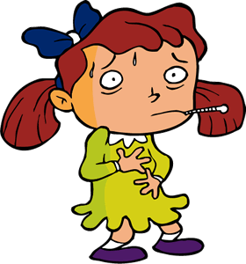 and some people have to go to hospital. 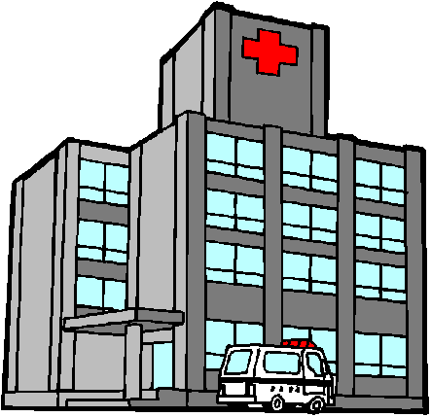

We can try and stop ourselves from getting sick by washing our hands more for at least 20 seconds. 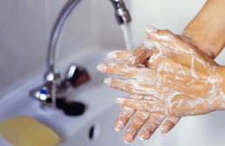
Coughing into our elbows or a tissue that we bin straight away. 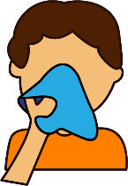

To stop as many people as possible from getting sick, the schools are going to close for a while to try and stop the bug from spreading. 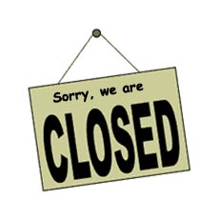

This is to protect you, your friends and adults in the school and in your family. 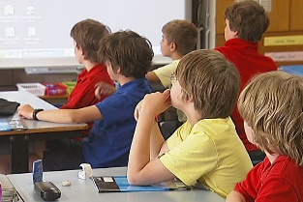

Your teachers will give you some work to do at home to keep you busy and help you to keep learning. 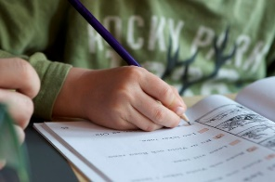

The adults in your home will help you stay up to date with when school is open again. We don’t know when this will be at the moment. 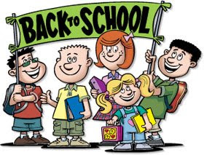

There are some things we can do to help us feel happy and healthy when we are off school.
Get our bodies moving and do some exercise. 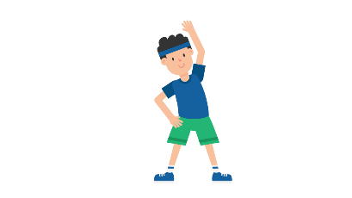

Eat some healthy fruit and vegetables if you can.

Speak to a trusted adult if you feel upset or have any worries. 