Coronavirus
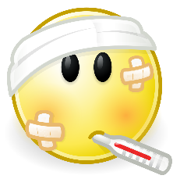
Sometimes, people get ill. .At the moment, lots of people are getting ill.
This Photo by Unknown Author is licensed under CC BY-SA

There is a new illness called coronavirus which is making people ill in lots of different places all over the world.
This Photo by Unknown Author is licensed under CC BY-SA

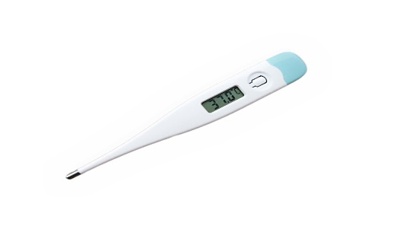
Coronavirus is making lots of people ill. People with coronavirus may have a fever or a cough.
This Photo by Unknown Author is licensed under CC BY-SA

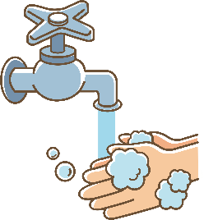
To keep healthy, I need to wash my hands throughout the day to keep them clean. I need to wash my hands for 20 seconds. My parents/carers will help me work out the best way to make sure I wash them for 20 seconds. I can choose a song to help me time this.

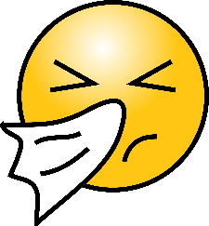
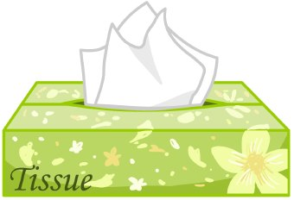
If I cough or sneeze, I should cover my mouth and nose with a tissue, put the tissue in the bin and then wash my hands.
This Photo by Unknown Author is licensed under CC BY-ND

Sometimes when people are ill, they need time at home to get better. This is OK.
When lots of people are ill at the same time, schools and busy places may close. This is OK. Closing schools and busy places will help stop coronavirus spreading.

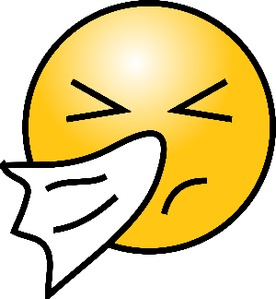
To keep healthy, I need to cover my mouth with a tissue when I cough or sneeze, wash my hands and I may need to stay at home. This is OK. My parents/carers and staff will be proud of me for doing this.

