Cumbernauld Primary School
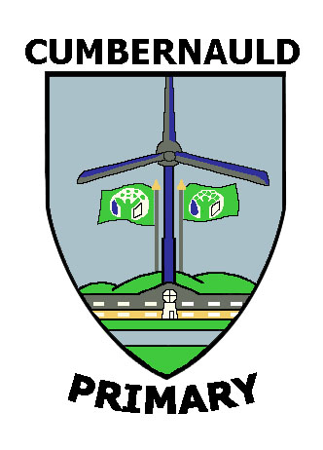
6 Kinds of RESPECT
I respect myself | I respect others | I respect the environment | I respect my learning | I respect my achievements | I respect my community
- I make good choices about my learning and behaviour  - I want to learn  - I know how to stay safe and avoid danger  - I eat healthy foods  - I exercise  - I know how to relax  - I know my strengths and weaknesses  - I like myself  - I stand up for myself  - I am proud to be unique and special  - I have a good sense of identity  - I am happy  - I am positive  - I have good friends | - I respect the rights of others  - I respect the views of others  - I am tolerant and understand difference  - I don’t bully or put people down  - I co-operate with others  - I am a good team player  - I value friends, family and relationships  - I am polite and mannerly  - I let everyone have a fair go  - I listen to others, I share and can take my turn  - I am kind to others  - I work together to find a solution  - I praise and encourage others | - I care for all living things  - I help to look after natural habitats, plants and trees and flowers  - I try to save energy  - I reduce, reuse and recycle  - I clean up after myself and never drop litter  - I am aware of and use products that are environmentally friendly  - I get involved in projects which help to support our environment | - I value my learning opportunities  - I try my best  - I am a positive learner – ‘have a go’  - I am curious and want to learn about the world around me  - I am a good listener and learn from others  - I learn from my mistakes  - I know what kind of learner I am  - I am creative and innovative  - I always do my homework  - I am a critical thinker | - I try lots of different things – challenge myself  - I know what I am good at and what I enjoy  - I have a ‘have a go’ attitude  - I do my best and want to achieve  - I pursue excellence  - I set myself goals and targets  - I persevere and never give up  - I have good communication skills  - I make good choices about my purpose and role models  - I show good leadership skills  - I have aspirations about what I want to do | - I can follow rules  - I behave  responsibly  - I am honest and seek the truth  - I am useful and get involved in community projects  - I share with and care for those in need  - I strive for justice and a fair go for all  - I support freedom  - I strive for peace

