

Literacy and English tasks

**Week beginning** 29/10/18 **–** Pyramid Spelling

**Week beginning** 05/11/18 **–** Ask an adult or a friend to read you out your spelling words. How many can you get correct in your jotter?

Chryston Primary 5 Homework 5 55sheet

Numeracy and Mathematics tasks

**Week beginning 29/10/18** –Multiplication Worksheet.

**Week beginning 05/11/18** **–**Division Worksheet.

Spelling word list- learn

|  |  |
| --- | --- |
| giving | sack |
| taking | actress |
| hoping | saucer |
| getting | sense |
| tanned | service |
| tripped | suggest |

Reading

**Week beginning** 29/10/18- read two chapters of your group novel

**Week beginning** 05/11/18- read two chapters of your group novel

Learn its - You need to know learn its off by heart.

Beat an adult:

Race an adult (or older sibling) at home to see who can write out their 8 and 9 times table the fastest!



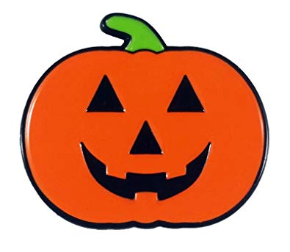

Create a Spooktacular Halloween Decoration to display in our class.

Optional tasks:

These tasks are **not** compulsory.

Write a few descriptive sentences about Bonfire Night. Think about your 5 senses, what could you smell, hear, see, taste, and touch?