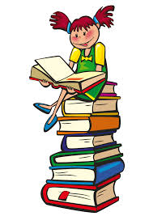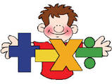

Learn Its

60mins= 1 hour

90 mins= 1 hour 30mins

120 mins= 2 hours

150mins= 2 hours 30 mins

180mins= 3 hours

Numeracy and Mathematics tasks

**Week beginning 12/03/18** – Record the start and end times of your favourite television shows and record the durations of each. Record at least 5 in your jotter.

**Week beginning 19/03/18**- Choose maths games to play on <https://www.topmarks.co.uk/>

List the names of the games you played in your jotter and score them out of 10.

Literacy and English tasks

**Week beginning 12/03/18**– Choose 8 words and make word jumbles for each. Ask a friend to solve them in class.

**Nouns**- next 2 pgs of spelling/phonics booklets then an IDL module.

**Week beginning 19/03/18** –Your spelling words this week are homophones. Write sentences for 6 words to show their different meanings.

**Nouns**- next 2 pgs of spelling/phonics booklets then an IDL module.

**Week beginning 12/03/18**– Read 2/3 chapters of your home reader. Draw a character from the story and write at least two sentences about them.

**Week beginning 19/03/18** – Read 2/3 chapters of your home reader. Record in your jotter a list of nouns and adjectives from the section you have read.

*Remember to borrow a book from the class library if you need to.

.

Create a piece of spring themed art. You can use any materials you wish.

Spelling word list-(Write in your jotter each week)

|  |  |
| --- | --- |
| break | brake |
| cent | scent |
| course | coarse |
| him | hymn |
| sight | site |
| reel | real |

Chryston Primary 5 Homework March

The government has launched a campaign to encourage parents to give their children two, one hundred calorie snacks a day, out with main meals.

Research snacks that are approximately 100 calories. You can cut pictures out of magazines then stick them into your jotter or draw them.

Choice Tasks- Complete one task per week.



Explore the following website-

http://kids.saveonenergy.ca/en/what-is-electricity/

Complete independently or work alongside an adult to carry out a house hold chore. Write a paragraph about what you did and what you learned.