Bochdainn-bìdh Food Poverty
What is in place in school?
- Breakfast Club is open in school from 8:15am. This is free to all pupils in P1-P3, and all who are entitled to a free school meal.
- All staff will ensure that any child who arrives at school hungry will be offered breakfast regardless of whether they are entitled to a free breakfast or not.
- Club 365 is available to families during holiday periods.
- Parents can apply for free school meals at: fsm@northlan.gov.uk
As our dinner hall is cashless, there is no obvious distinction between those who receive a free school meal and those who do not.
What support is available out-with school?
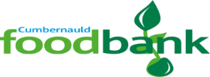
There are a number of foodbanks available in the Cumbernauld area. These require a referral from the school or another agency. Please contact Mrs Price if you wish a referral to be made.

https://cumbernauld.foodbank.org.uk/
If you find your family are experiencing food crisis please contact the school for immediate support until a referral can be made. No family should be hungry.
All discussions will be held in the strictest confidence. We are here to help.
A’ Barraicheadh Teachd A-staigh Maximising Income
What is in place in school?
- All our pupils learn about managing finances as part of the curriculum.
- The financial team attend some open afternoons to offer advice to parents if needed.
What support is available out-with school?
The Financial Inclusion Team can offer support to families in order to maximise benefits, manage debts and offer money advice.
School staff or other professionals such as health visitors, can make a request for assistance to this team on behalf of a parent via email.
Parents can request assistance from the Financial Inclusion Team independently by calling 01698 332551.

The Cumbernauld and Kilsyth Citizens Advice Bureau can also provide advice and links to other services. They can be contacted on 01236 723201 or at: bureau@cumbernauldcab.casonline.org.uk
Bochdainn Conadh agus Stuthan Fuel & Material Poverty
What is in place in school?
- All materials needed for learning within school are provided.
- The school will be starting a uniform bank in the near future.
- Parents can apply for a clothing grant at: fsm@northlan.gov.uk
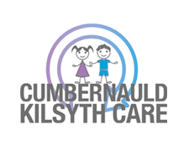
What support is available out-with school?

The Cumbernauld & Kilsyth Baby Bank provides general clothing from birth to teenagers, baby and toddler essentials as well as school uniforms including coats and essentials such as underwear (all new). Referrals to this can be made via the school, health visitor, social work or charities. Further information can be found at: www.cumbernauldkilsythcare.org.uk
Help can also be sought through the Citizens Advice Bureau and Social work. Cumbernauld Social Work can be contacted on 01236 638700.
If you find your family are experiencing fuel or material poverty please contact the school for immediate support until an appropriate referral can be made to support your family.
Remember all discussions will be held in the strictest confidence. We are here to help.

