Coltness High School



S2 Geography

Rich World/Poor World

**Course**

* To learn about the different names for rich and poor countries, and where they are found/located.
* To find out about the living conditions in poor countries.
* To learn about Indicators of Development, which show how we know if a country is rich or poor.
* To find out about Medical Geography e.g. malaria and malnutrition diseases in poor countries.
* To learn about either Brazil as an example of a poor country, or Japan as a rich country.

**Terms for Rich and Poor Countries**

Rich countries are called **Developed Countries** e.g. the USA, France and Australia.

Poor countries are called **Developing Countries** and the **Third World** e.g. Tanzania, Ethiopia and Bangladesh.

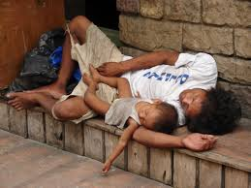

**The North/South Divide**

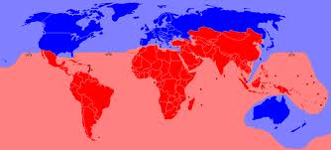

**LOCATION**

1. Developed countries are found in the **Northern Hemisphere**, apart from Australia and New Zealand. Developing countries are found in the **Southern Hemisphere**.

**The RICH North**

1. Most countries in the North are **developed** as **most** people work in **factories** or **offices.** They then earn a **decent wage**, and also pay **taxes** to the **Government** which it can use to fund **health** and **education**. **Most** people live in towns and cities, in **good** houses with **clean water**, **sanitation** (**toilets**).

**The POOR South**

1. Most people in developing countries are **SUBSISTENCE** farmers and live in the countryside. SUBSISTENCE farmers only grow enough food to feed themselves: they do **NOT** pay **taxes** to the **Government**, so it can’t fund **healthcare** and **education** in **every** place. This means that **many** people **can’t read and write**, and that **many** have **no access** to a **doctor**. The **majority** live in **poor** houses, with **no clean** **water and sanitation (toilets).**

**TASKS**

1. Cut, and stick a copy of the North/South Divide map into your jotter. Under this, make a **FACT FILE** of information about **DEVELOPED** and **DEVELOPING** countries. Include names, location and reasons why the North is rich, and the South poor.
2. **HOMEWORK**: Pick a poor country of your choice, and find out 4 reasons why it is poor. You can research this on the **INTERNET**.

**CASE STUDY: Kibera, a SHANTY TOWN in Nairobi, Kenya**

**FACT FILE**

**Kibera, Nairobi, Kenya, Africa**

* 3 billion people live on less than £1.50 per day. This means that more than ½ of the world’s population live in dire poverty.
* Kibera is the largest shanty town in Africa, with 1 million people crowded into 1 and ½ miles. The government has declared Kibera to be an illegal settlement, so doesn’t provide healthcare, schools, clean water and sanitation.
* Public toilets are holes in the ground and are shared by up to 1000 people. The toilets have to be emptied by hand, with the waste being dumped in rivers people use for washing and drinking. This leads to diseases like cholera and typhoid.
* People have to pay money for clean water, and many can’t afford to do this.
* Shanty towns like Kibera are dangerous places, especially at night. There is lots of violent crime, and the police do not patrol the area.

**TASKS**

Use your **DVD notes**, the **Kibera Fact File**, and the information on **pages 114 and 115** in **Connections,** and any **personal internet research,** to write a detailed **blog/diary entry,** on **life** and **living conditions** in **Kibera**. Include the **sources** you used at the end i.e. where you found your information.

**SUCCESS CRITERIA**

1. Using detail from the fact file describe what is life like in this **SHANTY TOWN**.
2. Why do people migrate to shanty towns like Kibera?
3. What are the houses are made of?
4. What happened to Bernard and his family?
5. Describe the jobs Lenny, Angela, Reggie and Samantha had to do?
6. Would you like to live here? Explain your answer.

|  |  |  |  |  |  |  |  |  |  |  |
| --- | --- | --- | --- | --- | --- | --- | --- | --- | --- | --- |
| **Success Criteria** |  |  |  |  |  |  |  |  |  |  |
| Shanty Town Facts |  |  |  |  |  |  |  |  |  |  |
| Reasons for migration |  |  |  |  |  |  |  |  |  |  |
| Houses |  |  |  |  |  |  |  |  |  |  |
| Bernard and his family |  |  |  |  |  |  |  |  |  |  |
| Jobs Celebrities do |  |  |  |  |  |  |  |  |  |  |
| Want to live there? |  |  |  |  |  |  |  |  |  |  |
| Sources |  |  |  |  |  |  |  |  |  |  |
| /10 |  |  |  |  |  |  |  |  |  |  |

**Indicators of Development**

Indicators of development can tell us whether a country is **DEVELOPED** (rich) or **DEVELOPING** (poor). They can be divided into **SOCIAL** **INDICATORS** (to do with people) and **ECONOMIC** indicators (to do with money).

**TASKS**

1. What do a) **SOCIAL INDICATORS**, and b) **ECONOMIC** **INDICATORS** tell us about a country?

**INDICATORS of DEVELOPMENT**

We can work out whether or not a country is rich or poor using **INDICATORS of DEVELOPMENT**.

**SOCIAL INDICATORS**

* **ADULT LITERACY RATE** is the % of adults who can read and write in a country. This tells us about education provision.
* **BIRTH RATE per 1000** of the population is also a measure of development. This tells us about access to healthcare and the role of women.
* **INFANT MORTALITY RATE** is the average number of babies who die before their first birthday per 1000 of the population.
* **DEATH RATE per 1000** of the population tells us about the number of adults who die.
* These indicators tell us about **healthcare provision**, **living conditions** and **food provision**.

**ECONOMIC INDICATORS**

* **GNP (Gross National Product)** is the average wage in a country and is measured in US dollars. This allows us to easily compare countries in terms of wealth.
* **ENERGY USE per tonne of coal, or equivalent** tells us about the ability to buy fuel, and about the use of them e.g. in homes and industry. These tell us about how much **money** there is in a country.

**TASKS**

1. In **pairs**, using pages **150-157** in the atlas, using the **3** separate indicators of development in the table below, list **3** countries which are **DEVELOPED** and **3** countries which are **DEVELOPING**.
2. Make a **table** of the indicators you have used, and **the results** for each country.
3. **Research** reasons why your **least developed** country is **poor**, and your **most developed** country is **rich**.

|  |  |  |  |
| --- | --- | --- | --- |
| RICH | Adult Literacy | Birth Rate | Life Expectancy |
| Australia | 95% | 14 | 82 |
| Country 2 |  |  |  |
| Country 3 |  |  |  |
| Country 4 |  |  |  |

|  |  |  |  |
| --- | --- | --- | --- |
| POOR | Adult Literacy | Birth Rate | Life Expectancy |
| Ethiopia | 39% | 34 | 63 |
| Country 2 |  |  |  |
| Country 3 |  |  |  |
| Country 4 |  |  |  |

**S2 Indicators of Development Written Task**

**SUCCESS CRITERIA**

1. **Using a BAR GRAPH, DESCRIBE** the differences between a named **developed**, and a named **developing** country, in terms of their **BIRTH RATE**, **ADULT LITERACY** and **LIFE EXPECTANCY.** Use your most **up to date** figures, and a year if possible.
2. **EXPLAIN** reasons why one **DEVELOPED** country is **rich,** and one **DEVELOPING** country is **poor.**

**INDICATORS of DEVELOPMENT PROCESSING SHEET**

**LINE GRAPHS** and **MULTIPLE LINE GRAPHS** show trends or changes over time. Two separate lines for different subjects on one graph can make them easy to compare e.g. one for rural and one for urban populations.



**PIE CHARTS** are good at showing %, and can be enhanced with colour to highlight differences. They are also good for easy comparisons.

**BAR Graphs** and **DIVIDED BAR Graphs** both show % and proportions well, and also allow for easy comparison between different pieces of information as all the information can be shown on one graph. Data can be ranked from high to low. Colour can also be used to highlight differences. **TABLES** can be used to rank data in order of importance, or from high to low. This can be done with data in %. This is a clear way to show differences between different pieces of data. A table can also be colour coded to highlight differences.

**SCATTER GRAPHS** can be used to show links, patterns and relationships between two variables.

**S2 Medical Geography: Malaria**

**TRANSMISSION**

**MALARIA** is a disease which is spread by the **FEMALE ANOPHELES** **MOSQUITO** as she takes a blood meal to provide protein for her growing larvae. To make sure she gets enough blood, the mosquito injects an **anti-coagulant** into the person’s blood stream so that it doesn’t **clot**, and at the same time, she injects **malaria parasites,** which end up in the **liver**.

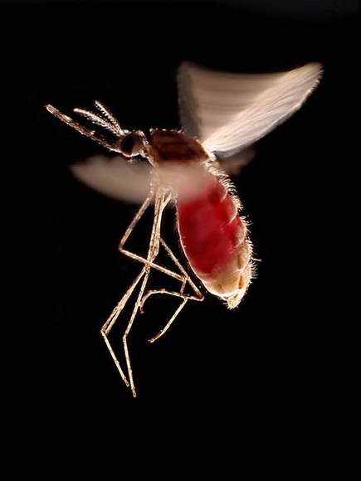

**Female ANOPHELES mosquito**

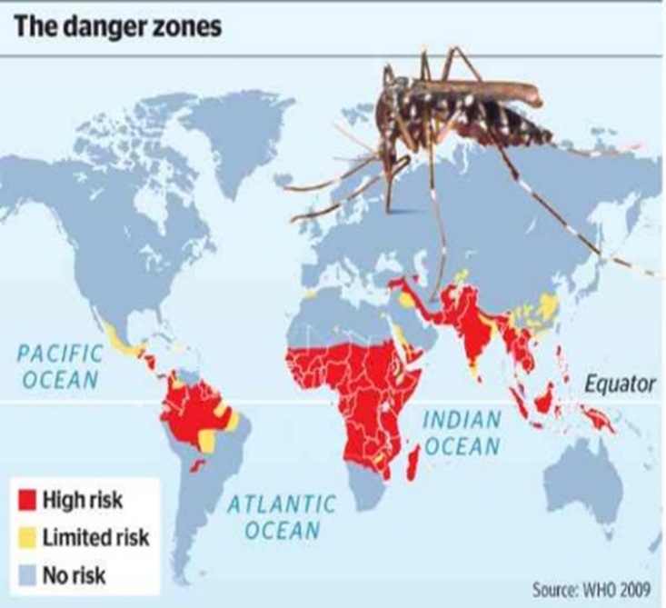

**LOCATION of MALARIA infested areas**

**LOCATION**

The female anopheles mosquito needs warm temperatures (above 16oC) and wet, humid conditions to breed in. They can also stand altitudes up to 3000 metres. That is why malaria is generally found in the Tropics.

Symptoms of malaria include a sore head, extreme fever, stomach pain, coma then death.

**MALARIA METHODS OF PREVENTION (Control Methods)**

* Spraying **insecticides** on malarial breeding grounds can **kill the mosquito larvae** **before they hatch**. **DDT** is an example of an insecticide developed in the 1950’s. It was **cheap**, and only had to be sprayed **once** a year, however, the female anopheles mosquito built up a **resistance** to DDT and as a result it **no longer works**. It also turned out that DDT was **harmful to the environment** so it was **banned** in **2007**.
* Introducing small **larvae eating fish** into stagnant water is an effective method of prevention, as the fish **eat the larvae**, then people can **eat the fish** which provides **protein** in their diet.
* **Draining** areas of **stagnant water** e.g. **swamps**, **destroys the breeding grounds of the mosquito**. However, it involves a lot of **hard labour** to do this, bearing in mind that it would have to be done very often in a **wet** climate, so it is not a practical control method. Also, **paddi fields** can’t be drained as **rice** grows here, and, in addition, the mosquito can lay her larvae in **barrels**, **footprints** and **puddles**.
* A **cheap** and **effective** prevention method would involve **education**. People can be taught to sleep under **insecticide soaked nets**, **cover up** in **long** **clothes** when they go out at night, as the mosquito is most active then, and use **mosquito sprays** e.g. **Autan** to prevent bites.

**TASKS**

1. Explain how malaria is **TRANSMITTED**. Mention the **type** of mosquito, and **why** she needs the blood.
2. Why does the mosquito inject an **anti-clotting**, or **anticoagulant agent** into the blood stream as she takes a blood meal?
3. Cut and stick the **malaria transmission diagram** into your jotter.
4. Now watch the **Comic Relief David Tennant** **WMV**, and take notes.
5. Explain **3** ways malaria can be **controlled/prevented**.



1. In groups of no more than **3**, make a **poster** about malaria. Include information on **transmission**, **location**, **symptoms** and **control methods**.

**MALNUTRITION**

**MALNUTRITION** is the condition when the body is not getting enough nutrients and calories to stay healthy. Poverty, natural disasters, political problems and wars all contribute to malnutrition and starvation. **KWASHIORKOR** and **MARAMUS** are examples of malnutrition diseases.

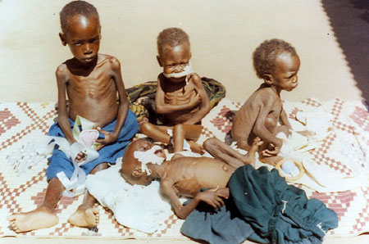

**TASKS**

In groups of no more than 3, use a **LAPTOP** to research the following questions. Take **notes** in your jotters, and make a **poster, or a power point** with the information. You can also use pages **94/95** in **NWW (F)** to add to your notes.

* 1. What is **MALNUTRITION** and what **CAUSES** it?
  2. Research the **SYMPTOMS** of **MARASMUS**, which affects children under 1, and of **KWASHIORKOR** which affects older children.
  3. Find out how these diseases can be **TREATED**.

**BRAZIL: A DEVELOPING country**

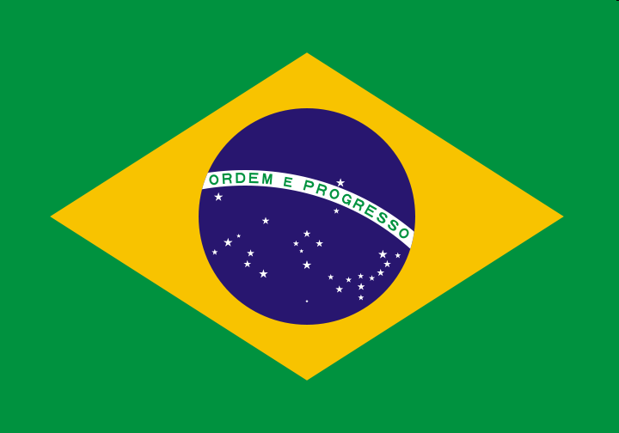

**INTRODUCTION**

1. In **pairs**, **brainstorm** any information you know about Brazil, and **write** in down in your jotter.
2. Watch the **WMV**, and then **add** in any new things you haven’t already written down.
3. **Relay Race**: **boys** and **girls** line up at the board. You have **1 minute** to write down as **many things** about Brazil as you can, **without** **repetition.**

**Where is Brazil?**

Brazil is in **South America**. It is bounded by the **Atlantic Ocean** on the **east**, and by **several countries** to the **north** and **west**.

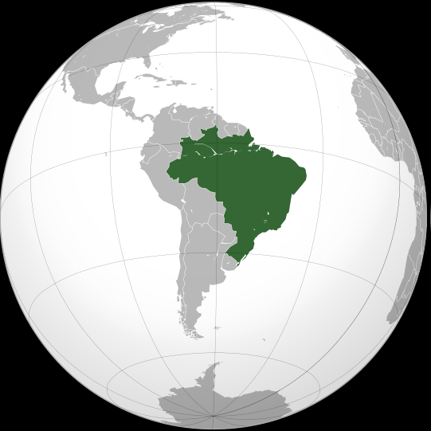

Brazil covers **nearly half** of South America, and the **Amazon** is a **third** of the size of Brazil. **Brasilia** is the capital city, but the cities of **Sao Paulo** and **Rio de Janeiro** are much **bigger**.

**TASKS**

1. Take a copy of the **map** of South America. Use page **72** in the atlas to **label** all the **countries** in South America. Also, find out their **capital cities,** and **write** this on the **map**.
2. **Shade** each country in a **different** **colour**.
3. **Stick** your map into your **jotter**.