S3 History

Hitler and Nazi Germany

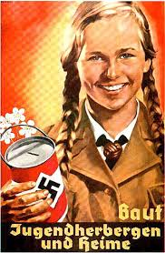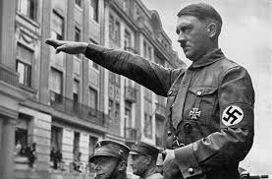

**Hitler and Nazi Germany 1918-1939**

In this unit you will learn about:

* What Germany was like at the end of the First World War
* What the Treaty of Versailles was and how it affected Germany
* The Economic Problems Facing Germany from 1918-1929
* Why Hitler rose to power and appealed to many Germans
* How the Reichstag Fire helped Hitler get into power
* How the Nazis kept their power through Fear and Terror
* How the Nazis controlled the Young People in Germany
* The Treatment of the Jews in Nazi Germany
* The Holocaust



**Activity 1**

1. Look at the illustrations on the hand out your teacher has given you. The illustrations show problems in Germany in 1918. Cut out the boxes and match them with the correct pictures. Stick these in your jotter under the title The German Revolution.
2. Which two problems do you think were the worst ones facing the German people? Write a short paragraph explaining your choice.
3. How do you think these problems were affecting German people’s opinion about fighting in the war?

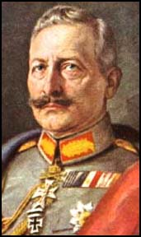**The End of the Monarchy in Germany**

|  |
| --- |
| LETTER OF ABDICATION |
| **I herewith renounce for all time claims to the throne of Prussia and to the German Imperial throne connected therewith. At the same time I release all officials of the German Empire, as well as all officers and men of the navy and of the Germany, from the oath of fidelity which they tendered to me as their Emperor, King and Commander-in-Chief.**  **I expect of them that until the re-establishment of order in the German Empire they shall render assistance to those in actual power in Germany, in protecting the German people from the threatening dangers of anarchy, famine, and foreign rule.**  http://images.vector-images.com/133/germany.gif**Proclaimed under our own hand and with the imperial seal attached.**  **Amerongen, 28 November, 1918** |

**Why did the Kaiser abdicate?**

1. The Americans refused to negotiate with the Kaiser. Before peace talks could begin the Kaiser was told that he had to go. Some form of democracy had to be introduced in Germany.

2. Revolution was breaking out in Germany. Berlin had erupted into violence and Munich was also under the control of communists. The country was falling apart and no longer wanted the Kaiser. Strikes and demonstrations against the war were taking place throughout the country.

3. The Kaiser was blamed for starting the war and refusing to end it. Millions had been killed and the people were starving as a result of the British blockade.

4. The German High Seas Fleet had mutinied on 28 October and some of the Kaiser's most trusted regiments raised the Bolshevist flag.

5. Hindenburg believed that Germany could not win the war and the Kaiser should abdicate. Hindenburg’s staff interviewed 39 top commanders to see if they thought their troops would follow the Kaiser- only one said yes!

6. The Social Democrats, the biggest political party in Germany, said they would join the revolution if the Kaiser did not abdicate.



**Activity 2**

1. Draw a spider diagram like the one below and add on the reasons why the Kaiser abdicated.

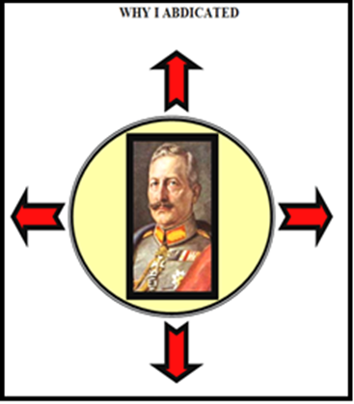

1. On 11th November 1918 WW1 came to an end after Germany surrendered. Using all the information you have learnt describe, in detail, the reasons why war came to an end. You should include at least 3 reasons.

Extension

Using the information gathered from the short film and your mind-map, write a letter as the Kaiser to your country as to why you decided to abdicate.

*“Dear fellow countrymen,*

*Today November 12th 1918, I have decided to leave my position as leader of this wonderful country.”*

# *http://images.vector-images.com/133/germany.gif*The Weimar Republic 1919-1933

**A New Democracy**

The Weimar Republic is the term used to describe the German democratic Republic that lasted from 1919 until 1933. The Republic was established after workers and troops revolted in early 1918 against the Government's refusal to end the First World War. On November 9, Kaiser Wilhelm II fled the country and a provisional (temporary) government was formed by Friedrich Ebert. The new Parliament met in Weimar, in February 1919 and drew up a new Constitution that established Germany as a democracy. There were two houses of Parliament, the Reichstag and the Reichstrat. Ebert was elected the first President of the new Republic.

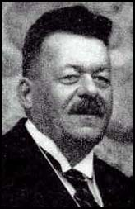****

**Activity 3**

1. How long did the Weimar Republic last?
2. Why was this new Republic established?
3. What did the new Constitution establish Germany as?
4. What was the name given to the two houses of Parliament?
5. What was the name of the new German President?

Summary of Problems facing the Weimar Republic

Although the Weimar Republic was democratic it was **weak and unpopular** with many Germans. The Weimar Republic had too many political parties which often formed weak coalitions and did not last long. It was blamed for surrendering to the Allies in 1918 and was associated with defeat by many who believed that Germany should have continued to fight, these politicians were known as the ‘November Criminals’. Political extremists such as the Communists (left wing e.g. Spartacists, in 1919) and the Nationalists (right wing e.g. the Kapp Putsch, 1920) **tried to seize power** from the Weimar Republic. The Weimar Republic also had to deal with severe economic problems **in 1923 during the Ruhr** **Crisis** and after **the Wall St. Crash of 1929**. *These problems caused the Weimar Republic to collapse and helped the Nazi Party take control.*

1. Write down two reasons why the Weimar Republic was unpopular.
2. What did some people do to show their unhappiness with the Weimar Government?
3. When did a) the Ruhr crisis and b) the Wall St Crash happen?

Problem No 1 **The Weimar Constitution**

Before the First World War Germany had no real democracy. The Kaiser was an autocratic ruler, which meant he could dissolve the Reichstag, the Parliament, whenever he wanted. He was also in charge of the armed forces and foreign policy. The new Constitution aimed to change this. Below is a copy of the main points of the Constitution.

THE PRESIDENT

Elected every seven years



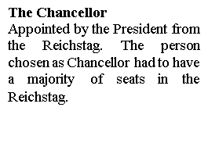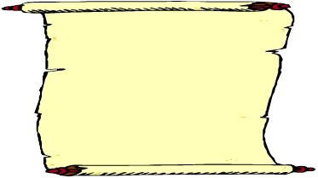



## Article 48

In an emergency the President could make laws without the Reichstag.

# The Houses of Parliament

# The Reichstag

The Upper House. Elected by the German people through **proportional representation**. (PR) If a party got a fifth of all the votes it would get a fifth of the seats. It resulted in too many parties and made it hard to govern properly.

# The Reichsrat

The Lower House. Each state of Germany e.g. Bavaria or Prussia would send representatives.



# The German People

All adults over 20 had the democratic right to vote for members of the Reichstag. They enjoyed freedom of speech, freedom of assembly, freedom of belief and freedom from arbitrary arrest for the first time in Germany’s history.

# The German People

All adults over 20 had the democratic right to vote for members of the Reichstag. They enjoyed freedom of speech, freedom of assembly, freedom of belief and freedom from arbitrary arrest for the first time in Germany’s history.

**Activity 4**

1. Read the main points of the new Constitution. Which points do you think are the most important in making Germany a democracy?
2. Do you think people in Germany would be happy about the new Constitution?
3. Copy the diagram of the Constitution into your jotter.
4. What was dangerous about Article 48?

One of the weaknesses of the Constitution was the fact that it used PR. This voting system tended to result in coalition Governments. Coalitions mean that several parties come together to jointly rule the country. This would work in a country where parties have policies in common but the new Weimar Germany was full of parties who all wanted different things. For example Communists wanted more equality whereas the Nationalists’ priority was to make Germany strong again as they hated the fact that Germany surrendered in WW1.

PR also allowed small extreme parties to be represented in Government. They used this as an opportunity to advertise their extreme views. Many historians argue that this was a main reason for the collapse of the Weimar Republic as it was very difficult for the Government to defend democracy when so many in the Reichstag were fighting against it. Coalitions also meant that it was difficult to carry out a consistent programme of policies and because there tended to be fallouts and when coalitions broke up the policies were put on hold.

This resulted in many Germans growing impatient with democracy and the Weimar Republic. They wanted strong leadership and for the problems to be resolved not constant changes in Government. The new democracy was associated with failure.

1. What does proportional representation mean and what did it tend to result in?
2. Why were coalitions a problem in the Weimar Republic?
3. How did many Germans feel about coalitions?

Problem No 2 **The Treaty of Versailles**

After the war, the victors, led by the ‘Big Three’, Britain, France and the USA, met at the Palace of Versailles, near Paris, in 1919 to tell Germany the terms of peace. Many of the victors, including France wanted revenge on Germany. Only President Woodrow Wilson of the United States wanted to be careful about how much they punished Germany. The Allies declared that Germany was responsible for the war and therefore had to pay reparations (compensation for damages). A special committee was to be established to set the price for the German government to pay. Germany was also to take full responsibility for starting the war. Many historians argue that these terms were too harsh and that the treaty is partly responsible for the Nazi rise to power.

When the Germans heard about the Treaty of Versailles, they **felt ‘pain and anger’**. They felt it was unfair. They had not been allowed to take part in the talks – they had just been told to sign. At first they refused and some Germans even **wanted to start the war again.** But the new Weimar Government realised they could not return to fighting a war that they were highly likely to lose so they agreed to sign the ‘dictated peace.’

1. Germany will lose 13% of her land. This will include coalmines and much of Germany’s industrial areas including the Saar region. This will help to create a number of new countries like Poland.

2. Germany will have a small army so that she can never again threaten her neighbours. It will only be 100,000 strong.

3. The German Navy will be very small. No battleships and no submarines. Germany will not be permitted to have an air force.

4. Germany will lose all of its colonies and Britain and France will take them over. She must also return Alsace- Lorraine to France.

5. Germany must pay the allies compensation amounting to £6,600,000,000.

6. Germany must accept total responsibility for causing the war.

Activity 5

1. Think, Pair, Share

Look at the terms of the treaty and think about why the Germans would believe the terms were unfair. Then turn to your partner and discuss your thoughts.

1. Think, Pair, Share

Look at the following table. The sentences have been split into heads and tails. With your partner match them up to form a sentence which explains how the terms of the treaty were unfair or fair.

|  |  |
| --- | --- |
| HEADS | TAILS |
| A) Germany was forced to accept the blame for causing the war | 1) by the fact Germany lost industrial regions such as the Saar and colonies. |
| B) Most of the fighting took place in France and the land, industry and villages had been totally destroyed. | 2) as her military was restricted. |
| C) The German ability to pay the reparations was restricted | 3) so it was good that this was ending as it stopped her from being a threat. |
| D) Germany had to give up Alsace-Lorraine. | 4) but the war was really started between Austria-Hungary and Serbia. |
| E) Germany would not be able to defend herself | 5) This was only right as Germany had taken this territory off France in the 19th century. |
| F) Germany had been an ambitious and militaristic country | 6) Someone had to pay for the damage. |

1. Can you now select which of the sentences show that the treaty was fair and which sentences show the treaty was unfair?



The Germans and the Treaty

**GERMANY DEMANDS VENGEANCE**

SOURCE 1

The German government reluctantly accepting the treaty in 1919.

Yielding to overpowering might, the government of the German Republic declares itself

ready to accept and sign the peace treaty. But in doing so, the government of the German Republic in no way abandons its conviction that these conditions of peace are unjust."

SOURCE 2

The view of the British economist, J. M. Keynes.

"I believe that the campaign for securing out of Germany the general costs of the war was

one of the most serious acts of political unwisdom for which our statesmen have been responsible."

SOURCE 3

The reaction of a German newspaper, 28 June 1919.

"Vengeance, German nation! Today in the Hall of Mirrors the disgraceful treaty is being

signed. Do not forget it. The German people will with unceasing labour press forward to re-conquer the place among nations to which it is entitled. Then will come vengeance for the shame of 1919.”

Activity 6

1. Why according to Source 1 are the Germans signing the treaty?
2. What was the most damaging part of the treaty according to Source 2?
3. Evaluate the usefulness of Source 3 as evidence of Germany’s reaction to the Treaty of Versailles? (Think about who wrote the source? What date was written in?)
4. The politicians who signed the Treaty were nicknamed the ‘November Criminals’. Why do you think they were called this?

Problem No 3Reparations & Hyperinflation

We already know that the Germans were forced to pay huge sums in reparation payments to the Allies. The figure amounted to £6,600,000,000 and was to be paid in regular instalments. This was a massive figure and some historians believe that it was in fact too much for a defeated and crippled economy to cope with.

We also know that the Ruhr Crisis at the beginning of 1923 only made matters worse for Germany. The Ruhr was the industrial centre of Germany and with production halted it crippled the German economy even further. The Government had to find a way of paying for the workers who were now on strike and it decided to print more money. This was the worst thing they could do because it resulted in HYPERINFLATION. This happens when prices rise rapidly. The effect of hyperinflation was HUGE.

Activity 7

1. What is HYPERINFLATION?
2. How did the Ruhr Crisis cause hyperinflation?
3. The diagrams below give us an indication of how fast and how high prices for goods increased. Copy the diagrams into your jotter and answer the following questions.

A) What has happened to the cost of goods?

B) What has happened to the worth of the Mark?

Explain your answer using examples.



|  |  |
| --- | --- |
| DATE | HOW MUCH WAS THE MARK WORTH |
| **JULY 1922** | 1$ = 400 DM |
| **FEB 1923** | 1$ = 7000 DM |
| **JULY 1923** | 1$ = 160,000DM |
| **AUG 1923** | 1$ = 1,000,000DM |
| **NOV 1923** | 1$ = 130,000,000,000 DM |

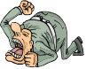How did Hyperinflation affect people in Germany?

**THE WORKERS** - People were paid by the hour and rushed to pass money to loved ones so that it could be spent before its value meant it was worthless. People had to shop with wheelbarrows full of money. Bartering became common - exchanging something for something else but not accepting money for it. The poor became even poorer and the winter of 1923 meant that many lived in freezing conditions burning furniture to get some heat.

**PENSIONERS** - on fixed incomes suffered as pensions became worthless. Shops were constantly changing their prices, so an elderly person on a budget struggled to buy all their necessities such as food. Many of the old either froze or starved to death.

**BORROWERS-** People who borrowed money from banks were better off as they could pay back the money very quickly. This meant they were no longer in debt.

**THE RICH** - suffered least because they had sufficient contacts to get food etc. Most of the very rich were land owners and could produce food on their own estates.

**THE MIDDLE CLASS** – suffered a great deal. Their hard earned savings disappeared overnight. They did not have the wealth or land to fall back on as the rich had. Many middle class families had to sell family heirlooms to survive. It is not surprising that many of the middle class, who suffered in 1923, were to turn to [Hitler](http://www.historylearningsite.co.uk/adolf_hitler.htm) and the Nazi Party.

**BUSINESSMEN**- Businessmen suffered a great deal due to hyperinflation asmany businesses went bankrupt as they did not have enough money to buy in raw materials or pay the higher wages.

Activity 8

1. Why would a pensioner on a fixed pension be worse off than a worker who was paid every day?
2. Why do you think people with savings were so badly affected by hyperinflation?
3. Collect a sheet from your teacher and in the appropriate boxes explain how hyperinflation affected the different groups of people in Germany in 1923.

Source Questions

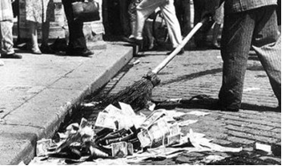Source A. A German man who lived through the inflation.

One fine day I went into a café to have a coffee. As I went in I noticed the price was 5000 marks – just about what I had in my pocket. I sat down read my paper, drunk my coffee and spent altogether about one hour in the café. The waiter duly presented me with a bill for 8000 marks. “Why 8000 marks?” I asked. The mark had dropped in the meantime, he said. I gave the waiter all the money I had and he was generous enough to leave it at that.

Source B. A German student at the time of the great inflation.

You very often bought things you did not need. But with those things you could start to barter (swap). You went round and exchanged a pair of shoes for a shirt, or a pair of socks for a sack of potatoes … and this process was repeated until you eventually ended up with the thing that you actually wanted.

Source C. The memories of a German writer.

Two women were carrying a laundry basket filled to the brim with banknotes. Seeing a crowd standing at a shop window, they put the basket down for a moment to see if there was anything they could buy. When they turned round a few moments later, they found the money there untouched but the basket was gone.

Source D. A report by the German health minister in 1923.

The shocking decline in health conditions affects the whole of Germany. Especially hard hit are the middle class, those living on small sums, the widows and the pensioners who with their modest incomes cannot afford today’s prices. Death rates from hunger are increasing.

Activity 9

1. What do sources A and B tell us about the impact hyperinflation had on people buying goods?
2. What is strange about the story in source C?
3. What is the impact of Hyperinflation on the nation’s health?

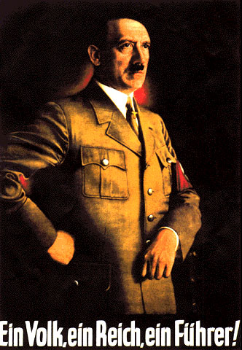**ADOLF HITLER (1889-1945)**

Adolf Hitler was born in Austria in 1889. He left school at the age **of sixteen and went to Vienna** where he hoped to enter the Academy of Fine Arts and become a painter. However, things went wrong for him in Vienna and in 1909 at the age of **20 he was homeless and jobless.** He began to hate Jews and foreigners who were doing well in his country.

**In 1914, Hitler joined the German army. He became a runner delivering messages** in the trenches. This was a very dangerous job and he was awarded the Iron Cross for his bravery. Hitler did not accept that Germany had been defeated in the war and he blamed Jews and Communists within Germany for betraying Germany.

**THE NATIONAL SOCIALIST PARTY**

* Abolition of the Versailles Treaty
* Union of Germany and Austria
* A stipulation that only ‘true’ Germans (Aryans) shall live in Germany – the Jews especially had to go.
* All large businesses and industries should be nationalised
* Old age pensions should be introduced
* A strong central government

**Hitler hated the Versailles Treaty and the Weimar government for signing the treaty** and dreamt of a return to the days of the Kaiser.

After the war he stayed in the army, but as an intelligence officer. His job was to spy on new political parties. His activities took him to the German Worker’s Party led by Anton Drexler. He was asked to gather information on this small party. He liked the ideas of the party and joined in 1919. Drexler realised that Hitler was something special and put him in charge of the political ideas and propaganda of the party. In 1920, the party announced its 25-point programme that included: (see opposite)

The party was renamed the National Socialist German Worker’s Party – Nazis. In 1921, Hitler became leader of the party.

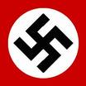Hitler stirred up Nationalist passion giving the people something to blame for Germany’s problems. His opponents tried to disrupt the meetings, so for protection Hitler set up the SA – Storm troopers. Although the actual membership of the NAZI party remained quite low in this period Hitler raised their profile through speeches and meetings.

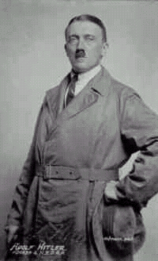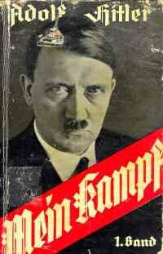The Munich Putsch

Hitler felt that November 1923 was the right time for the Nazis to try to seize control because **the people in Germany were so unhappy due to the hyperinflation crisis caused by sky high reparation payments. Also the government was so unpopular. The Nazi Party wanted to replace the Weimar democracy with a strong national government, and felt this could be achieved by force (a putsch)**

The trigger for the Putsch was the government’s decision to start paying reparations again. Hitler, the Nazi Party and many right wing organisations in Germany, regarded this as a national humiliation.

Hitler was confident that his attempt to overthrow the Government would have the support of the Republic’s army because **the high-ranking General Ludendorff had shown sympathy with Nazi ideas. Unfortunately Hitler over-estimated this support.**

http://us.cdn2.123rf.com/168nwm/milinz/milinz1105/milinz110500001/9481736-cartoon-character-blinky-writing-with-big-blue-pen-vector-illustration.jpg

Activity 10

1. Give two reasons why 1923 was seen as a good year for the Nazi Party to seize control of Germany?
2. What was the final act that triggered the Putsch?
3. Which important person supported the Nazi Party?
4. What is meant by the word **PUTSCH**?

**What happened?**

**EVENT ONE**

On November the 8th 1923 the leader of Bavaria Von Kahr held an important meeting in a Beer Hall in the centre of Munich. Around 3000 people attended the meeting including important members of the army and Bavarian Government. **Hitler and 600 of his Nazi supporters stormed their way into the meeting**; many of them were carrying guns. Eyewitnesses have stated that Hitler climbed onto a table and shouted **“the national revolution has begun!”**

**EVENT TWO**

**General Ludendorff, the famous World War One hero promised to support Hitler** because he was impressed by what Hitler was planning. Hitler took the main leaders into a side room and at the point of a gun Von Kahr, Von Seisser and Von Lussow were “persuaded” to support Hitler. Hitler came out of the room and told the cheering crowds that **“your leaders are with us.”** Hitler thus gave the impression that with the support of Ludendorff and the Bavarian Government the Putsch had succeeded**.**

**EVENT THREE**

Hitler decided to leave Ludendorff in charge of the beer hall while he sorted out problems in other parts of the city. Ludendorff**, after gaining a promise of support, allowed Von Kahr and the others to go free.** At this point Von Kahr issued a statement saying that he only promised to support Hitler because he was being **threatened at the point of a gun**. He said that the **all statements issued under** **duress were now null and void and that any attempt to overthrow the German Government would be disastrous.**

**EVENT FOUR**

On hearing that the Bavarian leaders had withdrawn their support, Hitler decided to **march on the centre of Munich to obtain** **public support.** Hitler and Ludendorff led 3000 Nazi’s into the centre, where they found their path blocked by the army and police. The two sides faced each other for a number of minutes then the shooting began. After less than a minute 14 Nazi party members were killed and three policemen also died. Hitler and the Nazi party scattered in all directions. Hitler along with Hess and Ludendorff were later captured and put on trial. For Hitler this was the moment that would catapult him into Germany’s memory.

http://us.cdn2.123rf.com/168nwm/milinz/milinz1105/milinz110500001/9481736-cartoon-character-blinky-writing-with-big-blue-pen-vector-illustration.jpgActivity 11

Complete the questions and put the event number as your heading.

**READ EVENT ONE**

1. Who was the leader of Bavaria at the time?
2. How many Nazi’s stormed the meeting?
3. What did Hitler declare?

**READ EVENT FOUR**

1. What did Hitler do with his 3000 SA?
2. How many people were killed?
3. What happened to Hitler and Ludendorff?

**READ EVENT THREE**

1. What mistake did Ludendorff make?
2. Where was Hitler at this time?
3. What did Von Kahr do next?

**READ EVENT TWO**

1. Who decided to help Hitler?
2. In what way were the others “persuaded”?
3. Name those who were persuaded.
4. What did Hitler do after leaving the room?



The Impact of the Munich Putsch

Ironically the putsch managed to have some degree of success because Hitler used the trial as a public platform to put forward his ideas and to condemn the Weimar Republic. The judge, a Nazi sympathiser, allowed him to question witnesses and make political speeches. Suddenly this low level extremist politician was a recognised figure. Everyday he was front page news. This publicity enabled him to have a voice. He attracted the support of thousands of people. Hitler was sentenced to five years in jail but this was reduced to nine months. Whilst serving time in jail, he lived in luxury. He was allowed as many visitors as he wanted and he had an open cell. Hitler also wrote his infamous book “Mein Kampf” (My Struggle). This became a bestseller. He dedicated it to those Nazis who had died in the putsch, and so made the event even more notorious. Hitler had learnt his lesson. He realised he could not overthrow the government so his aim was to now win power legally.

The Munich Putsch.

**Prison**

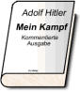

**The Press**

**Mein Kampf**

**The Trial**

http://us.cdn2.123rf.com/168nwm/milinz/milinz1105/milinz110500001/9481736-cartoon-character-blinky-writing-with-big-blue-pen-vector-illustration.jpg

Activity 12

1. Copy and complete the diagram above to summarise what impact the Munich Putsch had in Germany.
2. To what extent was the Munich Putsch a success? (8 marks)

**The Wall Street Crash and the Economic Depression**

The Weimar Republic enjoyed much success after 1923. After a very unstable start the Government appeared to be offering stability to those Germans who were very unhappy due to the economic and political changes. However, this stability was destroyed when the Wall Street Crash occurred in 1929. Many historians argued that this was the key event that changed Weimar Germany’s fortunes.

**What was the Wall Street Crash?**

The Crash is the name given to the collapse of the US Stock Market. When this happened the American banking system collapsed as did their economy. This resulted in mass unemployment in the USA. Well over 20 million people were out of work.

**How did the crash affect Germany?**

The flow of money that had been keeping the German economy growing now stopped and the Americans began to call in their loans. America was the world’s biggest market for goods and it purchased a large amount of European products thus keeping Europeans in work. With large amounts of Americans out of work they no longer purchased European and German goods. The German economy suffered greatly and within a few years the unemployment figure was standing at 6 million people.

The Crash, although it happened in America, had devastating consequences for Germany. Living standards dropped due to the rise in unemployment, businesses went bankrupt and farmers were unable to pay their mortgages. The economic prosperity that many had enjoyed quickly disappeared.

|  |  |
| --- | --- |
| **September 1928** | **650,000 unemployed** |
| **September 1929** | **1,320,000 unemployed** |
| **September 1930** | **3,000,000 unemployed** |
| **September 1931** | **4,350,000 unemployed** |
| **September 1932** | **5,102,000 unemployed** |
| **January 1933** | **6,100,000 unemployed** |

Companies throughout Germany - though primarily in the industrial zones such as the Ruhr - went bankrupt and workers were laid off in their millions. Unemployment affected nearly every German family, just 6 years after the last major economic disaster - [hyperinflation](http://www.historylearningsite.co.uk/hyperinf.htm) - had hit Weimar.

Most, though not all, of the unemployed were male. These men were almost certainly family men who could see no way ahead with regards to providing for their families. Money was required for food, heating a home, clothes etc. With no obvious end to their plight under the Weimar regime, it is not surprising that those who saw no end to their troubles turned to the more extreme political parties in Germany - the Nazi and Communist Parties.

**http://us.cdn2.123rf.com/168nwm/milinz/milinz1105/milinz110500001/9481736-cartoon-character-blinky-writing-with-big-blue-pen-vector-illustration.jpg**Activity 13

1. Take the title ‘Wall Street Crash’
2. What was the Wall Street Crash?
3. Why did it affect Germany?
4. What was the economic impact of the crash on Germany?

MC900383810[1]

How do you think the crisis of the Wall Street Crash is going to affect the Weimar Government?

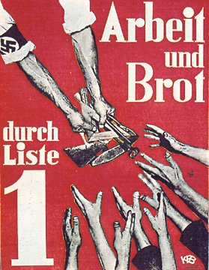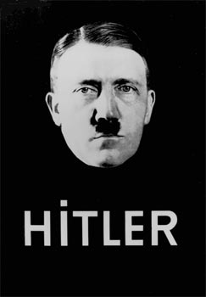

THE COLLAPSE OF WEIMAR

&

THE RISE OF HITLER

How could the Nazi Party, which had only 12 seats in the Reichstag in 1928, become the largest party in German politics in less than four years?

The answer is very simple - **mass unemployment.**

“It was the great depression that put the wind in Hitler’s sails.”

This quote at the top of the page by the famous historian AJP Taylor sums up how Hitler gained power in 1933. In 1929 the German economic recovery ended. The reason for this was the Wall Street Crash in the USA.

|  |  |  |  |
| --- | --- | --- | --- |
| **YEAR** | 1928 | 1930 | 1932 |
| **UNEMPLOYMENT** | 2M | 4M | 6M |
| **SEATS** | 12 | 107 | 230 |

**UNEMPLOYMENT AND NAZI SEATS IN THE REICHSTAG**

**How did the Depression weaken the Weimar government?**

**UNPOPULAR ECONOMIC POLICIES**

The Weimar government had no idea how to deal with the affects of the Great Depression. The USA had stopped lending Germany money and unemployment went up as factories closed down. Instead the government decided to raise taxes, cut wages and unemployment benefit. This angered ordinary people in Germany and turned them against the Government.

**PRESIDENTIAL RULE**

The Social Democrats decided to leave the government so the Chancellor had to use ARTICLE 48, which allowed the President to rule without the Parliament. The President was the 84 year old General Hindenburg, who was probably too old to rule properly. Did this mean democracy was already at an end before Hitler gained power?

**THE RISE OF THE NAZI AND COMMUNIST PARTIES**

Many people turned to extremist groups to solve the problems. The COMMUNISTS said that only communism offered the answer. The NAZIS blamed the Weimar government, the Treaty of Versailles, the Jews and the Communists and promised to get rid of them. Political violence increased as the two groups fought running battles against each other.

**Question - Explain, using evidence from each paragraph, how the depression made the Weimar government weaker.**

* **Write about the things that the government did to solve the problems**
* **Write about how the government ruled and how weak the President was**
* **Write about the groups that Germans supported instead of the government**

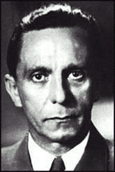**PROPAGANDA AND THE ELECTION CAMPAIGNS**

For Hitler, the master speech maker, the long awaited opportunity to let loose his talents on the German people had arrived. He would find in this downtrodden people, an audience very willing to listen. In his speeches, Hitler offered the Germans what they needed most, encouragement. He gave them heaps of vague promises while avoiding the details. **He used simple catchphrases, repeated over and over. “Work and Bread” was the most popular.** His campaign appearances were carefully staged. Audiences were always kept waiting, deliberately increasing the tension.

**1.** Explain the role of Hitler and Goebbels during the election campaigns.

**2.** In what way did they increase attention to the Nazi Party?

Adolf Hitler and the Nazis waged modern whirlwind election campaigns unlike anything ever seen in Germany. Hitler **travelled the country** delivering dozens of major speeches, attending meetings, shaking hands, signing autographs, posing for pictures, and even kissing babies. **Joseph Goebbels organized thousands of meetings,** torchlight parades, plastered posters everywhere and printed millions of copies of special editions of Nazi newspapers.

**3.** Why do you think the audience was so willing to listen to Hitler and what was he offering.

**4.** Why were audiences kept waiting?

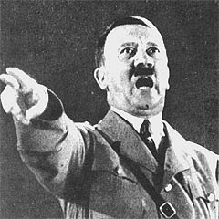

Hitler offered something to everyone; work to the unemployed, prosperity to failed business people, profits to industry, expansion to the Army, Rid the farmers and businessmen of the greedy Jewish bankers, social harmony and the restoration of German glory to those in despair. He promised to bring order amid chaos, a feeling of unity to all and the chance to belong. He would make Germany strong again, end payment of war reparations to the Allies, tear up the treaty of Versailles, stamp out corruption, keep down Marxism, and deal harshly with the Jews.

Hitler began each speech in low**, hesitating tones, gradually raising the pitch and volume of his voice then exploding in a climax of frenzied indignation.** He combined this with carefully rehearsed hand gestures for maximum effect. He skilfully played on the emotions of the audience bringing the level of excitement higher and higher until the people wound up a wide-eyed, screaming, frenzied mass that looked upon him in adoration.

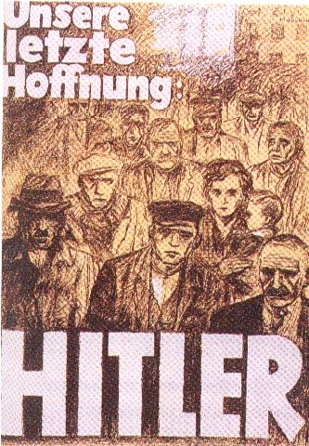

6. How did Hitler try to make the most of his speeches and what was the reaction of the audience to this?

**5.** Make a list of different groups of people and what Hitler offered each of them.

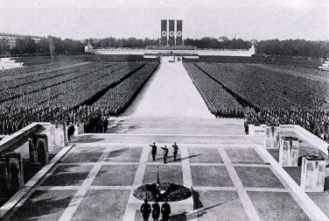

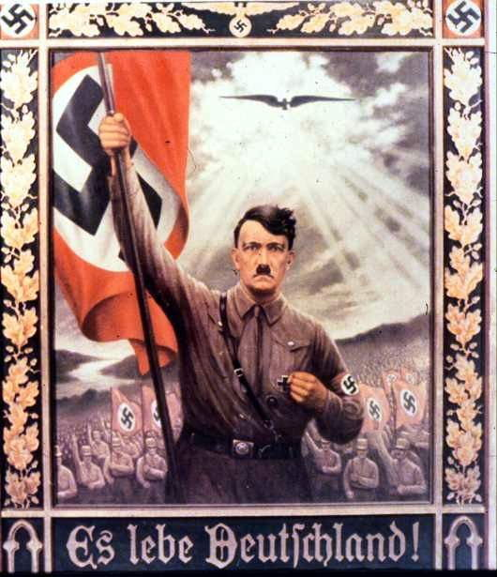 WHO VOTED FOR HITLER?

BELOW IS A LIST OF STATEMENTS

FROM DIFFERENT GROUPS OF GERMANS. EACH OF THE STATEMENTS EXPLAINS WHY PEOPLE VOTED FOR HITLER.

He will get rid of the communists for good. We are terrified of them. They want to take our wealth away.

He will restore pride in Germany; at last he will make our nation great again. No longer will our country be walked over by France.

Hitler promised me a job. There are six million of us unemployed here in Germany. We want work and only Hitler will give us this.

Hitler said he will increase our wages and give us pride in our jobs.

He will get rid of the greedy Jews who refuse to lend us money. He will set the prices for our crops that will give us more money.

Hitler promised us big orders for tanks, aircraft, machine guns and other weapons. Our factories will be busy again. We will give him the money he needs to fight the elections.

Hitler is promising to make our army bigger. It will increase to over 1 million men. No one will ever threaten Germany again!!!!!

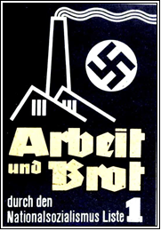

**NAZI POSTER SAYING WORK AND BREAD.**

**SIMPLE POSTERS LIKE THIS ATTRACTED HUGE SUPPORT FOR THE NAZI PARTY.**

German Election Results 1924-1933.

|  |  |  |  |  |  |  |  |
| --- | --- | --- | --- | --- | --- | --- | --- |
| **Political parties in the German Reichstag** | **May 1924** | **Dec 1924** | **Sept 1928** | **July 1930** | **Mar 1932** | **Nov 1932** | **May 1933** |
| **Communist Party (KPD)** | 62 | 45 | 54 | 77 | 89 | 100 | 81 |
| **Social Democratic Party (SDP).** | 100 | 131 | 153 | 143 | 133 | 121 | 120 |
| **Centre Party (BVP)** | 81 | 88 | 78 | 87 | 97 | 90 | 93 |
| **Nationalist Party (DVNP)** | 95 | 103 | 73 | 41 | 37 | 52 | 52 |
| **Nazi Party (NSDAP)** | 32 | 14 | 12 | 107 | 230 | 196 | 288 |
| **Other parties** | 102 | 112 | 121 | 122 | 22 | 35 | 23 |

|  |
| --- |
| There were numerous elections in Weimar Germany between 1919-1933. The results of these elections reflect clearly the periods of recovery and stagnation at this time. |

1. **Which party had the largest number of seats in 1928?**
2. **Why did the Nazis and the Communists win relatively small numbers of seats between 1924–1928?**
3. **Which political party gained the greatest number of seats between 1928–1930?**
4. **How could this increase be explained?**
5. **Why would the moderate centre parties have lost seats between 1928–1930?**
6. **What happened to the Nazi Party in the 1932 election? Does this tell you anything?**

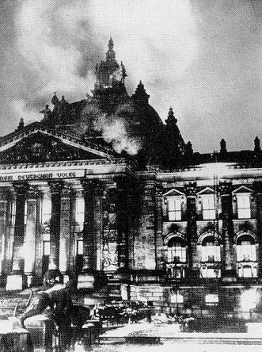THE REICHSTAG FIRE

27TH FEB 1933

The Reichstag (the German Parliament) burned down on the 27th Feb 1933.  A Dutch Communist named van der Lubbe was caught red-handed with matches and fire-lighting materials.    Hitler used it as an excuse to arrest many of his Communist opponents, and as a major platform in his election campaign of March 1933.   The fire was so convenient that many people at the time claimed that the Nazis had burned it down, and then just blamed the Communists.  Historians, however, tend to believe that van der Lubbe did cause the fire, and that Hitler just took advantage of it. Historians are still divided over the issue.

**EMERGENCY LAW PASSED**

Source A is the Reichstag Fire decree.

The Constitution of the German Reich is suspended until further notice. We will restrict the rights of personal freedom, freedom of opinion, including the freedom of the press, the freedom to organize and assemble, the privacy of postal, telegraphic and telephonic communications, and warrants for house searches, orders for confiscations as well as restrictions on property.

1. How fully does source A explain the political events after the Reichstag fire?

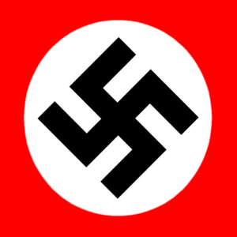

**THE ENABLING BILL**

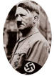

"I set for myself one aim ... to sweep these thirty parties out of Germany!"

On March 23, 1933, the newly elected members of the German Parliament met in the Kroll Opera House in Berlin to consider passing Hitler's Enabling Act. It was officially called the 'Law for Removing the Distress of the People and state.' If passed, it would effectively mean the end of democracy in Germany and establish the legal dictatorship of Adolf Hitler.

On the day of the vote, Nazi storm troopers gathered in a show of force around the opera house chanting,"Full powers - or else! We want the bill - or fire and murder!!" They also stood inside in the hallways, and even lined the aisles where the vote would take place, glaring menacingly at anyone who might oppose Hitler's will.

Just before the vote, Hitler made a speech to the Reichstag in which he pledged "The government will make use of these powers only insofar as they are essential for carrying out vitally necessary measures...The number of cases in which an internal necessity exists for having recourse to such a law is in itself a limited one."

**Activity 14**

1. What would the Act do to democracy?
2. Why might the delegates feel they had to vote for the act?
3. What promise did Hitler make about the act?

A two thirds majority was needed, since the law would actually alter the German constitution. Hitler needed 31 non-Nazi votes to pass it. He got those votes from the Centre Party after making a false promise to restore some basic rights already taken away by decree.

However, one man arose amid the overwhelming might. Otto Wells, leader of the Social Democrats stood up and spoke quietly to Hitler. "We German Social Democrats pledge ourselves solemnly in this historic hour to the principles of humanity and justice, of freedom and socialism. No enabling act can give you power to destroy ideas which are eternal and indestructible."

This enraged Hitler and he jumped up to respond. "You are no longer needed! - The star of Germany will rise and yours will sink! Your death knell has sounded!"

The vote was taken - 441 for, only 84, the Social Democrats, against. The Nazis leapt to their feet clapping, stamping and shouting, then broke into the Nazi anthem, the Hörst Wessel song. They achieved what Hitler had wanted for years - to tear down the German Democratic Republic legally and end democracy, thus paving the way for a complete Nazi takeover of Germany. From this day on, the Reichstag would be just a sounding board, a cheering section for Hitler's pronouncements.

1. Why did Hitler need the support of two thirds of the Reichstag and how was this achieved?
2. What was Otto Wells’ reaction to the Act?
3. What was the reaction of those Nazi’s in the building at the time?
4. Did Hitler achieve his aim – discuss?

THE CONSEQUENECES

**Copy out the information in the box.**

* The Enabling Law gave Hitler the power to pass any laws without consulting the Reichstag, and without the approval of President Hindenburg.
* After March 1933 the Reichstag only really met to hear speeches by Hitler. The authority of all other political parties had been swept away.
* In the next elections, the Nazis were the only party allowed to stand.

Hitler was now dictator of Germany. His first move was to take over the trade unions. Its leaders were sent to concentration camps and the organization was put under the control of the Nazi Party. The trade union movement now became known as the Labour Front.

Soon afterwards the [Communist Party](http://www.spartacus.schoolnet.co.uk/GERkpd.htm) and the Social Democrat Party were banned. Party activists still in the country were arrested. A month later Hitler announced that the Catholic Centre Party, the Nationalist Party and all other political parties other than the NSDAP were illegal, and by the end of 1933 over 150,000 political prisoners were in concentration camps. Hitler was aware that people have a great fear of the unknown, and if prisoners were released, they were warned that if they told anyone of their experiences they would be sent back to the camp. Executions were made legal against “enemies of the state”.

It was not only left-wing politicians and trade union activists who were sent to [concentration camp](http://www.spartacus.schoolnet.co.uk/GERconcentration.htm)s. The [Gestapo](http://www.spartacus.schoolnet.co.uk/GERgestapo.htm) also began arresting beggars, prostitutes, homosexuals, alcoholics and anyone who was incapable of working. Although some inmates were tortured, the only people killed during this period were prisoners who tried to escape and those classed as "incurably insane".

**TASK**

Put four headings in your workbook. Under each of the headings describe what happened as a result of the act.

**TRADE UNIONS POLITICAL PARTIES POLITICAL ACTIVISTS INDIVIDUALS**

The Night of the Long Knives 1934

Hitler was worried about the growing strength and power of Rohm.

Why?

The SA was causing trouble on the streets of Germany. Hitler was worried that they were becoming uncontrollable. Destroying Rohm would impress the army and give him control of the SA.

Rohm wanted the army brought under his control. He wanted to merge the army with the Brownshirts. This would make him even powerful than Hitler.

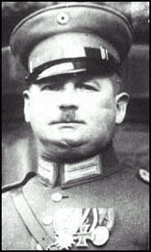

Rohm wanted more to be done for ordinary party members. Hitler needed the support of big business and so supported them instead. Rohm was furious at this.

Rohm fancied himself as the equal and successor to Hitler. He often boasted about this in public even mocking Hitler.

**Activity 15**

1. **Write a short paragraph explaining why Hitler was concerned at Rohm.**

By 1934, Hitler felt threatened by Ernst Rohm. Rohm had been very important in the 1920s. He had founded the SA and by the early 1930s it had swollen in number to over 2.5 million members. Without them Hitler would never have gained power. Himmler and the SS wanted to bring down Rohm. On 29th June 1934, Hitler summoned the SA leaders to Wiesse for a conference. That night over 200 were arrested or murdered by the SS including Rohm. Hitler claimed about 70 deaths, others about 400. This of course was illegal murder, but Hitler argued that:

"In this hour I was responsible for the fate of the German people, and thereby I become the supreme judge of the German people. I gave the order to shoot the ringleaders in this treason."

The real reason for the murder of Rohm and the SA was to remove the final threat to Hitler’s dictatorship. He had removed the threat from parliament by arresting all members of the opposition. Now he had removed the threat from within his Party. **HITLER NOW HAD COMPLETE CONTROL**

1. How big was the SA by 1930 and why should Hitler be concerned by this?
2. How important were the SA to Hitler?
3. What happened on the 29th of June 1934?
4. What was the real reason behind the **“night of the long knives”?** http://www.fotosearch.com/thumb/OMU/OMU142/22P0130.jpghttp://www.fotosearch.com/thumb/OMU/OMU142/22P0130.jpg

|  |
| --- |
| **What happened to Rohm?**  After his arrest, Hitler gave him a pistol with one bullet so that he would commit suicide. Rohm refused, and he said that if Hitler wants him dead, he should do it himself. Two SS guards came in, saw that Rohm had not killed himself, and shot him dead.  On July 2, the list was completed. Estimates of deaths range from 200-1,000. Less than half of the murders were actually SA officers. On July 13, Hitler made a speech that said 74 people had been shot.  A few weeks later, Hitler rewarded the SS by raising its status from a part of the SA, to its own group. Now, the leader of the SS would only answer to Hitler and nobody else. From then on, the number of SA members got gradually lower, and the SA eventually disappeared. The SS soon became Hitler's main group for mass murders and terror. They helped him carry out more bloody and terrible acts for another 11 years. |

**TASKS**

1. Explain what happened to Rohm.
2. How many are estimated to have been killed?
3. What happened to the SS as a result of this?

**Source A. Adolf Hitler’s view of the SA in the 1920’s.**

With blind confidence they followed me. During the war they had fought with bayonets and thrown hand grenades. They couldn’t let the country be sold out to those scum who were the product of defeat …. These fine chaps, what sacrifices they were willing to make. All day at their jobs and all night off on a mission for the party.

**Source B. The views of a senior Nazi official.**

By 1934 Hitler had decided that Rohm and the SA were dinosaurs refusing to move on. The SA was violent and outdated and needed to be “re-educated”. He himself stated “that they are carriers of intellectual poison, they are damaging the economy and are a menace to both the state and the people.”

Compare the views of Sources of A and B on the SA.

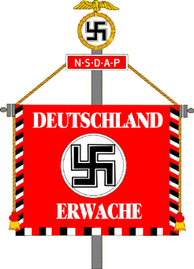**THE FUHRER**

http://www.calvin.edu/academic/cas/gpa/posters/einvolk.jpg

**THE DEATH OF HINDENBURG**

The only person with higher power than Hitler was the President, Hindenburg. On 2nd August 1934, Hindenburg died aged 87. Immediately Hitler declared that he was **President**, as well as being **Chancellor** and **Head of the German army.**

These positions meant that Hitler could now give himself the title of **“Fuhrer”.**

The Nazi control of Germany was now totally complete. All areas of opposition had been removed by one method or another.

1. Why was the death of Hindenburg beneficial to Hitler?
2. What was Hitler’s new title?

**Source A. The view of a Modern Historian.**

On August the 2nd 1934, a few weeks after the night of the long knives President Hindenburg died. Within a few hours Hitler declared himself President. He was also Chancellor, Head of state and commander of the armed forces. Hitler had ultimate power in Germany and nothing would stand in his way.

**Source B. The army oath of allegiance.**

I swear by God this sacred oath: that I will render unconditional obedience to the Fuhrer of the German people, Adolf Hitler, the supreme commander of the armed forces, and will be ready as brave soldier to risk my life at any time for him.

**Compare the views of sources A and B on the power of Adolf Hitler as Fuhrer?**

**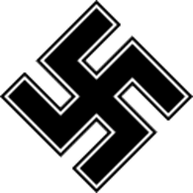****The Nazi Terror System**

Learning Intentions:

* Describe how the Nazis used fear and intimidation to keep control.
* Explain why people were afraid to oppose the Nazis.

Many Germans were intimidated – or frightened – into accepting Nazi control. Underneath the rallies and the propaganda, Hitler deliberately created an atmosphere of fear in Germany. Any organisation or individual who spoke against the Nazis inside Germany was silenced. All political parties apart from the Nazi party were banned. By the end of 1933, 150,000 political prisoners were in concentration camps.

The most feared parts of Nazi control were the Gestapo and the concentration camps, run by the SS.

The Gestapo was started in 1933 and was the secret police force of the Nazis. The Gestapo was responsible for rounding up Communists, Jews and others who were considered to be a threat to the Nazi state. The Gestapo was also feared because of its use of torture to gain confessions from suspects.

Gestapo members dressed in ordinary clothes so the German people didn’t know when they were being spied on. Nor did they know which of their friends or neighbours would report what they said. There were never as many Gestapo members as people thought there were. There did not need to be. It was enough for people to believe that they were being spied on to make them afraid and suspect every stranger of being part of the Gestapo.

Some reports suggest they there were up to 45,000 people on the Gestapo but its real power lay in the number of informers and special agents it used. Up to 160,000 people were employed by the Gestapo to inform on friends and neighbours or anything they thought was anti-Nazi.

Why did people inform on their friends and neighbours? Sometimes when a person was arrested, the Gestapo put pressure on their families to inform on other people. At other times, people informed on their friends for a small bribe or to protect their own families. At other times it was because people wanted revenge for personal arguments or jealousies.

Nobody was sure where the Gestapo was operating but stories swept through towns about friends and relatives who mysteriously vanished when the Gestapo arrived at their door.

The result was that people kept their mouths shut and their opinions to themselves. They did not want to be taken away to concentration camps.

In the early years of Nazi Germany, concentration camps were places where the Nazis sent political opponents such as socialists, communists and trade unionists. Conditions were at first just like an uncomfortable prison, but soon they became places of torture and murder as the camps filled up with anyone the Nazis did not like.

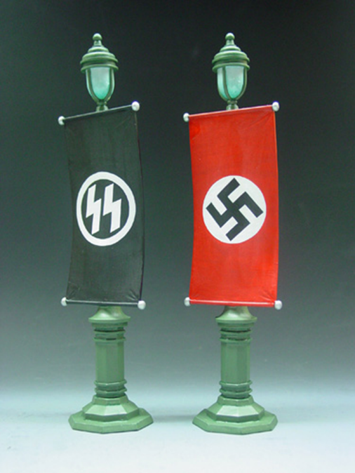Nazi Germany’s first concentration camp was built at Dachau, a village a few miles from Munich, but soon many other camps were built across Germany.

The camps were filled by people described by the Nazis as ‘undesirables’ and the prisoners’ clothes were marked with colour-coded badges so as to identify the reason for their imprisonment;

* red for political prisoners
* green for criminals
* black for those to be considered anti-social
* pink for homosexuals.

It was only later, during the Second World War, that the concentration camps became places of mass murder of Jews during the Holocaust.

The concentration camps were an important part of the fear that the Nazis used to keep control over the German population. Most Germans never saw a concentration camp but it was enough to know that these places existed and that people could vanish from their homes in the middle of the night and would never be seen again. The concentration camps were places to be feared and were yet another form of intimidation putting pressure on the German people not to cause trouble for the Nazis.

The Gestapo and concentration camps were the most feared parts of Hitler’s totalitarian state. Behind the scenes, Hitler destroyed the civil rights and individual freedoms that people had enjoyed under the Weimar Republic. Once the people started to miss those freedoms it was too late.

Hitler created a totalitarian state. That means a government that has total control over everything in the country. Nazi Germany was also a police state. That meant that the Nazi government controlled the law makers, the courts and the police. In other words, the Nazis had the power to make laws, to enforce the laws and to decide who was guilty of breaking the laws.

The ordinary German people could say and do nothing against the state. All they could do was shout their approval of the Nazis at rallied or keep quiet if they disagreed. The police state used fear and punishment to enforce obedience. For most people it was just too dangerous to so anything to show you were against the Nazis.

Activity 16

With the information you have collected, as well as the information in this booklet, to create a Poster with a partner explaining all the Nazi Fear and Terror System and why it was effective.

**Who did Oppose the Nazis?**

Learning Intentions:

* Describe some of the groups that did oppose the Nazis.
* Explain why opposition to the Nazis was so difficult.

Activity 17

Each group will be given an opposition group to research and create a presentation on their group to show the class.

You should explain:

* Who is your group?
* Why do they oppose the Nazis?
* What do they do to show their opposition?
* What happened to them?

**The Nazis and Propaganda**

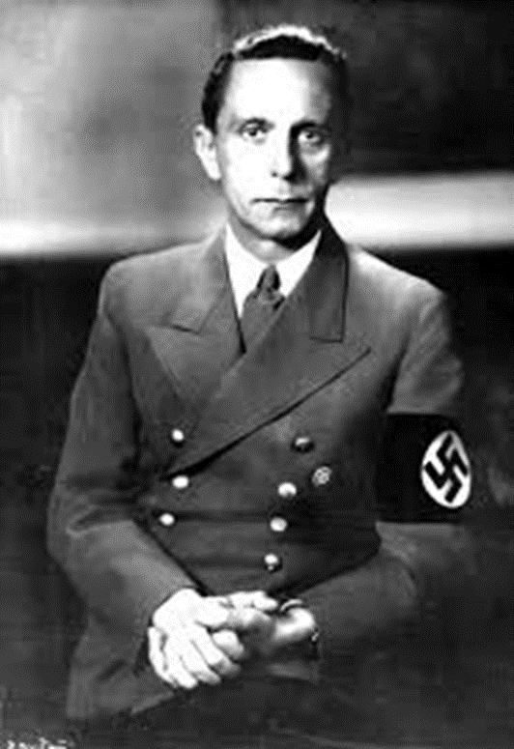Joseph Goebbels was the man who was given the job of spreading the Nazi message across Germany. He was important to the Nazis as he worked hard to persuade the Germans to vote for the Nazis, and once Hitler became Fuhrer Goebbels worked hard to persuade the Germans that they liked living in a dictatorship.

The radio was important to the Nazis because they could get messages into people’s homes. By 1939 over 70 per cent of German homes had a radio. The Nazis produced millions of cheap radios that could only receive Nazi stations, resulting in Germany having the highest ownership of radios in the world at that time.

Hitler was important to Nazi propaganda because he was the star that people wanted to see and hear. He rehearsed for speeches, even down to the way he moved his arms, thoroughly. He manipulated crowds often arriving late and standing in front of them silent for a few minutes to increase the tension. He was able to reach the inner fears and hopes of each person listening to him. Hitler’s speeches were a performance that could be spell-binding. He knew the importance of keeping speeches simple, repeating main points and using humour and anger to drive his audiences wild with enthusiasm.

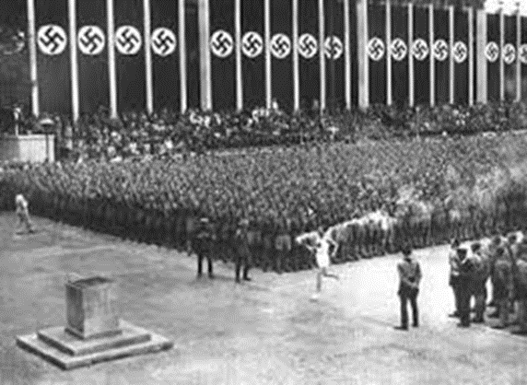Hitler used the Berlin 1936 Olympic Games to show the world how powerful the Aryan ‘master race’ really was. The anti-Semitic posters and signs were taken down, and the chief of police arrested all Roma people and kept them in a nearby concentration camp during the games to keep up the racially pure image. The stadium held 100,000 people, 20,000 more than the London 2012 Olympic stadium, and ticket sales generated a profit of one million marks. The games were also the first to have television coverage. Germany’s superstar athlete was Lutz Lang, but the true hero was an African American who won four gold medals. This ruined Hitler’s master race ideology, and Hitler left the stadium when a black athlete won a gold medal and was not present when Owens won his medals. A Nazi propagandas film Olympia was released showing a distorted view of the events, and Lutz Lang as the hero of the games.

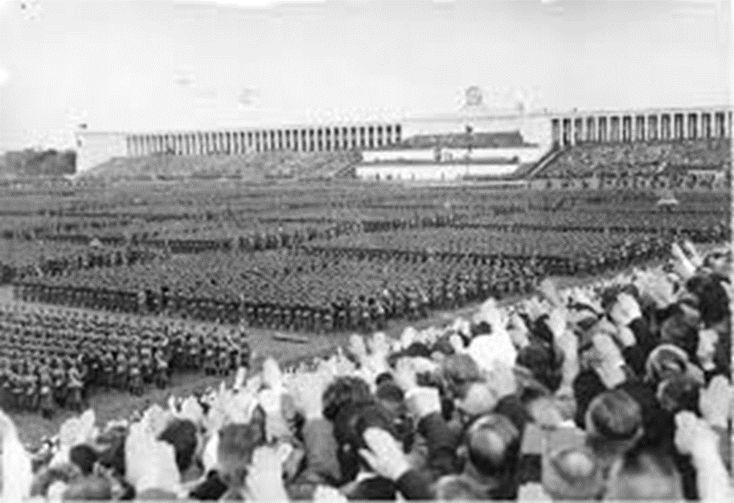The Nuremberg rallies showed off Nazi power. They were officially called the National Congress of the Party of the German People, and so suggested a strong link between the Nazi Party and all the German people. Each years the rallies got bigger and bigger and by the late 1930s there were over half a million people talking part. They were like huge rock concerts or religious ceremonies. The crowd were dazzled by vast displays of athletic strength and military power. Mock battles with tanks and aircraft were staged, and torch-lit parades, sound, light and smoke created a magical atmosphere and worked the crowd. Hitler would appear and give one of his famous speeches, dazzling the crown and becoming more exaggerated and theatrical working the crowd into an emotional frenzy.

Hitler could also show off his military power at the rallies, and convince the German people that Germany should arm itself for war, only 15 years after the slaughter of the First World War. The Nuremberg rallies were also turned into a movie, called Triumph of the Will. Foreign visitors were dazzled and afraid of the sheer size of the German military. However, some of the military equipment shown at the rallies was fake.

The Ministry for Popular Enlightenment and Propaganda (RMVP) controlled the content of the press and provided roughly half the content of the newspaper, including the length and position of articles. The Nazi Party’s publishing house gradually took over most of the press with the party’s circulation growing from 3% in 1933 to 82% by 1944. Although owned by the Nazis, most newspapers kept their original name. Film was seen more as a means of relaxation than directly for explicit propaganda purposes. The state exercised increasing control over film companies and film content and by 1942 all film companies were nationalised. Several American films were banned and Geobbels made himself responsible for approving every film made in Germany. During the regime over 1000 feature films were produced with only about 1/6 being overtly propagandist. The most famous producer was Leni Riefenstahl who was commissioned to make detailed recordings of rallies and festivals. His films included Triumph of Will about the 1934 Nuremberg Rally and Olympia about the 1936 Olympic Games in Berlin. These 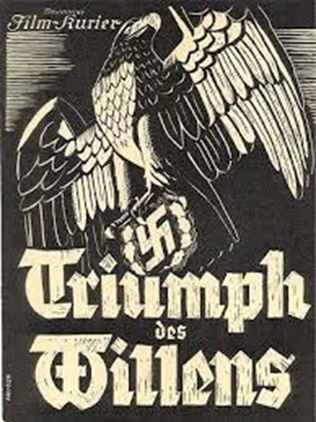types of film put the emphasis on Nazi strength and achievement. Several anti-semitic films were also produced but films were probably more effective in keeping support for the regime than indoctrinating people with Nazism. Hitler had an official photographer and key images were carefully stage managed. A series of photographs was widely reproduced, some as postcards, others inside cigarette packets.

Activity 18

1. Who was Joseph Goebbels and why was he important to the Nazi Party?
2. Why was radio important to the Nazis?
3. Explain why Hitler was important to Nazi propaganda.
4. In what way did Hitler use the 1936 Olympic Games as a propaganda tool?
5. Explain why staging mass rallies was one of the most effective ways of maintaining and gaining support for the Nazis.
6. Explain the possible other purposes of these rallies

**The Young in Nazi Germany**

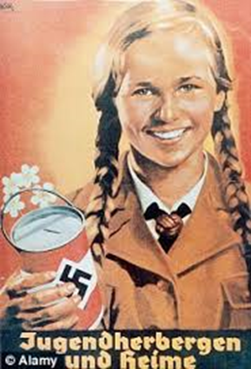Learning Intentions:

* Describe how Hitler tried to turn the youth of Germany into true Nazis.
* Explain why Hitler put such importance on education and leisure activities for Germany’s youth.

The aims of the Nazis for the control of the young people were to educate young people ‘in the spirit of National Socialism’. They wanted to train boys into soldiers and girls into submissive wives and mothers.

How Did They Aim To Achieve This?

Hitler wanted to brainwash or indoctrinate all od Germany’s children to make them grow up as good Nazi supporters.

Throughout the education of Germany’s children, Nazi indoctrination never stopped. By controlling every part of educariuon the Nazis planned to create a generation of unthinking, obedient Nazis ready to continue Hitler’s dream of creating an empire of 1000 years. When Hitler was asked about adults who disagreed wuth him he sais *‘they may disagree with me, but their children are mine already’*.

**Reorganising Schools**

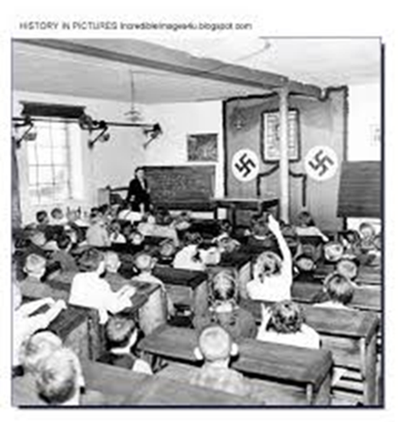Hitler stated ‘whoever has the youth has the future’. In 1933 Hitler appointed Bernhard Rust (Prussian Minister of Education and Minister of Culture later to include Minister for Science). Rust was responsible for ensuring the teaching profession carried out the Nazification of education.

The curriculum was changed to promote Nazi ideology. All Jewish teachers were fired, and teachers were encouraged to join the National Socialist Teachers’ Alliance (NSLB). By 1936 32% of NSLB members were party members, and by 1937 97% or 320,000 teachers had joined.

In 1937 an elite school system was set up consisting of Adolf Hitler Schools (Napolas and Ordensburgen). These schools were under the influence of the leaders of the Hitler Youth.

In order to control the minds of young people the entire school curriculum was revised. Sport was compulsory and aimed to engineer a new military youth. History aimed to politically indoctrinate Germans about the past. Biology became the study of racial stereotypes and emphasised the superiority of the Aryan race. Maths and physics passed on racial or military messages. RE was dropped as a subject by 1935. Overall, academic standards dropped as did the status of teachers, by 1938 there were 8,000 teaching vacancies to be filled.

**Out of school – Youth Organisations**

By 1933 Hitler appointed Baldur von Schirach to coordinate all youth groups and bring them under the control of the Hitler Youth. Its membership by this time stood at 100,000. By 1936, the figure stood at 4 million members. By 1935 60% of all German Youth belonged to the Hitler Youth. By 1936 was the only youth organisation allowed to organise activities for young people aged up to 14, this was later extended to 18. By March 1939 the Hitler Youth Law made it compulsory.

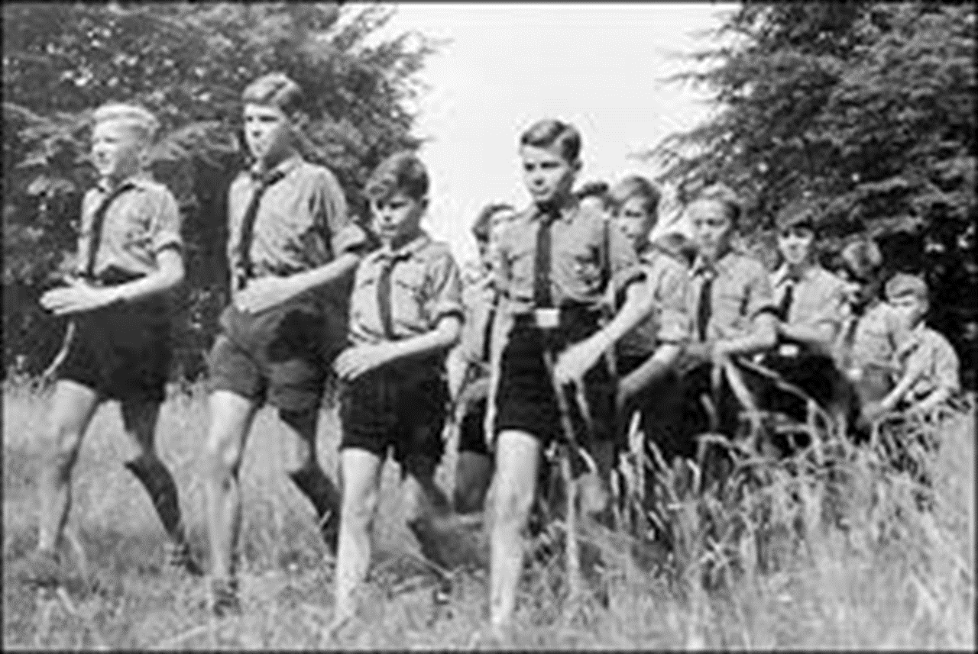Boys aged 10-14 joined the German Young People (jungvolk), then by aged 14 they joined Hitler Youth. In Hitler youth the boys earned military skills such as marching, using a bayonet, grenade throwing, trench digging, map reading, how to get under barbed wire and pistol shooting. In 1937, a Hitler Youth rifle school was also established. About 1.5 million boys were trained in rifle shooting and military field exercises over the next years. There were also tests to see if they had learned about Nazism and all boys who passed the test were given a special dagger marked ‘Blood and Honour’.

Girls aged 10 joined the JM-League of Young Girls (Jungmadelbund), here they were taught how to become good mothers and housewives. Housekeeping skills, health and nutrition were all part of the girls’ education, as was maintaining a healthy body for later childbearing. Girls had to be able to run 60 metres in 14 seconds, throw a ball 12 metres, complete a two-hour march, swim 100 metres and know how to make a bed. Then by age 14 would become members of the BDM – League of German Girls (Bund Deutscher Madel). Here they were further prepared for their roles as mothers of future Germans. By 1936 BDM membership was over 2 million. At age 17 they would join the Faith and Beauty organisation established in 1937. Faith and Beauty specialised in education in domestic science and preparation for marriage.

Activity 19

Create a Propaganda leaflet showing the New Nazi Curriculum and Youth Groups on offer.

**Jews in Nazi Germany**

Learning Intentions:

* Describe ways in which the Nazis persecuted Jews.
* Explain why persecution of the Jews was useful to the Nazis.

**What was a Jew, according to the Nazis?**

In most countries, a Jew was simply a person who believed in a particular religion. In Nazi Germany Jews were defined by their race, their blood and who their parents and grandparents were. If a person had at least three Jewish grandparents, then this person was of Jewish race. A person was a ‘half-Jew’ if he or she had two Jewish grandparents. If a person had only one Jewish grandparent, the person was a ‘quarter-Jew’. Quarter-Jews were hardly affected by the Nazi persecution but pure Jews and half-Jews suffered the full force of Nazi persecution. Hitler persecuted because used them as a scapegoat. He blamed them for Germany losing the First World War, for Germany’s economic crises and for plotting with Communists to take over Germany and eventually the world.

**How were the Jews persecuted?**

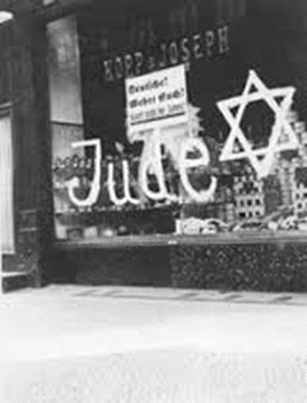The German people were encouraged to boycott Jewish stores as of 1 April 1933. Nazi Brownshirts stood outside Jewish shops to stop the Germans from using them. By 1934, all Jewish stores were marked with the yellow Star of David or had the word Juden written on the window.

On buses, trains and park benches, Jews had to sit on seats marked specifically for them. Non-Jewish children at schools were taught to hate and persecute Jews. Teachers humiliated Jewish school children. When Jewish children were bullied ay school nothing happened to the bullies. If the Jewish children then started to avoid going to school, Nazi propaganda claimed that Jewish children were lazy and could not be bothered to attend.

The Nuremberg Laws were passed in 1935 and were designed to make life so unpleasant for the Jews that they would emigrate. Those that could pay a fine were allowed to leave the country, and approximately 300,000 of Germany’s 500,000 left the country between 1933 and 1941 before emigration was halted. The laws included: Jews were not citizens of Germany, they were not allowed to marry non-Jews and could not swim in the same swimming pool as non-Jewish people.

**Kristallnacht**

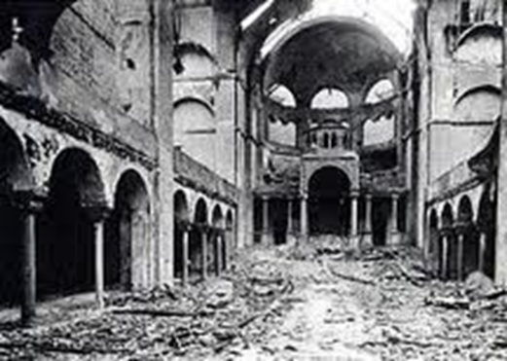Kristallnacht means the night of the Broken Glass in English, the literal translation is ‘Chrystal night’. The Nazis claimed that Kristallnacht happened as a natural reaction to news that a Jew in Paris had killed a German official. However, evidence suggests that this was an organised attack planned and implemented by the Nazis. On the night of 9-10 November 1938 ten thousand shops owned by Jewish people were destroyed and their content stolen. Four hundred synagogues were burnt down. Homes and synagogues were set on fire and left to burn. Ninety-one Jews were killed and around 20,000 were sent to concentration camps.

Despite the huge amount of damage done to Jewish property, the Jewish community was ordered to pay a one billion mark fine for all the damage and the clearing up afterwards.

**From Persecution to Genocide**

Kristallnacht was the most organised attempt so far to persecute the Jews, and by 1939 the desire of the Nazis to wipe out the Jews was clear. During the Second World War the technology to murder millions of Jews was developed. A policy of genocide – an attempt to wipe out an entire race of people. Though the Nazis also mudded gypsies, Jehovah’s Witnesses, Communists, homosexuals, and the mentally and physically handicapped, they did not try to wipe out these groups, only the Jews were to be destroyed completely. The persecution of the Jews by the Nazis did not end until Allied armies defeated the Nazis in 1945.

Activity 20

Use the information above to answer the questions in full sentences in your jotter.

1. How did the Nazis define a Jew? List three reasons why Hitler and the Nazis hated the Jews.
2. Describe how Jews were treated in public places and how children were treated at school.
3. What were the Nuremberg Laws, and when were they passed? List 3 examples of the Nuremberg Laws.
4. What does Krystalnacht mean in English? Describe the events that led up to Krystalnacht and what happened on that night.
5. What did the Jews have to do in their communities as a result of Krystalnacht?
6. Explain how the treatment of the Jews proceeded from persecution to genocide.

**The Holocaust Investigation**

Your task is to create a Presentation describing what happened during the Holocaust to the Jewish population and explain why it is important for us to remember.

It is up to you how you choose to do this…Poster, Talk or PowerPoint.

Everyone in the group must be involved in some way.

You should think about:

* Why did the Nazis persecute the Jews?
* How were the Jews treated in Nazi Germany?
* What was the final solution?
* What happened in Concentration and Death camps?
* Why is it important that we remember the Holocaust?

Each person should take on a role in the preparation of your presentation.

Group Roles:

* Team Leader: Ensures everyone is involved and prepared
* Resource Manager: Ensures the group has all resources they need
* Time Manager: Ensures everyone is on task and working to the deadline
* Researcher: Ensures all information is collected and available.
* Creative Director: Ensures resources are eye-catching and informative