**COLTNESS HIGH SCHOOL**

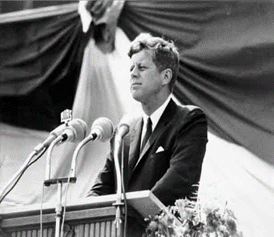

**S2 HISTORY**

**JFK**

**Introduction to John Fitzgerald Kennedy**

**By the end of the lesson I will be able to:**

* Describe the early life of JFK and the Kennedy family

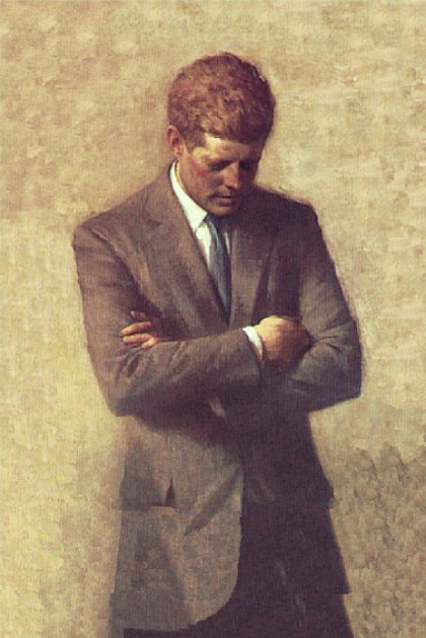John Fitzgerald Kennedy (May 29, 1917 – November 22, 1963), often referred to as JFK because of his initials, was the [35th President of the United States](http://en.wikipedia.org/wiki/List_of_Presidents_of_the_United_States), serving from 1961 until [his assassination](http://en.wikipedia.org/wiki/John_F._Kennedy_assassination) in 1963.

Those who were alive when President Kennedy was shot will never forget the moment they heard the news. JFK’s murder shook the whole world as did the chain of events which followed.

Over the next few lessons we are going to investigate JFK’s life and death and discover how he became one of the greatest presidents ever known to the world.

A portrait of President Kennedy

**Activity 1:** Write the heading ‘John Fitzgerald Kennedy’ and today’s date.

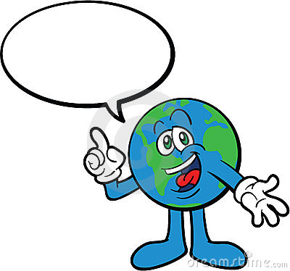

1. http://us.123rf.com/400wm/400/400/lodka/lodka1105/lodka110500129/9556630-cartoon-brush-with-a-big-poster-and-a-bucket-of-paint.jpg**Think Pair Share:** Think about anything that you already know about JFK. This could be from watching T.V, reading books, listening to parents or older family members. Then discuss this information with your partner, making a list in both your jotters. Be prepared to discuss your list with the rest of the class.
2. You should design a title page in your jotter using the heading ‘John Fitzgerald Kennedy’. It should be the size of one page in your jotter and you should make it as colourful as possible.

**Early Life and Family Background**

John F. Kennedy was born in the state of Massachusetts in Brookline, a suburb of Boston. He was born on the 29th May 1917, the second son of Joseph and Rose Kennedy. The Kennedy’s were wealthy **Irish-Americans** and a big close knit Catholic family. Joseph was a self-made millionaire who later served as **Ambassador** to Britain in the late 1930s. There were nine children- Joseph Junior was the eldest then came John, then Rosemary, Kathleen, Eunice, Patricia, Robert, Jean and Edward.

Word Bank

**Irish-American:** a citizen of the United States who can trace their ancestry to Ireland.

**Ambassador:** representative from one country to another.

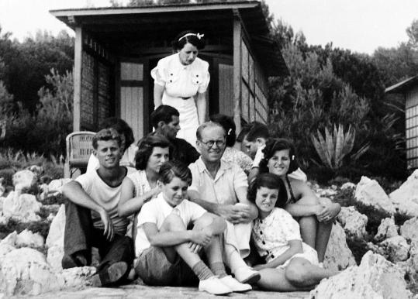

**Above:** Family photograph (JFK is sitting on the left).

**http://us.cdn2.123rf.com/168nwm/milinz/milinz1105/milinz110500001/9481736-cartoon-character-blinky-writing-with-big-blue-pen-vector-illustration.jpg**

**Education**

The Kennedy family all did well at school and had a very happy childhood. Joseph and John (who was called Jack by his family and friends) were both particularly good at sports and at their studies. JFK’s father was keen that both his sons succeed in life. Kennedy attended various schools whilst growing up including Brookline's public [Edward Devotion School](http://en.wikipedia.org/wiki/Edward_Devotion_School), [Noble and Greenough](http://en.wikipedia.org/wiki/Noble_and_Greenough_School) Lower School, [Dexter School](http://en.wikipedia.org/wiki/Dexter_School), a private school for boys and also [the Choate School](http://en.wikipedia.org/wiki/Choate_Rosemary_Hall), an elite boys boarding school.

JFK aged 11.

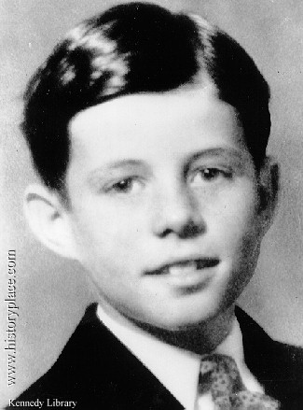

**Source A** is part of a letter that Joseph senior wrote to JFK while he was at the Choate School.

“Now Jack. I don’t want to give the impression that I am a nagger...I feel that you know if you didn’t really have the goods I would be charitable in my attitude towards your failings. After long experiences in sizing people up I definitely know you have the goods and you can go a long way...”

MC900230911[1]In 1936, John went to Harvard University in Boston to study law, politics, history and economics. While attending Harvard he tried out for the football, golf, and swimming teams and earned a spot on the varsity swim team.

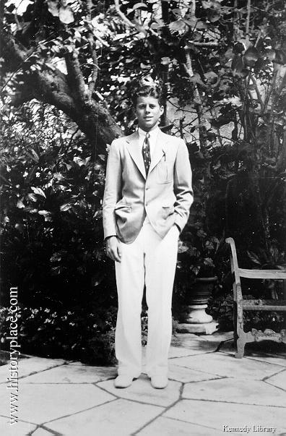

FK also visited Europe including France, Germany, Holland and England several times to see his father. He graduated with top honours from Harvard as a result of developing an interest in History, a lot of hard work and his experiences in Europe.

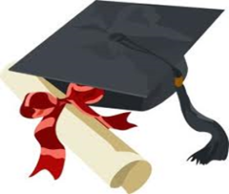

**http://us.cdn2.123rf.com/168nwm/milinz/milinz1105/milinz110500001/9481736-cartoon-character-blinky-writing-with-big-blue-pen-vector-illustration.jpg**

JFK at university

**War Hero**

In September 1941 John volunteered for the Navy. Less than three months later the U.S. was at war after the Japanese attacked the U.S. naval base at Pearl Harbour in the Hawaiian Islands. By March 1943 he was in command of a torpedo boat, PT 109, in the South Pacific.

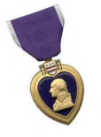 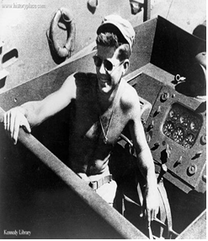

He was in action many times. His boat was wrecked by a Japanese destroyer in August 1943 and he kept up the spirits of his men by his own good humour. He also saved the life of a wounded man by towing him to safety on an island three miles away. For this he was awarded the Purple Heart, the Marine Medal and the Navy Medal. However, because of back injuries suffered during the ordeal, he saw no more action in the war.

JFK on board PT 109

However, in 1944 tragedy struck the family. Joseph Junior, JFK’s eldest brother, who was serving as an American bomber pilot during World War II, was killed during action. Their father had expected Joseph Junior to be one who got involved with politics but with his death, it was now up to JFK to pursue the dream.

[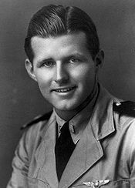](http://en.wikipedia.org/wiki/File:Lt._Joseph_P._Kennedy,_Jr._Navy.JPG)

Joseph Kennedy Jr.

**Kennedy’s Family Life**

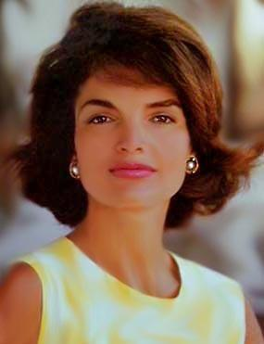

JFK met his future wife, [Jacqueline Bouvier](http://en.wikipedia.org/wiki/Jacqueline_Kennedy_Onassis), when he was a congressman at a dinner party in 1951. ‘Jackie’ came from a very wealthy Rhode Island family and she was very well-educated graduating in 1951 with a Bachelor of the Arts degree in French literature from [George Washington University](http://en.wikipedia.org/wiki/George_Washington_University) in Washington. She had even studied in the Sorbonne in Paris. Jackie was also extremely beautiful with jet black hair, dark brown eyes and a very lady like manner. It was love at first sight between Jackie and JFK.

Jacqueline Lee Bouvier

JFK and family, 4 August 1962

They were married a year after JFK was elected senator, on September 12, 1953 at her home town in Rhode Island. Twelve hundred guests attended the wedding which was the social event of the year.

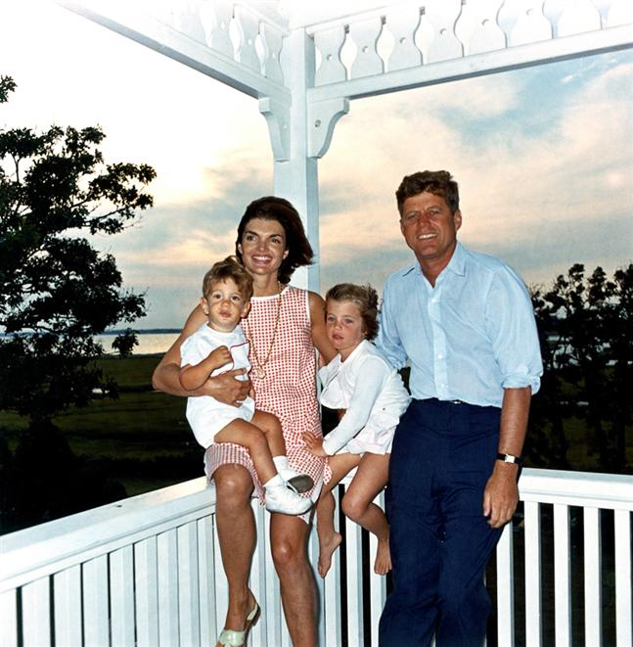

Jackie was an extremely popular First Lady. Almost every day the American newspapers and TV stations carried stories and pictures of Jackie. Her clothes and hair styles were copied by women all over America and Europe.

When the Kennedy’s made a state visit to France, Jackie’s fashion got more attention than any of the political issues. They went on to have two children, Caroline and John Junior, however, they also experienced personal tragedy when their third child, Patrick Kennedy, died just two days after being born in August 1963.



Caroline, JFK, Jackie and

John Junior.



**Activity 2**

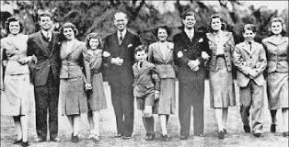**JIGSAW:** Copy out the diagram below onto a sheet of A4 paper. You will be split into groups of 4 and each member of your group will research an aspect of JFK’s life which is included in the diagram. Each member of the group will find out information about a different section, using pages 1-6 of this booklet to help them. Everyone will then have the opportunity to tell the rest of the group about the section of JFK’s life they have learned about

.

Family Background

War Hero

**John Fitzgerald Kennedy**

Marriage and Children

Education

JFK as Senator in the Democratic Party

**Political Career**



**By the end of the lesson I will be able to:**

* Understand the key moments in JFK’s political career
* Explain what JFK’s domestic and foreign policies were

Joseph Kennedy Senior was tough and **dictatorial,** encouraging his family to be winners at all they tried. The Kennedy boys wanted to please their father.

A self-made millionaire, Joseph senior had political ambitions and was made U.S. Ambassador in London. However he wanted MORE for his sons and he was willing to use his wealth to make sure his sons would go far in politics.

Word Bank

**Dictatorial:** bossy and domineering

**Congress:** makes the laws of the United States, controls all of the money, and has the power to declare war. Similar to the British Parliament.

**Democratic Party:** one of the two major political parties in the United States, along with the Republican Party.

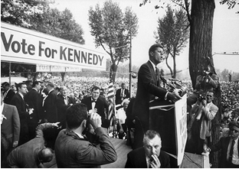

In 1946 JFK went into **Congress** as a Representative for Massachusetts. Kennedy looked younger than he was and was more than once taken for the lift attendant when he first entered the House of Representatives. Six years later, in 1952, he became a Senator in the **Democratic Party.**

MC900437787[1]

[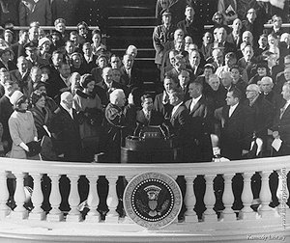](http://www.google.co.uk/url?sa=i&rct=j&q=jfks%20inaugral%20speech&source=images&cd=&cad=rja&docid=ZU-R0dS16bPImM&tbnid=ervhdOBN0nio-M:&ved=0CAUQjRw&url=http://www.historyplace.com/speeches/jfk-inaug.htm&ei=k3y3Ude6GOKU0AWP_YHIAg&bvm=bv.47534661,d.d2k&psig=AFQjCNGrF969gtdHNHY15q8jhQPYeEJmHQ&ust=1371065839652101)

In 1960, after lots of hard work and campaigning, John F Kennedy defeated Richard Nixon and became **President of the United States of America.**

There were both advantages and disadvantages surrounding Kennedy’s campaign for Presidency.

**Above:** JFK being sworn in as President

Two disadvantages Kennedy had at the start of his political career were his religion, Catholicism and the great wealth of his father. JFK joked after the 1960 election that his father did not buy one more vote than was necessary. Truman, a former President said:

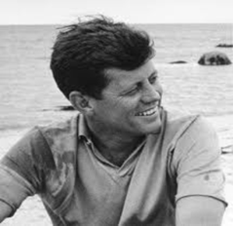

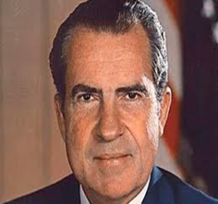

On the positive side, for the first time in American elections, the importance of T.V. became clear. Kennedy was young, good looking and was a very good speaker. He came over much better than Nixon, his rival, in televised debates causing many to vote for him in the election.

[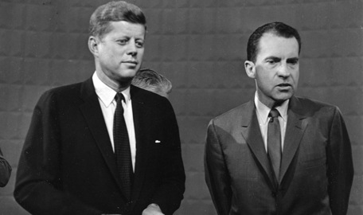](http://www.google.co.uk/url?sa=i&rct=j&q=&source=images&cd=&cad=rja&docid=7oJxKVCkeYy3gM&tbnid=XghdTOYSYYuF3M:&ved=0CAUQjRw&url=http://www.findingdulcinea.com/news/on-this-day/September-October-08/On-This-Day--Nixon-and-JFK-Appear-in-First-Televised-Presidential-Debate.html&ei=Owa6UebZMaeP0AXyyoHoDQ&bvm=bv.47883778,d.d2k&psig=AFQjCNGCEqfVIq5zl-Of8tSWZXWMFshBnw&ust=1371232039957907)

Kennedy and Nixon after a televised debate

**President of the United States**

John F Kennedy was a remarkable President in many ways. For instance, he was the youngest President ever to be voted into office, and the first Roman Catholic to reach that position. He inspired a whole generation, especially young people, with his ideals.

He began by electrifying the nation. At the inaugural ceremony on the 20th of January 1961 in Washington D.C. he proclaimed,

**Source A**

“Ask not what your country can do for you, but what you can do for your country”

[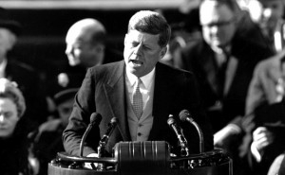](http://www.google.co.uk/url?sa=i&rct=j&q=inaugral%20speech%20jfk&source=images&cd=&cad=rja&docid=HAIzExT_ClQwuM&tbnid=yz3GBl1W_A2tYM:&ved=0CAUQjRw&url=http://www.okmagazine.com/videos/google-doodle-celebrates-50th-anniversary-john-f-kennedy-inaugural-address&ei=ZQe6Ue7oI-fY0QXzpYFY&psig=AFQjCNE-gPzzsn2CaoYzUcbUuIEqNWv4Eg&ust=1371232482489469)He felt that there were many things to be done in the U.S.A. and many challenges waiting. He saw Americans treating blacks as second-class citizens. He saw children going hungry while surplus food rotted. Kennedy warned Americans that they could not expect to remain the world’s leading nation if they did not work harder and care more about poverty and hardship.

Kennedy delivering his inaugural speech

 

**Kennedy’s Domestic Policies**

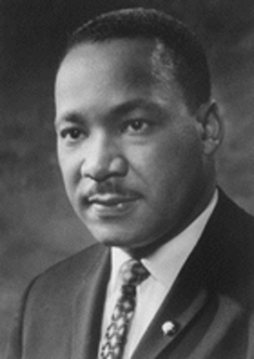**Civil Rights**

At this time in many of the southern states of America black people were treated very differently from white people – very unfairly.

Black people did not have the same rights as white people for example; black people were not allowed to vote or allowed to have good jobs. There was also **SEGREGATION** which meant that black and white people were kept apart on buses and public places like waiting rooms, shops and restaurants.

Martin Luther King

Even park benches, drinking wells and public toilets were labelled “WHITES ONLY”. Black children had also to go to separate schools. The **civil rights** movement, led by Martin Luther King had campaigned long and hard to improve the position of blacks in America. You will have the opportunity to learn more about the **civil rights movement** later on in this unit.

**Kennedy’s Aims MC900440442[1]**

**EQUAL RIGHTS**

1. To give black people in the USA a better deal by getting rid of SEGREGATION.
2. To give all Americans equal civil rights such as the right to vote, to get a decent education and to be treated fairly by the police and courts.

Word Bank

**Domestic Policy:** What the President tries to do for America.

**Segregation:** Separating different races and not allowing them to mix.

**Civil Rights:** Rights and freedoms for people for example; freedom of speech.

**The Poor**

America was the richest country in the world when John F Kennedy became President in 1960.

However millions of people still lived in poverty in America – in the cities and in the countryside. In the 1950s and 1960s it was very common for farmers to earn less than $1000 a year and nearly a million closed down their farms and either tried to find work in nearby towns or live off ‘hand-outs’ from the Government.

**Kennedy’s Aims**

1. To help the poorest citizens of the USA.
2. To have more money spent on housing, schools and welfare for everyone.

**Activity 3**

Complete the following sentences by using the endings in the boxes below:

|  |  |
| --- | --- |
| **Heads** | **Tails** |
| Domestic Policy is the … | …existed in many states in America and meant that blacks were not allowed to use the same facilities as whites. |
| Segregation … | …like the British Parliament. |
| The Civil Rights Movement … | …policy of the government which deals with all things at home. |
| Congress is … | …was led by Martin Luther King and used peaceful methods to try to bring equal rights to the blacks in America. |

**http://us.123rf.com/400wm/400/400/lodka/lodka1105/lodka110500129/9556630-cartoon-brush-with-a-big-poster-and-a-bucket-of-paint.jpg**

**Kennedy’s Foreign Policy**

**The COLD WAR**

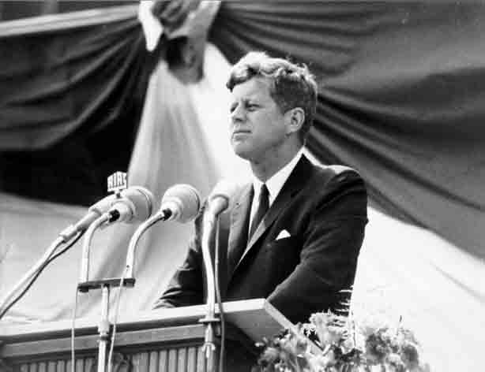Kennedy became President in 1962 at the height of the **COLD WAR**. The Cold War was fought by two **SUPERPOWERS** - U.S.S.R and the U.S.A. They were known as superpowers because of their size and their armies.

The USA and the USSR were suspicious and afraid of each other and this led them to quarrel and make threats against each other. No war was actually fought. The USA believed in **capitalism** and **democracy** while the USSR believed in **communism**.

Both the USA and the USSR had huge numbers of nuclear weapons and they realised that a war between them would have serious consequences not only for them, but for the world.

**THE CUBAN CRISIS**

The Cuban Crisis was an incident which brought the two superpowers close to war.

Word Bank

**Capitalism:** An economic system which means things such as factories and railways are privately owned by the people rather than the government.

**Communism:** The belief that a country should be run based on the idea that people share everything.

**Democracy:** A **democracy** is a form of [government](http://encyclopedia.kids.net.au/page/go/Government) in which the people take part in governing for example through voting.

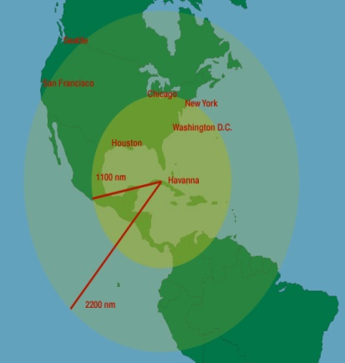Cuba was led by Fidel Castro who had been successful in overthrowing the Cuban government in a violent revolution in the 1950s. Castro turned Cuba into a communist country and became an ally of the Soviet Union. This horrified the USA because Cuba was only 90 miles off the US coast. Communism, therefore, was very close to America.

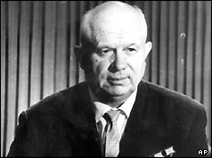On Tuesday 16th October 1962, President Kennedy received a report that Soviet missile sites had been identified on the island of Cuba. The President was shown photographs of the missile sites taken by a US air force plane. The President was extremely worried about this and, after consulting his advisors, decided to set up a barrier of American ships around Cuba to prevent more missiles and equipment being imported.

Kennedy had taken decisive action; the next move was left to the Soviet leader, Khrushchev. On the 28th October, after a number of incidents, Khrushchev backed down and ordered the Soviet missiles in Cuba to be dismantled.

Nikita Krushchev

A special telephone ‘hot line’ was even installed in the White House to allow the President to talk to Moscow to avoid any more dangerous misunderstandings between the USA and Soviet Union.

 

President Kennedy’s foreign policy did win him a lot of support at home from people that believed Communism was extremely dangerous. However, there were many who disagreed with his policies because they saw them as aggressive, expensive and interfering, or as not going far enough to tackle the Communist threat.

**Activity 4**

Answer the questions below, in full and meaningful sentences.

1. Who were the two superpowers involved in the Cold War?
2. Why was it called the “Cold War?
3. Explain how Kennedy handled the Cuban Crisis.

Extension

Use the information above to create a timeline of events surrounding the Cuban Crisis.http://us.cdn2.123rf.com/168nwm/milinz/milinz1105/milinz110500001/9481736-cartoon-character-blinky-writing-with-big-blue-pen-vector-illustration.jpg

**The President in Dallas**

President Kennedy had decided to make a personal tour of the state of Texas for political reasons. The Democratic Party in Texas had become divided and the President was hoping he would be able to help patch up differences between Governor John Connally and Senator Ralph Yarborough, the leaders of the two sides. Opposition to President Kennedy was strong in the Southern States and the President was concerned about losing votes in the upcoming Presidential election. He decided that a personal tour of the Southern States with his wife and Vice President Lyndon Johnson would help to win over some of the voters.

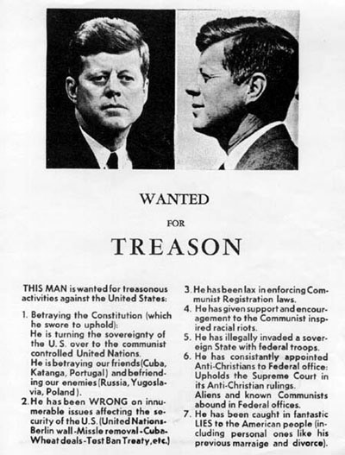

An anti-JFK poster “Treason” poster.

Dallas was an important city in the heart of Texas, however, it was also the city in which Vice President Lyndon Johnson had been attacked by a crowd. A month before the President’s visit the US Ambassador to the United Nations, Adlai Stevenson, had also been insulted and spat on by demonstrators. Other Democratic politicians warned the President not to go to Dallas.

**Activity 5**

Imagine that you are the head of the Secret Service Detail.

You must make a decision: would you tell the President that it was safe to go to Dallas, or would you advise against the trip?

Write a paragraph explaining your decision to the President. You must give at least 2 reasons why you have reached this decision.

**The Day the President Died**

**By the end of the lesson I will be able to:**

* Outline the events which happened in Dallas on 22nd November 1963

**DALLAS, FRIDAY 22ND OF NOVEMBER 1963**

The President and the **First Lady** flew in from Fort Worth and landed at Love Field Airport just before noon. The President and First Lady were greeted by cheering crowds, local officials and Democratic political chiefs. There was an election coming up and Texas was one of the most important states so Kennedy hoped his trip would smooth things over. The Presidential party were to travel by **motorcade** which was to pass through the business district of Dallas before arriving at the cities Trade Mart building at 12:20pm where the President was to make a speech to local businessmen, in particular wealthy oil men who were afraid that the President’s plan to help the rich would mean higher taxes on the oil industry.

The President and First Lady leaving Love Field Airport.

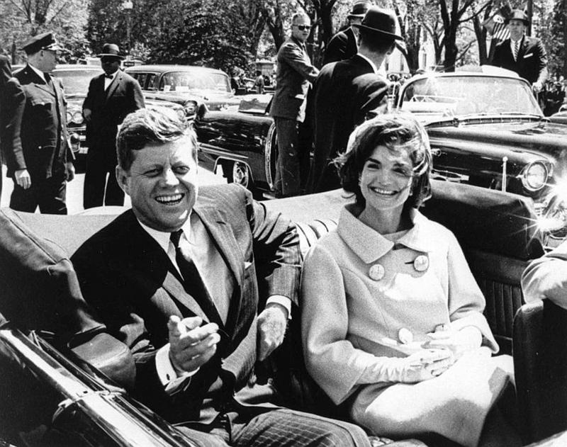

A police car drove in front to make sure the route was clear. In the Presidential limousine, the front seats were occupied by the driver William Greer and a **secret serviceman** Roy Kellerman. Behind Greer sat Mrs. Connally wife of the Governor of Texas with John Connally sitting beside her. In the back seat was the President, directly behind Governor Connally. Jackie was beside her husband. Two motorcade outriders were on each side at the rear. The following car carried eight secret servicemen, four seated inside and two standing on each running board.

Word Bank

**First Lady:** Wife of the President.

**Motorcade:** A Procession of cars.

**Secret servicemen:** A US government agency responsible for the protection of the president and their immediate family.

At 12:30pm, the motorcade passed though Houston Street onto Elm Street. The President’s limousine moved ahead at 11.2 miles per hour. Local businessman, Abraham Zapruder, slowly followed the car with his new movie camera and found himself filming the back of a freeway sign as the limousine passed by it. For a brief moment the entire car was obscured by the sign but it was no longer hidden from the sixth floor corner window of the School Book Depository.

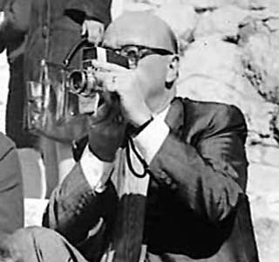

A five year old boy standing on the sidewalk with his father, Charles Brehm timidly waved his hand and waved at the President. The President smiled warmly and began to raise his hand to wave back.

There was sudden, sharp, shattering sound. Clint Hill, a secret serviceman in the following car, saw Kennedy lurch forward and grab his neck. Hill leaped out and charged forwards. The President was wounded but not fatally. A 6.5 mm bullet had entered the back of his neck, ripped his windpipe and exited from his neck, nicking the knot in his tie.

Abraham Zapruder

Next to be hit was John Connally, sitting directly in front of the President, a bullet passing through his back, chest, wrist and thigh. At that moment, he had been glancing over his shoulder in the direction of what he thought he recognised as a rifle shot.

Kellerman thought he heard the President say, “My God...I’m hit!” Now it was too late. The assassin was supposedly standing silently at a sixth floor window of the School Book Depository. He was there and ready.

**HE SQUEEZED THE TRIGGER.**

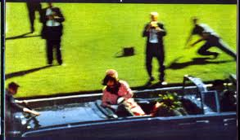The First Lady cradled her husband in her arms. He looked puzzled. He raised his right hand, as though to brush back his hair but the motion faltered. He had been reaching for the top of his head but it was not there anymore. By this time Clint Hill reached the President’s car and was trying to climb on to the boot. Jackie climbed out towards him. They raced towards Parkland Hospital. The President of the United States was dead on arrival.

**A View of the Dealey Plaza**

**A- Book Depository sixth floor window:** Witnesses claim to have seen a gunman here. Rifle and cartridge cases were later recovered from here.

**B-Wooden Fence on Grassy Knoll**-Witnesses claim to have seen a ‘puff of smoke’ come from this area.

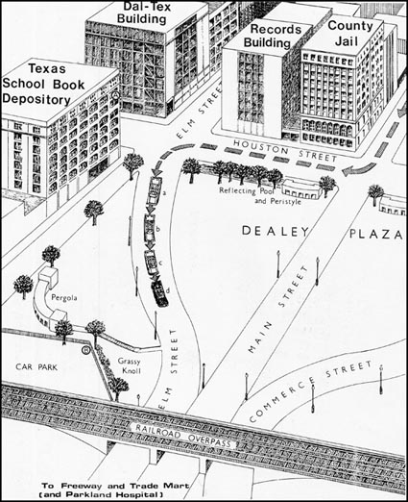

a. Position where view of Presidential Limousine was blocked by trees.

b. Position of car at time of Presidents reaction to first shot.

c. Position of car at time Governor Connally reacted to a shot.

d. Position of car at time of fatal head shot.

**Activity 6**

Collect a copy of the Dealey Plaza map and glue this into your jotter.

Look at your diagram of the Dealey Plaza, the points marked A and B are on the basis of eye witness statements giving the most likely positions of the gunman.

In your opinion which of the two positions, A or B, is in the best place for firing a shot and escaping? Give reasons for your choice.

Answer the questions below in full and meaningful sentences.

1. Why was Kennedy in Dallas on 22nd November 1963?
2. Why did Kennedy want the roof removed from the car?
3. Who was in the presidential car that day? What security did he have on that day?
4. At what time did the shooting begin?
5. How long was it between Kennedy arriving at the hospital and him being pronounced dead?

**Homework Task:** Collect a homework sheet from your teacher and create an eyewitness statement describing the events that unfolded in Dallas on 22nd November 1963.

**Lee Harvey Oswald**

**By the end of the lesson I will be able to:**

* Explain who Lee Harvey Oswald was
* Describe the early life of Lee Harvey Oswald

The police had pinpointed the Texas School Book Depository as the source of the shots. Near a window on the sixth floor they found three empty cartridge cases. A few minutes after the shooting, a motorcycle policeman was talking to the janitor of the building when a man named Lee Harvey Oswald walked out of the elevator on the second floor. The janitor informed the policeman that the man was Oswald and that he worked in the building. Oswald was allowed to go.

**Lee Harvey Oswald**





Half an hour or so after the assassination, Oswald was walking down a nearby street when police officer J D Tippit, driving a patrol car, called him over. Oswald spoke to him calmly then began to walk away. Tippit jumped from the car and ran after him; Oswald turned, pulled out a revolver and killed Officer Tippit.

Inside the book depository

An hour later a ticket seller at the Texas Theatre saw Oswald walk in without buying a ticket; she called the police. As they approached Oswald he pointed his gun and pulled the trigger; it misfired. Moments later he was in custody.

**Fact File – Lee Harvey Oswald**

* Lee Harvey Oswald was born on the 18 October 1939 in New Orleans, Louisiana.
* Oswald was an ex-marine who had defected to the USSR and married a Russian girl named Marina.
* Oswald returned to the USA in 1962, with his wife and baby daughter, after the Russians refused to grant him a residence permit.
* In March 1963 he bought a rifle with a telescopic sight from a mail order firm using the name A.J. Hidell, - his original intention was to assassinate a retired army general.
* Oswald worked in the Texas School Book Depository in November 1963.

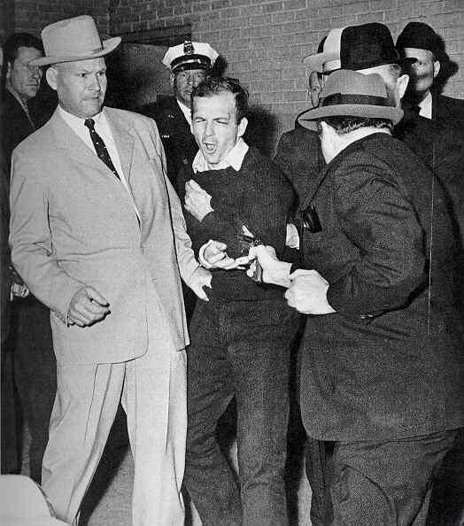The rifle with the telescopic sight was found on the sixth floor of the Book Depository and one of Oswald's palm prints was found on it. He denied killing the President and Officer Tippit and answered questions arrogantly.

At 11.20am on Sunday 24th November 1963, Oswald was being taken from the Dallas Police Headquarters to a car waiting outside and the crowds of photographers - including television crews - were taking pictures, when a man stepped forward, jammed a revolver against Oswald's chest and pulled the trigger. The man was grabbed by a policeman as Oswald collapsed. Newsmen yelled to ask his name and the man shouted back: "I’m Jack Ruby! ‘

Oswald in the centre of the photo, Jack Ruby is holding the gun with his back to the camera

Oswald was rushed to Parkland Hospital (the same hospital as the president!) and was operated on by the same surgeon who had tried to save Kennedy's life; but by 1.07pm he was pronounced dead.

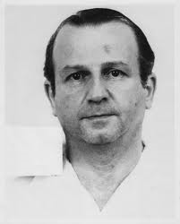Jack Ruby was a Dallas nightclub owner who had many friends in the police force - as well as mafia connections. He was born in Chicago, Illinois in 1911 and when he was a teenager he worked as a delivery boy for the gangster Al Capone. Witnesses reported that Ruby had been behaving oddly since Kennedy's assassination, and his **charlady** (cleaner) mentioned that he had been talking to himself on the morning he killed Oswald. Tried for murder in 1964, Ruby was sentenced to death, but died of cancer in 1967 before the sentence was carried out. Ruby claimed he shot Oswald out of grief over the death of JFK and that he wanted to spare Mrs Kennedy the anguish of having to go through a long trial.

Jack Ruby

**http://us.cdn2.123rf.com/168nwm/milinz/milinz1105/milinz110500001/9481736-cartoon-character-blinky-writing-with-big-blue-pen-vector-illustration.jpg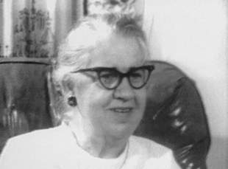Source A is by Oswald’s mother, Marguerite, (pictured right) who insisted Oswald had a normal childhood.**

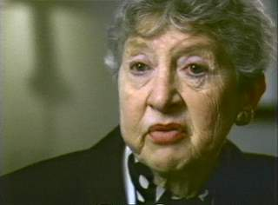**Mrs. Oswald:** "We must understand that Lee had two brothers, so he was not raised just with a woman alone . . . . He was a happy-go-lucky youngster actually. He studied animals, was often in the zoo, and as we know he was picked up in the Bronx Zoo while in New York playing hooky from school, and I consider that normal also -- playing hooky from school. Many boys do this."

**Source B is by Evelyn Siegel, a social worker at Youth House in New York where Oswald was held for three weeks in 1953. Siegel had a very different memory of the young Lee Harvey Oswald.**

**Mrs. Siegel:** "I remember him vividly, he was a skinny, unprepossessing kid. He was not a mentally disturbed kid. As a matter of fact, his I.Q. was better than average. He was just emotionally frozen. He was a kid who had never developed a really trusting relationship with anybody. From what I would gather, he really interacted with no one. He made his own meals. His mother left at around seven and came home at seven, and he shifted for himself. You got the feeling of a kid -- nobody gave a darn about him. He was just floating along in the world, with no emotional resources at all."

**MC900434389[1]**Do these 2 sources agree with one another about the young Lee Harvey Oswald? Why might these two women disagree about what Oswald was like?

**http://us.cdn2.123rf.com/168nwm/milinz/milinz1105/milinz110500001/9481736-cartoon-character-blinky-writing-with-big-blue-pen-vector-illustration.jpg**

**Activity 7**

Write the heading ‘Source Task’ and today’s date.

Copy and complete the sentences below.

Source A and Source B **agree/disagree** about the young Lee Harvey Oswald.

Source A says _____________________________________________,

while Source B says _________________________________________.

Source A and Source B **agree/disagree** about the young Lee Harvey Oswald.

Source A says _____________________________________________,

while Source B says _________________________________________.

**The Warren Commission**

**By the end of the lesson I will be able to:**

* Explain what the Warren Commission was
* Outline the recommendations that the Warren Commission made

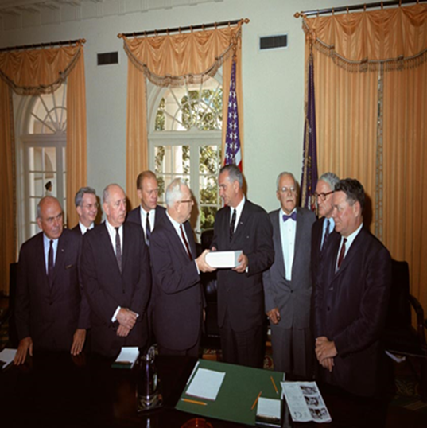One week after the assassination of President Kennedy, the new President, Lyndon B Johnson set up a Commission, to “ascertain, evaluate and report upon the facts relating to the assassination of the late president John F Kennedy”. This meant that the Commission was to look at the facts and find out who was guilty of the murder of the President. The Commission was let by Chief Justice Warren and was made up of seven respected American men including the former director of the CIA and a future US President. It employed a large staff of lawyers and used the FBI to gather information on their behalf. Almost ten months later Warren Commission released its findings.

**The findings of the Warren Commision:**

* President Kennedy was murdered by a single gunman Lee Harvey Oswald using a Manlicher-Carcano rifle.
* Oswald fired 3 shots from the sixth floor of the Book Depository.
* The President had been struck from behind by two bullets, one causing a fatal head wound.
* Oswald worked alone. There had been no conspiracy.
* Oswald also killed Officer Tippit to avoid arrest.

However, below is a list of facts that do not agree with the findings of the Warren Commission:

* Lee Harvey Oswald was a trained marine wjo could speak different languages. Why was he working in such a low paid job in a book depository?
* Lee Oswald was a known friend/associate of Jack Ruby. Why would Ruby kill him?
* Oswald claimed that he was innocent from the start. “I’m just a Patsy”. Which means he was framed for the murder.
* Oswald’s palm print that was found on the rifle was only discovered after his death.
* Many witnesses say shots came from the grassy knoll area as well as the Book Depository. If the witnesses are to be believed then there must have been two gunmen. This means a conspiracy.

**Activity 8**

Using the information on pages 21-26, and what we have discussed, answer the questions below in full and meaningful sentences.

1. What was found near the window of the Book Depository?
2. Whose murder was Oswald charged with?
3. Who shot Oswald?
4. What is suspicious about Oswald’s palm print being found after his death?
5. What does the word conspiracy mean?

**http://us.cdn2.123rf.com/168nwm/milinz/milinz1105/milinz110500001/9481736-cartoon-character-blinky-writing-with-big-blue-pen-vector-illustration.jpg**

**The Zapruder Film**

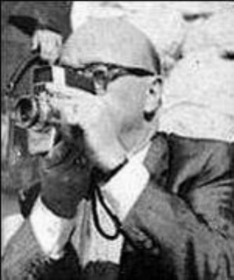

Abraham Zapruder was a tailor who was one of the crowd who was watching the Presidential motorcade in Dealey Plaza. The film footage he took on his home movie camera provided a permanent and graphic record of the assassination of President Kennedy.

[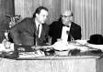](http://home.arcor.de/starluver/manics/tme/images/zapruder.jpg)The Zapruder film was closely examined by the Warren Commission. It was a valuable piece of evidence because it provided a clear time frame for the assassination.

Mr Zapruder on the news just after the shooting

The film shows the President smiling and waving to the crowds and suddenly reacting to a shot. A few seconds later Governor Connally also appears to react to a shot and then Kennedy’s head is seen to explode as his body jerks backwards.

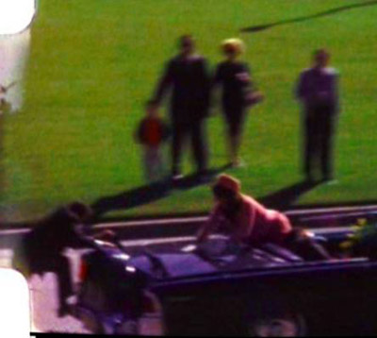Although Zapruder’s footage only lasts about 22 seconds, it is made up of a series of frames or still photographs, meaning each event can be placed on a timescale. FBI investigators calculated the exact time between each gun shot as being 1.6 seconds with the maximum time between the first and third shot as 5.6 seconds.

Zapruder Film Frame 368

**http://us.cdn2.123rf.com/168nwm/milinz/milinz1105/milinz110500001/9481736-cartoon-character-blinky-writing-with-big-blue-pen-vector-illustration.jpgActivity 9**

Write the heading ‘The Zapruder Film’ and today’s date.****

**Watch the Zapruder film carefully and then, with your partner, put the events below into the correct order in your jotter.**

|  |  |
| --- | --- |
| **Frame** | **Event** |
| 166-207 | Bullet strikes the president’s head |
| 208-224 | President’s car is blocked by a street sign |
| 225 | Violent backward movement of the President after the head shot. President Kennedy falls to his left into the lap of his wife |
| 235-238 | Presidential limousine reappears from behind the street sign. President is already reacting to the first shot |
| 239-312 | Governor Connaly appears to respond to a shot |
| 313-314 | Mrs Kennedy turns to look at her husband and reaches towards him |
| 315-335 | Bullet strikes the president |

Having read the evidence we must now decide who we believe. If the evidence has persuaded you that Lee Harvey Oswalk was a lone gunman then you have found your killer.

However, if you believe there was more than one gunman involved then you must decide who done it and more importantly, why?

**Conspiracy Theories**

?

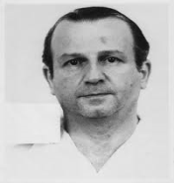

?

It has been over 50 years since JFK was assassinated and there are still many theories about who was responsible. You will have the opportunity to research this topic in more detail and produce an investigation into the assassination. You will examine evidence and delve into the conspiracy theories that surround JFK’s assassination in order to discover the truth.

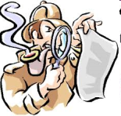

?

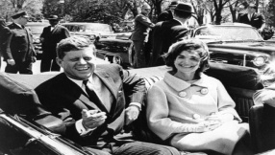

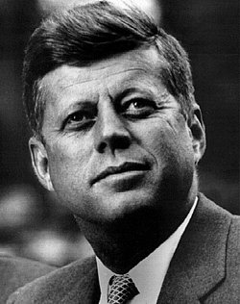

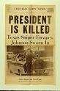

?

?

A **Conspiracy Theory** is the idea that an important political event was the result of a secret plot which is unknown to the general public. Below are 4 of the most famous **conspiracy theories** about the assassination of JFK:

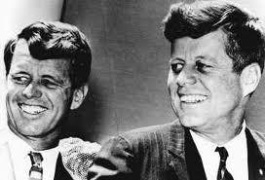

**The Mafia**

JFK had his brother Bobby, the Attorney General, arrest 288 Mafia members in 2 years. Jack Ruby had connections to the Mafia and it is believed by some that Ruby killed Lee Harvey Oswald to stop him from revealing the names of the powerful Mafia members responsible for the assassination.

Jack Ruby had links to the Mafia

Bobby and JFK

**The Communists**

Russia and Cuba were enemies of the USA and some people insist that one of these communist countries was behind the assassination. Oswald had lived in Russia and campaigned for the USA to treat Cuba more fairly leading some to believe, including President Johnson, that the assassination was a communist plot.

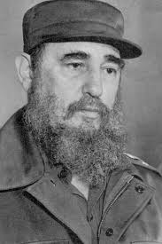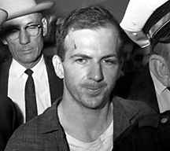

Lee Harvey Oswald

Fidel Castro, leader of Cuba

**The FBI**

The Federal Bureau of Investigation is a government agency which is responsible for investigating crime in the USA. Some people have accused the FBI of covering up the truth about the assassination. The FBI ignored many key witnesses and were said to have changed witness statements that claimed there was more than one gunman. Lee Harvey Oswald had the phone number of an FBI agent in his notebook when he was arrested.

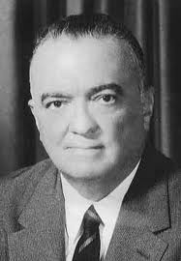

J. Edgar Hoover was the Head of the FBI at the time. He did not like Kennedy and feared he was trying to get rid of the FBI.



**The CIA**

The Central Intelligence Agency gathers intelligence from foreign countries to protect the USA from threats. Kennedy had made enemies when he got rid of four powerful CIA bosses, including the Head of the CIA, after a failed attack on Cuba. After it was revealed that Jack Ruby worked for the CIA in the 1950s, some people claimed that the CIA was somehow involved, or covered up the truth about the assassination.

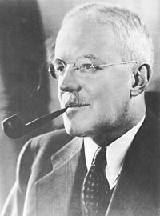

Allan Dulles, Director of the CIA, was forced to resign following a failed mission. Dulles was also a member of the Warren Commission.



**Investigation**

Using the information we have discovered write a detailed essay. In this essay you must consider all of the suspects and why you believe their innocence or guilt.

**MOST IMPORTANTY** you must state who you think killed Kennedy and why.

**Plan**

**Introduction**:

* Give information about JFK and his life.
* Think about his family.
* Think about his political career.

**Assassination**:

* Explain what happened on the day of the assassination.
* What was the president doing?
* What happened when the shots were fired?

**Conspiracy**:

* Outline the conspiracy theories and why you think they are likely to be true or false.
* Evaluate these theories – say the strengths and weaknesses of these (are they likely to be true or false?)

**Conclusion**:

* Outline what you think happened and who was responsible for the assassination of JFK.
* Say who you think was responsible for the assassination of JFK.
* Explain why you have reached this decision.