The Civil Rights Campaign up to 1968
Why was the decision of the Supreme Court in 1954 so important to civil rights?
One of the first parks to ignite the civil rights movement in the 1950s was an argument in a town called Topeka in the state of Kansas. The argument was about which school an eight-year-old girl called Linda Brown should go to. Oliver Brown, Linda’s father, thought it was wrong that his daughter should have to go to a school for black children that was further away from her home and was less well looked after than nearby schools for white children.
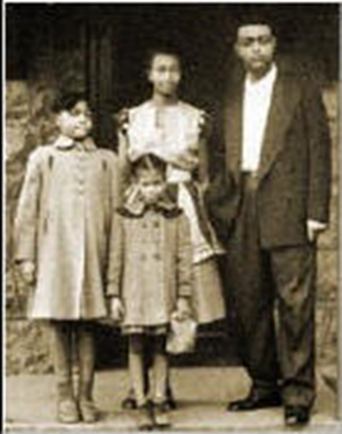
In 1952, Mr Brown took the Topeka Board of Education to court over which school his daughter Linda could attend. Mr Brown was supported in this action by the National Association for the Advancement of Coloured People (NAACP). The NAACP aimed to achieve civil rights by working within the legal system. The NAACP saw the case of Linda Brown as an opportunity to attack segregation in education.
The court case was called ‘Brown versus the Topeka Board of Education’ (Brown v. Topeka) and eventually reached the Supreme Court. In 1896 the Supreme Court had decided that segregation was acceptable. It said the black people should have ‘separate but equal’ facilities, which included schools.
On 17 May 1954, the Supreme Court completely changed the decision they reached nearly 60 years earlier. It was decided that segregated schools were unequal and that schools should be desegregated. The court declared, ‘in the field of public education the doctrine of “separate but equal” has no place’. In other words, the Supreme Court said the idea of ‘separate but equal’ had no place in modern-day USA and that separating children in schools because of the colour of their skin was wrong.
The court’s decision was very important for the civil rights movement of the 1950s. The case of Brown v. Topeka and the Supreme Court decision was the first victory for civil rights campaigners. However, there was a long way to go. The problem now was how to make southern states desegregate their schools.
Even the US president, when he heard about the decision of the Supreme Court, said, ‘I don’t believe you can change the hearts of men with a law.’ By the end of 1956 not one black child attended a white school in the South. Most southern states believed the Supreme Court was out of touch with the realities of southern life.
The realities of southern life were given national publicity was the third reason for the growth of civil rights after 1945: the murder of Emmett Till.
Task 1
- Outline the Brown v. Topeka case.
- What was the decision of the Supreme Court? Why was this significant for the civil rights campaign?

The Montgomery Bus Boycott
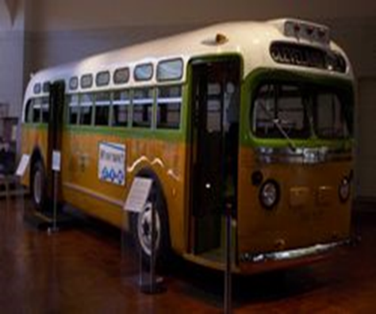
How did the Montgomery Bus Boycott begin?
On a December night in 1955 in the city of Montgomery, Alabama, Rosa Parks was going home after a long day working in a large city-centre shop. She sat in the black section of the bus. When the white people’s section of the bus was full and more white people got on, the driver moved the sign marking the boundary between white and black seats to create more white seats. Rosa Parks was now sitting in the white area. The driver asked her to move. She refused. The driver had her arrested.
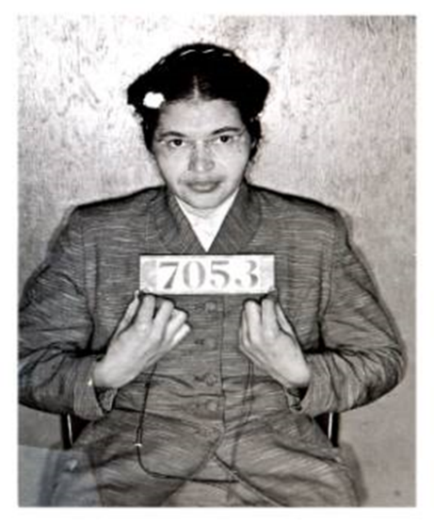
Rosa Parks was a member if the National Association for the Advancement of Coloured People (NAACP), a civil rights organisation, who had been waiting for an opportunity to launch a high-profile campaign against segregation in the city buses. There had been lots of times when black youths had been arrested for challenging bus segregation but the youths were unlikely to be reliable in a court of law. Rosa Parks was a mature woman and a respected person among her black and white colleagues in the shop where she worked.
The year before this occurred, the Supreme Court had declared that segregation was wrong in schools, and the NAACP argued that if it was wrong in schools then it was also wrong in everyday life, such as on buses.
When news spread of the arrest of Rosa Parks, 50 respected leaders of the black community met in a Montgomery church to discuss their plans. They agreed to boycott the city bus system.
Why was a boycott started?
One year before the arrest of Rosa Parks, a letter written to the mayor of Montgomery had explained why it was in the bus company’s best interest to end segregation:
“Seventy per cent of the riders on the buses are Negroes. If the Negroes did not use the buses, then the bus company could not operate. More and more of our people are already arranging with neighbours and friends to keep from being insulted and humiliated by bus drivers. Plans are being made to ride less, or nor at all, on your buses.”
The mayor refused to stop segregation on buses, which meant that black passengers still had to pay their fare at the front door but could only take a seat in the black section after they walked to the back door of the bus to get on. The black community argued they were humiliated each time they used a bus.
Eventually, the Supreme Court decided that segregation on Montgomery’s buses was against the US constitution. The buses were eventually desegregated in December 1956 after a boycott that lasted for 381 days. However, the bus company had started to desegregate anyway. The company could not afford to lose black passengers.
Why was the Montgomery Bus Boycott important?
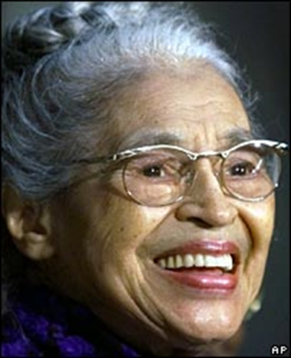
- It was a mass protest, involving all social groups in the black community. It showed what could be achieved by people if they stayed united and determined to achieve their target. For months, black Americans refused to use the buses in Montgomery.
- It lasted for a long time and showed what could be achieved by disciplined non-violence. The police found it difficult to cope with civil rights protest that was organise, broke no law and was peaceful. How could they arrest people who simply did not get on buses?
- It produced an outstanding new leader, an important new organisation (SCLC) and a new philosophy.
- It drew attention of the north to the system of segregation in the south, and exposed the unreasonable behaviour of many southern white people. This was helped by the growing influence of television in the 1960’s.
- In company with the recent Brown decision, it raised the question of federal response to illegal acts of segregation and discrimination in the south.
- The boycott showed the economic power of the black community. Since black Americans made up 60-70 per cent of al bus passengers, the company was faced with a choice: desegregate its buses or go out of business. For the first time the black population had shown its economic power.
Task 2
- Why was Rosa Parks a good case for the civil rights cause in Montgomery?
- Why was it decided to perform a Bus Boycott?
- What decision was made by the Supreme Court?

Little Rock
What happened at Little Rock High School in the state of Arkansas in 1957?
Although the Supreme Court’s decision in 1954 had outlaws school segregation, southern states tried to ignore this ruling. Schools in the South which did try to desegregate were met by furious white racist mobs. The mobs, along with the Ku Klux Klan (KKK) members, attacked black students. Schools were even blown up. The most famous struggle to integrate schools was in Little Rock, the capital city of Arkansas.
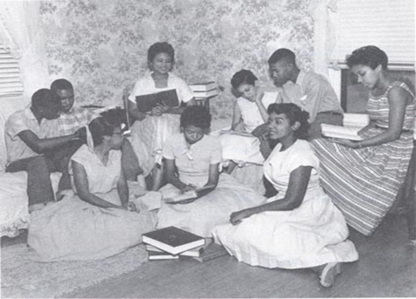
In September 1957, the NAACP decided it would test the willingness of states in the South to desegregate their schools. Little Rock High school was a very successful all-white school. In 1955, the school boards had agreed to start integration in the autumn of 1957. The NAACP selected nine grade A students so that the school could have no complaints about the ability of the new black students.
The news of this attempted integration ripped through the white parts of Little Rock. It was clear from what was said by white racists in the city that black students trying to go to Little Rock High School would be risking their lives.
The NAACP knew there was a huge danger to the nine black students due to go to school, so the students were telephoned and told not to attend the next day. However, one student, Elizabeth Eckford, did not have a phone so she was not warned to stay at home. The next day she turned up at school, on her own, to face a white mob. Elizabeth also had to face a line of soldiers blocking her path.
The governor of Arkansas, Orval Faubus, had ordered a line of troops from the National Guard to block the path to the school. Faubus argued that he had used the National Guard to keep the mob away from the black students. In effect, what the National Guard did was to form a human blockade, preventing the black students getting to the school.
Task 3
- Why did white residents of Little Rock want to keep Black students out of Little Rock High school?
- Why do you think the Black students wanted to attend Little Rock High School?
Why did events at Little Rock become a national and international issue?
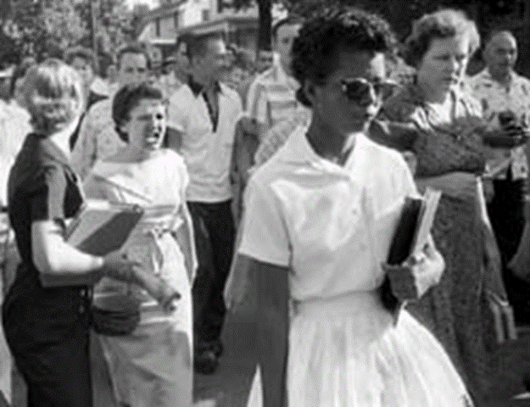
By the mid-1950s, most US homes had television sets. For the first time, people could see what was happening. The world was shocked when it saw and heard what happened to a 15-year-old girl trying to go to school.
The late 1950s were also the time of the Cold War. When film of Elizabeth Eckford being bullied and threatened just for attending a white school was shown round the world, Russia used those images to claim that the USA was very far from being a land of the free. President Dwight Eisenhower was embarrassed. Something had to be done.

What did the president do to solve the crisis?
The US president was no longer willing to have individual states in the USA ignoring federal law. Nor was he prepared to allow the USA to be criticised in the world’s newspapers. When Faubus removed the National Guardsmen, there was now nothing to stop the mob from attacking any black student going to school in Little Rock. President Eisenhower took action. He sent 1000 US paratroopers to ‘invade’ Arkansas. These soldiers would then protect black children on their way to school.
Armed soldiers carrying rifles with fixed bayonets surrounded the black students on their way to school. When they travelled to and from school, the students were protected by troops in jeeps with machine guns. The soldiers stayed in Little Rock for a year and they even patrolled the school corridors to make sure the children were safe. Naturally, the events in Little Rock attracted worldwide attention to the civil rights movement.
Eventually, the tension died down as the interest of the media went elsewhere but the black students in Little Rock were still bullied. Ernest Green was the first black student to graduate from Little Rock High School in 1958 but it took a long time to solve the issue of school integration.
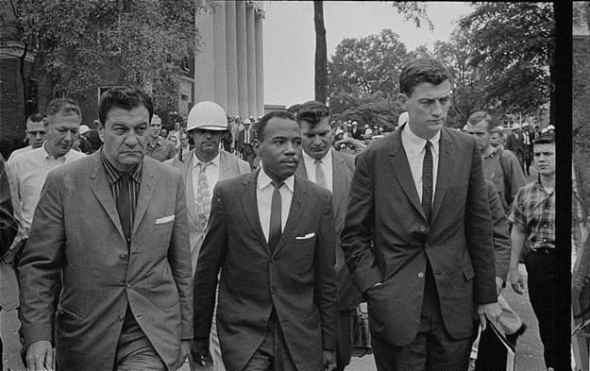
In 1962, a black student, James Meredith, attempted to attend the University of Mississippi Law School. His admission was blocked, and during the violence that followed, federal troops were once again used to restore order and enforce national law. The Mississippi authorities trued to ban Meredith from the university because he was black. However the federal government decided that he should be allowed into the law school. On Sunday 30 September 1962, 123 federal marshals, 316 US border patrolmen, and 97 federal prison guards escorted Meredith to the college campus. Facing Meredith was a mob of over 2000 men and women. Riots broke out and two journalists were killed. President Kennedy had to send 16,000 troops to restore order at the university. Twenty-eight US marshals had been shot and another 160 of the law enforcers were injured. Federal troops remained at the university for over a year just to protect one black student.
Did the Civil Rights Act of 1957 make much of a difference?
After the events in Montgomery, Alabama and Little Rock, Arkansas, the US government introduced the Civil Rights Act in 1957. The Civil Rights Act was not a huge step, but it was the first national act on civil rights for nearly 100 years. Opinion was divided as to the importance of the act. On one hand, it seemed to show that the federal government was no longer willing to allow the southern states to do as they pleased as far as race relations were concerned. On the other hand, some civil rights campaigners were disappointed with the limited power of the act. BY 1959 the new Civil Rights Act had not added a single southern black person’s name to the voting register. The pressure for civil rights continued to grow during the early 1960s.
Task 4
Read the information then answer the questions:
- Why would President Eisenhower be embarrassed about Little Rock?
- What solution did Eisenhower impose? Do you think this is a good idea? Give reasons for your answer.
- Who is Ernest Green?
- Who is James Meredith and why is he important?
- In what ways did the Civil Rights Act of 1957make a difference?
- In what ways was the Civil Rights Act of 1957 limited?

Sit-ins and Freedom Rides
What were sit-ins?
The sit-ins were part of the Student Non-violent Co-ordinating Committee (SNCC) campaign for civil rights. Black students had created the SNCC in April 1960 to help co-ordinate, support and publicise the sit-in campaign. The SNCC’s targets were segregated lunch counters across the South.
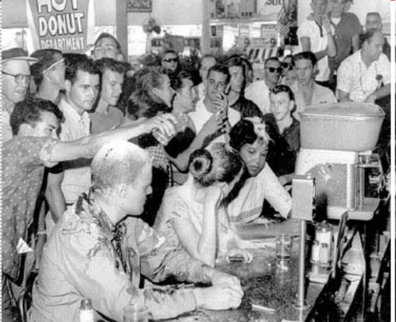
Lunch counters were like fast-food cafes with a counter where food was served. At the counters, there were tools for white customers only. When a mixture of white and black SNCC students sat down at lunch counters, it marked the beginning of ‘sit-ins’, an effective method of using civil disobedience in peaceful protest.
The students of the SNCC were well organised and well prepared. Protest classes were run by a student called Jim Lawson in the University of Nashville. In Lawson’s classes, students prepared for the day they would have to remain non-violent even when they were being assaulted and insulted.
On 1 February 1960, four black students sat down and attempted to order some food at a whites-only lunch counter in Greensboro, North Carolina. They were refused service but remained in their seats until closing time. They returned the following day with 25 supporters who continued the sit-in. By 5 February there were more than 300 students, black and white, taking part in the protest.
Television news showed local white youths attacking the demonstrators but when the police arrived it was the demonstrators who were arrested. However, as soon as the demonstrators were carried away from the lunch counters, more demonstrators took their place. The police, the prisons and the courts all over the South were being overwhelmed by the campaign to ‘fill the jails’.
By the end of the year, more than 700,000 protestors had participated in sit-ins across the country. Although thousands of the students were arrested and physically assaulted, they refused to retaliate. The campaign methods of the students are a good example of civil disobedience and non-violent protest.
How successful were the sit-ins?
In many ways, the sit-ins were highly successful. National television coverage highlighted the violent racist reaction of many southerners, while the courage, commitment and sacrifice of the demonstrators won them support across the USA. By the summer of 1960, many lunch counters in the South had been desegregated. However, the sit-ins did not end all segregation in the South and their impact was only really felt at a local level.

Task 5
- Describe the sit-ins.
- Explain the success of the sit-ins.

What were the Freedom Rides?
In 1960, a Supreme Court decision had banned segregation in public areas such as toilets, waiting rooms and restaurants for bus travellers going from one state to another.
In 1961, a group of black and white members of a non-violent protest group called the Congress of Racial Equality (CORE) wanted to see if such segregation really had ended.
In May 1961, 13 CORE members travelled from Washington, DC to New Orleans in the southern states of Mississippi. The bus journeys were called Freedom Rides and the passengers became known as Freedom Riders. The purpose of these was to travel on the buses to check and challenge racial segregation. Along with CORE members there were SNCC members.
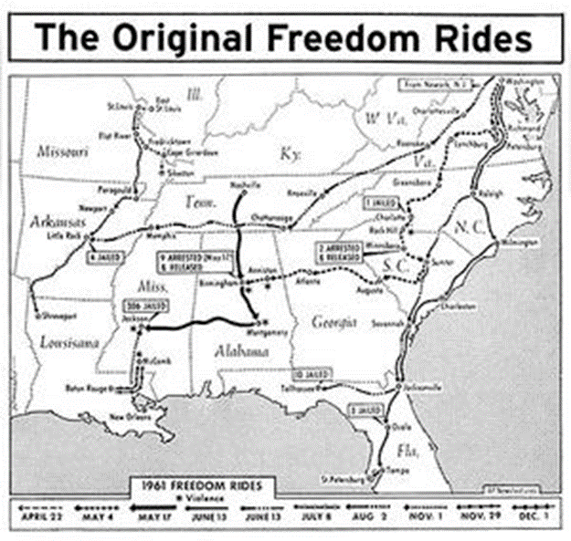
The plan was to travel south on interstate buses. Interstate highways (like motorways) and the service area toilets were the responsibility of the national federal authority, not the state authority. In areas under federal authority there should have been no segregation. The Freedom Riders wanted to see if segregation in interstate public facilities had really ended. Black students would try to use whites-only toilets and white students would use black-only toilets at stopping points along the routes.
The Freedom Riders expected a violent reaction from the southern racists. At first, there was little violence, but as they travelled south, bus tyres were slashed, buses were firebombed and the Freedom Riders were beaten up.
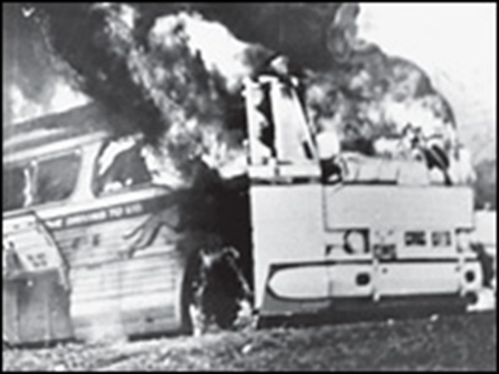
The Freedom Riders were met with heavy resistance from southern whites who knew the route that the students were following. When the buses arrived in Alabama, the Ku Klux Klan (KKK) was waiting for them. In Anniston, Alabama, two ‘Freedom’ buses were stopped and burned. Passengers who tried to get off were beaten. The students then travelled to Birmingham, Alabama, where they got onto another interstate bus. The bus was again stopped and eight white men boarded the bus. They brutally beat the students with sticks and chains. One of the students, James Peck, had to have 50 stitches in his head. Even when faced by such vicious attacks, the students stuck to their non-violent protest beliefs.
Did the Freedom Rides help to gain civil rights?
The intention of CORE was to gain publicity for its protest and it achieved this aim. Once again, the television news coverage of the attacks on the Freedom Riders deeply shocked the American public. Martin Luther King Jr attempted to persuade the riders to stop for fear that they would be killed, but the Freedom Riders continued throughout the summer – as did the violence.
Another aim of the protestors was to force the federal government in Washington to take action.
President Kennedy was concerned about the Freedom Rides and he sent one of his advisors to see first hand what was happening. When the president’s advisor arrived, he was beaten unconscious. Eventually police escorts were provided for the riders, although this did not prevent further violence.
The FBI was then asked to investigate the violence used against the students and how US officers were also sent in to protect the students. As the risk of serious violence increased, Martin Luther King Jr once again attempted to get the students to stop, but they refused. CORE and SNCC agreed to continue the bus rides.
Eventually, in the face of national publicity and pressure to change, new orders were sent to all interstate bus companies that ended segregation at interstate bus stations. Finally, in late 1961, the US government ordered the end of segregation in airports, rail and bus stations.

How important were the Freedom Rides?
The Freedom Riders, like the sit-ins before them, were successful in making northern white Americans more and more sympathetic towards the civil rights cause. Many people agree that of all the tactics used, the Freedom Riders did the most to increase support for the civil rights movement.
A CORE publicity leaflet said:
The Freedom Rides, like the sit-ins before them, demonstrated that anyone who opposed segregation could take action themselves to work toward sending Jim Crow laws. They helped the spread of civil rights through the south.
However, there are different opinions about important the Freedom Rides were. There is a view that the Freedom Rides did not do much to change the real problem which was that black Americans had little power to alter the way the country was run. As Jim Lawson, writing in the Southern Patriot newspaper, reported in 1961:
The Freedom Rides won concessions but not real changes. Police help keep the peace and let us use interstate restrooms but there will be no revolution until we see Negro faces in powerful positions in this country.
Task 6
- What were Freedom Rides?
- What problems did the Freedom Riders face?
- What success did the Freedom Rides have towards gaining civil rights?
- In what ways were they limited in their success?

Birmingham, Alabama 1963
Why was the civil rights movement facing problems in 1962?
In early 1962 the civil rights demonstrations had only won small victories and made limited progress. King and other leaders had no idea if the civil rights demonstrations would be successful or not.
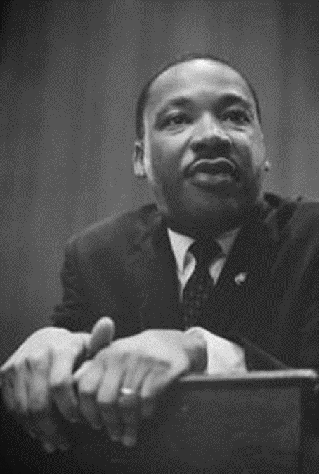
A big demonstration involving Martin Luther King Jr (MLK) and the SCLC in Albany had failed to achieve any real changes. Many civil rights protestors were disheartened.
The civil rights demonstrations also depended on large numbers of protestors who were prepared to break the law and risk going to prison. Usually the SCLC would get its supporters out of prison by paying bail but after the demonstration in Albany the movement was losing money. Supporters were now afraid that if they stayed in prison they would lose their jobs and their families would suffer. As a result, King’s reputation as a leader was weakened and he knew he had to grab the headlines back and achieve success. The place he chose to do that was Birmingham, Alabama.
Why was Birmingham chosen?
MLK described Birmingham as being the most segregated city in the USA and explained:
I think I should give the reason for my being in Birmingham. Birmingham is probably the most segregated city in the United States. Its ugly record of police brutality is known in every section of the country. There have been more unsolved bombings of Negro homes and churches in Birmingham than in any city in this nation. These are the hard, brutal and unbelievable facts.
King knew that civil rights protestors would be risking their lives when they arrived in Birmingham. The Ku Klux Klan (KKK) in Birmingham was one of the most violent in the entire USA. Klan members were responsible for dozens of bombings throughout the area. One of the civil rights leaders called the city ‘Bombingham’ because of the violence that was common there. It was also no secret that the Klan had the support of the Birmingham police force, led by Eugene ‘Bull’ Connor.
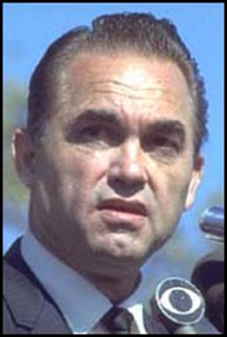
Added to this, George Wallace, the new governor of Alabama, was totally opposed to the civil rights movement. He famously proclaimed: ‘Segregation now, segregation tomorrow, segregation forever.’
The two main leaders of the demonstration in Birmingham were MLK and Reverend Fred Shuttlesworth. They had made clear their objectives: to desegregate public facilities and department stores. However, even those limited aims were too much for the Birmingham police.
Even before the march started, King and Shuttlesworth were arrested for planning to break an order not to march. While he was in prison, King wrote a reply to those who said that Black Americans should wait for white America to give slow changes:
I guess it is easy for those who have never felt segregated to say wait. But when you have seen vicious mobs lynch your fathers and mothers and drown your brothers and sisters…when your tongue becomes twisted as you try to explain to your six-year-old daughter why she can’t go to the amusement park advertised on TV and see the tears welling up in her little eyes when you tell her that Funtown is closed to coloured children…then you will know why it is difficult to wait.
What was Project C?
When King and Shuttlesworth were released from prison, a new campaign plan was made called Project C. The ‘C’ stood for confrontation. King knew the police chief in Birmingham, Eugene ‘Bull’ Connor, was a violent racist. He also knew that if he could provoke Connor into taking extreme action then the cameras would show the images that would shock the world. At first, the demonstrations, boycotts and sit-ins achieved little. As the weeks went on, King then decided to use a risky strategy – his plan involved using school children.
Why was the USA shocked by events in Birmingham?
King and other young black leaders realised the importance of television and the media. They hoped that images of white racist police attacking black schoolchildren would cause public opinion to swing behind the civil rights campaign and force the US government to take action.
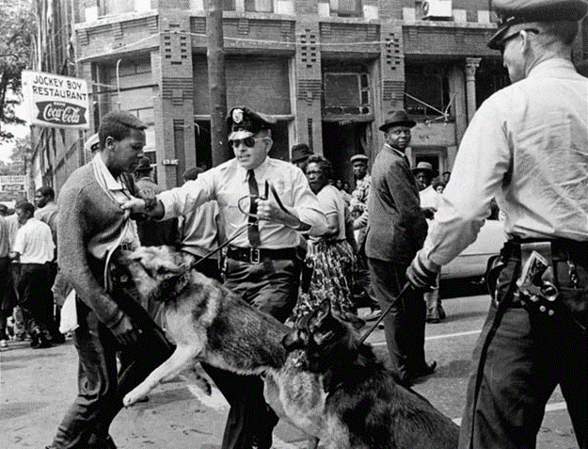
On 2 May1963, over 1000 schoolchildren marched through Birmingham – and Connor was waiting for them. Connor was determined not to give in to the civil rights demonstrators. Over 900 children from the ages of six to 18 were jailed. The following day, Connor called out the water cannons and the dogs. As marchers came parading down the streets, the police attacked. Connor used fire hoses, billy clubs (batons like baseball bats) and dogs to attack peaceful protestors.
American people watched their televisions in shock and disbelief as white police officers savagely attacked schoolchildren first with powerful hoses and then with tear gas, dogs and even electric cattle prods.
Was Project C effective?
MLK’s tactics were risky but they worked. The world had been shocked by pictures of children being attacked by police dogs and washed down the streets by fire hoses in Birmingham. However, the SCLC were having second thoughts, King wanted to call the march off. He was concerned about the violence being suffered by the demonstrators. They were getting good publicity but at a terrible cost.
Local businessmen were desperate for a solution. Their trade had collapsed and the bad publicity that Birmingham was getting on national television was likely to damage their businesses for a long time. Black Americans in Birmingham were against the tactics used by the civil rights campaigners. After the protests were over, black Americans who lived in Birmingham still had to live with the hostility of the white Americans of the city.
Both black and white businessmen knew the publicity was ruining the reputation of Birmingham for everyone so they got together to sort out a deal. They agreed toilets, lunch counters, changing rooms and water fountains would be desegregated within 90 days.
When word leaked out about the deal, the local KKK was furious. Klansmen rioted in the city and firebombed several black churches, businesses and homes. Many of the civil rights protesters were staying at the Gaston Motel which was firebombed by the KKK. As the occupants ran out of the building, they were attacked by Alabama state police. Several of the protestors were seriously injured but this time they fought back. A riot broke out. When it was all over 40 people had been injured and seven shops were destroyed by fire. Many black Americans were also wondering if non-violent peaceful protests really was the best policy.
Why did President Kennedy get involved?
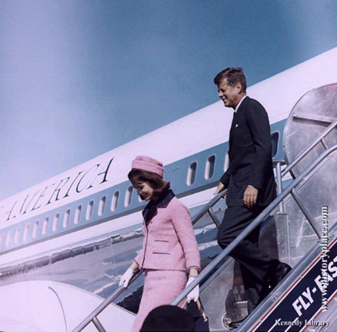
President Kennedy was forced to take federal action. He realised that only federal law could stop the violence that had sparked off in Birmingham spreading across the USA. Kennedy appeared on television and promised action on racism based on the principle that ‘race has no place in American life or law’.
Public sympathy for civil rights was high and Kennedy could not ignore the mood of the people. Kennedy ordered an end to segregation in Birmingham. By 13 May, 3000 federal troops were on the streets of Birmingham to restore order.

Task 7
Use the information above to answer the questions below.
- What problems were the civil rights facing in 1962?
- What reasons did MLK give for choosing Birmingham?
- What do you think the statement by George Wallace shows about attitudes in Birmingham?
- What do you think MLK means in his letter sent from prison?
- Describe Project C.
- Why do you think MLK chose to involve school children?
- What happened on 2nd and 3rd May 1963? How would Americans have felt about this?
- Was Project C successful?
- What were its limitations?
- Why did the businessmen decide to meet?
- What was the reaction of the KK to the decision?
- How do we know the KKK had a lot of support from the state police in Birmingham?
- Why did President Kennedy get involved and what was his solution? Do you think this was a good idea?

‘I Have a Dream’
Is there a link between the Birmingham campaign and the March on Washington in August 1963?
Martin Luther King (MLK) Jr’s reputation increased hugely after the Birmingham campaign and most of the world saw him as the leader of the civil rights movement. Second, President John F. Kennedy had promised federal authority to give civil rights to all black Americans.
The protests of the early 1960s – sit-ins, freedom Rides and the Birmingham demonstrations – all increased the pressure on President Kennedy to do something about civil rights. On the evening of 11 June 1963, Kennedy spoke on national television to explain what he intended to do and why he intended to do it. He said:
The events at Birmingham have so increased the cries for equality that no nation can chose to ignore them. I am, therefore, asking the Congress to enact legislation giving all Americans the right to be served in facilities which are open to the public. I am also asking Congress…to end segregation in public schools.
How could pressure be kept on Kennedy to keep his promise?
Civil Rights leaders knew it would not be easy to get a new civil rights laws passed. Politicians, such as Governor Wallace of Alabama, had said they would stop it becoming law.
In the 1940s, A. Philip Randolph had suggested a March on Washington in an attempt to force the US government to improve civil rights. He had been persuaded not to organise the march by promises that civil rights would improve. However, 20 years later it looked as if nothing had been achieved. In the summer of 1963 the time seemed right to carry out a March for Jobs and Freedom.
While black leaders organised the march, politicians in Washington were afraid that there would be violence. Kennedy, however, saw it as an opportunity to gain support from black Americans.
What was the purpose of the March on Washington?
On 28 August 1963, over 2000,000 black and white people marched towards the Lincoln Memorial in Washington. The site was significant because President Lincoln had freed slaves 100 years before.
The huge gathering of demonstrators was not designed to gain anything other than publicity, which it achieved brilliantly. It was the largest civil rights demonstration in US history and four national television channels broadcast the event live. The speech that Martin Luther King (MKL) Jr have has become known as the ‘I Have a Dream’ speech and is considered to be one of the most famous and important speeches of the twentieth century.
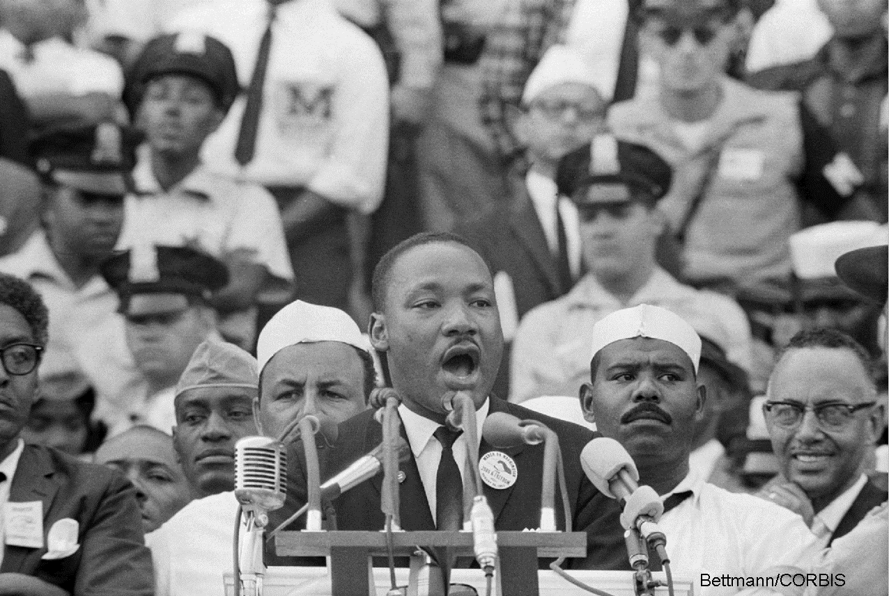
I have a dream that my four little children will one day live in a nation where they will not be judged by the colour of their skin but by the content of their character…I have a dream that even the state of Mississippi will one day be transformed into an oasis of freedom and justice. So let freedom ring out. When we allow freedom to ring from every town and every hamlet, from every state and every city we will be able to speed up that day when all God’s children will be able to join hands and sing in the words of the old Negro song ‘Free at last! Free at last! Great God Almighty, we are Free at last’.
King and other leaders of the civil rights movement felt that they had a friend in President Kennedy. By 1963, Kennedy seemed to support the movement wholeheartedly. However, in November 1963, Kennedy was assassinated.
The March on Washington had put the civil rights movement back in the headlines but when President Kennedy was assassinated it looked like the movement had gained nothing. However, the new resident, called Lyndon B. Johnson, made sure that the Civil Rights Act became law.
Years of protests eventually resulted in the 1964 Civil Rights Act. When the act was being discussed by the US government, all southern politicians fought against it with all their energy. However, it did become law, and was the most important new civil rights law at that time. It did a great deal to get rid of discrimination and segregation.
What did the Civil Rights Act of 1964 do?
The Civil Rights Act of 1964 made discrimination and segregation based on skin colour or race illegal. Discrimination on the basis of race in any or all public places in the USA was banned. This included petrol stations, restaurants, hotels, cinemas and airline terminals.
There were also to be equal opportunities in the workplace. It became unlawful for a business employing more than 25 people to discriminate on the basis of race, national origin, religion or gender. The federal Justice Department was allowed to prosecute any state government that still discriminated against black people.
How important was the Civil Rights Act of 1964?
Most people agreed that the Civil Rights Act was a big move towards helping Americans achieve full civil rights. Of course, it was impossible to make a law to change the way people thought and felt. However, many politicians believed the Civil Rights Act had gone as far as the law could to help black Americans.
On the other hand, some black Americans were concerned that the Civil Rights Act did nothing to solve discrimination in housing or give black people a fair and free vote. The act did not end fear and discrimination. The Ku Klux Klan, often helped by the police, still used terror against any black person who tried to use the freedoms that the act was supposed to guarantee.
Task 8
Use the information above to complete the tasks below.
- From the following list, choose the two best answers to this question: ‘How important was the publicity gained from the Project C demonstration in Birmingham?’
- segregation was still a problem
- President Kennedy said he would help pass a law to give civil rights
- Martin Luther King Jr made a speech
- public opinion across the USA supported civil rights
- Project C achieved very little.
What is the best answer?
- Give reasons using some factual examples to support your choices in Q1.
- Can you explain why the March on Washington was organised?
- How would you summarise what Martin Luther King meant when he said ‘I Have a Dream?’
- What would you say was the importance of the Civil Rights Act of 1964?

Voting Rights in 1965
Why was it so difficult for black people to vote?
The Civil Rights Act of 1964 did not end fear and discrimination. The Ku Klux Klan still used terror against any black person who tried to use the freedoms that the act was supposed to guarantee. Martin Luther King Jr (MLK) and others argued that the only way to get real changes was to get rid of the racists in the local and state politics. He said that the new Civil Rights Act gave black people ‘some part of their rightful dignity, but without the vote it was dignity without strength’. King believed that the right to vote without fear or difficulty was vital if civil rights were to mean anything at all. Black Americans were still in the majority in many southern cities and could easily elect their own leaders into positions of power if only they had the opportunity to vote for them.
The problem was that very few black Americans had registered to vote. In the USA, any adult who wants to vote must register. Black Americans had been given the right to vote in 1870, but in the years that followed white authorities who ran the voter registration offices in the southern states made it almost impossible for black Americans to register.
The civil rights movement now aimed to get more black Americans voting. That meant campaigners had to be able to do so without fear of violence or threats. It also meant that any unfair barriers that stopped black Americans voting would have to be removed.
In many areas of the South, ‘Jim Crow’ laws made it hard for black Americans to qualify for the vote. For white supporters of segregation, the consequences of allowing black Americans to vote were unthinkable. It would end white power in the South. Black politicians would be elected.
Why was Selma, Alabama chosen as the focus of protest?
Selma, Alabama had 15,000 black adults who should have had the right to vote, but only 335 had been able to register. This meant one person out of 50 with the right to vote was actually able to vote. During 1963 and 1964, hundreds of black Americans who should have had the right to vote freely were prevented from voting by difficulties created when they tried to register at the courthouse in Selma.
In January and February 1965, protests were held in Selma to bring attention to the actions of the white racists who were denying black Americans their legal rights. Civil rights leaders, including MLK, decided to hold a protest march from Selma to Montgomery on 7 March 1965.
Black leaders had learned that one of the main reasons why President Kennedy had become involved in the civil rights issue was because public opinion had been shocked by the violence used by white police during Project C.
The civil rights campaign leaders knew very well that a large march from Selma to Montgomery would be met by violent white resistance, especially since the governor of Alabama, George Wallace, had already promised ‘Segregation forever!’. The sheriff of Selma, Jim Clark, was also known to be very like Eugene Connor, the police chief in Birmingham, Alabama, in his attitudes and speed at which he lost his temper.
On 1 February 1965, over a month before the march was due to take place, King got himself arrested quite deliberately. He had just gained fame as the winner of the Nobel Peace Prize, a world-famous award. He was on the front cover of almost every magazine and newspaper. He was on television news and chat shows almost every night.
King’s arrest was therefore big news. Before he was arrested, King and others in the Southern Christian Leadership Conference (SCLC) had prepared a letter that would be sent to newspapers when King was in prison. On 5 February the New York Times printed the message:
Why are we in jail? When the Civil Rights Act of 1964 was passed many decent Americans thought the day of difficult struggle was over. By jailing hundreds of Negroes the city of Selma, Alabama has revealed the persisting ugliness of segregation. There are more Negroes in jail with me than there are on the voting registers. This is the USA in 1965. We are in jail because we cannot tolerate these conditions for our nation.
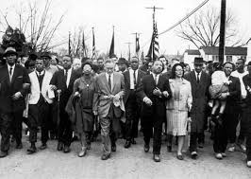
Sunday 7 March 1965 was the starting date for the Selma to Montgomery march. Approximately 600 marchers started out. On the Edmund Pettus Bridge the marchers were met by about 200 state troopers and local police mounted on horseback. The police were all armed with tear gas, sticks and whips. The marchers were ordered to turn back. When they did not the marchers were attacked by the law enforcement officers. The air filled with tear gas and marchers were beaten, whipped and trampled by the horses. Finally they turned around and went back to Selma. Seventeen marchers were hospitalised.
The effect of television coverage of the march?
Television coverage of the march and the attack caused national anger. Sunday 7 March 1965 – ‘Bloody Sunday’, as the day came to be known – was a turning point in the campaign for fair voting. All across the USA people were horrified at what they saw on television.
Eventually, MLK and his supporters gained legal permission to march from Selma to Montgomery. On 21 March, the march began again. This time US troops protected the marchers. At the end of the Selma to Montgomery march on 25 March 1965, King spoke to the 250,000 marchers and once again made it clear what the purpose of the civil rights campaign was:
America’s conscience has been sleeping but now it’s waking up. Let us march on segregated housing…Let us march on segregated schools…Let us march on poverty…Let us march on ballot boxes…Let us march to the American Dream.
Was the Selma march successful?
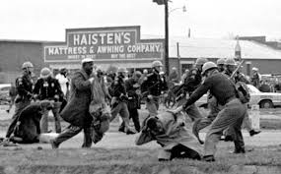
Many people believe that MLK and the other civil rights leaders not only expected violence from white authorities but even wanted it. The demonstrators knew that television would turn public opinion against the white racists and they hoped that televised racist violence would persuade the government to do something about voter registration. If true, then their plan worked!
In August 1965, Congress passed the Voting Rights Act and removed various barriers to registration such as the ability to read and write. Literacy had often been used to stop black Americans voting. President Johnson even made clear that he would soon sign the new law in the same room where, a century before, President Lincoln signed a document to free slaves who had been made to fight for the southern armies in the US civil war.

The effect of the Voting Rights Act
By the end of 1965, over 250,000 black voters were newly registered. Within three years of the act being passed most of the black population of the south was registered to vote.
In Mississippi in 1960 there were 22,000 black Americans registered to vote; six years later there were 175,000. In Alabama in 1960 there were 66,000 black Americans registered to vote; six years later there were 250,000.
The 1965 act was a big move towards making voting rights a reality for thousands of black Americans in the South. The act said there were to be no more literacy checks or checks on poll tax payments which had been used to prevent black Americans from voting in the past. The new law also helped to improve the living and working conditions of many black Americans because white politicians now realised they needed black voters if they wanted to stay in power.
Many black Americans now saw an opportunity to become politicians themselves and in 2009 Barack Obama became the first black president of the USA. The Voting Rights Act marked the end of the civil rights campaigners in the South. Segregation, discrimination and ‘Jim Crow’ laws had been outlawed, if not entirely removed. It is always easier to change laws than to change what people believe no matter how wrong those beliefs might be. By 1965, the focus of civil rights protest moved north and the style of protest also changed. Non-violence protest was about to become violent.
Task 9
Use the information to help you answer the questions below:
- Why did Martin Luther King Jr continue to campaign for voting rights after the Civil Rights Act was passed in 1964?
- Describe why Selma was chosen for the march.
- King said that the new Civil Rights Act gave black people ‘some part of their rightful dignity, but without the vote it was dignity without strength.’ How could you say that in your own words?
- How would you summarise the attitude of Governor Wallace towards the civil rights movement?
- What evidence could you suggest to support King’s decision to challenge white authority by marching over the Edmund Pettus Bridge?
- Do you agree that King’s strategy to win a Voting Rights Act was successful, both in the short and long term? Give reasons for your answer.
Black Radicals and Black Power
Why did the civil rights movement split in the 1960s?
From the mid-1960s onwards, disagreements increased about what the civil rights movement should do next. The movement had always contained different points of view about the use of violence. Those differences in opinion came to a head during the March Against Fear in 1966. During the march, the differences between the non-violent strategies of Martin Luther King Jr (MLK) and the more militant campaigners became obvious. White King and his supporters chanted ‘Freedom Now’ and encouraged white Americans to join the march, the new leader of the Student Non-Violent Coordinating Committee (SNCC) called Stokely Carmichael chanted ‘Black Power’ and rejected white help.
Who was Stokely Carmichael?
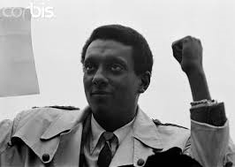
Stokely Carmichael first emerged in the civil rights movement as a 19-year-old Freedom Rider. By 1963 he was a well-known member of the SNCC. In that year he began to disagree with members of the SNCC and other civil rights leaders about non-violent protest. He wanted stronger action against the white racist violence and he also wanted more black Americans to be able to vote easily. In that sense, Stokely Carmichael had the same aims as the non-violent section of the civil rights movement. However, the split in the civil rights movement was made even more obvious when Carmichael, then leader of the SNCC, changed the meaning of the ‘N’ in its name from ‘non-violent’ to ‘national’. By the mid-1960s, many black Americans no longer believed that non-violence was the way forward. They looked towards ‘Black Power’ for help.
What was Black Power?
Some critics of Stokely Carmichael said that the ‘Black Power’ slogan was racists and too simple. All it did, said his critics, was to make people angry and violent. On the other hand, many young black Americans living in the ghettos were attracted to the Black Power movement by Carmichael’s more extreme, aggressive message, summed up when he said:
The only way we gonna stop them white men from whippin’ us is to take over. We been sayin’ freedom for six years and we ain’t got nothin’. What we gonna start sayin’ now is Black Power.
Stokely Carmichael explained that ‘Black Power’ meant black Americans taking control of their political and economic future. He said that black Americans should not rely on white people to ‘give’ them civil rights and that white support for the civil rights movement was not wanted. He said ‘I am not going to bed the white man for anything I deserve. I’m going to take it.’ He argued that black Americans should build up their own schools, communities, businesses, even hospitals, without interference from whites.
This was all very different from the style and ideas of MLK and, by 1966, the idea of Black Power had become established as an alternative to King’s non-violent protest methods.
Task 10
- Explain why the civil rights movement split.
- Why did Stokely Carmichael not like Martin Luther King’s ideas?
- What is Black Power?
How relevant was the civil rights campaign to northern black Americans?
While MLK had concentrated on civil rights issues in the southern states, new ideas and new leaders were growing in the northern cities.
The campaign in the South to send segregation and discrimination was more or less over. However, the problems of black Americans in the main cities of the North had hardly been touched.
By 1965, half of all black Americans lived in the cities of the North and West. Most of them lived in slum areas that were known as ghettos. They had to live with poor housing, high rents, unemployment, poverty and hunger. Gang violence and drug-related crime were also increasing. Faced with these problems, many black Americans in the cities were attracted to the ideas of the Nation of Islam.
What were the beliefs of the Nation of Islam?
The Nation of Islam, also known as the Black Muslims, was founded in Detroit, Michigan in 1930 and was led by Elijah Muhammad. It supported the creation of a separate black nation on the US mainland, separate from white society in every way – economically, politically and spiritually.
The Nation of Islam attracted many black Americans with its ideas pf strict moral discipline, respect for religious faith and apparent ability to ‘straighten out’ the lives of many individuals such as drug addicts and criminals who had been considered beyond hope. One of those ‘saved’ souls was Malcolm X.
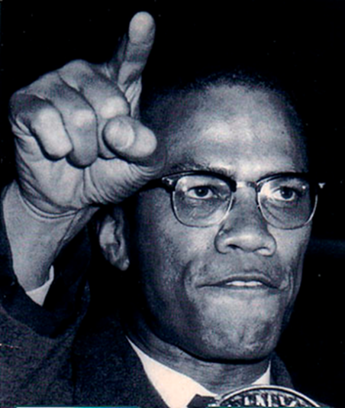
Who was Malcolm X?
Malcolm Little was a petty criminal who was converted to the Nation of Islam while in prison and changed his name to Malcolm X. He claimed that his surname of ‘Little’ was a white name given to his family by slave owners many years before, so the ‘X’ referred to his unknown African name. Until he and his followers rediscovered their African names, they would use letters as their last names, representing their stolen identities.
Malcolm X was a very different black leader compared to MLK. The Nation of Islam completely rejected the integration ideas of people such as King. Malcom X criticised King’s non-violent appeals by saying:
The goal of Dr King is to give Negroes a chance to sit in a segregated restaurant beside the same white folks who have persecuted, beaten and lynched black people for years. Dr King seems to want black people to forgive the people who have beaten, bought, sold and lynched our people for 400 years.
Malcolm X became a preacher for the Nation of Islam and spoke out against King’s belief in non-violence. He declared that non-violence was another word for being defenceless and he clearly rejected the aims and methods of King. Malcolm X believed that the USA’s claim to be a land of the free was false and applied only to white people. He rejected help from whites and stated that black Americans needed to work out their own futures without relying on white help. Malcom X was one of the first black activists to draw attention to the increasing problems within the ghettos of American cities: crime, prostitution, drugs and unemployment.
Malcolm X warned that if nothing were done, violence would erupt in the USA’s cities. He was right!

Task 11
- Why was the Nation of Islam popular with black Americans?
- Why did Malcolm X not like Martin Luther King’s ideas?
- What did Malcolm X believe about their surnames?

What were the Black Panthers?
While the Nation of Islam was strong in New York and the north-eastern cities of the USA, another radical group was growing on the west coast. The Black Panther Party for Self-Defence was founded in October 1966 in Oakland, California by Huey P. Newton and Bobby Seale. The Black Panthers represented the complete opposite of MLK’s ideas and supported the anti-white, black separatist ideas of Stokely Carmichael and Malcolm X. The Panthers were prepared to use violence in order to achieve their goals and saw the police as the enemy of black communities. When Black Panther leaders explained their ideas, they stated many of the complaints of the USA’s black population. Their demands included full employment for all, better housing which was ‘fit for shelter of human beings’, honest education, an end to police brutality and fair trials with black juries for black people.
Why did the Black Panthers choose that name?
Huey P. Newton explained that the name ‘Black Panther’ was chosen because the panther is a strong fighter when it is cornered and will protect its family. Black Panther leaders spoke about using violence to protect black communities against white violence. According to Newton, their most important demand was an immediate end to police brutality and the murder of black people. He also said that Panther patrols should carry guns on the streets of US cities so that they could protect their ‘brothers’ (other black people). He said:
What good was non-violence when the police were determined to rule by force? Out on patrol we stopped whenever we saw the police questioning a brother or sister. We would observe from a safe distance so that the police could not say we were interfering with the performance of their duty. We were checking out the police.
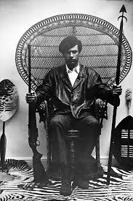
The Black Panther Party became very popular among young black Americans who lived in the big cities. By the summer of 1968 a branch of the Black Panthers had been established in most US cities.
Were Black Panthers only interested in violence?
The Black Panthers were usually shown on television and in magazines in deliberately threatening poses, wearing black leather jackets, black berets and dark glasses, and carrying guns.
What was not so well publicised were the self-help programmes launched by the Black Panthers in their own communities. Panthers not only talked about ‘serving the people’, they also had a policy of doing things to help improve a life in the ghettos. They organised community programmes such as free breakfasts for children, free health clinics, local school support groups, free clothes for the poor and campaigns to stop drugs and crime in the black areas of US cities.
How important were the Black Panthers?
The deliberately threatening poses in the self-publicity of the Black Panthers grabbed headlines at a time when much of white society was afraid of black protest movements. However, even at their height, the Black Panthers only had 2000 members.
Public attention was distracted by the riots erupting in cities all across the USA and the Black Panthers were thought to be just a small part of the violence sweeping over the country in the late 1960s.
What happened to the Black Panthers?
The Panthers were the most violent group to emerge in the late 1960s but by 1969, 27 panthers were dead and over 700 were in prison. By 1970 the more violent of the Black Panther leaders were either dead or in prison. Many black Americans realised that all the riots did was destroy black property and kill black people.
The Black Panther Party lost its influence when quarrels among its leaders broke out. By the middle of the 1970s the Black Panther Party no longer existed.

Task 12
- What were the beliefs of the Black Panthers?
- Why did the Black Panthers choose their name?
- How were the Black Panthers portrayed by the media, and was this accurate?
- How successful were the Black Panthers to the civil rights cause?
How did the federal authority react to the black radical groups?
By the mid-1960s federal authorities worried about protest groups generally. The USA was involved in an unpopular war In Vietnam and there were increasing protests about it at home. This was also a time of youth protest and thousands of young people in their teens and twenties were rebelling against the rules of an older generation. The civil rights movement seemed to have made real gains with new federal laws in place – and then riots broke out in the big cities.
The president, federal authorities and state governor all became worried that there was some sort of plot to take over the USA.
Why did the federal government see Malcolm X as a threat?
Malcolm X became a very powerful preacher. His message of self-help attracted many listeners who were tired of having to wait on white authority to improve conditions. Malcolm X also spoke of a separate nation for black Americans only.
The US government was afraid that Malcolm X was building up hatred against whites that could erupt in national riots and revolution. Already there had been riots in Los Angeles, California. The white authorities were afraid that these riots would spread as more and more black Americans were attracted to the Nation of Islam, more commonly known as the Black Muslims.
Malcolm X left the Black Muslims after serious arguments with Elijah Muhammad and Malcolm was warned by other followers that there was a plot to kills him. Probably as a result of falling out with Elijah Muhammad, Malcolm X’s home was firebombed and a week later he was murdered while giving a speech. The three gunmen were linked to the Nation of Islam but there was suspicion that the FBI was also involved.

How did federal authority react to black radical groups such as the Black Panthers?
The head of the FBI, J. Edgar Hoover, told his agents that they should cause as many arguments and splits within the Black Panther Party as possible> he went on to ask FBI officers to plan ways of destroying the Black Panther Party.
During the 1960s, the FBI spied on many black leaders. When black radicals became more violent, the FBI increased its activities to undermine and weaken black organisations. The FBI called its targets ‘Black Nationalist Hate Groups’. Memos sent to FBI agents told them to disrupt the meetings of any black protest group and especially to prevent the rise of any black leader who would unify the various protest organisations.
The FBI also tried to make black organisations look bad in order to stop the growth of any white support for the protest groups. For example, FBI action was taking to destroy the positive work of the Black Panthers such as the free breakfast programme. FBI agents were used to make it difficult to sell the party’s newspaper and to disrupt local education classes run by the Black Panthers.
While the FBI said it was protecting law and order, many others said the FBI was taking away basic freedoms in the USA, such as the right to support the political ideas you agree with and the right to print newspapers which may or may not support the government,
Task 13
Use the information to help you answer the questions below:
- List three black radical leaders and describe their ideas.
- What were the problems of the ghettos that made many black Americans support radical groups?
- Why do you think white magazines usually showed pictures of black radical leaders looking angry or threatening?
- How would you summarise the attitudes of many white people in the USA to black radicals?
- What information would you use to support the view that black radicals were unfairly shown as violent and aggressive in the media?
- Outline the ways the federal authorities reacted to radical groups.
- Give arguments for and against the reaction of the federal authorities to black radicals.
Did the assassination of Martin Luther King Jr mark the end of the civil rights campaigns?
King knew his influence was slipping away. Despite increasing pressure to change his ideas to attract new support, King stuck to what he believed in. He intended to show the USA he could still use non-violence protest to improve people’s lives, but on 4 April 1968, Martin Luther King Jr was shot and killed as he stood ion his motel balcony in Memphis, Tennessee. When word spread of his death, riots erupted in 168 cities. It took 70,000 troops to restore order. It seemed that the non-violent civil rights movement had died with King.
What did Martin Luther King Jr achieve?
Martin Luther King Jr was a charismatic leader who knew how to use the relatively new medium of television to gain public sympathy and to put pressure on the federal authority. He helped to make changes so that life in the USA, especially in the South, was very different in 1965 to what it had been in 1955. Even Stokely Carmichael said that King was the one man who the masses of black Americans would listen to. Nearly every black American, and most whites, agreed that King was one of the most important leaders of any colour in the twentieth century. Today, King remains an icon representing dignified protest against unjust conditions and unfair treatments of human beings.
1968: ‘Free at last?’?
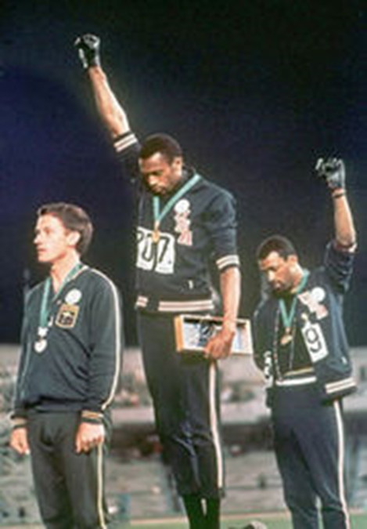
In 196, King was dead. That same year, the world was reminded of the civil rights issue at the Mexico Olympic Games when two black American runners mounted the rostrum to receive their medals. The USA was shocked and embarrassed by what happened next. As the USA flag was raised and the national anthem was played, the two athletes, John Carlos and Tommie Smith, dropped their heads and refused to look at the flag. They raised one arm, with a black glove clenched fist, in a Black Power salute. It was a message that some black Americans did not feel they belonged to the USA and that the athletes were supporters of Black Power.
This course is called ‘Free at Last?’ and ends in 1968. The question mark is important, as we are not stating that black Americans were free at last in 1968, but rather how successful was the campaign. In 1968 it seemed that the USA was still divided.
Task 14
Use the information to help you answer the questions below:
- What happened to Martin Luther King Jr?
- How important was Martin Luther King to the civil rights movement?
- To what extent had the civil rights campaign been successful by 1968? (8 marks).

