HIGHER HISTORY
USA 1918-68
PAPER 1 – REVISION GUIDE
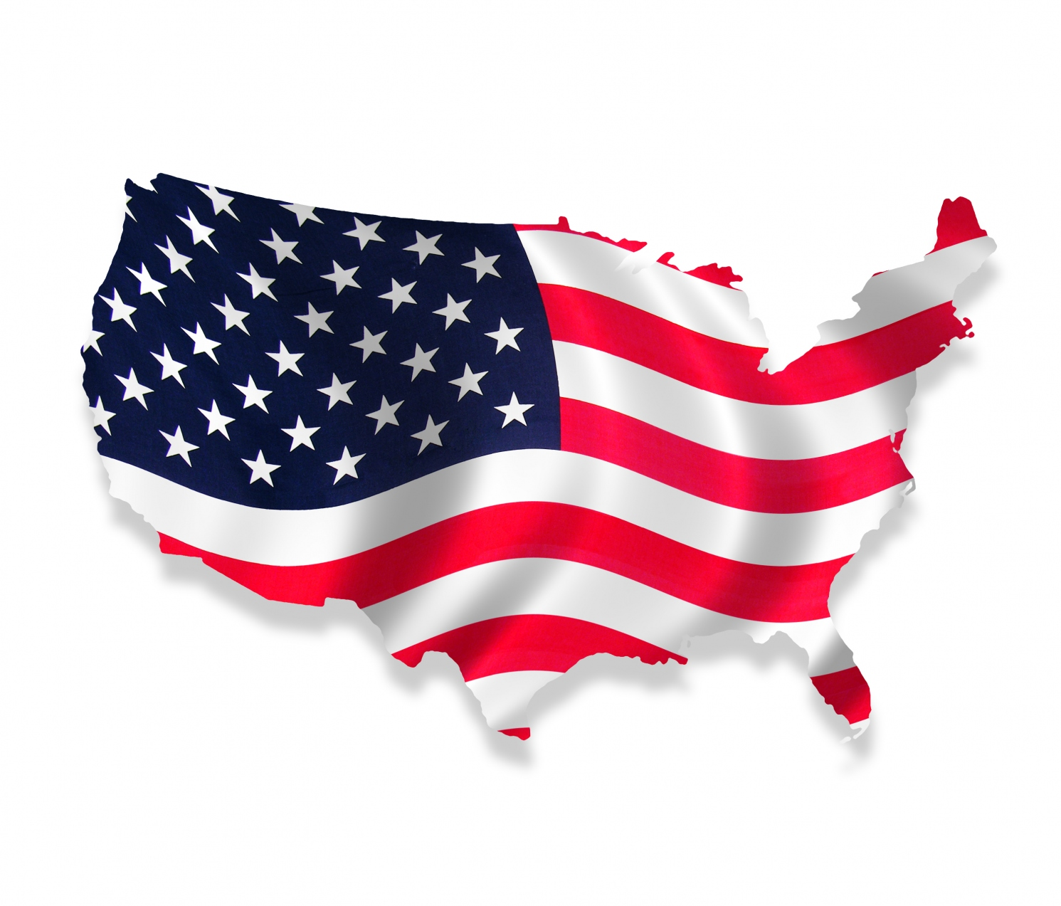

USA 1918-1968
Background to USA topic
- 1901-1920 US population grew by 39% to over 105 million.
- In this period, 15 million immigrants came to America compared to the 20 million that arrived between 1821 – 1900.
- USA was created in 1787 after the 13 original states fought and won against British rule and created the CONSTITUTION – a set of rules about how the country was to be government – amendments can be made to alter these rules. These are not changed easily and need approval from House of Representatives, Senate and ¾ of States. Supreme Court = the highest court of Law in USA & the decision makers about whether a law is constitutional.
- 2 main political parties: Republicans and Democrats – both followed ‘laissez faire’ and ‘rugged individualism’ approach until 1920s when ‘progressivism’ developed which called for greater democracy, honest government and tighter controls over business.
- By 1919, there were 48 states (today there are 50) which had their own State government and laws concerning education, justice system, transport and local government.
- The Federal government based in Washington D.C can overrule State law through the American Congress which passes Federal law.
- 13th amendment – outlawed slavery in 1860s
- 14th amendment – granted citizenship to former slaves and granted them equal civil liberties.
- 15th amendment – granted voting rights to all American citizens regardless of ‘race, color, or previous condition of servitude’
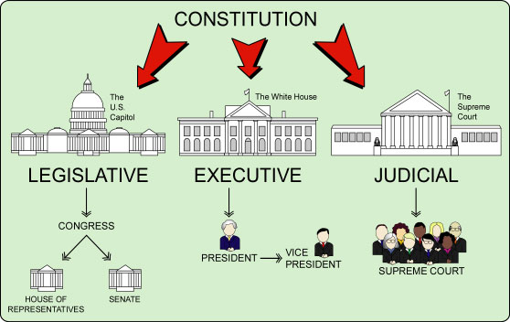

ISSUE 1 – Evaluate the reasons for changing attitudes to immigration in the 1920s

- Context – As early as 18th century – America was a land described as a ‘melting pot’ – 1915 Woodrow Wilson: “great melting pot of America, the place where we are all made Americans…were men of every race, and every origin…ought to send their children, and where, being mixed together, they are all infused with the American spirit and developed into the American man and the American woman.”
REMEMBER: Blacks were not immigrants so don’t include them in questions about immigrants.
- AMERICAN DREAM = “We hold these truths to be self-evident, that all men are created equal, that they are endowed by their Creator with certain unalienable rights, that among these are Life, Liberty and the Pursuit of Happiness.” Declaration of Independence, 1776
- WASPs hostile to new wave of immigrants (Southern and Eastern Europeans) – encouraged nativism and 100% Americanism movement.
Before 1920 the USA had an ‘open door’ policy — almost anyone could enter. In the 1920s the USA made new laws which limited the number of immigrants entering the country. WHY did attitudes change after the First World War?
- Pre-1920s attitudes – 1920s restrictions were not radical, USA had tried to limit immigration before 1900. 1882 Federal Immigration Act -Convicts, lunatics and very poor were barred entry. 1882 Chinese Exclusion Act and 1907 Gentlemen’s Agreement which segregated Japanese and Americans schooling in California. 1913 Alien Land Law – to prevent immigrants owning Californian land (later 11 other states enforced this). Dillingham Commission 1911— advised government that southern and eastern European posed a serious threat to American culture and should be curbed through a literacy test.
- Isolationism & WWI – WWI catalysed the process of immigration restriction. Conflict of loyalties during the war – suspected that German immigrants were sympathetic to the Kaiser. Patriotism in war turned to xenophobia of Germany – e.g. No German language in schools, sauerkraut became liberty cabbage, German Americans beaten, tarred and feathered. Danger that American society would split as hostility to all things ‘foreign’ grew. Did not ratify ToV and refused to be in League of Nations which showed their determination to stay out of European affairs and curb immigrants who might bring associated problems.
- Political fears – Fear sparked by 1917 Bolshevik Revolution in Russia. Americans were afraid immigrants brought in dangerous new ideas — anarchism and communism. These ideas were anti-American and used violence to change the system of government. 1919 Palmer raids- Mitchell Palmer, Attorney General’s house was blown up and blamed the radical element in society. 1920- Communist raids in 33 cities, 6,000 foreign ‘radicals’ arrested, 600 deported. It looked like revolution was close. Fears exaggerated as most immigrants more focussed on economic success than political subversion. e.g. Sacco and Vanzetti trial of 2 anarchists executed for robbery and murder serves as an example of how dislike for immigrants was linked to fear of organised crime and revolution to create intolerant attitudes towards immigration by 1920s. Doubt over their guilt, belief that they were sentenced due to anarchic links.
- Social/Economic fears — Americans wanted to stop immigrants competing for jobs during times of unemployment as they were taking ‘American jobs’. Immigrants employed as strike breakers and consequently resented by trade unions who were trying to improve wages and working conditions. Ghettoes were created, belief that there were higher crime rates here.
- Racism and prejudice - For many WASPs the change in the type of immigrant was worrying. Attempts to stop immigration were aimed at ‘new’ immigrants from southern and eastern Europe. Kenneth Roberts, a journalist, perpetuated pseudo-scientific racism – e.g. Called Polish Jews ‘parasites’ and called for restrictions to Russians because they would produce a ‘hybrid race of people as worthless and futile as the good-for-nothing mongrels of Central America and South Eastern Europe’. Their physical appearance, language, custom appeared alarming to Nativist Americans who thought them a threat to American vitality.
- Religious fears - They were afraid that Americans religious strength would be weakened by more Catholic and Jewish immigration.
PREJUDICE — pre-judging someone before you know what they are like.
RACISM — the belief that your race is superior to all other races. By 1920, America was becoming a prejudiced, racist society.
1917-1924 America passed a series of laws designed to limit immigration. After three centuries of free immigration the USA tried to shut its doors on newcomers and the flood of immigrants ended.

Immigration Laws
1921 —USA introduced a limit of 3% of incomers from each nationality living in the USA in 1910. Let in more from Britain, Ireland and Germany and restrict immigrants from southern Europe and the Far East
1924 – Limit was reduced to 2% based on ethnic groups from 1891 census – laws were clearly designed to give favour to ‘old’ immigrants.
1929 — only 150,000 immigrants can come into the USA each year. Coolidge signed and said “America must be kept American” thus showing federal reinforcement of prejudice.

ISSUE 2 – Evaluation of the obstacle to civil rights for black people up to 1941

Legal impediments – Social divisions were enshrined in law. Supreme Court decision 1896 - “Separate but Equal” - HOMER PLESSEY CASE — Homer refused to move on a train and sit with fellow blacks. The case was taken to the Supreme Court who ruled it was acceptable to have separate facilities for blacks and whites so long as they were equal. Segregation was now officially ‘legal’ and facilitated the creation of Jim Crow laws. Supreme Court did nothing to prevent this and failed to uphold the 15th amendment. After 1875, Congress passed no laws to protect blacks – they indicated it was the responsibility of state authorities.
- KKK - 1924 — KKK had nearly 5 million members. Nobody knew how strong it was because it was a secret organisation. Between 1885 & 1917, 2734 blacks were lynched in the USA. Few were brought to justice signalling widespread support of their actions. Blacks had no legal protection. Many powerful people were members and the Klan could make others do what it wanted by threats, blackmail and bribery. They also gave each other alibis and were frequently jurors. Popular in south although growing in north due to migration e.g. Michigan had highest membership of all states. However, post 1930s Klan collapsed due to leadership scandal, laws against wearing masks in public, and $10 membership fee which was expensive during the Depression.
- Popular prejudice – migration north 1910 — 10% of black people lived in the North
1940 — 22% of black people lived in the North
North = no segregation but still racially prejudiced society. Black people could only get the worst jobs and lowest wages. Black people and poor whites competed for the same jobs and housing. This led to race riots.
- Lack of political influence – blacks were inadequately educated or organised to expand their political power. They were disenfranchised in many states so could not vote for a candidate that could argue against Jim Crow.
- Divisions in black community – Lack of unity in belief, aims and methods:
Booker T. Washington = Accommodationist (favoured focus on economic improvement before fighting for political equality), called for improved education through Tuskegee Institute, influential as an early campaigner, later advised FDR on race issues. Opposed by Du Bois.
Marcus Garvey = Black Nationalist, called for a return to Africa, attracted working class blacks, UNIA=1925 ½ million members (more than NAACP), popular but unrealistic. Raised black consciousness.
W.E.B Du Bois = called for racial equality and protest, NAACP attracted middle class blacks and whites, campaigned against lynching and argued for educated black elite to lead campaign.

ISSUE 3 – Evaluate the reasons for the economic crisis of 1929-33

- Overproduction/under consumption – New technology and mass production method increased industrial productivity to record levels which forced prices down which in turn led to a fall in wages. Industry was dependent on high levels of consumerism. Cars, radios, vacuums & washing machines were being produced – more than people could buy! By 1929, those who could buy had bought, poor could not afford. E.g. Ford T – 23 million cars in the road by 1929. By 1925, Ford factory produced a car every 10 seconds. Result is overproduction, without consumers, industry and wages decline, jobs lost. Overproduction also hit farmers with surplus – Coolidge did not intervene resulting in lost land and bitter farmers. Economic growth was already slowing by 1929.
- Weak banking system – not part of a national organisation but a system of 30,000 small, state-based banks. No checks were made on their reliability. In the 1920s these banks used the money deposited to loan to speculators to make quick profits on the stock market. The easy terms offered by banks for loans encouraged high levels of borrowing that resulted in the speculation that caused the crash. A ‘run’ on banks to recoup their savings meant banks had to declare bankruptcy and close e.g. 659 closed in 1929, 5,500 closed by 1933. An economy cannot function properly without a stable banking system.
- Republican policies – 1922 Fordney-McCumber Act raised tariffs to 40%, this ensured that domestic markets were guaranteed and that American consumers bought cheaper US goods instead of imported goods. Limited control of big business allowed price fixing (illegal!) to take place preventing fair competition – Republicans turned blind eye. Large mergers resulted in companies monopolising industry which went against small business – government did not interfere. Low Capital Gains Tax policies resulted in high business profits that could be invested in stock market. Their policies resulted in great extremes of wealth and poverty. Historian Garraty argues too large a share of profits was going into too few pockets. Attitudes of public negative towards Republicans – blamed for inaction. E.g. Bonus marchers 1932 campaigned at White House for financial bonus they had been promised post-war, started the Hoovervilles.
- International economic problems – Historian Clements argues that international debt was at the heart of America’s economic problems. Europe unable to pay war loans. US tariffs meant Europe could not trade with US in order to make money to repay loans. German loans through Dawes and Young Plan meant that USA were effectively paying Germany to pay them back! It further tangled debt international debt.
- Wall Street Crash 1929 – ‘a symptom, not the disease’. 24th October 1929 Black Thursday, 29th October 1929 Black Tuesday. Share collapse caused panic. Rush to sell and repay loans to banks, withdraw savings. Loss of confidence in the stock market was the death knell for the economy. However, it was a trigger of the economic depression not a cause.

ISSUE 4 – Assess the effectiveness of the New Deal

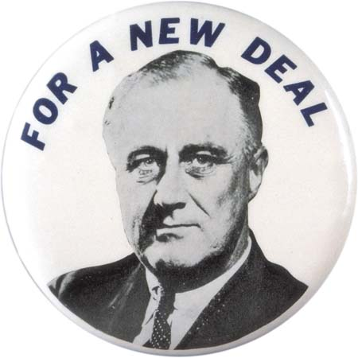
- Aims 3 R’s: RELIEF (help millions unemployed), RECOVER (rebuild the shattered economy), REFORM (make new laws for a fairer society) Associated with FDR and the Democrats and signalled a shift away from ineffective policies of ‘laissez-faire’ Republicans towards intervention.
- First New Deal – RELIEF & RECOVERY in First 100 days, FDR passed a series of new bills that became known as the Alphabet Agencies.
Agricultural Adjustment Act (AAA) | To help farmers keep steady prices and limit overproduction – government aid them not to plant crops.
Civilian Conservation Corps (CCC) | Created conservation work for men aged 18-25. 3 meals a day and decent wage.
Federal Emergency Relief Act (FERA) | Helped the poor by providing more soup kitchens and money to cover clothing and school costs.
National Industrial Recovery Act (NIRA) | Aimed to increase workers’ wages so they had more to spend. Tried to increase price of goods so factory owners made more.
Tennessee Valley Authority (TVA) | Aimed to build dams and power plants for electricity in 7 rural states along the Tennessee River.
Banking Act – Closed banks for 3 days March 1933, to check accounts and ensure efficiency. Allowed those to re-invest and raised confidence. (Originally Hoover’s idea)
Beer-Wine Revenue Act – March 1933, ended Prohibition to increase income through taxation of alcohol, end gangster crime and raise morale.
- Second New Deal – REFORM – aimed to make long-term welfare changes between 1935-37. 1935 ‘Wagner’ Act (National Labour Relations Act) gave workers right to join trade unions. 1935 Social Security Act – provided foundation for a new state pension for elderly and widows. Banking Act, (1935) established the Federal Bank Deposit Insurance Corporation, which insured deposits up to $5,000, and later, $10,000. WPA [Works Progress Administration] (1935) launched programme of public works across America. By 1938 it provided employment for 3 million men [and some women]. Rural electrification [1936] provided loans to electrify rural areas of America.
- Power of the Federal Government – Changed people’s attitudes about the role of the government. Debate over how much it should interfere. Role of the Supreme Court changed since 1930s. Some opposition from State and Supreme Court. Liberty League formed in opposition to New Deal. Government now regulated banks and business and had a more powerful role.
- Economic effects - Debate on the economic effects in terms of relief and recovery: certainly provided basic relief. Roosevelt's first term in office saw one of the fastest periods of GDP growth in US history but downturn in 1937–38 raised questions about how successful the policies were. Never reached the heights pre-Depression, the New Deal did result in positive economic results. Between 1933 to 1939 GDP increased by 60% from $55 billion to $85 billion; the amount of consumer products bought increased by 40% while private investment in industry increased by 5 times in just six years. However, unemployment never went below 14% of the population. WWII argued by historians as more effective in reducing unemployment and revitalizing the American economy was considerable, particularly after the mini-slump of 1937.
- Confidence Building – Confidence building measures such as checking banks in 1933 to ensure they were well run and credit worthy.[Emergency Banking Act], and only allowing ‘sound’ banks to reopen. By end of 1933 many small banks had closed or were merged. Most depositors regained much of their money. Role of Roosevelt and his ‘fire side chats’: over 30 from March 1933. Roosevelt declared that "the only thing we have to fear is fear itself" and his "fireside chats" on the radio did a great deal to help restore the nation's confidence and show government compassion.
- OVERALL – New Deal built confidence and increased power of Federal government. It did not end depression nor create a welfare revolution. Laissez-faire Republicanism and the power of big business was ended. Josef Alsop, a journalist of the time, said of FDR that the combined result of his policies were successful.

ISSUE 5 – Evaluate the reasons for the development of the civil rights campaign after 1945.

- Continued Racism & Prejudice- Shown in case of Emmet Till. Education: 1954 Brown v Board of Education of Topeka; 1957 Little Rock Central High School, Transport: 1955 Rosa Parks and the Montgomery Bus Boycott. Determination to put an end to this discrimination. Garrow claims the bus boycott started the civil rights movement. Newman counter argues that it did not spark a mass movement of people. Their protests eroded Jim Crow Laws in the south.
- Effective black organisations - Historian Fairclough argues that the origins of the movement lie in the 1930s and 1940s with organisation such as NAACP. Although they did not have the force of the 1950s campaign. 1957 Martin Luther King and other black clergy formed the Southern Christian Leadership Conference (SCLC) to coordinate the work of Civil Rights groups. King urged African Americans to use peaceful methods. 1960 a group of black and white college students organised Non-violent Coordinating Committee (SNCC) to help the Civil Rights movement. They joined with young people from the SCLC, CORE and NAACP in staging sit-ins, boycotts marches and freedom rides. Proved combined efforts of the Civil Rights groups were successful as they ended discrimination in many public places including restaurants, hotels, and theatres. Spurred on the movement and gained more northern white support. KKK violent reaction further gained campaign sympathy.
- Effective black leaders - A. Phillip Randolph first to galvanise campaign during WWII, called for a 1 day transport boycott and march on Washington long before King and Montgomery. Martin Luther King – inspirational. Linked with SCLC. Peaceful non-violence and effective use of the media. Malcolm X – inspirational, but more confrontational. Articulate voice of Nation of Islam. Stokely Carmichael – Black power and rejection of much of MLK’s non-violent approach. All leaders attracted media coverage, large followings and divided opinion across USA. Black Panthers attracted attention but lost support by their confrontational tactics. Other leaders and organisations eclipsed by media focus on main personalities.
- Martin Luther King Jr.- Historian Badger argues that no person was more important than King. Figurehead of movement, used media to raise national awareness. Influential in public speaking also raised his profile e.g. March on Washington speech 1963. Some historians argue he was led rather than leading the movement. Some thought him too moderate, the SCLC achieved little however he was involved in every significant events of the civil rights movement and as a figurehead brought unity to the movement.
- Experience of WWII- Historian Newman argues that foundation of campaign was laid during the war. Double V Campaign (Victory at home and abroad) spurred on returning soldiers. Planned March on Washington in 1941 to protest against racial discrimination - Roosevelt’s response – Executive order 8802. Roosevelt also established the Fair Employment Practices Committee to investigate incidents of discrimination. Creation of the Congress of Racial Equality (CORE) 1942 triggered a mass movement.

ISSUE 6 – Assess the effectiveness of the campaign in meeting the needs of African-Americans up to 1968.

Context: Aimed to end racial discrimination and achieve social and political equality. They wanted the Federal government to uphold the constitutional rights that had been granted to them. Little significant federal legislation had been passed since 1865 to support civil rights on a universal basis; most laws passed had been piecemeal and localised.
CORE - Organised sit-ins during 1961 and freedom rides. Helped organise March on Washington. Successful in desegregating lunch counters but still a way to go.
NAACP - Work of NAACP in the Brown v Topeka Board of Education, 1954. Montgomery Bus Boycott, 1955. Raised awareness and achieved local desegregation.
SCLC and King – Aim to attract national attention. Little Rock, Arkansas – success= desegregation following national publicity. King’s supported non-violent protest as exemplified by Sit-ins and Freedom Rides (1961). Birmingham, Alabama 1963: use of water cannon put pressure on President Kennedy to end segregation in Birmingham. March on Washington, August 1963 achieved massive publicity. Martin Luther King believed that the Civil Rights Act of 1964 ‘gave Negroes some part of their rightful dignity, but without the vote it was dignity without strength’. March 1965, King led a march from Selma to Birmingham, Alabama, to publicise the way in which the authorities made it difficult for black Americans to vote easily. Achieved Federal support.
Federal changes - Use of executive orders: Truman used them to make black
appointments, order equality of treatment in the armed services: Kennedy signed 1962 executive order outlawing racial discrimination in public housing, etc. Eisenhower sent in army troops and National Guardsmen to protect them protect nine African-American students enrolled in a Central High School: Kennedy sent troops to Oxford, Mississippi to protect black student: James Meredith. Johnson and the 1964 Civil Rights Act banning racial discrimination in any public place-most significant piece of legislation for the campaign as ended discrimination in public places, the workplace and charged state governments who violated this. However, housing and voting not tackled, KKK still used terror. Voting Rights Act of 1965 removed barriers to vote e.g. literacy test, over 250,000 Blacks newly registered to vote. This marked the end of the campaign in south.
Social, economic and political changes - Civil Rights Acts of 1964 and 1965 irrelevant to the cities of the North. Economic issues more important in the North. Watts riots and the split in the Civil Rights movement. King and the failure to tackle housing problem in Chicago – 800,000 lived in 2 Chicago ghettoes, King moved in and organised a march. March failed and discredited his peaceful tactics. Urban poverty and de facto segregation still common in urban centres – failure of King’s campaign to attack poverty.
Rise of black radicals – Stokely Carmichael and ‘Black Power’, ‘Burn baby burn!’ reflects more militant actions and reflected split in movement. Lost them white support and perceived as racist. Malcolm X did not support integration as saw white society as corrupt: “Non-violence is another word for defenceless”. He publicised the increasing urban problems within the ghettos of America and rejected King’s approach. Successfully attracted attention to the problems in the cities. The Black Panthers (1966) had a threatening image which raised publicity and fear but were also involved in self-help schemes throughout poor cities e.g. free breakfasts for children, free health clinics in local communities. Divided movement further, discredited civil rights campaign. Kerner commission 1968 recognised US society still divided e.g. 40% of all African-Americans lived in poverty. Kerner - “our nation is moving towards two societies, one black, one white – separate and unequal” – this evidently showed that equality and full civil rights had not been achieved by 1968.

