Coltness High School
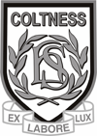

Science Department

Chemical Reactions Homework Booklet

Materials: Chemical Changes
Through experimentation, I can identify indicators of chemical reactions having occurred. I can describe ways of controlling the rate of reactions and can relate my findings to the world around me. SCN 3-19a

Name:_____________________________________ Class:___________

Homework | Parental Signature | Teacher Comment
1
2
3
4
Chemical Reactions Homework 1 Physical Changes

- Complete the following sentences:

Melting and freezing are examples of ____________________ changes. No new __________________ are formed. These changes can / cannot be reversed.

- What do we call the following changes of state?

- solid to liquid _________________________
- liquid to gas _________________________
- gas to liquid _________________________
- liquid to solid _________________________

- Give an example of another physical change: _________________________________

- A pupil added sucrose to water at different temperatures. She measured the mass of sucrose which dissolved. Here are her results:

Temperature(^{O}C) | 20 | 30 | 40 | 45 | 50 | 60 | 65
Mass dissolved (g) | 30 | 40 | 52 | 80 | 62 | 72 | 77

- Draw a line graph of the pupil’s results on graph paper. Put temperature (ºC) across the way (the x-axis) and mass dissolved (g) up the way (the y-axis).

- One of the experimental results seems to be inaccurate. Which result is inaccurate?

_______________________________________

- Predict how much sucrose which would dissolve at 35⁰C.

_______________________________________

Chemical Reactions Homework 2 Chemical Reactions

- Complete the following sentences:

Chemical reactions always make ___________ substances. The signs of a chemical reaction could be:

- a in colour.
- a being formed.
- a __ being given off.
- a change in .

- Complete the following table by deciding if each line is a chemical reaction or not:

Description | Chemical reaction? (Yes or No)
A puddle evaporating
Petrol burning
Salt dissolving in water
Wool growing on sheep
Plastic melting
Oil forming from dead sea animals
Glass breaking
Ice melting
Fireworks exploding

- A pupil wrote the following description of his science experiment.

“The teacher took some shiny copper metal and put it in a gas jar with some smelly green gas called chlorine. The metal shrivelled up, went on fire and a black solid was formed at the end.”

Write down the two pieces of evidence that shows a chemical reaction has occurred.

__________________________________________________________________

__________________________________________________________________

Chemical Reactions Homework 3 Reactant/Products

1. Identify the reactants and products in each of the following sentences:

- When carbon burns in a limited supply of oxygen, the gas carbon monoxide is produced.

Reactant(s) _____________________________________________________

Product(s) _____________________________________________________

- Shiny silver coloured magnesium reacts with blue copper sulphate solution to produce a clear colourless solution of magnesium sulphate. A red/brown solid called copper is also made.

Reactant(s) _____________________________________________________

Product(s) _____________________________________________________

- Iron metal is produced in a blast furnace by the reaction of iron oxide with carbon monoxide. The gas carbon dioxide is also produced.

Reactant(s) _____________________________________________________

Product(s) _____________________________________________________

- Silver oxide is easily broken up into its elements by heat.

Reactant(s) _____________________________________________________

Product(s) _____________________________________________________

- Write word equations for each of the reactions listed above.

- ________________________________________________________

- ________________________________________________________

- ________________________________________________________

- ________________________________________________________
Chemical Reactions Homework 4 Reaction Rate

1. When magnesium is put in acid, it reacts, producing bubbles. Jane wants to investigate if increasing the concentration of the acid affects the reaction rate. She has been given the following chemicals:

1M hydrochloric acid, 2M hydrochloric acid, 4M hydrochloric acid, magnesium metal lumps, magnesium metal powder

- In the space below draw diagrams to show how she would carry out this experiment
(you can use any science apparatus found in the laboratory).

b) Name any two variables she should not change: ____________ and ____________

c) How would you know which reaction was fastest_______________________________
____________________________________________________________________________________________________________________________________

2. When Matthew added manganese dioxide to hydrogen peroxide solution, oxygen was produced. Manganese dioxide is a catalyst.
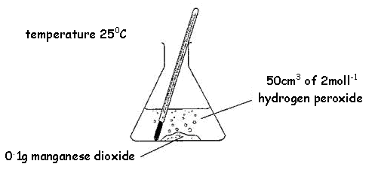
a) What is a catalyst?
_______________________________________
_______________________________________

b) What will be the mass of manganese dioxide
at the end of the reaction? _____ g

c) He then wanted to see if increasing the
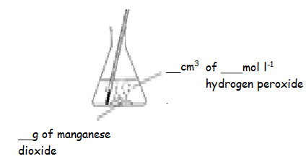
temperature to 35ºC would speed up the reaction.
Complete the labelling of the diagram to show how
he would make his second experiment a fair test.

3. Complete the following sentences:

The speed of a chemical reaction can also be called the ___________ of the reaction. We can increase the rate of a chemical reaction by
- _________________ the concentration.
- _________________ the temperature,
- _________________ the particle size,
- Using a catalyst. A catalyst speeds up a reaction but is not ___________________.

