Coltness High School


Science Department
Cells Alive Homework Booklet

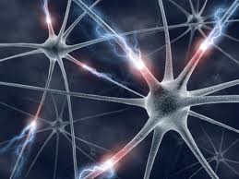

Name:
Class
Homework | Parental Signature | Teacher Comment
1
2
3
4

Homework 1

- The diagrams below show three different cells, not drawn to scale.
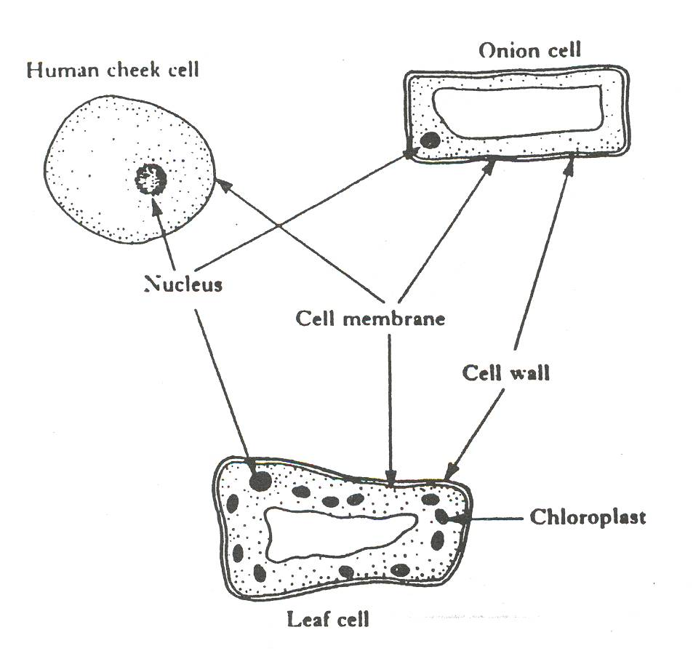

Select information from the diagrams above to complete the table below.
Tick = present cross = absent.

Part of cell | Human cheek cell | Onion cell | Leaf cell
Nucleus
Cell membrane
Cell wall
chloroplast

- Describe how cells can be treated so that the cell contents
become more visible.
______________________________________________________________________________________________ (1)
- The diagram below shows some human cheek cells as they appear
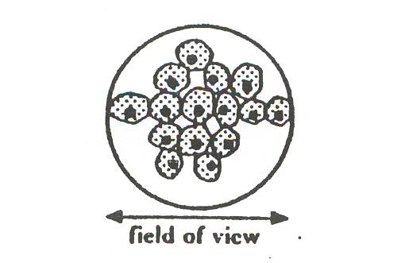
when viewed through a microscope. The diameter of the field of
view of the microscope is 120 micrometers. Calculate the
average width of a human cheek cell.

Average width = _______________ micrometers
(1)

Homework 2

- Choose two examples of cells from the list and describe their
Special function or structure:
sperm, red blood cell, nerve cell, root hair cell, skin cell

Cell type-
Description- ______________________________________
________________________________________________ ________________________________________________.
Cell type-
Description- ______________________________________
________________________________________________
________________________________________________.
- Gametes (sex cells) are essential for human reproduction. Copy and complete the sentences below by inserting the correct words.

- Human male sex cells are called ___________ and are produced in the _____________.
- Human female sex cells are called __________ and are
produced in the ______________. (2)

- What is the name of the organ that allows oxygen and nutrients to pass from mother to baby?

_____________________________. (1)

- What should expecting mothers avoid to ensure the healthy development of her baby?

_____________________________. (1)
Homework 3

1. What is the function of xylem? (1)
___________________________.
2. What is the function of phloem? (1)
___________________________.
3. The diagram below shows the organs which play an important role in
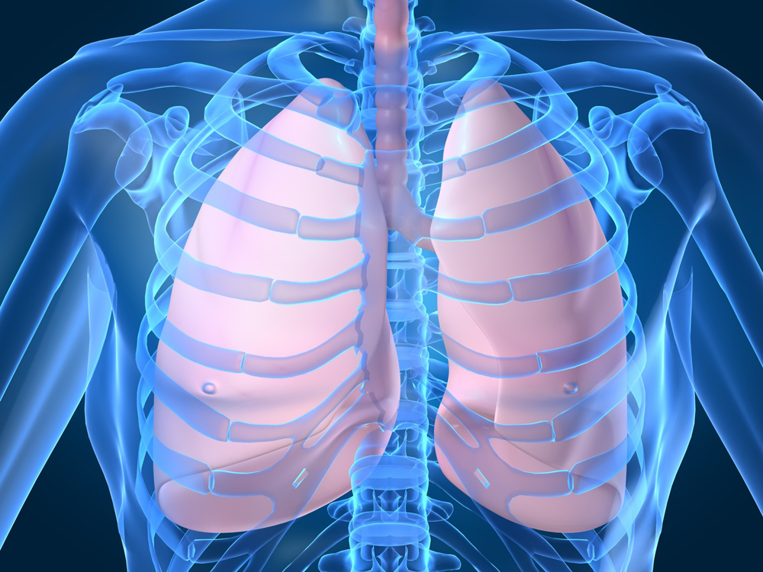
breathing.
- What are they called?
__________________.
- How are they protected?
_____________________________.
- Name the large, dome shaped muscle that lies below the lungs.
_____________________________.
- How can we look after them?
_____________________________. (4)
4. Describe one of the issues associated with organ donation.
____________________________________________
____________________________________________
____________________________________________ (1)

Homework 4

1. Complete the word equation below for aerobic respiration

glucose + ________ → water +_________ + __________ (1)

2. Give one reason why cells and living things need energy?
_____________________________________________ (1)
3. What might affect how much energy a person needs?
______________________________________________ (1)
4. Which type of cells carry out respiration? (Circle the correct answer)

Skin cells Muscle cells All cells (1)
5. Answer the following questions using the table below.
Name of substance | Inhaled air | Exhaled air
Nitrogen | 79% | 79%
Oxygen | 21% | 16%
Carbon Dioxide | 0.04% | 3.5%

a) Which gas is there less of in exhaled air? Explain why this may be.
__________________________________________________
__________________________________________________
__________________________________________________.
(1)
b) Which gas is unchanged? Explain why this may be.
_________________________________________________
_________________________________________________
(1)
_________________________________________________
c) Which gas is there a higher percentage of in exhaled air? Explain
why this may be.
__________________________________________________
__________________________________________________
(1)
__________________________________________________
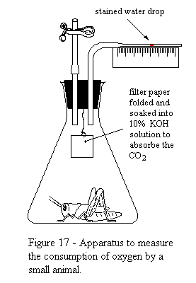
6. The diagram below shows a respirometer.
a) What do you expect to happen to the
stained water drop?
______________________________
______________________________
______________________________
______________________________
______________________________
(1)

Cells Alive Checklist
I can ……… | ☺ | 😐 | ☹
Microscopes and Cells
label the parts of a microscope to include:
eyepiece lens, focusing knob, objective lens, stage and mirror
state that stains can be used to make cells more visible under the microscope, e.g. iodine solution
identify the main structures of animal and plant cells: cytoplasm, nucleus, cell membrane, central vacuole, cell wall and chloroplasts
state the functions of the following cell structures:
Cytoplasm – it is a jelly-like substance where chemical reactions take place
Nucleus – controls the cell’s activities
Cell membrane – controls what enters and leaves the cell
Central vacuole – contains a liquid called cell sap
Cell wall – gives the plant cell shape and support
Chloroplasts – contain a green chemical called chlorophyll
state that plants and animals are made up of lots of different types of cells, all doing different jobs
state that all cells have a nucleus, a cytoplasm and a cell membrane
state that plant cells also have a cell wall, vacuole and chloroplasts
Different types of cells
give examples of how different cells are adapted to their function, including sperm cells, red blood cells, nerve cells, root hair cells, palisade mesophyll cells and epidermal cells
state that sex cells are called gametes.
state that the male gamete is the sperm and the female gamete is the egg
state that fertilisation is when the nuclei of the sperm and egg fuse together
state that the placenta is the organ which provides oxygen and nutrients for the developing foetus
state that the umbilical cord attaches the foetus to the placenta
understand the process of foetal development
understand the risks that face the developing embryo

I can ……… | ☺ | 😐 | ☹
Tissues and Organs
understand the relationship between:
Cells  tissues  organs  organism
give an example of an animal organ and describe its function
state that breathing rate is a measure the number of complete breaths in one minute
give an example of how we can monitor health conditions such as asthma
describe the problems associated with organ donation
Respiration
state that living cells need energy for cell growth, cell division and building up large molecules.
state that respiration is the process in which chemical energy is released during the breakdown of a foodstuff such as glucose.
state that living things need oxygen to release energy from food during (aerobic) respiration
state that the respiratory gases and glucose are transported around the body in the blood
state that carbon dioxide is given off by respiring cells
state that all our body cells carry out respiration
state that the oxygen required for respiration comes into the lungs during breathing in, and the carbon dioxide released is removed from the lungs during breathing out
describe the differences between inhaled and exhaled air
state that respiration can be written as a word equation:
Glucose + oxygen ENERGY + carbon dioxide + water
state that heat is given off during respiration
describe how to set up a simple respirometer
describe how to use a respirometer to measure the rate of respiration
describe how to set up a control for a simple respirometer
state factors that would affect the rate of respiration

