Coltness High School
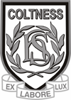

Science Department
Made in the Stars Homework Booklet

I have developed my knowledge of the periodic table by considering the properties and uses of a variety of elements relative to their positions SCN 3-15a

Having contributed to a variety of practical activities to make and break down compounds I can describe examples of how the properties of compounds are different from their constituent elements SCN 3-15b

I can participate in practical activities to extract useful substances from natural resources
SCN 3-17b

I have collaborated with others to find and present information on how scientists from Scotland and beyond have contributed to innovative research and development.
SCN 3-20a

Name ______________________________________
Class ______________________________________

Homework | Parent’s Signature | Comments
1
2
3
4

Homework 1: Classifying Elements

- Tick the statements which are true of metal elements
- metals are shiny when polished
- metals do not conduct heat and electricity
- all metals are solid at room temperature, except mercury which is a liquid
- metals are usually brittle
- metals can exist as solid, liquid or gas at room temperature
- metals usually have low melting and boiling points

- Using the list below, find the metals and write their names in the metal box.
Find the non metals and write their names in the non metal box.
copper carbon oxygen sulphur iron gold
zinc nitrogen neon sodium aluminium

Metal Elements Non Metal

- The elements listed below all have important uses –
Iron, potassium, titanium, aluminium, argon, copper, gold

Complete the table by
- Inserting the element beside the correct use of the element.
- Explaining which property the element has that makes it useful. (electrical conductivity, shiny)

Element | Use of element | Property of the element
 | for making pipes
 | for filling light bulbs
 | Joining bones together
 | hard
 | For making aircraft
 | For making fire works
 | For making jewellery

- A metal dealer had the following stock of metals in his store:

Name of metal | Mass (Kg)
Copper | 250
Aluminium | 400
Tin | 100
Lead | 250

a) Draw a bar graph of these figures in the graph paper below.

b) Which of the metals is a transition metal?

______________________________________________________

Homework 2: The Periodic Table 1

- Use your Periodic Table in your homework planner or in your science homework pack to complete the table below

element | symbol | Atomic number | Metal/non metal | state
Carbon | C | 6 | Non metal | solid
Magnesium
 | Ag
 |  | 11
 |  |  | Non metal | gas
 |  | 1
 |  |  | Non metal | liquid
 |  |  |  | Gas
(7 mark)

2. Decide which of the following statements are true and which are false.

Statements | True | False
There are roughly 160 elements listed on the periodic table
Non metal elements are usually shiny solids
Metals elements are conductors of electricity
Group 1 elements are called the transition elements
Groups are the vertical columns on the periodic table
Elements in group 1 are very unreactive
(6 mark)

3. Sort these materials into two groups – elements and compounds.

silver salt water iron carbon dioxide
aluminium carbon sugar tin
Elements Compounds

(3 mark)

4. Look carefully at these diagrams.

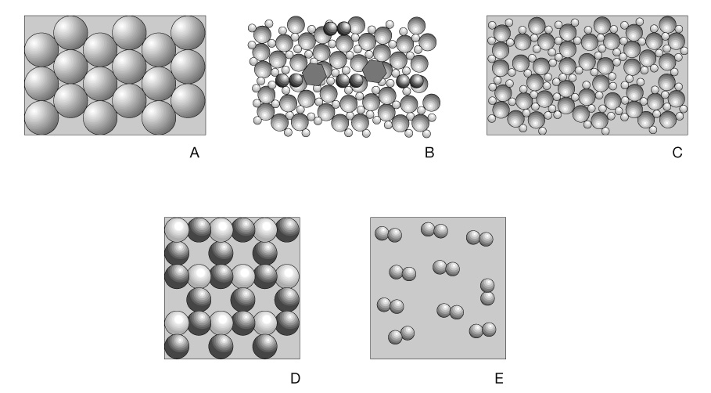

Which diagram(s) represents a compound?

Letter ___________________

(1 mark)
Homework 3: The Periodic Table 2

Use your periodic table to complete the table below

Element | symbol | group | Atomic number
copper | Cu | Transition metal
lead
oxygen | O | 6 | 8
argon
potassium
Magnesium
 | He
Nitrogen
 | C
Silver
Francium
 |  |  | 15
 |  |  | 5

Which group of elements are called the alkali metals?

___________________________________________________________________________

Which group of elements are called the halogens?

___________________________________________________________________________

Where do you find the transition metals on the periodic table?

___________________________________________________________________________

Homework 4: Characteristics of the Periodic Table

- a) Complete the table below using your periodic table

Element | Symbol | Atomic No. | Group Number
Sodium | Na | 11 | 1
Chlorine
 | F
 | Ca
 |  | 19
 |  | 12
Caesium
 | Kr
 |  | 18

b) Name three alkali metals _________________________________________________________________
c) Name three halogens _________________________________________________________________

- a) Explain what happens when the alkali metals are put into water.

_________________________________________________________________________

_________________________________________________________________________

b) Why do all the alkali metals react in a similar way when put into water?

______________________________________________________________________

c) state the order of reactivity of the alkali metals (the most reactive first).

______________________________________________________________________

______________________________________________________________________

3. Group 8 such as neon and argon are very unreactive. Can you suggest a reason why these elements are unreactive?

_____________________________________________________________________

4. Chlorine and iodine are both members of the same group in the periodic Table
- What is the family name for the group to which chlorine and iodine belong?
______________________________________________________________________

- State a use for chlorine?
____________________________________________________________________________________________________________________________________________
- The table shows the percentage of iodine used to make other substances.

Use | Percentage present
Medicines | 25
Animal feeds | 15
Photography chemicals | 10
Catalysts | 15
Other uses | 35

Present the information in a bar chart.

Made in the Stars Checklist

I can ……… | ☺ | 😐 | ☹
- What are Elements and Compounds?
State that elements are made in stars.
State that an element contains only one type of particle, called an atom.
State that a compound contains more than one different kind of atom.
State that a molecule is a group of atoms joined together.
Identify pictures which represent the atoms present in elements and compounds.
2. Where do Elements Come From?
State elements can be extracted from substances called ores found in the Earth’s crust
State elements look different from the ore from which they were extracted
State ores are compounds containing metals and non-metals joined together
State compounds can be broken down into their elements using heat or electrical energy
3. Properties of Elements
State elements are grouped as either metals or non-metals
State metals are shiny when polished, and conduct heat and electricity
State all metals are solid at room temperature, except mercury which is a liquid
State solid non-metals are usually brittle
State non-metals can exist as solid, liquid or gas at room temperature
State non-metals generally have low melting and boiling points and are poor conductors of heat and electricity

I can ……… | ☺ | 😐 | ☹
I can ……… | ☺ | 😐 | ☹
4. The Periodic Table
State elements can be solids, liquids or gases
State elements vary in appearance
State elements are listed on a periodic table
State elements have their own chemical symbol, and atomic number for each element
State elements can be grouped in many different ways
State elements are arranged in the periodic table by their increasing atomic number
Use a periodic table to identify the symbols and atomic number for elements
Group elements similar in appearance
State the uses for some common elements
- More about the Periodic Table
State that the groups are the vertical columns
State there are 8 groups on the periodic table
State that Group 1 are called the alkali metals
State that Group 7 are called the Halogens (salt makers)
State that Group 8 are called the noble gases
State that rectangular block with no number is the Transition metals
- Structure of the Atom
Describe the structure of the atom.
State that the atomic number is the number of protons in the nucleus.

