Coltness High School Science Department

Forces Homework Booklet

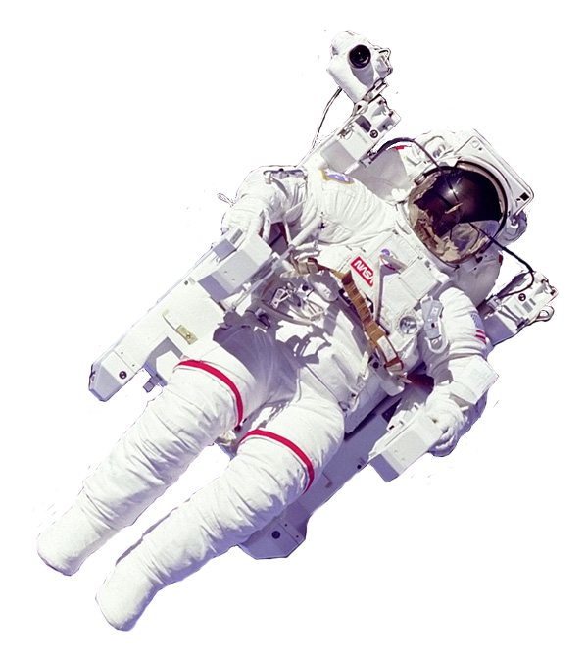

Homework | Date due | Parental Signature | Teacher Comment
1
2
3
4
Name: _______________________ Class: ______

Homework 1 - Forces

- Look at this list of forces:
pushing pulling twisting squeezing
Complete the table to show which kind of force you would use for each activity. The first one is done for you.
Activity | Type of force
Opening the fridge | pulling
Locking a door
Moving a supermarket trolley
Taking the lid of a jar
Peeling an orange
Taking part in a Tug of War game
Closing a drawer
Using a screwdriver

2. What piece of apparatus can you use for measuring the size of a force?
_____________________________________________________________

3. What units do we use to measure forces?
_____________________________________________________________

4. A force is applied to a ball of plasticine. What might the force do to the plasticine? Give at least two answers.
_____________________________________________________________
_____________________________________________________________

5. Unscramble the jumbled words to show some different kinds of forces:
unpch ________ kkic ________ rnut ________ gard ________
Homework 2 – Friction

1. Complete the sentences below, using the word bank.

slow down speed up surfaces force increase decrease

Friction is a ___________ which acts between ___________ which touch.

Friction always tries to ___________ moving objects. Sometimes we try to

___________ friction so that objects can go faster. If you want a good grip on

something, you try to ___________ friction.

2. Describe how you would reduce friction in these examples:

A squeaky door hinge ____________________________________________

A ring stuck on your finger _______________________________________

Cycling your bike _________________________________________________

3. Complete the sentences below.

In car engines, ___________ can cause heat, which can damage the engine.

It can also wear away the inside of the engine.

To reduce friction, a lubricant like ___________ is put in the engine.

4. Use the words “increase” or “decrease” to complete the sentences below.
In PE, your trainers help to ___________ friction between your feet and the floor.
Badminton players put tape round their racket handles to ___________ friction.
Sprinters wear skin-tight suits to ___________ friction.
Formula 1 cars have wide rubber tyres to ___________ friction.
Skiers put wax on the bottom of their skis to ___________ friction.
Homework 3 – Mass and Weight

1. Complete the sentences below, using the word bank.
You can use the words more than once.

weight mass kilograms newtons

The amount of matter in an object is called its ____________.
This is measured in units called ____________.
The force of gravity pulling an object down is called its ____________.
This is measured in units called ____________.
When an object goes to another planet, its ____________ changes,
but its ____________ stays the same.

2. How many newtons of weight pull down on each 1 kg of mass on the Earth?
____________________________________________________________

3. Calculate the weight of a girl with a mass of 38 kg.
____________________________________________________________

4. If you went to the Moon, what would happen to:
(a) your weight? __________________________
(b) your mass? __________________________

5. Imagine you went to a space station where there was no gravity, and you had no weight. Write a few sentences about what it would be like. What would be easier, and what would be more difficult?
____________________________________________________________
____________________________________________________________
____________________________________________________________
____________________________________________________________
____________________________________________________________
Homework 4 – Balanced and Unbalanced Forces, Speed

1. Complete the sentences below, using the word “balanced” or “unbalanced”.

Newton’s Laws tell us that if the forces on an object are ____________, then it will stay still, or move with a steady speed.

If the forces are ____________, the object will get faster or slower.

2. Circle the diagrams below which show balanced forces acting on the box.

3. Put the letters of the descriptions below into the correct box, to show if the forces are balanced or unbalanced. The first two have been done for you.
Unbalanced forces

b
Balanced forces

a

a. A man pushing a shopping trolley at a steady speed.
b. A car speeding up along a road.
c. A car travelling at a steady 70 mph.
d. A parachutist floating down towards the ground at a steady speed.
e. A boy braking so that his bike slows down.
f. A car parked on a steep hill.
g. An aeroplane accelerating on the runway.
h. The space shuttle accelerating upwards just after launch.
i. A boat floating in a pond.
j. The rope in a tug of war with both teams pulling equally.

4. Calculate the speed of a bike which travels a distance of 32 m in a time of 4 s.
Show your working!

What I should know:
Forces
Examples of forces are pushing, pulling and twisting.
Forces can change the speed, shape, size or direction of an object.
Forces are measured in newtons (N).
A force is measured with a Newton balance or spring balance.
Friction is a force which always acts to slow down objects, or keep them at rest.
Friction is a nuisance if you are trying to move fast.
Friction can be reduced by streamlining, lubricating with oil or using a layer of air.
Friction is useful for gripping things, for tyres, shoe soles and brakes.
Friction can be increased by using high friction materials like rubber.
Gravity and Weight
Mass is a measure of the amount of matter in an object.
Mass is measured in kilograms (kg).
If an object is taken to a different planet, its mass remains the same.
Gravity is a force which pulls objects towards the centre of a planet or star.
The force of gravity on an object is called its weight.
The weight (force of gravity) acting on each 1kg on Earth is 10 newtons.
I can calculate the weight of an object on earth, given its mass in kg.
The strength of gravity is different on different planets.
The strength of gravity on the Moon is less than on Earth.
Balanced and Unbalanced Forces
Equal forces in opposite directions are called balanced forces.
An object acted on by balanced forces stays still, or moves at a steady speed in a straight line.
I can give an example of balanced forces, e.g. an evenly matched Tug of War.
Unbalanced forces are forces which are not balanced. There may be only one force.
An object acted on by unbalanced forces will speed up or slow down.
I can calculate the total force from a diagram showing two unbalanced forces.
I can give an example of a situation with unbalanced forces, e.g. a car speeding up.
Measuring Speed
The speed of an object can be found by measuring the time it takes to cover a certain distance.
The speed is the distance divided by the time (speed = d/t)

