Coltness High School


Science Department
Biodiversity Homework Booklet

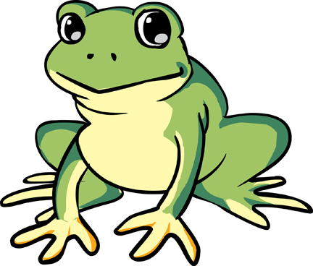

Name:
Class:

Homework | Parental Signature | Teacher Comment
1
2
3
4
5

Homework 1

- An example of a biotic factor is ___________________. (1)
- Write down two abiotic factors that might affect where a plant grows.
a) __________________________.
b) __________________________. (2)
- John is investigating the effect of abiotic factors around Coltness High School. What piece of equipment would he need to measure:
a) The temperature of the soil?
_______________________________________. (1)
b) The moisture content of the grass?
_______________________________________. (1)
c) The light intensity in the car park?
_______________________________________. (1)
- What precaution must John take when measuring:
a) The moisture content of the soil?
__________________________________________
__________________________________________. (1)
b) The light intensity in the car park?
__________________________________________
__________________________________________. (1)

Homework 2
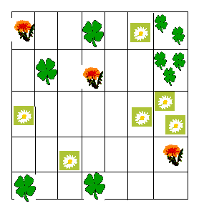
- Sophie used a quadrat to sample the different types of plants found around the school. The results from one quadrat are shown below.

a) How many dandelions did she sample?
___________. (1)
b) How many clovers did she sample?
___________. (1)
c) How many daisies did she sample?
__________ . (1)
2. In the space below, draw how you would set up a pitfall trap.

(3)

Homework 3
- Use the key to identify organisms 1-6.
61
1
21
31
41
51
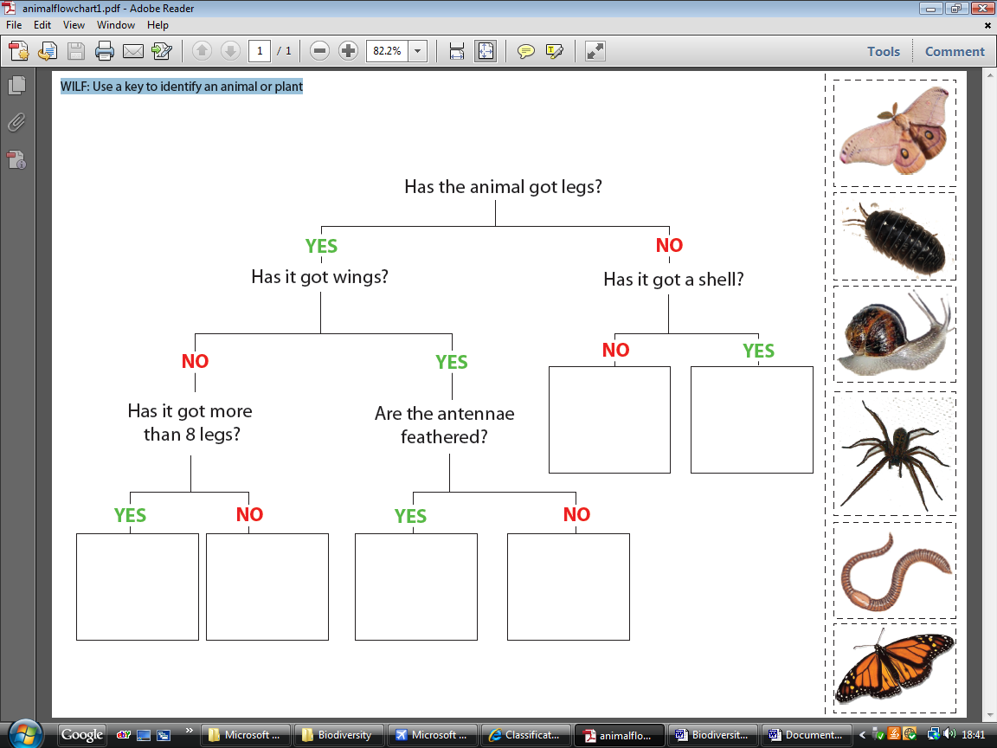
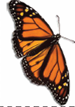

Number | Name
1
2
3
4
5
6
Snail
Worm
Moth
Butterfly
Wood-louse
Spider
(6)

Homework 4

- What is competition?
_______________________________________________
_______________________________________________
_______________________________________________. (1)

- Give 3 examples of resources that plants compete for.
  - _______________________
  - _______________________
  - _______________________ (3)
- Give 3 examples of resources animals compete for.
  - _______________________
  - _______________________
  - _______________________ (3)
- Why is biodiversity important to humans?
_____________________________________________
_____________________________________________
_____________________________________________ (1)
- In what ways are humans reducing Biodiversity?
_____________________________________________
_____________________________________________
_____________________________________________ (1)

Homework 5

- What evidence supports the theory of evolution?
___________________________. (1)
- What name is given to animals that were unable to adapt to the changing environment and no longer exist on earth today?
___________________________. (1)
- Give an example of an animal no longer found on planet earth.
___________________________. (1)
- What name is given to animals such as the Giant Panda whose numbers are dangerously low?
___________________________. (1)
- Give an example of another animal at risk.
___________________________. (1)

