Unit 1

Controlling the Rate: Learning Outcomes | Got it?
I understand why it is important for chemists to control the rate of reaction
I can predict how the rate of a chemical reaction will be affected by changing the concentration, particle size, temperature or by using a catalyst
Collision theory can be used to explain how these factors affect the rate of a reaction
I understand energy distribution diagrams and can explain the effect of increasing the temperature, or adding a catalyst, on the rate of a reaction
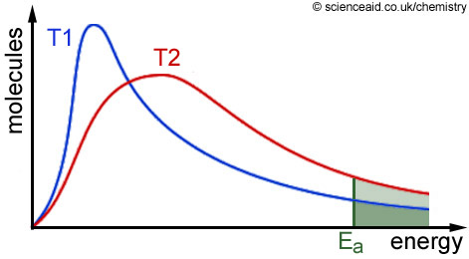

I understand the concepts of collision geometry and activation energy
I understand the effect of pressure on gases
I know different methods to monitor reaction rates
I can use the reciprocal of the equation below to calculate time in seconds (s):
I can calculate activation energy and enthalpy change from energy profile diagrams
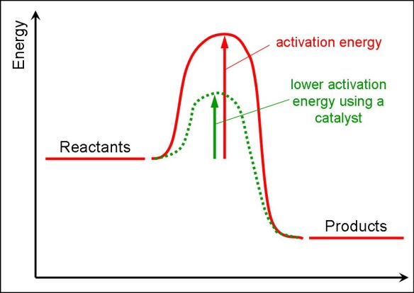
I know what is meant by an ‘activated complex’
I can show the position of an activated complex on an energy profile diagram
I can show the effect of adding a catalyst on an energy profile diagram

Learning Outcomes: The Periodic Table – Bonding and Structure | Got it?
I can identify groups and periods in the periodic table
I know where to find the metals, non-metals, halogens, noble gases and transition metals on the periodic table
I can explain the reactivity of elements by considering electron arrangement
I can discuss the bonding and structure of the first 20 elements:
- The metallic elements (Li, Be, Mg, Al, K, Ca)
- The covalent molecular elements (H₂, N₂, O₂, F₂, Cl₂, P₄, S₈ and C₆₀)
- The covalent network elements (B, C (diamond and graphite) and Si

Learning Outcomes: Trends in the Periodic Table | Got it?
I know how to use the covalent radius to state the size of an atom
I can explain the meaning of electronegativity
I know how to use the data booklet to find out the covalent radius and electronegativity values for elements
I can explain the trend in electronegativity and covalent radius across a period or down a group
I know the meaning of and can write the equation for the first and subsequent ionisation energies of elements
I know where to find ionisation energy values in the data book
I can describe and explain trends in first ionisation energies across a period or down a group
I can explain patterns in successive ionisation energies and identify the group of an element from these

Learning Outcomes: Bonding in Compounds | Got it?
I can describe how ionic and covalent bonding arises
I can identify a molecule as being polar or non-polar and know how to represent this on a diagram
I understand how London dispersion forces, permanent dipole-permanent dipole interactions and hydrogen bonding arise; and understand these are all types of van der Waal’s forces
I can use the shapes of molecules to predict whether they are polar or non-polar
I can draw diagrams to show hydrogen bonding between molecules
I can use electronegativity data to predict bonding type and understand the concept of the ‘bonding continuum’
I can relate physical properties such as melting and boiling points; viscosity, solubility (miscibility) to the type of intermolecular forces present in substances
I can relate hydrogen bonding in water to its density when solid and liquid

Unit 2

Learning Outcomes: Alcohols, Carboxylic Acids and Esters | Got it?
I can name, draw full structural formulae and write shortened structural formulae for alkanes, alkenes, alkynes, cycloalkanes and cycloalkenes
I can name, draw full structural formulae and write shortened structural formulae for alcohols, carboxylic acids and esters
I can name the functional groups in alcohols, carboxylic acids and esters
I can describe, in detail, the procedure to make an ester
I can name esters and predict the reactants from the ester and vice versa
I know some uses of esters
I can explain the process of hydrolysis of esters and predict the products of this

Learning Outcomes: Fats, Oils, Soaps and Detergents | Got it?
I can name some sources of fats and oils
I can state the benefits of fats and oils in our diet
I can describe the structure of fats and oils and use these to explain their melting and boiling points
I know how fats and oils are formed from fatty acids and glycerol
I can predict the structure of the fatty acid from the structure of the fat or oil formed
I can recognise glycerol (propan-1, 2, 3-triol)
I can describe the test for unsaturated fats or oils
I can explain the process of hardening oils
I can explain the solubility vitamin C and vitamin A in relation to their polarity
I can explain how soap is made from fats and oil
I can explain the cleaning action of soap and detergent in terms of their structure
I can describe where detergents are particularly useful
I can describe an emulsion and name some examples
I can explain why a molecule can act as an emulsifier in terms of its structure

Learning Outcomes: Protein | Got it?
I know some examples of proteins
I can explain how proteins can be hydrolysed into their constituent amino acids
I can explain how proteins are made from amino acids; recognise amino acids from proteins and vice versa
I can draw and recognise an amide (peptide) link
I can draw a section of protein from amino acids
I can describe ‘essential amino acids’ as being obtained only from our diet
I know that enzymes are proteins and that they are biological catalysts
Learning Outcomes: The Chemistry of Cooking & Oxidation of Food | Got it?
I can predict whether a molecule is likely to be fat/oil soluble or water soluble by examining the functional group/s present
I can predict how volatile a molecule is likely to be by examining the size and structure of the molecule
I can describe the structure of a protein
I can describe how heating a protein can change its structure
I can state whether an alcohol is primary, secondary or tertiary and whether it is likely to be oxidised
I can name some common agents capable of oxidising alcohols and aldehydes and describe the results of these tests
I can draw full structural formulae, shortened structural formulae and name alcohols, aldehydes and ketones
I can name and recognise the functional group in aldehydes and ketones
I can name and draw products formed when an alcohol or aldehyde is oxidised
I can explain why carboxylic acids are weak acids
I can write equations for and predict the products when carboxylic acids react with bases to form salts
I can describe oxidation of a carbon compound in terms of the oxygen hydrogen ratio
I can state the function of an antioxidant and describe some uses of these
I can write ion-electron equations for antioxidants
I can describe the reaction of edible oils and oxygen

Learning Outcomes: Fragrances | Got it?
I can describe essential oils and name some of their uses
I can explain that terpenes are major components of essential oils
I can draw and recognise isoprene, give its systematic name and state how many isoprene units are in a terpene from its structure
I can describe the oxidation of terpenes and predict the products that may be formed

Learning Outcomes: Skin Care | Got it?
I can explain why UV light can be damaging to skin
I can explain how sunblock can prevent damage from UV light
I can describe what a free radical is
I can write equations for the three steps in a free radical reaction and name these steps
I can describe a ‘free radical scavenger’
I can describe and explain the use of free radical scavengers

Unit 3:

Learning Outcomes: Getting the most from Reactants | Got it?
I can explain how industrial processes are designed to maximise profit and minimise the impact on the environment
I can describe some of the factors influencing industrial process design
I can describe some environmental consideration in industrial process design
I can balance equations and use these to calculate the mass of a reactant or product
I can express quantities in terms of moles
I can perform calculations involving solutions, volumes and concentrations
I can perform calculations to identify the excess reactant and the limiting reactant
I can perform calculations involving molar gas volumes
I can calculate the volumes of reactant and product gases from the number of moles of each reactant and product

Learning Outcome: Percentage Yield and Atom Economy | Got it?
I can explain that the efficiency with which reactants are converted into the desired product is measured in terms of the percentage yield and atom economy
I can perform percentage yield calculations:

I can perform atom economy calculations:

I can use the percentage yield and atom economy to comment on the choice of route for making a chemical

Learning Outcomes: Equilibria | Got it?
I know what is meant by the term 'dynamic equilibrium'
I know what is meant by a 'closed system'
I understand why chemists want to alter the position of equilibrium
I understand and can predict the effect of changing the temperature and concentration on a system at equilibrium
I understand that a catalyst has no effect on the position of equilibrium

Learning Outcomes: Chemical Energy | Got it?
I can calculate the enthalpy change of a reaction using: E_{h} = c m ΔT
I know the definition of enthalpy of combustion and enthalpy of formation
I can describe how enthalpy of combustion data can be obtained by experiment
I can evaluate different experimental methods used to obtain enthalpy of combustion data
I know the definition of Hess's Law
I can use Hess's Law to calculate the enthalpy change for a chemical reaction
I can use bond enthalpies to calculate the enthalpy change for a reaction
I understand that bond breaking is endothermic and bond making is exothermic
I understand where mean bond enthalpy data comes from

Learning Outcomes: Oxidising and Reducing Agents | Got it?
I know the definition of oxidising and reducing agents
I can identify a substance as an oxidising or reducing agent
I can write balanced redox equations
I can combine ion-electron equations to make an overall redox equation
I understand the relationship between electronegativity and the ability of a substance to act as a reducing or oxidising agent
I know the strongest reducing agents are found in Group 1
I know the strongest oxidising agents are found in Group 7
I can use the electrochemical series to identify highly effective reducing and oxidising agents
I can write ion-electron equations for more complex oxidations and reductions involving compounds
I know examples of everyday oxidising agents and why these are used

Learning Outcomes: Chemical Analysis | Got it?
I can describe the basic principles of chromatography in terms of mobile and stationary phases
I can interpret simple chromatograms
I can explain the difference in separation of two compounds based on their size or polarity

Learning Outcomes: Volumetric Analysis | Got it?
I can used a balanced equation to calculate the quantity of an unknown reactant using information from a titration experiment
I can use balanced redox equations to calculate the quantity of an unknown reactant using information from a redox titration experiment
I know what is meant by the terms 'indicator' and 'standard solution'
I know that redox titrations involving potassium permanganate are self-indicating

