Entry to Higher Maths Pack

Plan
We will be working through four small Higher Maths topics that link nicely to National 5. These topics will be very important to your success in Higher and we will be assuming these are complete by your return to school. For the month of May you can ask questions by emailing maths@coltnesshigh.n-lanark.sch.uk and we will create a Microsoft Team when we have a list of those who have picked Higher Maths.
Resources
We will be using the Leckie & Leckie Higher Maths textbooks for our practice. You can access the textbook via the website https://connect.collins.co.uk/school/defaultlogin.aspx and using the login details below:
Username – COLTNESS1Student
Password – P@55word

For each topic there will be a PowerPoint and Notes page also. We will also give links to Rigour Maths video tutorials.
Content
- Trigonometry
Use the “Trigonometry Higher”, “Trig Graphs Nat 5” and “Trig Equations Nat 5” PowerPoints and Notes attached to the post.
  - Radians & Exact Values (Two Periods)
Read through the “Trigonometry Higher” PowerPoint “Connection between Radians, Degrees and Exact Values” section.
Watch videos:
https://youtu.be/U7XaqnEGLZA
https://youtu.be/qwugcPkrkww
https://youtu.be/c_ev7leMrJ4
Work through the textbook exercise Chapter Two: Working with Angles measured in Radians
  - Trig graphs of the form y = asinbx +c (One Period)
Read through the PowerPoint “Trig Graphs Nat 5” up to and including “Graphs of the Form y =asinbx+c”.
Watch videos:
https://www.youtube.com/watch?v=LemAKXMpr3I&feature=youtu.be
https://www.youtube.com/watch?v=BebO8yo0rH8&feature=youtu.be
Work through the exercise below
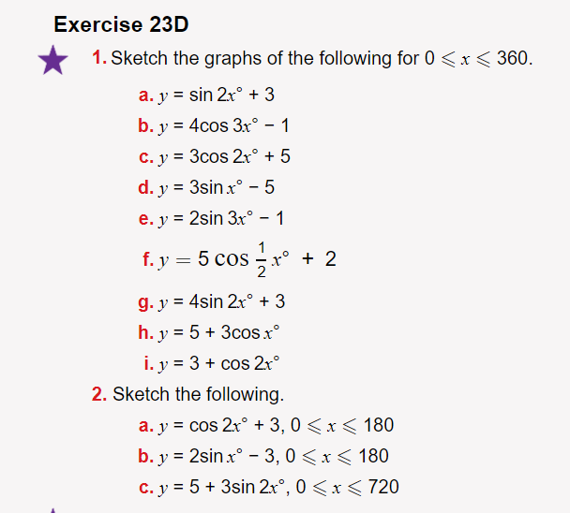
  - Phase shift angles (One Period)

Read through the “Trig Graphs Nat 5” PowerPoint “Phase Angle” section.
Watch video https://www.youtube.com/watch?v=tTi9TV7MaUE&feature=youtu.be
Work through the textbook exercise Chapter 3: Working with Trigonometric Graphs.
  - Solving trig equations (One Period)
Work through the “Trigonometric Higher” PowerPoint “Solving Basic Trig Equations” section.
Work through the textbook exercise Chapter Eight: Solving Trig Equations in Degrees, Solving linear equations of acosx+b=0, asinx+b=0 or atanx+b=0 and Chapter Eight: Solving Trig Equations in Radians: Solving Linear Equations.
  - Compound angle solutions (One Period)
Work through the “Trigonometric Higher” PowerPoint “Solving Harder Trig Equations” section.
Watch video https://www.youtube.com/watch?v=SccUbu5wBvI&feature=youtu.be
Work through the textbook exercise Chapter Eight: Solving Trig Equations in Degrees, Solving Linear Equations with Compound Angles and Chapter Eight: Solving Trig Equations in Radians: Solving Linear Equations with Compound Angles.

- Straight Line

  - Parallel and perpendicular lines (One Period)
Work through the “Straight Line” PowerPoint “Prior Knowledge” section, with focus on the gradient of parallel and perpendicular lines.
Watch videos:
https://youtu.be/JjSa5HSug30
https://youtu.be/FhD80DIxGos
Work through the textbook exercise Chapter Thirteen: Applying algebraic skills to rectilinear shapes: Parallel Lines and Chapter Thirteen: Applying algebraic skills to rectilinear shapes: Perpendicular Lines
  - Collinearity (One Period)
Work through the “Straight Line” PowerPoint “Collinearity” section.
Watch video https://youtu.be/e7RdNSySDXI
Work through the textbook exercise Chapter Thirteen: Applying algebraic skills to rectilinear shapes: Collinearity
  - Midpoint & distance formula (One Period)
Work through the “Straight Line” PowerPoint “Distance Formula” and “Midpoints” sections.
Watch videos and work through the questions:
https://youtu.be/WaZXPX-K_iU
https://youtu.be/nEgyqklYIpI
https://youtu.be/k8HREE41_8U
https://youtu.be/Xg222a_oEmw
  - Median, Altitude and perpendicular bisectors (Three Periods)
Work through the “Straight Line” PowerPoint “Perpendicular Bisector” section.
Watch video https://youtu.be/k1jMcDscQA0
Work through the textbook exercise Chapter Thirteen: Applying algebraic skills to rectilinear shapes: Special Lines in a Triangle: Perpendicular Bisectors
Work through the “Straight Line” PowerPoint “Altitudes” section.
Watch video https://youtu.be/UTm05Ja6of4
Work through the textbook exercise Chapter Thirteen: Applying algebraic skills to rectilinear shapes: Special Lines in a Triangle: Altitudes
Work through the “Straight Line” PowerPoint “Median” section.
Watch video https://youtu.be/l8ijTfgYSfA
Work through the textbook exercise Chapter Thirteen: Applying algebraic skills to rectilinear shapes: Special Lines in a Triangle: Medians
  - m=tanθ (Two Periods)
Work through the “Straight Line” PowerPoint “Median” section.
Watch videos:
https://youtu.be/3f7j87f6D08
https://youtu.be/nn6WugLRLbY
https://youtu.be/gM3D6xLWq0A
Work through the textbook exercise Chapter Thirteen: Applying algebraic skills to rectilinear shapes: Gradients and Angles

- Recurrence Relations

  - Forming and Using a RR (Three Periods)
Work through the “Recurrence Relations” PowerPoint “nth terms of a sequence” , “nth term of a recurrence relation” , “Problem Solving Recurrence Relation” and “Find a Formula” sections.
Watch videos:
https://youtu.be/WOygyasof7k
https://youtu.be/OQkObaHNxaI
https://youtu.be/F71JeL6VVfE
Work through the textbook exercise Chapter Fifteen: Modelling Situations using Sequences: Nth term formulae
  - Limits and what they mean in the context of the question (Two Periods)
Work through the “Recurrence Relations” PowerPoint “Divergence/Convergence” and “Find a Limit” sections.
Watch videos:
https://youtu.be/F71JeL6VVfE
https://youtu.be/Am69Cy9XpVU
https://youtu.be/TdXOsFgkVAQ
Work through the textbook exercise Chapter Fifteen: Modelling Situations using Sequences: The Limit of a Sequence.
  - Solving to find a and b (One Period)
Watch video https://youtu.be/FFiiiROqOyA and work through the questions
  - Applications (One Period)
Work through the “Recurrence Relations” PowerPoint “Applications” section.
Watch video https://youtu.be/_0azNCAfv70 and work through the questions.

- Graph Transformations
For all the topics below, read through “Graphicacy” PowerPoint “Graph Transformations” section.
  - f(x)±a, -f(x) and kf(x) (Two Periods)
Watch video https://youtu.be/cBZJy39htIE and do all questions.
  - f(x±a), f(-x) and f(kx) (One Period)
Watch video https://youtu.be/AlNdsT9ZPio and do all questions.
  - Mixed Transformations (One Period)
Watch video https://youtu.be/EdlJtkoPTPo
Work through the textbook exercise Chapter Three: Identifying and sketching related functions: Sketching the graphs of related functions

